Tactical automation of the SABA-driven Active Directory account lifecycle control
Design brief — for compliance approval and IDM peer review

Document reference | IAM-XSOAR-SABA-001 (draft)
Author | Ravi — Senior Lead Engineer, IAM Operations (Identity Governance)
Date | 23 June 2026
Status | Draft for review
Reviewers | Director of Compliance; Compliance Operations; IDM Principal Engineer (MyAccess / NetIQ)
Classification | Internal
Contents

1. Purpose and recommendation
This brief proposes a tactical automation of the existing manual control that disables Active Directory (AD) accounts for agents and agent-staff who have not completed required SABA Cloud training by its due date. The automation runs on the enterprise XSOAR platform and is deliberately designed as a bridge to the strategic MyAccess / NetIQ solution, not as a competing build.
Recommendation: implement the control as a declarative nightly reconciliation orchestrated by XSOAR, with the SABA course end date as the single policy lever, ServiceNow as the system of record for audit, and a transitional ownership tag written to AD extensionAttribute1. The decision logic and audit model are documented as an engine-agnostic contract so that the future NetIQ custom driver can assume the control with no change to policy, evidence, or user-visible behaviour.
The specific decisions requested are summarised in Section 14.

2. Current state
Today the control is executed manually end to end:
- A compliance analyst signs into SABA Cloud and downloads the incomplete-course report for two populations: returning agents with annual refresher training due within 120 days, and monthly new hires with onboarding training due within 30 days.
- Duplicate entries (a user assigned multiple courses) are removed by hand.
- The resulting user list is sent to IAM Operations, who disable the AD accounts.
- Because an agent acts as the manager for their agent-staff, disabling an agent also disables all of their direct-report agent-staff as collateral — including agent-staff who completed their own training.
- To restore access, a manager contacts the compliance team, who raise a ServiceNow re-activation request. The user passes an identity-verification step (24-hour SLA), is granted one day to complete the training, and is disabled again if it is not completed within that day.
Pain points: the process is analyst-driven at every step; de-duplication and the two due-date populations are reconciled by hand; the collateral re-enable of compliant agent-staff generates avoidable manual reactivations; and there is no single, queryable record of why an account was disabled.

3. Strategic alignment — the bridge to MyAccess / NetIQ
The enterprise IDM platform is OpenText NetIQ (MyAccess). Producer (agent) identities are not yet in IDM scope; the IDM team is actively developing producer identity management in MyAccess, with an expected production timeline of approximately one year. The strategic end-state is a custom MyAccess driver that pulls completion data from SABA via API and processes this control daily overnight with no manual intervention.
This brief does not pre-empt that work. It delivers the same control tactically now, shaped so the strategic driver can lift and shift the logic when it is ready. The bridge rests on a deliberate separation between the decision core, which NetIQ inherits, and the execution layer, which NetIQ replaces. The full contract is in Section 11.

4. Design principle — declarative nightly reconciliation
The control is modelled declaratively. On each overnight run, AD enabled-state is treated as a pure function of current SABA data and AD organisational structure: an account should be enabled if, and only if, the user has no required course whose end date has passed while still incomplete (and, for agent-staff, their agent is itself compliant). IAM and XSOAR hold no policy state and expose no override surface. The only policy lever is the course end date in SABA, where compliance already works — individual extensions, CAT-event extensions, and exceptions are all handled by editing the date in SABA, and the next run conforms AD to it.
This model removes three manual steps outright:
- De-duplication disappears. Evaluation is per user (does this user have any incomplete course past its end date), so multiple course assignments collapse naturally.
- The 30-day / 120-day split disappears. Each assignment already carries its own end date, so both populations are handled by the single rule: today is on or after the end date and the course is incomplete.
- The separate re-enable action disappears. Re-enable is the inverse of disable, so extending the date in SABA causes the next run to re-enable the account. There is no grace timer to maintain.

5. Options considered
Four implementation patterns were evaluated against speed, audit strength, the risk of a wrongful disable, and how cleanly each transfers to the strategic NetIQ driver.
Option | Speed | Audit | False-disable risk | Bridge to NetIQ
A. XSOAR orchestration  Owner: SOC platform / IAM logic | Fast | Strong | Low | Logic transfers; orchestration retired
B. AD attribute + PowerShell on AutoSys  Owner: IAM | Fastest | Moderate | Low–moderate | Logic transfers; attribute is transitional
C. Staging-DB mini-driver  Owner: IAM | Slowest | Strongest | Lowest | Strongest; schema is the contract
D. ServiceNow Flow Designer  Owner: ServiceNow / IAM | Moderate | Strong | Low | Ticketing survives; logic retired
Recommendation: Option A (XSOAR) as the orchestration engine, with ServiceNow retained as the audit system of record and extensionAttribute1 as a transitional state tag. A standalone staging database (Option C) was considered and set aside to avoid introducing new infrastructure and to avoid a build that competes with the MyAccess programme; its key benefit — a durable, queryable transition history — is preserved by using ServiceNow records plus XSOAR run incidents as the audit substrate. XSOAR is chosen because its AD and ServiceNow integrations are already enabled, it provides a native human-approval task for the volume threshold, and it produces strong, exam-ready run evidence.

6. Recommended architecture

Engine and scheduling
Two scheduled XSOAR playbooks. A morning forecast playbook (~07:00) pulls SABA as-of-morning, computes the population that would be disabled that night, and emails the compliance distribution list. The full business day between forecast and enforcement is the window in which compliance extends dates in SABA. An overnight enforcement playbook (~02:00) re-pulls SABA as-of-night, capturing any daytime extensions, recomputes, and reconciles AD.

SABA access
SABA has no native XSOAR content pack, so the REST enrollment query — authentication and pagination — is wrapped in a PowerShell automation executed inside XSOAR. This reuses IAM's existing PowerShell capability and requires no external scheduler and no database.

AD and ServiceNow
Account enable/disable, manager and direct-report lookup, and audit writes use the existing XSOAR AD and ServiceNow integrations.

Audit without a database
Each nightly run is recorded as a single XSOAR incident holding the evaluated population, every action taken, any errors, and the forecast-versus-actual delta; ServiceNow records form the business audit. This satisfies the no-new-database constraint.

Scope and exclusions
The in-scope producer organisational unit and the exclusion set (service, break-glass, and exempt accounts) are maintained as XSOAR lists. The reconciler never acts outside them.

Daily run
Phase 1 — morning forecast (~07:00):
- XSOAR pulls SABA for learners with a required course incomplete on or after its end date (as-of-morning).
- If the pull fails or returns an anomalous count, alert compliance and abort — no forecast is issued.
- Resolve identities against AD and expand the agent → agent-staff cascade; de-duplicate per user.
- Email the compliance distribution list the forecast: N accounts (X own, Y collateral), with the breakdown.
- During the business day, compliance extends any dates in SABA (individual, CAT, or exception).
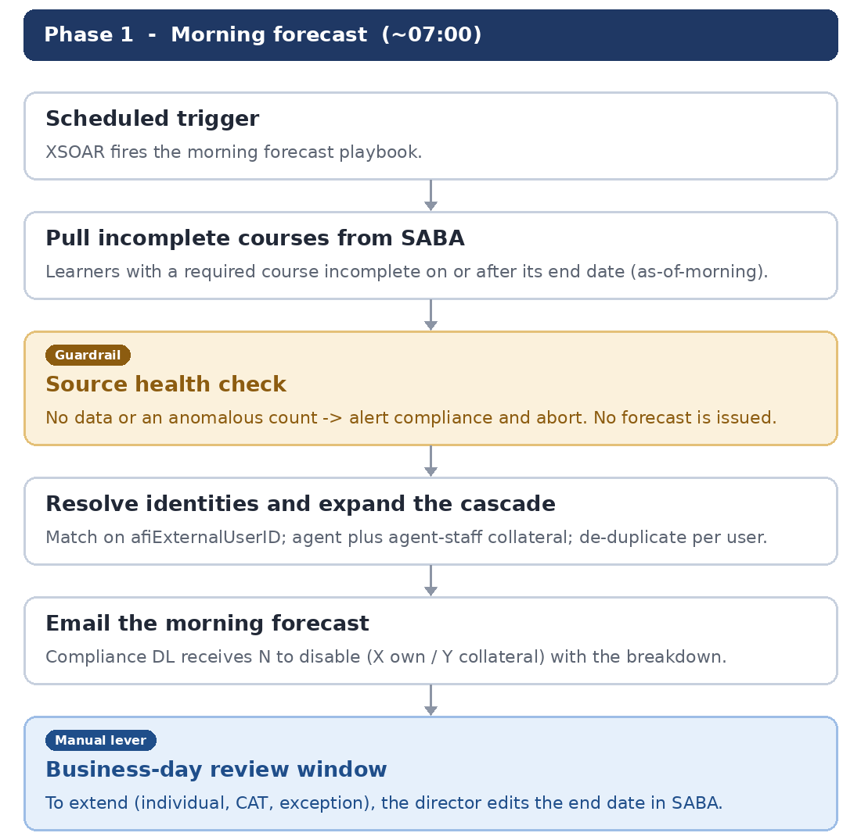
Figure 1. Phase 1 — morning forecast.
Phase 2 — overnight enforcement (~02:00):
- XSOAR re-pulls SABA as-of-night, capturing the day's extensions.
- Empty-source / anomaly guardrail: if the pull fails or looks wrong, make zero AD changes and alert compliance; end the run.
- Read extensionAttribute1 tags; compute the should-disable set (cascade) and the should-re-enable set (own-tagged accounts whose condition has cleared).
- Apply the threshold gate: 50 or fewer auto-execute; 51–100 await compliance approval; over 100 escalate to the Director; CAT events can halt the run.
- Disable and tag (OWN / COLLATERAL); re-enable own-tagged accounts whose condition cleared and clear the tag — only inside the producer OU, only the automation's own tags.
- Write audit records to ServiceNow and close the run as one incident with the forecast-versus-actual delta.
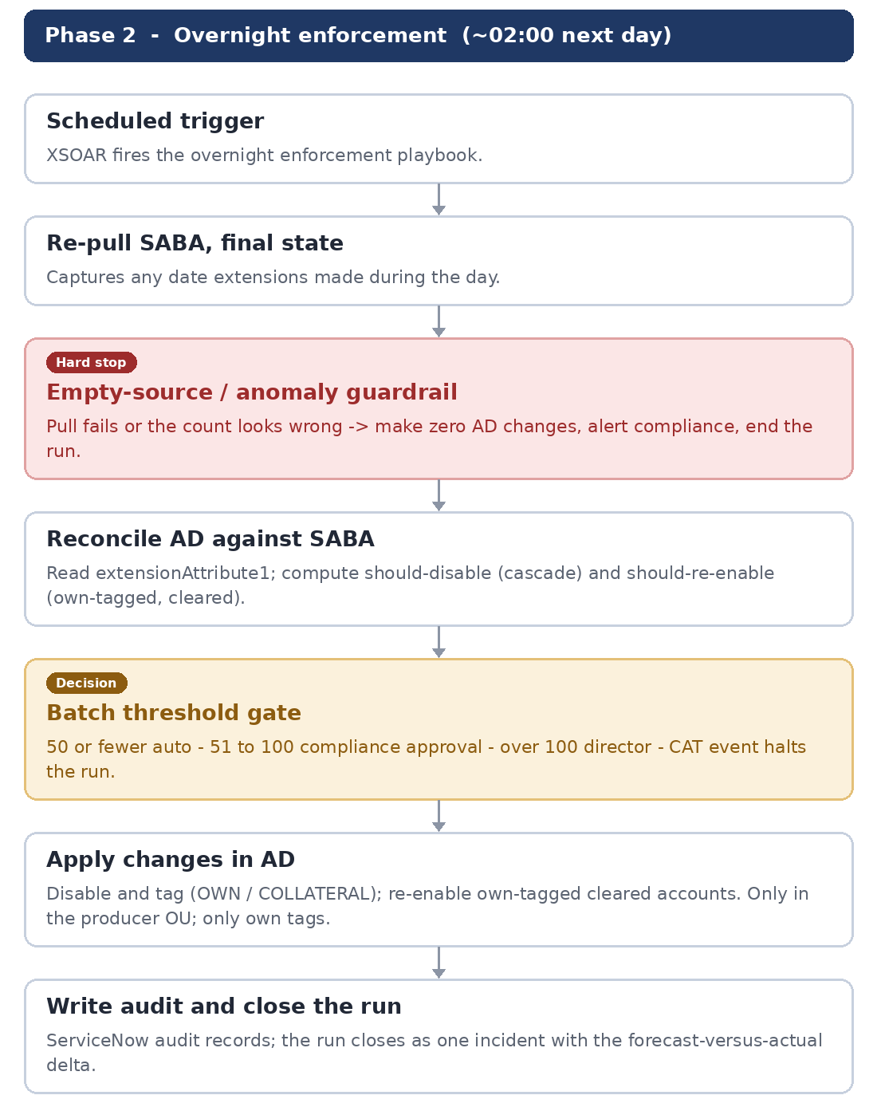
Figure 2. Phase 2 — overnight enforcement.

7. The agent → agent-staff cascade
The agent-staff relationship is sourced from AD (manager / directReports) and is one level deep. The disable rule:
- An agent should be disabled if they have a required course incomplete past its end date.
- An agent-staff member should be disabled if they have a required course incomplete past its end date, or if their agent should be disabled (collateral).
Collateral re-enable follows automatically under the declarative model: extending the agent's end date makes the agent compliant on the next run, and every agent-staff member whose disable depended only on that agent is re-enabled in the same run.
Process note for compliance: to release collateral agent-staff, extend the agent's date in SABA. Extending an agent-staff member's own date has no effect while their agent remains non-compliant.
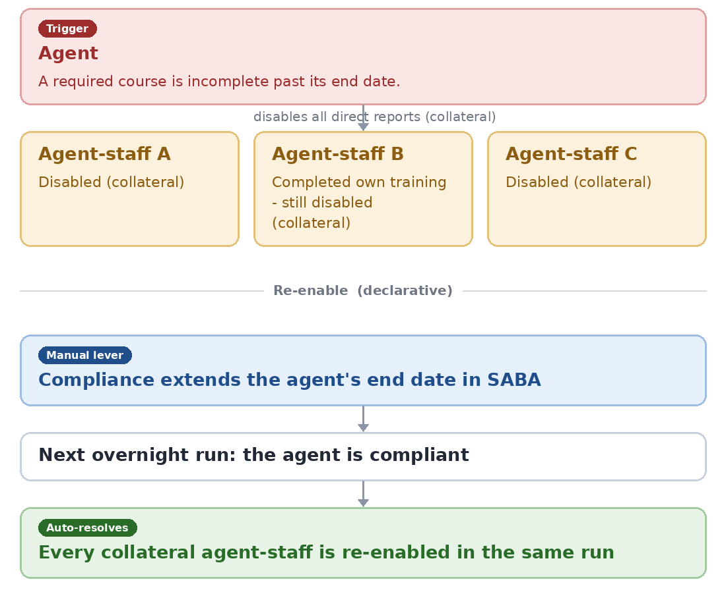
Figure 3. The agent → agent-staff cascade, and how collateral re-enable follows from extending the agent's date.

8. Guardrails and controls
Three guardrails are mandatory under a nightly full-reconciliation model:
- Ownership tag (extensionAttribute1). Every account the automation disables is tagged with its origin — for example TRAIN-DISABLED with a date and an OWN or COLLATERAL marker. The reconciler only re-enables accounts bearing its own tag, and only disables accounts inside the in-scope producer OU. This keeps the control in its lane: an account disabled by another process (termination, security hold) carries no such tag and is never re-enabled by this automation.
- Empty-source / anomaly abort. If the SABA pull fails or returns an anomalous count, the run makes zero AD changes and alerts the compliance distribution list. Without this, an empty result could be read as everyone is compliant (re-enable all) or no data (disable all) — a large-scale compliance incident.
- Threshold circuit-breaker. 50 or fewer accounts auto-execute; 51 to 100 hold for a go/halt decision from the compliance distribution list (an XSOAR data-collection task); more than 100 escalate to the Director of Compliance. A single run-level halt is available for CAT events, complementing per-user date extensions in SABA.
Least privilege: the account that performs enable/disable can affect any producer account, so it is vaulted in CyberArk, scoped to the producer OU and to enable/disable operations only, with every action logged.

9. Entra SSO consequence and reactivation
SABA Cloud is fronted by Entra SSO. A disabled AD account therefore cannot authenticate to SABA, so a user cannot complete the very course that would re-enable them while disabled. The declarative model handles this without a separate reactivation workflow: compliance extends the end date in SABA, the next overnight run re-enables the account, and the user — now able to sign in — completes the course and remains enabled.
The agreed re-enable latency is the next overnight run (up to roughly 24 hours). This removes the need for any same-day reactivation trigger and reduces ServiceNow to the audit record rather than an orchestration component.
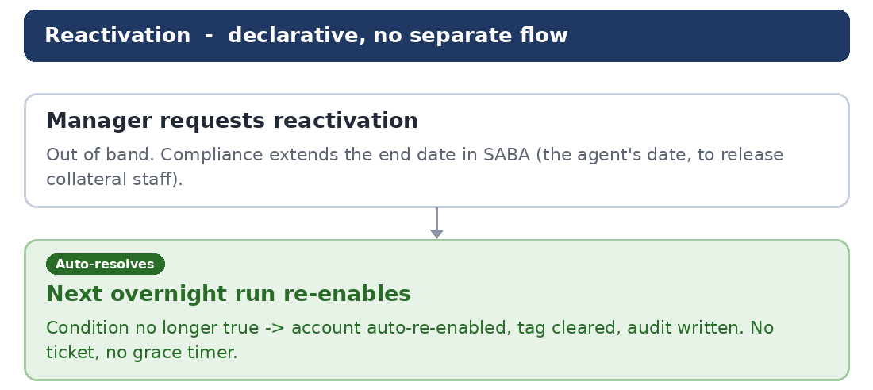
Figure 4. Reactivation is declarative: extending the end date in SABA re-enables the account on the next run.

10. Assumptions and open items for reviewer validation
The following are carried as assumptions and are flagged specifically for IDM and compliance validation:
- Identity join key. SABA is assumed to expose a stable, queryable identity key that maps to AD. The intended key is afiExternalUserID (anchored to sAMAccountName in AD). Confirmation is required that this field is populated and returned by the SABA enrollment API. Any user that does not positively match is routed to an exception queue and is never auto-disabled on the basis of a missing match.
- SABA data fields. The enrollment API is assumed to return, per assignment, both the course end (due) date and completion status. The control keys on the end date, not the assignment date.
- Producer provisioning timing. Producer identities are created in AD by the PMAC producer feed (mainframe-sourced). The timing of that feed relative to the overnight run should be confirmed so newly created producers are not evaluated before their training is assigned.
- Approaching-deadline warning. Under this model the deadline warning is the user's only notice before a silent overnight disable, so its source (SABA-native reminders or a separate step) and reliability must be confirmed.

11. Lift-and-shift contract to NetIQ
The tactical solution is structured so the strategic MyAccess / NetIQ driver can assume the control cleanly.
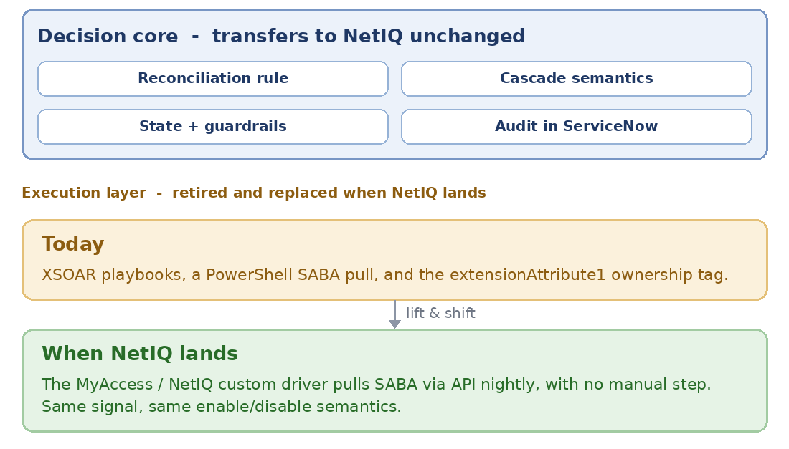
Figure 5. The decision core transfers to NetIQ unchanged; only the execution layer is replaced.

Transfers to the NetIQ driver (the decision core and evidence)
- The control definition and reconciliation rule: enabled-state as a function of SABA end date plus AD organisational structure.
- The cascade semantics: agent own-incomplete; agent-staff collateral; collateral re-enable on agent compliance.
- The state semantics (own versus collateral disable) and the threshold and abort guardrail definitions.
- The audit model and history held in ServiceNow.

Retired when NetIQ lands (the execution layer)
- The XSOAR orchestration and the two scheduled playbooks.
- The PowerShell SABA pull, replaced by the native NetIQ driver pulling SABA via API.
- The transitional extensionAttribute1 ownership tag; the NetIQ end-state manages state without a custom AD attribute.
When the driver is ready, it consumes the same SABA signal and applies the same enable/disable semantics, with ServiceNow remaining the audit front-end. No change to policy, evidence, or user-visible behaviour is required.

12. Risk register
Risk | Mitigation
Wrongful disable of revenue-generating producers | Act only on positively matched accounts; daily forecast for review; threshold circuit-breaker; empty-source abort.
Reconciler acting outside its scope (re-enabling accounts disabled by other processes) | Ownership tag on extensionAttribute1; OU-scoped action set.
SSO lockout prevents course completion | Re-enable is automated on the next run after the date is extended in SABA.
Revenue or operational impact during a CAT event | Date extension in SABA plus a run-level halt; escalation to the Director above 100 accounts.
Source-data error causes a mass change | Zero AD changes on a failed or anomalous SABA pull, with alerting.
Privileged account misuse | CyberArk vaulting, least-privilege scope, full logging.
Divergence from the strategic programme | Engine-agnostic decision core and a documented lift-and-shift contract; staging database deliberately avoided.

13. Regulatory alignment
The design supports the control objectives relevant to the enterprise's regulatory obligations: a defensible, evidenced access control tied to a mandatory-training requirement, with least-privilege administration and a durable audit trail. The per-run evidence (population evaluated, actions taken, approvals, and the forecast-versus-actual delta) together with the ServiceNow records provide the artefacts typically expected under NYDFS Part 500, PCI DSS, and NIST control frameworks for access governance and auditability. This brief does not assert a specific control mapping; the relevant control identifiers should be confirmed with the compliance and audit functions.

14. Decisions requested and next steps

From compliance
- Approve the declarative, end-date-driven model and the move of the policy lever entirely into SABA.
- Confirm the threshold values (50 and 100) and the distribution list for the 51–100 approval and the over-100 escalation.
- Confirm ownership and reliability of the approaching-deadline warning to users.
- Confirm the handling of the identity-verification step, which the automation proposes to retire.

From the IDM principal
- Validate the lift-and-shift contract in Section 11 and confirm it aligns with the MyAccess producer-identity roadmap.
- Confirm the join-key assumption (afiExternalUserID) and the Entra SSO behaviour in Sections 9 and 10.
- Confirm that a tactical XSOAR build on this contract does not create rework or conflict for the strategic NetIQ driver.

Proposed next steps after sign-off
- Confirm the open items in Section 10.
- Build the morning forecast and overnight enforcement playbooks with the guardrails in Section 8.
- Run the enforcement playbook in forecast-only (dry-run) mode for one cycle and reconcile the output manually.
- Enable enforcement against a limited pilot population before full rollout.

