WEB PROGRAMMING & SECURITY PROJECT
PART-3: WEB SECURITY
You will learn:
- revisit-usages of one-way hashing functions such as SHA-1
- importance of using smart passwords
- how to crack weak passwords using dictionary/rainbow table attacks
- using salt to mitigate dictionary attacks
- how to mitigate SQL injection
DELIVERABLES
There are three tasks; Task-1 (30 points) + Task-2 (35 points) + Task-3 (35 points) .
ZIP all the following documents into one file before submitting

Task-1:
(1) Selva’s password (plain text- after cracking) – see image-1 (save it in passwordTask1.txt)
(2) Screenshots –
(a) Login page showing username and password
(c) Selva’s Profile page
Task-2:
(3) Selva’s new password (after cracking) - see image-4 (save it in passwordTask2.txt)
(4) New programs (loginSalt.html, registerSalt.htm, loginSalt.php, registerSalt.php, memeberInfoSalt.php)
(5) Screenshots –
(a) Modified Records in ACM Members table with Salt (similar to image-4)
(b) Login page showing username and new password (similar to image-2)
(c) Greetings page (similar to image-3)
Task-3
- The new program login4.php that could prevent SQLi (see part-2)
- Screen shots-
- Login page that clearly shows the SAME payload (username and password) you used for SQL Injection attack in part-2
- Error page that informs that the username or password is wrong

TASK-1 (25%) : Password Cracking
Check: John The Ripper: http://www.openwall.com/john/ & https://wiki.skullsecurity.org/Passwords
Check: Security Tools: http://sectools.org/ & https://www.concise-courses.com/hacking-tools/top-ten/
Check the first 100 popular passwords and their MD-5 values http://www.passwordrandom.com/most-popular-passwords). Note that in this assignment we are using SHA-1 not MD-5.
# | Password | MD5 | SHA-1
1 | password | 5f4dcc3b5aa765d61d8327deb882cf99 | 5baa61e4c9b93f3f0682250b6cf8331b7ee68fd8
2 | 123456 | e10adc3949ba59abbe56e057f20f883e | 7c4a8d09ca3762af61e59520943dc26494f8941b
3 | 12345678 | 25d55ad283aa400af464c76d713c07ad | 7c222fb2927d828af22f592134e8932480637c0d
4 | 1234 | 81dc9bdb52d04dc20036dbd8313ed055 | 7110eda4d09e062aa5e4a390b0a572ac0d2c0220
5 | qwerty | d8578edf8458ce06fbc5bb76a58c5ca4 | b1b3773a05c0ed0176787a4f1574ff0075f7521e
Table-1 (first 5 popular passwords and their MD-5 and sha-1 values
Image-1 shows 3 entries in the Member table in ACM database (created in Part-1 of this Project). The passwords for the 1st and 3rd rows (Ray’s and Selva’s) were selected from the first 100 most used passwords (see the above link).
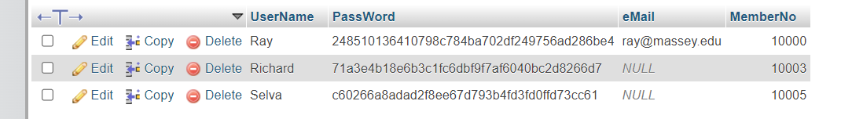 image-1
Before storing passwords in the ACM database, we encrypt them all using SHA-1. For example, Ray’s password is cowboy – it was 100th entry in the Table-1. You can generate sha-1 hash of ‘cowboy’ and check against the database table value in image-1. You may generate sha-1 hash function for any text using online-tools such as (https://passwordsgenerator.net/sha1-hash-generator/).
As you can see in the image-1, the sha-1 hash of Selva’s password is c60266a8adad2f8ee67d793b4fd3fd0ffd73cc61- obviously, Selva’s password is not known now.
Assume that somehow you hacked into ACM database, and you can see sha1 hash of Selva’s password (c60266a8adad2f8ee67d793b4fd3fd0ffd73cc61).
TASK-1 (25%): Password Cracking (with SHA-1 but without SALT)
Your Task-1 in Project-Part-3 is to crack Selva’s password.
In part-2 you were able to access Selva’s records using URL parameter manipulation and SQLi. In this section, you will try to retrieve Selva’s password itself.
Since sha1 hash is a one-way function, it is very difficult to retrieve the original text from the hash. But, since Selva’s password is selected from the first 100 popular passwords mentioned earlier. You may use Pre-computed dictionary attack/Rainbow table attack to crack the password. see https://en.wikipedia.org/wiki/Dictionary_attack). Anyway, in LLM era, this task may be very easy.
First you must include the second row (image-1) in the members table in the ACM database. Note that, the password c60266a8adad2f8ee67d793b4fd3fd0ffd73cc61 need to be included as plain text (don’t select function SHA1 – otherwise it will encrypt the encryption again). Alternatively, you can also include this row after you have cracked the password and enter it in plain text with SHA-1 function selected for password column – see image 13 in project-part-1).
After that, you can use the login.php code you developed in part-2 of the project to test the password. You should get Selva’s profile screen.
Deliverable: for Task1:
(1) Selva’s Password (text)
(2) Screenshots –
(a) Records in ACM members table.
(b) Login page clearly showing username and password (similar to image-2 but visible password)
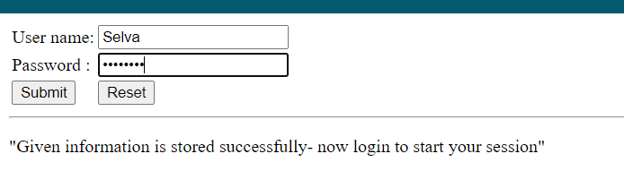image-2
(c) Greetings page (similar to image-3)
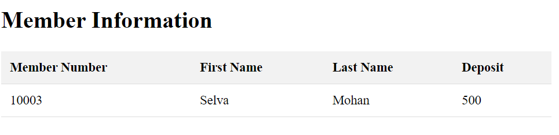image-3

See task-2 in next page.
TASK-2 (25%): Password Cracking (with SHA1 & SALT)
As mentioned earlier, in this LLM era, task-1 is very easy. You can also use https://sha1.gromweb.com/ Since Selva’s password is one of the very common passwords, dictionary/ Rainbow-table attack can also be used to crack this password (see https://en.wikipedia.org/wiki/Dictionary_attack). SALT can be used to prevent this type of attacks using pre-computed tables,
(see https://en.wikipedia.org/wiki/Salt_(cryptography)). In general, salt is a random string generated for each password and concatenated with password before generating hash function.
Check the following table in Image-4. It shows 3 entries in the Member table. Not like Image-1, this table includes a column for salts. Different salts will be randomly generated for each row and will be stored in plain text in the table.
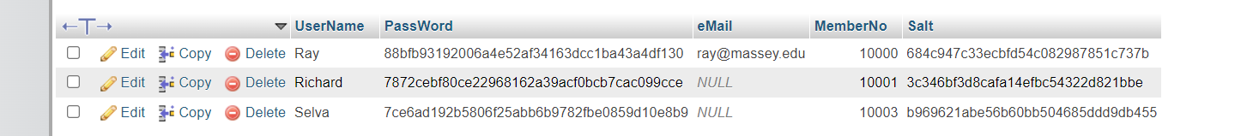
We will create this new table memebrPW2 with an additional column for random salt values now. We will also create a new table member-1 which is exactly same structure and data as member table.
First copy and paste the structure and the data of the table memebrpw1 and member1 and rename them to memberPW2 and member2. To do this, open phpMyAdmin, select the table memberpw1, and select operations, and change the name under copy to memberpw2, and GO. Similarly copy member1 and rename it member2.
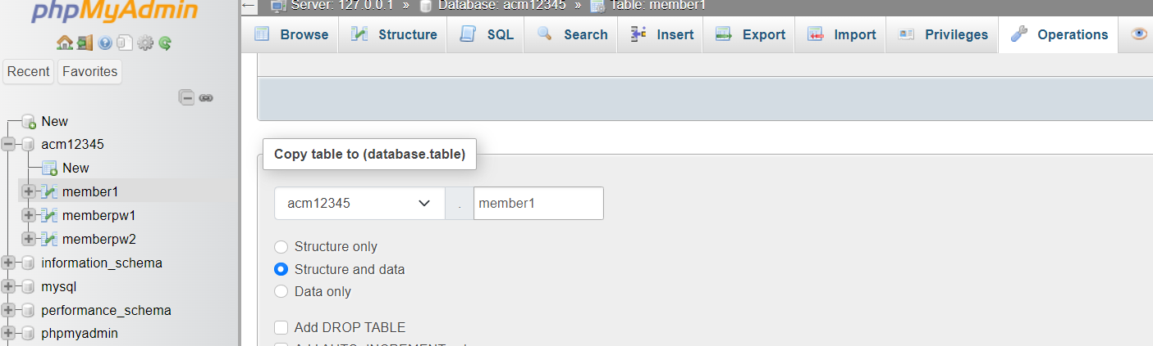
Select memberpw2 and select Structure. Add 1 Column. GO
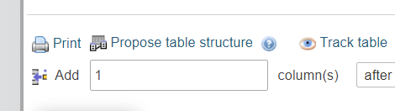
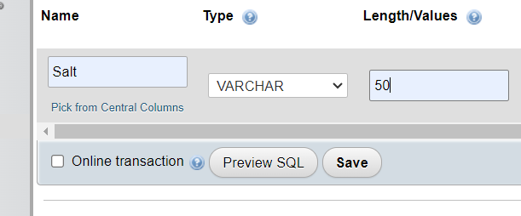
Name it Salt / VARCHAR/ 32 and save.
Now Select SQL and type the following and GO.
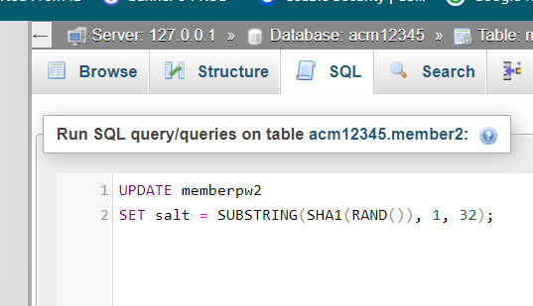image-4
Now select Browse, you will see the Salt column will be filled with some random strings. Since they are random your salt values will be different from the values given below.
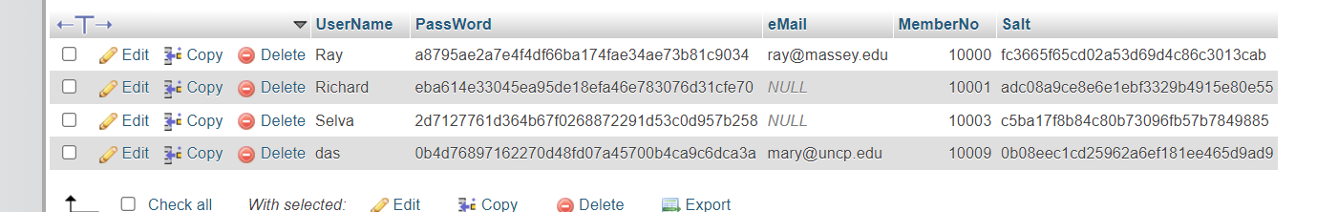
For example, for the first record in image-4, the salt is fc3665f65cd02a53d69d4c86c3013cab (again, since salts are generated randomly, you will have different salt values- use your salt value instead of the above salt). Therefore, Ray’s password cowboy is concatenated with salt and sha-1 hash of cowboyfc3665f65cd02a53d69d4c86c3013cab is a8795ae2a7e4f4df66ba174fae34ae73b81c9034 is included as Ray’s password a87….34. You can check this in https://passwordsgenerator.net/sha1-hash-generator/ or on any other sha1 online generators.
This hash-value is stored in the database (see image-4). But I entered this string manually in the table- For now, you also need to find sha1(cowboy + your salt) and enter that value in the password column manually. Later, you will modify the register.php file to include salt and new password entries.
IMPORTANT: Similarly, for each row, the Password entries should be manually updated with new hashed passwords – use any sha1 online generators to find sha1(your password + your corresponding salt).
However, since Selva’s password is changed and your task-2 is to crack this password- only for the Selva’s record, copy and paste the given salt and hashed password shown below. You need to crack Selva’s password text later.
Selva | 2d7127761d364b67f0268872291d53c0d957b258 | NULL | 10003 | c5ba17f8b84c80b73096fb57b7849885

Now we will link memberPW2 and member2 tables using memberNo. Select member2 table, select Structure, select Relational View, and link the tables (see below). We cannot use member1 since we will get foreign-key issues.
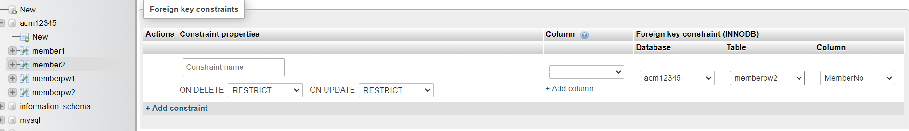

Modify register and login programs
Now, we will modify register.php, so that it can generate a random salt and store it in Salt column, and then, concatenate the salt with the given password, hash it and store it in the Password column. Also, we need to modify login.php to accommodate salt.
Copy the folder CSC3380PP2T2 and paste it in htdocs. Rename the folder CSC3380PP3
Now rename the register.php as registerSalt.php, and make the following changes. Change table name, include a line to generate salt (in this php program we use a different function to generate salt- compare with image-4) , and modify few lines (see below).
//functions
function usernameTaken($conID, $uName) {
$sql = "SELECT * FROM ??? WHERE UserName = '$uName'";
$result = $conID->query($sql);
return $result->num_rows > 0;
}

function write($conID, $fName, $lName, $eMail, $uName, $pw, $deposit) {
// Generate a random salt
$salt = bin2hex(random_bytes(16)); // 16 bytes = 32 hex characters
// Hash the password with the salt
$hashed_password = sha1($pw. ???);
$sql = "INSERT INTO ??? (UserName, PassWord, eMail, Salt) VALUES ('$uName', '$hashed_password', '$eMail', '$Salt')";
if ($conID->query($sql) === TRUE) {
$lastMemberNo = $conID->insert_id;
} else {
echo "Error: " . $sql . "<br>" . $conID->error;
return false;
}

$sql = "INSERT INTO ??? (MemberNo, FirstName, LastName, Deposit) VALUES ('$lastMemberNo', '$fName', '$lName', '$deposit')";
if ($conID->query($sql) === TRUE) {

First we have to change the register link in login.html to registerSalt.html and save it as loginSalt.html. Now if you click on register link it will open registerSalt.html. When the form in registerSalt is submitted it will run registerSalt.php. We also need to change action = login.php to action = loginSalt.php. The login.php won’t work now because of salts- later we will modify login.php to loginSalt.php.
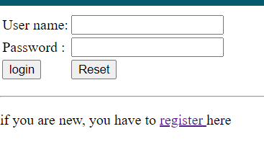
<!DOCTYPE html>
<html lang="en">
<head>
<-- fill-in -->
</head>
<body>
<p id="error" style="color:red;"> </p>
<form action ="loginSalt.php" method="post">
<table>
<tr> <td> User name: </td>
<td> <input name= "uName" type="text" required> </td> </tr>
<tr> <td> Password : </td>
<td> <input name="pw" type="password" required> </td> </tr>
<tr> <td> <input type = "submit"> </td>
<td> <input type="reset"> </td> </tr>
</table>
</form>
<hr/>
<p id="msg"> if you are new, you have to <a href="registerSalt.html"> register </a> here </p>
</body>
</html>

Now open localhost csc3380pp3/loginSalt.html (or open csc3380pp3/registerSalt.html directly) , and then select register (don’t try to login- it won’t work now because of salts- later we will modify login.php). Enter a new record and check the database.
Take a screen shot of the register form and table.
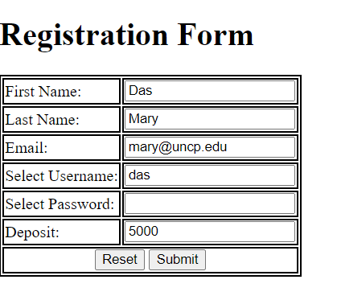
I gave das as the password. Even if you give the same password das your password hash should be different since the password is concatenated with the salt and the salt is random.

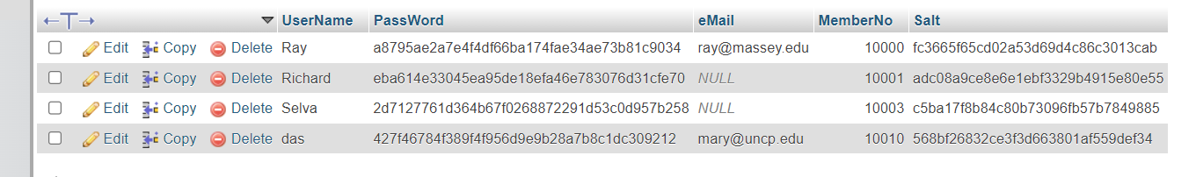
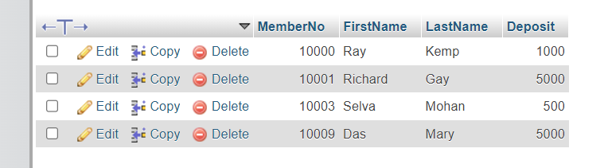

You will not be able to login with the given password because in this program the salt will not be concatenated with password.
Now we must modify the login.php and safe it as loginSalt.php. Compare this with the old code.
function pwOK($conID, $uName1, $pw1, &$memberNo1){
$SQL = " SELECT * FROM ??? ";
// the given password is encrypted before matching with the password in database
// make sure the column names in the DB table are UserName and PassWord
$SQL = $SQL . " WHERE UserName = '$uName1'"; // CHECK CHANGE
$result = $conID->query($SQL);
if (!$result) {
die( "Query Error: " .$SQL. " :" .$conID->connect_error;
} else {
$row = $result -> fetch_array();
if (!$row){ // if the row is empty, user name is wrong
return false;
} else {
$memberNo1= $row['MemberNo']; //should match table's column name
$hpw =$row['PassWord'];
$salt=$row['Salt'];
if ($hpw != sha1(???.???))
return ??? ;
else {
$result->close();
return true;
}
}
}
}

Now if you tried to login using any known un + pw, you will only see the member number.
We have to change the table name in one line on memberInfo.php (see below) and safe it as memberInfoSalt.php.
function getMemberInfo($conID, &$fName, &$lName, &$deposit, $memberno){
$SQL = " SELECT * FROM member1 WHERE MemberNo = $memberno";

Now we can login.
Try localhost/csc3380pp3/loginSalt.html and give the username das and Das’ password (I gave das).
We will get,
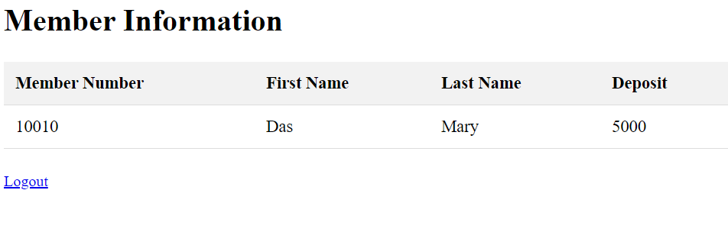
Suppose you can access the Selva’s password record, you will get
Selva | 2d7127761d364b67f0268872291d53c0d957b258 | NULL | 10003 | c5ba17f8b84c80b73096fb57b7849885

Your task is to crack Selva’s new password. This password also taken from the popular passwords given at the end of this document. All the sha1 values for these passwords are readily available in table format on internet. But since we used salt now, cracking the password is little hard. You can try to reverse 2d7127761d364b67f0268872291d53c0d957b258- but it will be impossible. As you know the password is selected from table-1, you may manually concatenate the Selva’s salt c5ba17f8b84c80b73096fb57b7849885 with each password given in table-1 and generate its sha-1 function and check it against the above hashed password entry (6e0701e7c4e8…). This is doable but tedious. There is another way- you can use a multiple line hash generator (see https://www.miraclesalad.com/webtools/sha1.php) . You need to do some modification to the list.
Yet another way is writing a program (may be in java- an incomplete java program is given at the end of this assignment to generate password strings given as an array and compare it with the given hash-
You only need to complete five blanks ?? on the program.
for (String password : commonPasswords) {
String saltedPasswordHash = sha1(?? + ??); //

// Check if the hashed salted password matches the given hash
if (??.equals(??)) {
System.out.println("The password is " + ??);
break; // Exit loop once the password is found
}

After filling the blanks, run the program and you will get the answer.
The password is ---------------------

Note: We may use proper password hashing functions like password_hash and password_verify to secure passwords (better than directly using sha1). password_hash: Automatically includes a salt in the hash. This makes it unnecessary to manually generate and store salt, which reduces complexity and the risk of implementation errors. Purpose of this assignment is to learn the fundamentals.
Optional (Easy Task 2: hash + salt)
We do not need a separate column Salt in memberPW table.
Only changes we need:
When writing the record in registerSalt.php:
Replace
function write($conID, $fName, $lName, $eMail, $uName, $pw, $deposit) {
// Generate a random salt
$salt = bin2hex(random_bytes(16)); // 16 bytes = 32 hex characters
// Hash the password with the salt
$hashed_password = sha1($pw. ???);
$sql = "INSERT INTO ??? (UserName, PassWord, eMail, Salt) VALUES ('$uName', '$hashed_password', '$eMail', '$Salt')";
With (also, no need to/ should not store Salt separately)
function write($conID, $fName, $lName, $eMail, $uName, $pw, $deposit) {
// Generate a random salt+ Hash the password with the salt
$hashed_password = password_hash($pw, PASSWORD_DEFAULT); //use Bcrypt algorithm now
$sql = "INSERT INTO ??? (UserName, PassWord, eMail) VALUES ('$uName', '$hashed_password', '$eMail')"; // no $Salt

PHP automatically handles salting and hashing securely.
$hashedPassword = password_hash($pw, PASSWORD_DEFAULT);
PASSWORD_DEFAULT uses a strong algorithm (currently Bcrypt), and it generates a unique salt each time. In Bcrypt, the salt is embedded within the hashed password string itself — you don’t need to store it separately.
For example:
$2y$10$wH6s5z3zWXYyYaB4b8JdL.8M8wrz0Mz3aVR9m5gDQG7L8WZ.3zv2K
This breaks down as: $2y$-Bcrypt algorithm identifier; 10$- Cost factor (log2 of iterations) → 2¹⁰ = 1024 rounds; Salt- wH6s5z3zWXYyYaB4b8JdL. 22-character salt (Base64-like format); and Hashed Password- 8M8wrz0Mz3aVR9m5gDQG7L8WZ.3zv2K Hash result of password + salt
While checking in loginSalt.php
Replace
$hpw =$row['PassWord'];
$salt=$row['Salt'];
if ($hpw != sha1(???.???))
return ??? ;
else {
$result->close();
With
$hpw =$row['PassWord'];
//no separate Salt column
if (password_verify($pw1,$hpw)) //$hpw contains salt
return ??? ;
else {
$result->close();

password_verify($enteredPassword, $hashedStoredPassword) verify whether the hash(enterdpassword+salt part in $hashedStoredPassword) is equal to the hash part of $hashedStoredPassword

Deliverable: for Task2:
(4) Selva’s new password (after cracking) - (save it in passwordTask2.txt)
(5) New registerSalt.php
(6) New loginSalt.php
(7) New memberInfoSalt.php
(8 above Java program snippet (only those five filled-in lines)
(7) Screenshots –
(a) Register form and old ACM Members tables (member1 and memebrsPW1) tables
New Records in ACM Members tables (member1 and memebrsPW1) tables
(b) Login page showing username and new password (to show password text you may change the input type from password to text)
(c) Greetings page

task-3 in the next page
Task3: SQLi mitigation
Salting and hashing passwords make it difficult for attackers to use precomputed hash tables (rainbow tables) to crack passwords if they manage to get access to the hashed passwords. Salting adds a unique value to each password before hashing, ensuring that identical passwords have different hashes.
Using a salt in conjunction with password hashing does not directly prevent SQL injection (SQLi). Salting and hashing are techniques for securing stored passwords, while SQL injection is a vulnerability in the way SQL queries are constructed and executed.
Recent study shows that there are millions of websites still have SQLi vulnerability.
SQL Injection (SQLi)
SQL injection occurs when an attacker can manipulate the SQL query sent to the database, typically by injecting malicious SQL code through user inputs. You were asked to do SQLi in Project Part-2 Task 2 Method-2.
To prevent SQL injection, you can use prepared statements and parameterized queries.
In this task, you are required to rewrite the program login.php in order to prevent SQL Injection- save it as login3.php. You may use PDO (PHP Data Objects) or some other suitable techniques.
To secure your application, you should:
- Database Connection Using PDO: The openDatabase function- use PDO to connect to the database.
- Prepared Statements: The pwOK function- use prepared statements and parameterized queries to prevent SQL injection.
- Error Handling: Improve error handling by using PDO's exception handling capabilities.
- Session Handling: Remain the same to ensure sessions are managed properly.
By using PDO and prepared statements, you prevent SQL injection and ensure the security of your application.
Deliverable for Task-3:
- The new program login3.php that could prevent SQLi.
- Screen shots-
- Login page that clearly shows the SAME payload (username and password) you used for SQL Injection attack in Task-3
- The page that informs that the user name or password is wrong

next page: Java program for Task-2
Task-2 Help (Java Program to find a password when used with a salt)
SHA-1 in Java
To get sha-1 hash of some "text", you need to call some function like SHA1("text") in java. But, SHA1() is not directly available in java libraries. You have to use the methods given below.(or use Apache codec).
http://www.anyexample.com/programming/java/java_simple_class_to_compute_sha_1_hash.xml

Read the program. Fill in the blanks and run the program. You will get the Selva’s password.
The first 100 common passwords are given in an array.

import java.io.IOException;
import java.security.MessageDigest;
import java.security.NoSuchAlgorithmException;

public class PasswordCracker {

/* Returns SHA1 of text as a hex string of length 80 (2 * 40) */
public static String sha1(String text) throws NoSuchAlgorithmException {
MessageDigest md = MessageDigest.getInstance("SHA-1");
byte[] sha1hash = md.digest(text.getBytes()); // sha1hash contains sha1(text) in byte array
return convertToHex(sha1hash); // to convert byte array to hex string
}

/* To convert a byte array to hex string; e.g. {11110001, 11100010} to f1e2 */
private static String convertToHex(byte[] bArray) {
StringBuffer buf = new StringBuffer();
for (byte b : bArray)
buf.append(convertByteToHex(b));
return buf.toString();
}

/* To convert a byte to hex digits- e.g. 11110001 to f1 */
private static String convertByteToHex(byte b) {
String h = "";
int firstNibble = (b >>> 4) & 0x0F;
int secondNibble = b & 0x0F;
h = h + convertNibtoHex(firstNibble) + convertNibtoHex(secondNibble);
return h;
}

/* To convert a nibble (4 bits) to a hex digit- e.g. 1111 to f, 0010 to 2, etc. */
private static char convertNibtoHex(int halfbyte) {
if ((0 <= halfbyte) && (halfbyte <= 9))
return (char) ('0' + halfbyte);
else
return (char) ('a' + (halfbyte - 10));
}

public static void main(String[] args) throws NoSuchAlgorithmException {
String salt = "c5ba17f8b84c80b73096fb57b7849885"; // Copy and paste Selva’s salt within quotes
String hPW1 = "2d7127761d364b67f0268872291d53c0d957b258"; // Copy and paste Selva’s hashed password within quotes

// Use an array instead of a file
String[] commonPasswords = {
"password", "123456", "12345678", "1234", "qwerty", "12345", "dragon", "baseball", "football", "letmein",
"monkey", "696969", "abc123", "mustang", "michael", "shadow", "master", "jennifer", "111111", "2000",
"jordan", "superman", "harley", "1234567", "hunter", "3456", "2001", "123456789", "test", "batman",
"trustno1", "thomas", "tigger", "robert", "access", "love", "buster", "1234567890", "soccer", "hockey",
"killer", "george", "sexy", "andrew", "charlie", "super", "3456", "3456", "dallas", "jessica",
"3456", "pepper", "1111", "austin", "william", "daniel", "golfer", "summer", "heather", "hammer",
"yankees", "joshua", "maggie", "3456", "enter", "ashley", "thunder", "cowboy", "silver", "richard",
"orange", "merlin", "michelle", "corvette", "bigdog", "cheese", "matthew", "121212", "patrick", "martin",
"freedom", "ginger", "3456", "nicole", "sparky", "yellow", "camaro", "secret", "3456", "falcon",
"taylor", "11111111", "131313", "123123", "3456", "hello", "scooter", "please", "porsche", "guitar", "chelsea"
};

for (String password : commonPasswords) {
String saltedPasswordHash = sha1(?? + ??); //

// Check if the hashed salted password matches the given hash
if (??.equals(??)) {
System.out.println("The password is " + ??);
break; // Exit loop once the password is found
}
}
}
}

Common passwords first 100:
{ "password", "123456", "12345678", "1234", "qwerty", "12345", "dragon", "baseball", "football", "letmein", "monkey", "696969", "abc123", "mustang", "michael", "shadow", "master", "jennifer", "111111", "2000", "jordan", "superman", "harley", "1234567", "hunter", "fuckme", "2001", "123456789", "test", "batman", "trustno1", "thomas", "tigger", "robert", "access", "love", "buster", "1234567890", "soccer", "hockey", "killer", "george", "sexy", "andrew", "charlie", "super", "asshole", "fuckyou", "dallas", "jessica", "panties", "pepper", "1111", "austin", "william", "daniel", "golfer", "summer", "heather", "hammer", "yankees", "joshua", "maggie", "biteme", "enter", "ashley", "thunder", "cowboy", "silver", "richard", "orange", "merlin", "michelle", "corvette", "bigdog", "cheese", "matthew", "121212", "patrick", "martin", "freedom", "ginger", "blowjob", "nicole", "sparky", "yellow", "camaro", "secret", "dick", "falcon", "taylor", "11111111", "131313", "123123", "bitch", "hello", "scooter", "please", "porsche", "guitar", "chelsea" };

en.wikipedia.org/wiki/Wikipedia:10,000_most_common_passwords

TABLE-1

- 123456
- password
- 12345678
- qwerty
- 123456789
- 12345
- 1234
- 111111
- 1234567
- dragon
- 123123
- baseball
- abc123
- football
- monkey
- letmein
- 696969
- shadow
- master
- 666666
- qwertyuiop
- 123321
- mustang
- 1234567890
- michael
- 654321
- pussy
- superman
- 1qaz2wsx
- 7777777

- 121212
- 000000
- qazwsx
- 123qwe
- killer
- trustno1
- jordan
- jennifer
- zxcvbnm
- asdfgh
- hunter
- buster
- soccer
- harley
- batman
- andrew
- tigger
- sunshine
- iloveyou

- 2000
- charlie
- robert
- thomas
- hockey
- ranger
- daniel
- starwars
- klaster
- 112233
- george

- computer
- michelle
- jessica
- pepper
- 1111
- zxcvbn
- 555555
- 11111111
- 131313
- freedom
- 777777
- pass

- maggie
- 159753
- aaaaaa
- ginger
- princess
- joshua
- cheese
- amanda
- summer
- love
- ashley
- 6969
- nicole
- chelsea
- biteme
- matthew
- access
- yankees
- 987654321
- dallas
- austin
- thunder
- taylor

