GETTING STARTED WITH THE COFFEESHOP DISPLAY FRAMEWORK

By Roberto Calderon
Media And Graphics Interdisciplinary Centre
University of British Columbia.
rvca@interchange.ubc.ca

The purpose of this guide is to get you started as quickly as possible with the MAGIC CoffeeShop framework, provided you have an Ubuntu machine and an Internet connection. This guide assumes you're installing everything from scratch. In a nutshell you will install a Broker2 server, Mysql, Apache2 (with PHP), Tomcat6, and deploy the CoffeeShop framework. You will then create your first web application.

DOWNLOAD AND START YOUR LOCAL OSGI BROKER (BROKER 2) SERVER.

If you haven't done yet, you need to configure a mysql server. In an Ubuntu box, you can do sudo aptitude install mysql-server follow the instructions and set up your root password.

Download the broker code from the repository, or visit:

http://pspi.magic.ubc.ca/code/index.php/p/osgibroker/downloads/

Download version 1.40-beta4, this version solves some bugs that would otherwise slow down your applications. (http://pspi.magic.ubc.ca/code/index.php/p/osgibroker/downloads/49/)

Unpack the tar.gz file. Now there's a couple of things you need to configure first:

- Go into the uncompressed folder and into osgibroker.parent.mvn-1.4.0/configurations/services/
- Open the mysql.properties file and change the dbUser and dbPassword fields. Please note that using root as dbUser poses a high security risk. We have set it up this way to make it easier for you to deploy, but DO NOT USE ROOT IF YOU'RE PLANNING TO DEPLOY THIS FOR PRODUCTION.

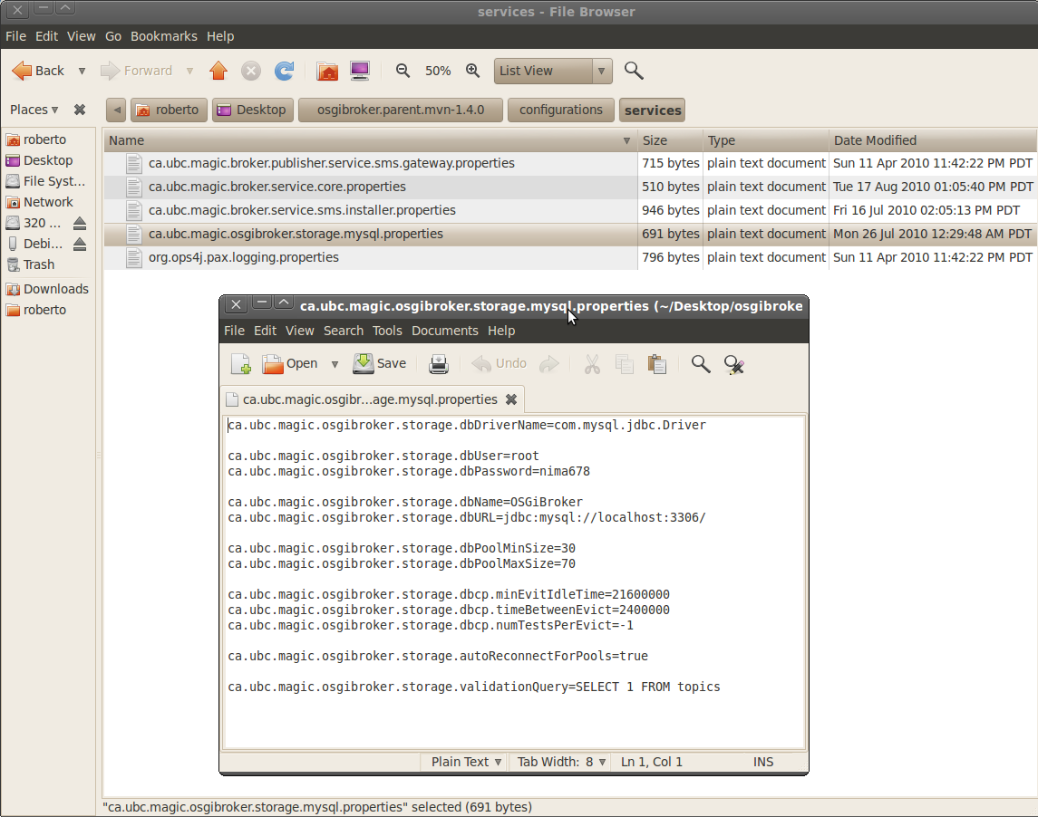

You're set up!! Now run the start.sh file through a command line (./start.sh) or use nohup to run as a background process. You can test if all is good by subscribing to a topic with the url:

http://localhost:8800/osgibroker/subscribe?topic=MAGIC&clientID=bigscreen1

You can find more on deploying and configuring your server at:

http://pspi.magic.ubc.ca/code/index.php/p/osgibroker/page/osgibroker-webservice/

CONFIGURE THE COFFEESHOP COINTAINER.

In the ca.ubc.magic.coffeeshop.config package open the file config.properties and configure

- the coffeeshopHost
- the coffeeshopPort
- the osgiHost
- the osgiPort

If you're supporting SMS interaction you need to configure

- smsDefaultTopic

To the osgi broker topic you're using to broadcast SMS messages in your broker configuration

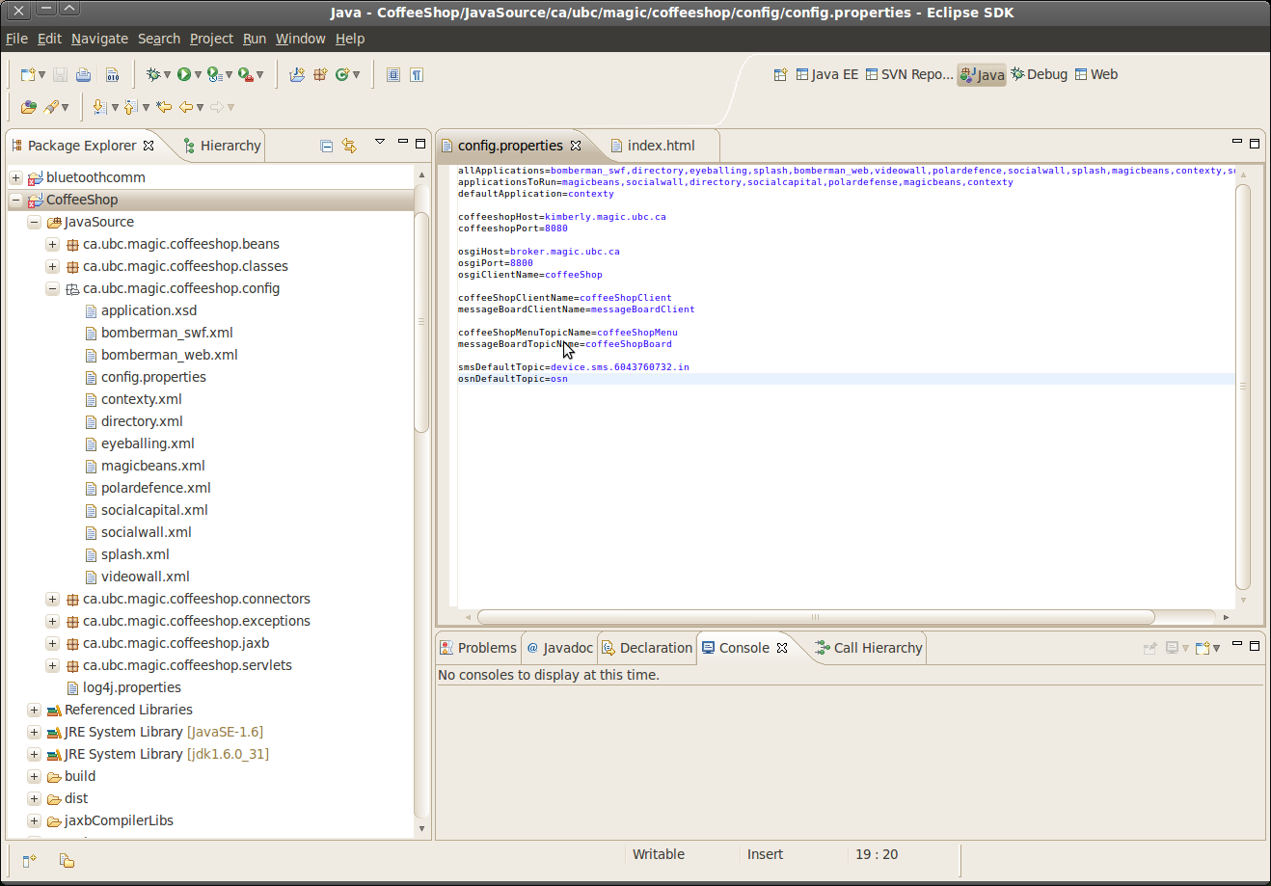

If you are going to deploy and access the CoffeShop framework in other host other than localhost you need to configure the GUI. Within WebContent open the file index.html and configure the domain used by the ajax calls.

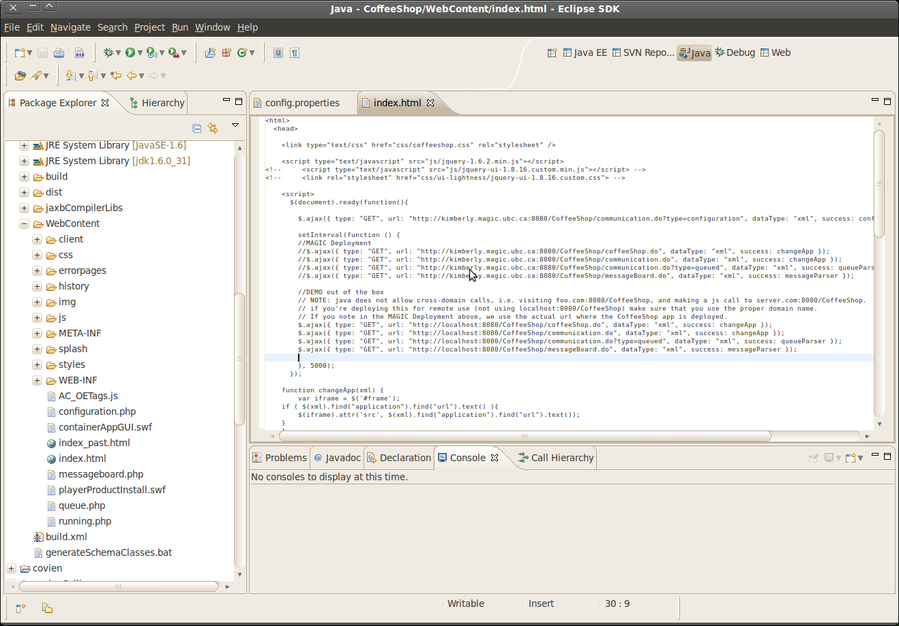

BUILD AND DEPLOY.

To build the project run the build.xml ant file located at the root of the project. Right click on the file and choose Run As > Ant Build.

A CoffeeShop.war file will be created in the dist folder. You can upload this file to your Tomcat installation through the tomcat's manager portal, or copy the file to /var/lib/tomcat6/webapps in an Ubuntu box. We have tested this war file under Tomcat6 with success.

IF YOU DON'T WANT TO COMPILE THE CODE WE HAVE PROVIDED A READY-FOR-DEPOLYMENT WAR FILE TO BE USED WITH A DEFAULT TOMCAT6 INSTALLATION. YOU CAN FIND THIS WAR UNDER THE “DIST” FOLDER.

Now let's visit our container at http://localhost:8080/CoffeeShop

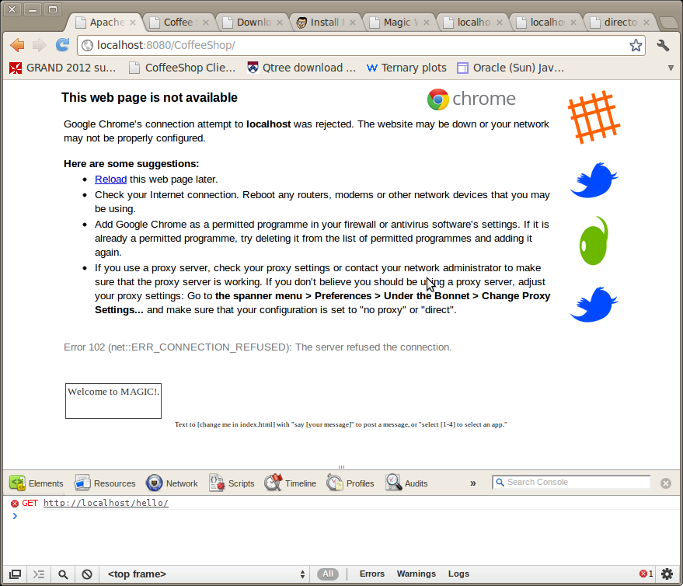

Oops! It looks like something is broken! Luckily we are going to fix it by creating our first application.

CREATING AND DEPLOYING YOUR FIRST APPLICATION

The CoffeeShop framework is good at managing interaction with different applications. It can manage servlet and web-based applications and the brokerage to them. Once an application has been selected the CoffeeShop framework will keep it active until messages delivered to the broker and targeted to such application cease to exist. A more in-depth explanation of the system can be found in the file CoffeeShop_TechnicalDocumentation.docx within the “documentaion” folder in the root of the CoffeeShop project.

Now let's create our first application.

First let's set up our Apache2 (with PHP support) server. Install with sudo aptitude install apache2 php5 (We need php to bypass Access-Control-Allow-Origin in Ajax calls configured out-of-the-box, and make it easier for you to just get going. If you wish to use Javascript-pure applications either use full domains instead of localhost or use json within your application.)

Now let's write a very quick and easy web application using jquery. We will use PHP to avoid same-domain problems using ajax. So let's write that code. When the document is ready we subscribe to a hello topic. Then every 5000 ms we will make a call for events on the broker and parse them. If we get events we will change the DOM and display it in our application.

Ok... I'll make your life easier. The app is already written and lives in the CoffeeShop project under the folder “hello” . Copy this folder to your /var/www/ folder in Ubuntu (or wherever your public html folder is)

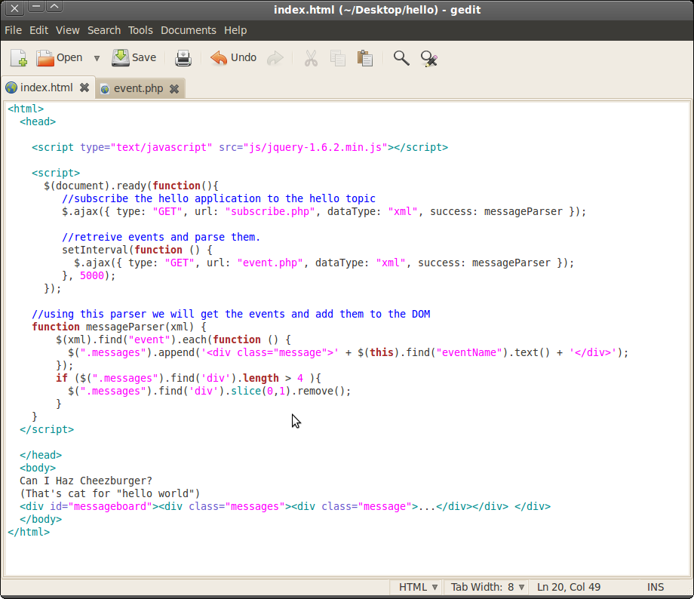
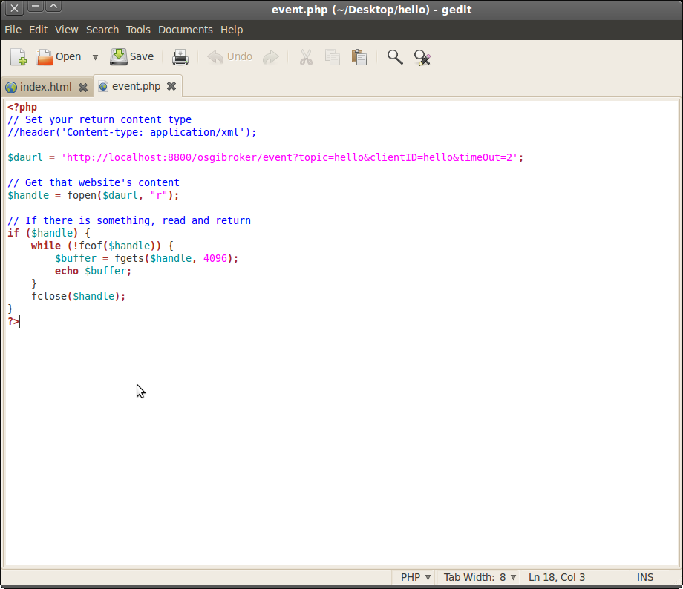
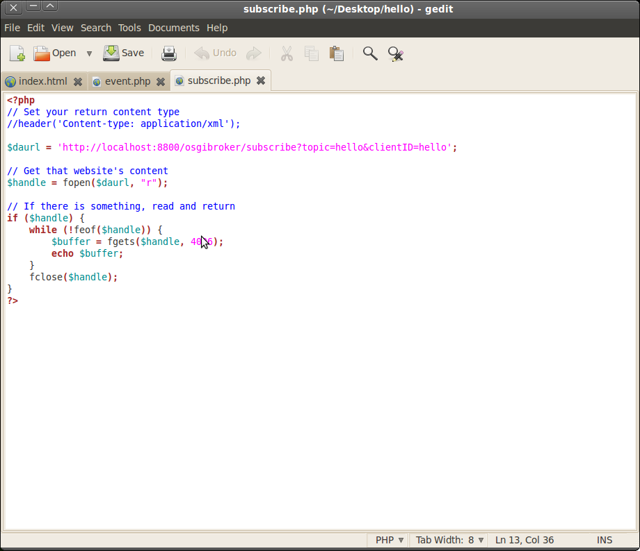

Let's re-load our CoffeeShop framework and... voila it works! Now that's exciting.

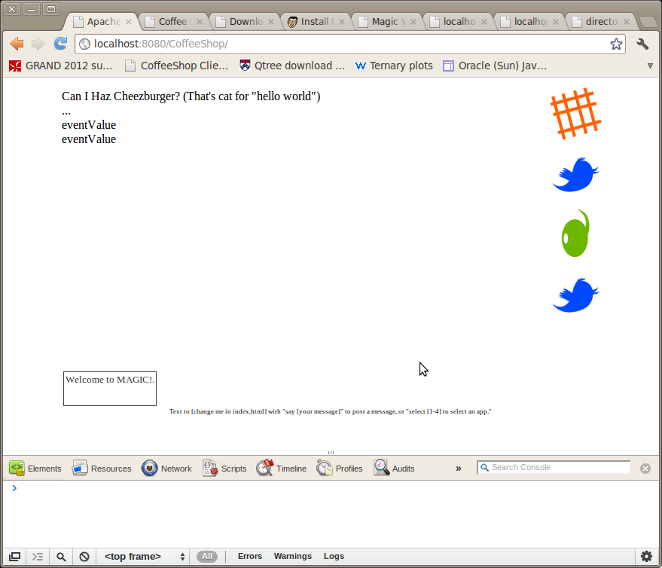

Now let's send an event to the broker. Open a web-browser and send the event with the url:

http://localhost:8800/osgibroker/event?topic=hello&clientID=hello&_method=POST&eventName=eventValue

Every time you visit that link you'll send an event to the app. Let's configure the framework using the provided manager applications within the app.

Visit http://localhost:8080/CoffeeShop/client/config.jsf . By clicking on view/edit you can configure the application name, image presented, idle time and most importantly the osgibroker topic name. So let's do that for the hello application.

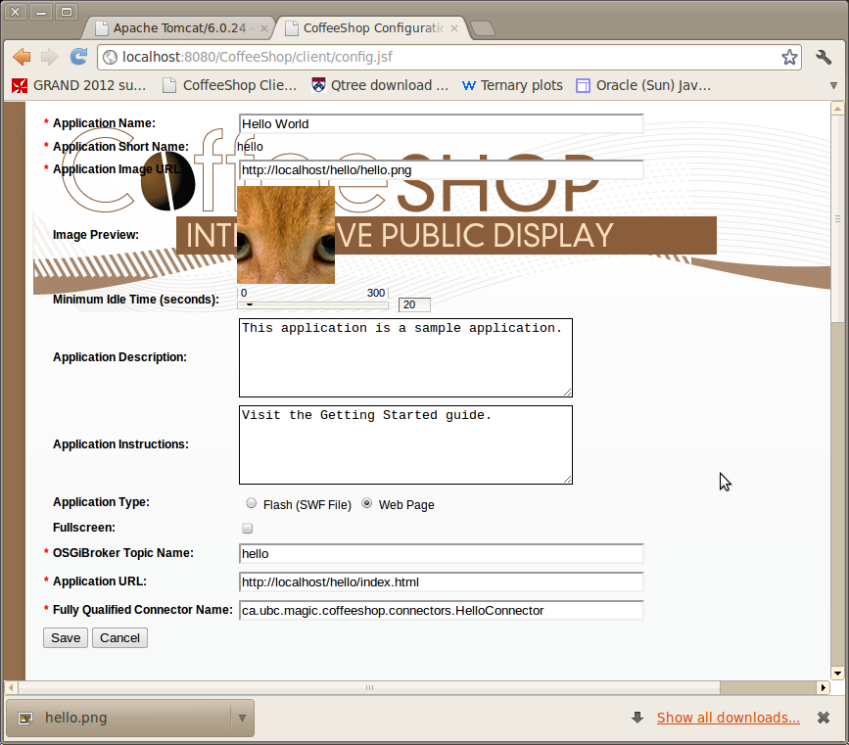

You're done!

Well... this is not entirely true... The Hello application is configured out of the box. If you are going to deploy a new application you need to do two things:

- Create a <application>.xml file under the package ca.ubc.magic.coffeeshop.config, just clone the hello.xml file.
- Create a connector <application>Connector.java in the package ca.ubc.magic.coffeeshop.connectors, just clone the HelloConnector.java and change the topic names to match your application configuration.

It is important to have these connectors as they are used to queue and de-queue any new application.

Now let's queue an application with the web interface provided. Visit

http://localhost:8080/CoffeeShop/client/select.jsf

Select any application and click on Queue this Application to Run if you want to run it. Or send a message to the Message Board.

