**How to update pages on the SGSA website**

The webmaster’s two-minute guide on how to fork and make a pull request in order to update the SGSA website!  
  
1. Fork the SGSA website repo. Head to <https://github.com/ubc-stat-grad/ubc-stat-grad.github.io> and click “Fork”. When asked, click “Create fork”.

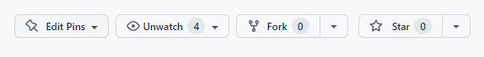

2. Clone the repo: `git clone git@github.com:<username>/ubc-stat-grad.github.io.git’

3. Make changes in your favourite code editor! For example, here we change the spelling of “Nikola” to “Nikolas” just for fun.

4. Once you have made your desired changes, we should `git add .’, `git commit -m “my commit message”’, and then `git push’.

5. After you have done the above, you are ready to make a pull request. Visit [https://github.com/<username>/ubc-stat-grad.github.io/pulls](https://github.com/%3cusername%3e/ubc-stat-grad.github.io/pulls) (replace <username> with your own username) and click on “New pull request”.

Review the changes and click “Create pull request”. Leave a description of the changes made and from there the webmaster will take over!