eigenvalue 3
spectrum 4
Compute DMD mode amplitudes b 5
DMD reconstruction 5
%load READY4DL_500.MAT;
all = [];
fs = 500;
%GoalDatasetName = "ALL_PD_GVSOFF_MEDOFF";
%GoalDatasetName = "ALL_PD_GVSOFF_MEDON";
%GoalDatasetName = "ALL_PD_GVSON_MEDOFF";
GoalDatasetName = "ALL_PD_GVSON_MEDON";
%GoalDatasetName = "ALL_HC_GVS_ON";
%GoalDatasetName = "ALL_HC_GVS_OFF";
GoalDataset = eval(GoalDatasetName);
[pt_no epochs_no] = size(GoalDataset);
for pt = 1 : 1 %patients
pt
for ep = 1 : 1 %epochs
one = GoalDataset{pt,ep}';
dt = 1/fs;
X = one;
X1 = X;
[u1,s1,v1]=svd(X,'econ');
figure,
suptitle(strcat("SVD on X, patient = ", num2str(pt), ", trial =", num2str(ep)));
subplot(2,1,1), plot(diag(s1)/(sum(diag(s1))),'ro','Linewidth',3), title("Eigen values")
subplot(2,1,2), plot(v1(1:100,1:5),'Linewidth',2), title("V basis")
r = 50;
nstacks = 38;
% construct the augmented, shift-stacked data matrices
Xaug = [];
for st = 1:nstacks
Xaug = [Xaug; X1(:, st:end-nstacks+st)];
end
[u1,s1,v1]=svd(Xaug,'econ');
figure,
suptitle(strcat("SVD on XAug, patient = ", num2str(pt), ", trial =", num2str(ep)));
subplot(2,1,1), plot(diag(s1)/(sum(diag(s1))),'ro','Linewidth',3),title("Eigen values")
subplot(2,1,2), plot(v1(1:100,1:5),'Linewidth',2), title("V basis")
% SVD and truncate to first r modes
X = Xaug(:, 1:end-1);
Y = Xaug(:, 2:end);
[U, S, V] = svd(X, 'econ');
U_r = U(:, 1:r);
S_r = S(1:r, 1:r);
V_r = V(:, 1:r);
% DMD modes
Atilde = U_r'*Y*V_r/S_r;
[W_r, D] = eig(Atilde);
Phi = Y*V_r/S_r*W_r;
%DMD eigenvalues
lambda = diag(D);
omega = log(lambda)/dt/2/pi;
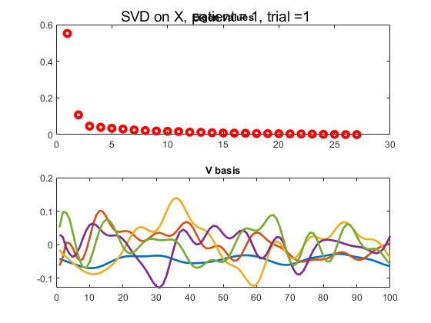
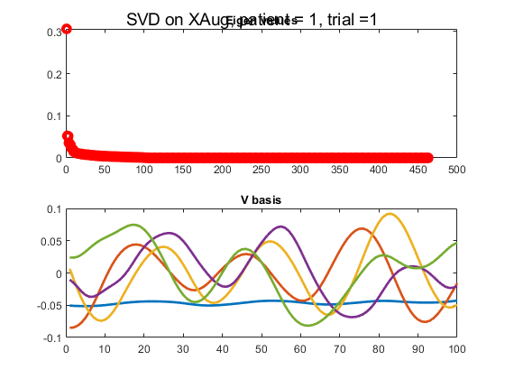

eigenvalue
figure,
subplot(1,2,1);
plot(lambda, 'k.');
rectangle('Position', [-1 -1 2 2], 'Curvature', 1, ...
'EdgeColor', 'k', 'LineStyle', '--');
axis(1.2*[-1 1 -1 1]);
axis square;
subplot(1,2,2);
plot(omega, 'k.');
line([0 0], 200*[-1 1], 'Color', 'k', 'LineStyle', '--');
axis([-8 2 -170 +170]);
axis square;
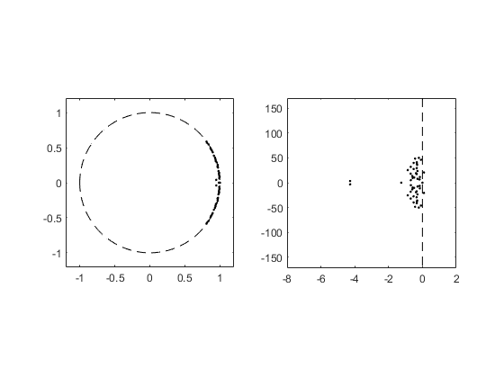

spectrum
alternate scaling of DMD modes
Ahat = (S_r^(-1/2)) * Atilde * (S_r^(1/2));
[What, D] = eig(Ahat);
W_r = S_r^(1/2) * What;
Phi = Y*V_r/S_r*W_r;
f = abs(imag(omega));
P = (diag(Phi'*Phi));
% DMD spectrum
figure,
subplot(1,2,1);
stem(f, P, 'k');
xlim([0 150]);
axis square;
% power spectrum
timesteps = size(X, 2);
srate = 1/dt;
nelectrodes = 27;
NFFT = 2^nextpow2(timesteps);
f = srate/2*linspace(0, 1, NFFT/2+1);
subplot(1,2,2);
hold on;
for c = 1:nelectrodes,
fftp(c,:) = fft(X(c,:), NFFT);
plot(f, 2*abs(fftp(c,1:NFFT/2+1)), ...
'Color', 0.6*[1 1 1]);
end;
plot(f, 2*abs(mean(fftp(c,1:NFFT/2+1), 1)), ...
'k', 'LineWidth', 2);
xlim([0 100]);
ylim([0 60]);
axis square;
box on;
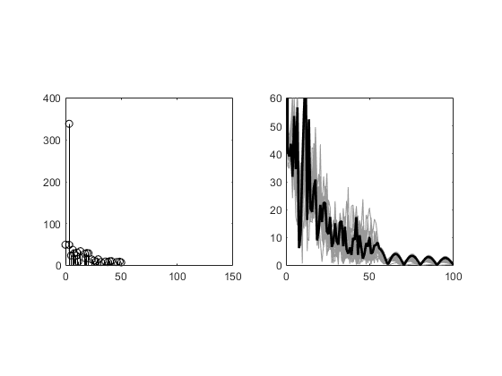

Compute DMD mode amplitudes b
x1 = X(:, 1);
b = Phi\x1;

DMD reconstruction
mm1 = size(X, 2); % mm1 = m - 1
time_dynamics = zeros(r, mm1);
t = (0:mm1-1)*dt; % time vector
for iter = 1:mm1,
time_dynamics(:,iter) = (b.*exp(omega*t(iter)));
end;
Xdmd = Phi * time_dynamics;
figure,
suptitle(strcat("X vs. Xdmd, patient = ", num2str(pt), ", trial =", num2str(ep)));
plot(X(1,:)),hold on, plot(real(Xdmd(1,:))), legend("X", "Xdmd");
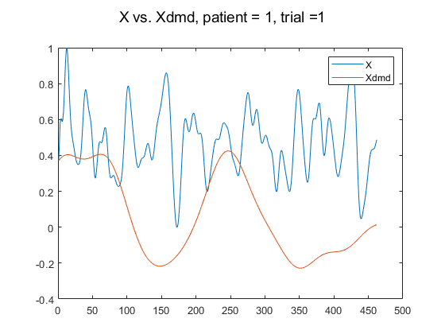
end
end
pt =
1
Published with MATLAB® R2020a

