**Chem E Car Battery Worksheet:**

**Go to** [**http://hyperphysics.phy-astr.gsu.edu/hbase/tables/electpot.html**](http://hyperphysics.phy-astr.gsu.edu/hbase/tables/electpot.html) **to assist with answering the following battery design questions.**

1. The standard potentials are all given for reduction half reactions, what does a negative value correspond to in this case?
2. Why is the potential for the reaction 2H+(aq) + 2e- -> H2(g) equal to 0?
3. Which metal is more easily oxidised, nickel (Ni) or Potassium (K)?
4. 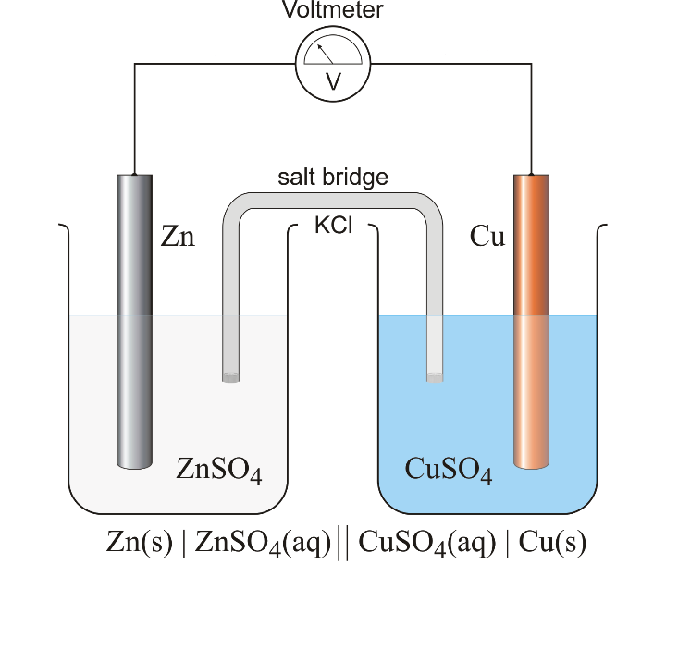Could you create a battery using lead (Pb) and aluminum (Al) half cells? Would it work, if so what potential would it create?  
     
     
   **You put together the following battery using zinc and copper, use the diagram to answer questions 5-8**
5. What half cell reactions would be taking place and what would be the maximum potential of the battery?
6. Which electrode is the anode and which is the cathode? Which way will the electrons flow through the voltmeter?
7. What is happening to the concentration of Zn and Cu ions in their corresponding solutions?
8. One electrode will grow in size and the other will shrink. Which electrode will be growing in your Cu-Zn battery?

|  |  |
| --- | --- |
| Cathode (Reduction) Half-Reaction | Standard Potential E° (volts) |
| Zn2+(aq) + 2e- -> Zn(s) | -0.76 |
| Ni2+(aq) + 2e- -> Ni(s) | -0.23 |

1. The Chem E Car team say they are designing a nickel-zinc flow battery with a nominal potential of 1.65 V. Being the investigative student you are you consult the table of reduction potentials and discover the following:

Are the Chem E Car team members lying about the nominal potential of their design or is there something missing from the table data?