Concentration-Dependent Iodine Clock Reaction Calibration

Standard Operation Procedure (SOP)
Chemical Team
October 18, 2016

Contents
Concentration-Dependent Iodine Clock Reaction Calibration 1
1.0 Purpose 2
2.0 Scope 2
3.0 Background 2
4.0 List of Chemicals 3
5.0 Equipment 3
6.0 Definitions and Acronyms 5
7.0 Responsibilities 5
8.0 Procedure 5
9.0 Forms/Records 8
10.0 References 9

Purpose
To establish standard operation procedures for measuring the color change time as a function of varying sodium thiosulfate concentration in iodine clock reaction calibration as the chemical stopping mechanism for the car model made by UBC Chem-E-car Design Team.

Scope
This SOP contains a list of chemicals to be used, steps for solution preparation, processes to perform iodine clock reaction, and guidelines for calibration curve generation from the concentration-dependent timing results. A description of the chemical principles leading to the color change from colorless to dark blue during the iodine clock reaction is also included.

Background
Iodine clock reaction results from the dynamic equilibrium between two separate ionic reactions occurring at the same time:
H₂O₂ + 2I⁻ + 2H⁺ → I₂ + 2H₂O;
2S₂O₃²⁻ + I₂ → S₄O₆²⁻ + 2I⁻;
The first reaction slowly oxidizes iodine ions (I⁻) into iodine (I₂) which has the potential to form a blue triiodide – starch complex. The second reaction rapidly reduces the product (I₂) from the first reaction back into its ionic form (I⁻). Due to the reaction rate difference, only same amount of triiodide exists in the solution which maintains the colorless state of the mixture. When thiosulfate ions (S₂O₃²⁻) are exhausted, chemical equilibrium moves to the accumulation and the solution turns from colorless into dark blue.
In this calibration process, the concentration of thiosulfate ions acts as the limiting reactant and the dependent variable and time before the color change delay is measured.

List of Chemicals
Starch
Potassium iodide (KI)
Sodium thiosulfate (Na₂S₂O₃)
30% hydrogen peroxide (H₂O₂)
2M Sulfuric acid (H₂SO₄)
DI water

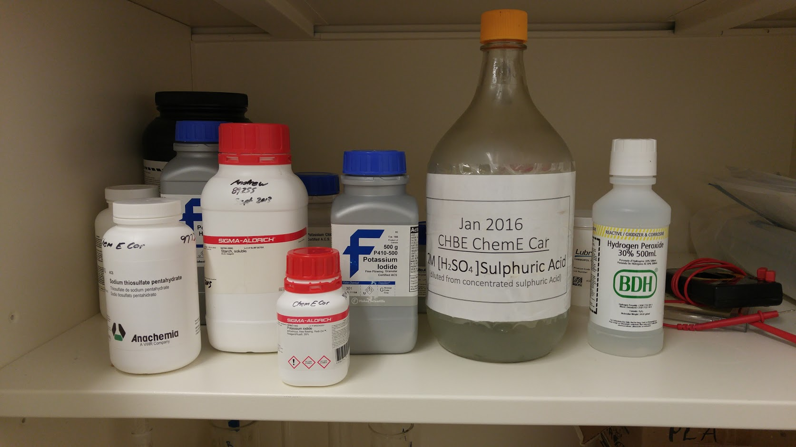Figure 1: Chemicals stored in cabinet

Equipment
5ml pipette with tips and a stand
Analytical balance
Glassware for solution storage and transfer (displayed in following pictures)

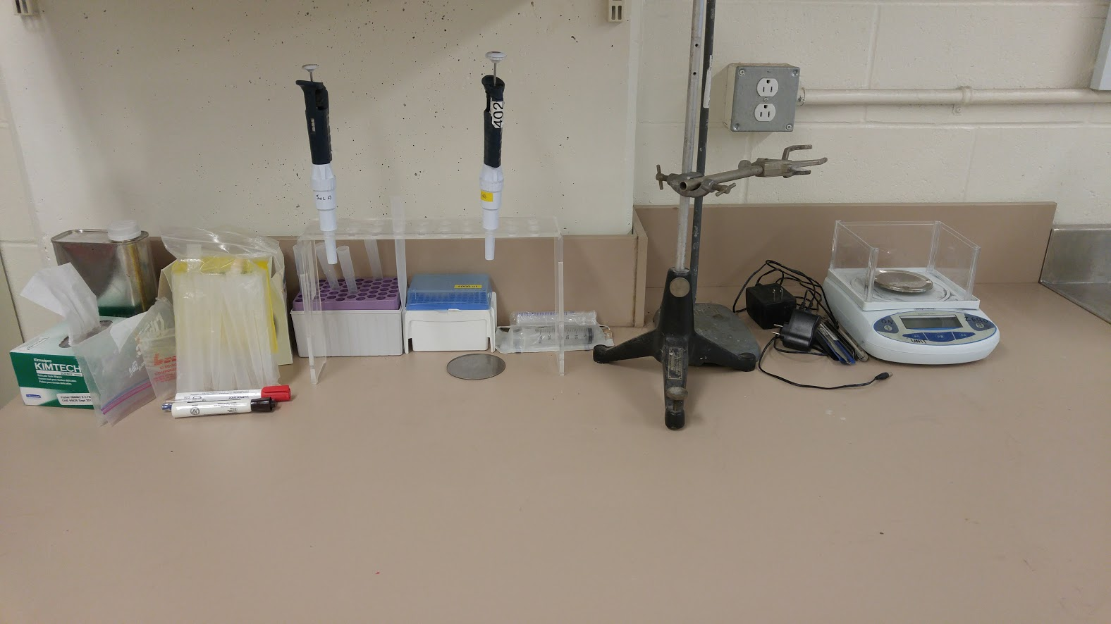Figure 2: Equipment for iodine clock calibration
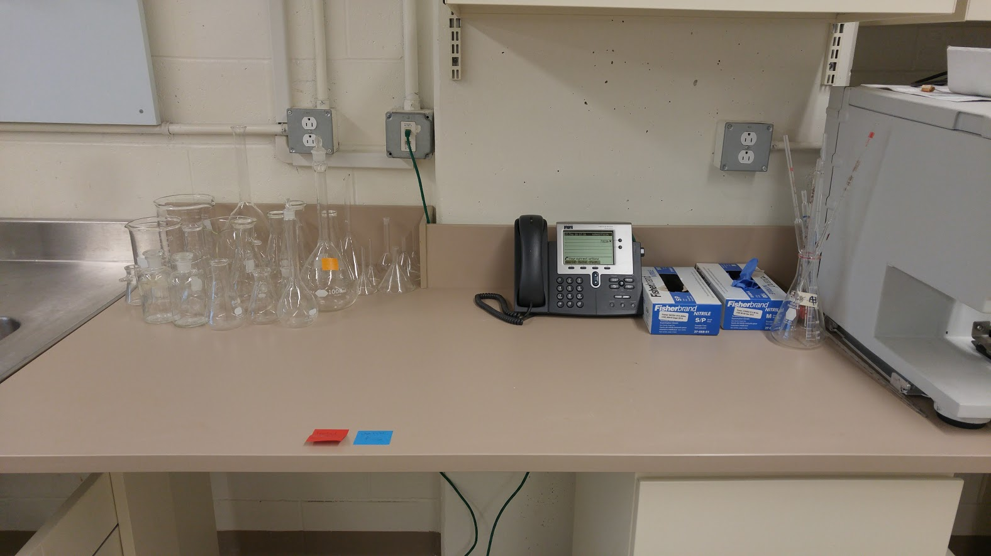Figure 3: glassware for iodine clock reaction calibration and chemical team work place

Definitions and Acronyms
Solution A: Thiosulfate solution with varying concentration, containing starch and KI
Solution B: acidic solution containing H₂O₂

Responsibilities
Ray Bi, Senior Chemical Team Lead, is responsible for ensuring the SOP is implemented and employed.
Negar Zaghi, Lab Manager, is responsible for compiling MSDS and monitoring safety measures are executed by UBC Chem-E-car Design Team members.

Procedures
Operation of the concentration-dependent iodine clock reaction calibration is outlined as follows:
- Prepare solution B.
- Prepare solution A with varying concentration.
- Conduct iodine clock reaction and record color change delay.
- Generate a calibration curve.

  - Prepare solution B
    - Measure 10ml 30% H₂O₂ with a pipette into a 1L volumetric flask.
    - Measure 80ml 2M H₂SO₄ with a pipette into the 1L volumetric flask.
    - Fill in the volumetric flask with DI water up to the graduation marking.
    - Measure 45ml prepared solution from the volumetric flask with a graduated cylinder as solution B.
    - Transfer solution B from the graduated cylinder into a 50ml beaker as the testing container.
  - Prepare solution A with varying concentration
    - Measure 8.0g Na₂S₂O₃ with an analytic balance and a weighing boat.
    - Dissolve 8.0g Na₂S₂O₃ in a 250ml volumetric flask. (Note: Dissolve Na₂S₂O₃ within the weighing boat first and then transfer the solution into the flask.)
    - Fill in the volumetric flask with DI water up to the graduation marking.

    - Measure 6.0g KI with an analytic balance and a weighing boat.
    - Dissolve 6.0g KI in a 250ml volumetric flask. (Note: Dissolve KI within the weighing boat first and then transfer the solution into the flask.)
    - Fill in the volumetric flask with DI water up to the graduation marking.

    - Measure 0.6g starch with an analytic balance and a weighing boat.
    - Microwave 150ml DI water until heated near body temperature.
    - Dissolve 0.6g starch with the heated DI water within the weighing boat
    - Transfer the solution into a 100ml volumetric flask.
    - Fill in the volumetric flask with the heated DI water up to the graduation marking.

    - Measure 20ml KI solution, 4ml starch solution, Xml Na₂S₂O₃ solution and (20-X)ml DI water (44ml mixture in total) into a beaker as solution A.

Note: the concentration of the resulting solution depends on the value of X and is labelled as “Xml” during testing. A series of sample concentrations are tabulated as follows:

Labels | 2 ml | 6 ml | 10 ml | 14 ml | 18 ml
Na₂S₂O₃(X, ml) | 2 | 6 | 10 | 14 | 18
DI water (20 – X, ml) | 18 | 14 | 10 | 6 | 2
KI (ml) | 20 | 20 | 20 | 20 | 20
Starch (ml) | 4 | 4 | 4 | 4 | 4
Total (ml) | 44 | 44 | 44 | 44 | 44
  - Conduct iodine clock reaction and record color change delay
A stationary testing condition is described in this SOP. As integrated with the design of E-car, testing methods may vary. Please refer to other documents for specific testing conditions.
    - Measure 10ml solution A with a pipette into a testing vial.
    - Prepare a stopwatch to record color change delay.
    - Pour solution A (10ml) into the 50ml beaker containing solution B (45ml).
    - Record time until solution color turns from colorless into dark blue.
    - Whirl the solution by gently shaking the beaker for better mixing.
  - Generate a calibration curve
    - Update color change delay time data under appropriate date in the following file:
Iodine Clock Reaction Calibration.xlsx
    - Insert a scatter chart for delay time (t, sec) against thiosulfate concentration (Xml).
    - Display calculated linear equation and R-value in the graph for future calculation use.
The linear relationship unveiled by this calibration process can be utilized by calculation necessary thiosulfate concentration (Xml) from the time required to finish the competition (t, sec). As a result, solution A with corresponding concentrations can be prepared.

Forms/Records
Team members have to review the MSDS sheets located in the shelf and obtain the following training certificates prior to performing the described experiment:
- Engineering Design Team Safety Orientation
- Preventing and Addressing Workplace Bullying and Harassment
- Chemical Safety Course
- WHMIS Training Course
All the above courses are available for UBC students from UBC RMS Course System.

References

