Example submission:

Topic: Fertilization impacts on ectomycorrhizal community composition.

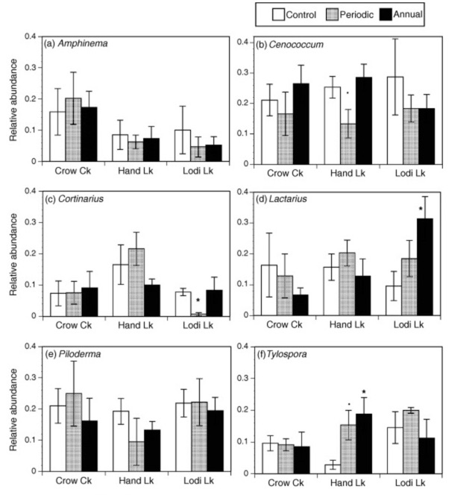

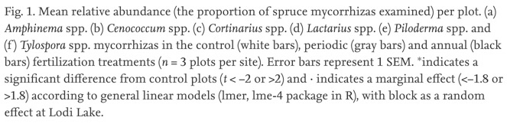

URL: <https://gw2jh3xr2c.search.serialssolutions.com/?ctx_ver=Z39.88-2004&ctx_enc=info%3Aofi%2Fenc%3AUTF-8&rfr_id=info%3Asid%2Fsummon.serialssolutions.com&rft_val_fmt=info%3Aofi%2Ffmt%3Akev%3Amtx%3Ajournal&rft.genre=article&rft.atitle=Ectomycorrhizal+community+structure+and+function+in+interior+spruce+forests+of+British+Columbia+under+long+term+fertilization&rft.jtitle=Forest+ecology+and+management&rft.au=Hay%2C+Tristyn+N&rft.au=Phillips%2C+Lori+A&rft.au=Nicholson%2C+Bailey+A&rft.au=Jones%2C+Melanie+D&rft.date=2015-08-15&rft.pub=Elsevier+B.V&rft.issn=0378-1127&rft.eissn=18727042&rft.volume=350&rft.spage=87&rft.epage=95&rft_id=info:doi/10.1016%2Fj.foreco.2015.04.023&rft.externalDocID=S0378112715002455&paramdict=en-US>

Summary of findings for figure:

This figure indicates that the relative abundance of *Lactarius* and *Tylospora* were the only genera which showed an increase in relative abundance with annual fertilization. Both *Cenoccoum* and *Cortinarius* relative abundance decreased in response to periodic fertilization.

Relevance to my project:

As my research is about the impact fertilization has on ectomycorrhizal community structure and composition this figure provides insight into the responses of six very dominant genera when subjected to periodic and annual fertilization.

*Primary Source Paper Summary - Rubric*

|  |  |
| --- | --- |
| Criteria | Pts |
| Figure Selected  -Figure and its caption are provided -URL for paper is provided -Figure is from the URL provided | 3 |
| Description of Figure  -Description provided is clear and easy to follow -Description provided accurately describes the figure provided -Description indicates that the student has a clear understanding of the information being conveyed by the figure | 3 |
| Relevancy to study  -Explanation is clear and the rationale -Student has provided a convincing explanation of the relevancy of this figure -Student shows a clear understanding of the significance of this figure to their study | 3 |
| Total: | 9 |