Lab_XX Assignment

Firstname Lastname, Section YY

Date of lab (e.g. Sept 12, 2017)

Use 2 hashtags to precede your question numbers, as follows:

## Question 1

Then provide your typed answers in here, and any R code in the “chunks” (see below).

When you click the Knit button a document will be generated that includes both content as well as the output of any embedded R code chunks within the document. You can embed an R code chunk like this:

In these “chunks” is where you type your R code that you wish to run. Don’t put non-code text in the chunks.

head(iris)

## Sepal.Length Sepal.Width Petal.Length Petal.Width Species  
## 1 5.1 3.5 1.4 0.2 setosa  
## 2 4.9 3.0 1.4 0.2 setosa  
## 3 4.7 3.2 1.3 0.2 setosa  
## 4 4.6 3.1 1.5 0.2 setosa  
## 5 5.0 3.6 1.4 0.2 setosa  
## 6 5.4 3.9 1.7 0.4 setosa

You can insert new chunks by clicking on the green “Insert” button at the top of this window, or using the keystroke shortcut that is shown under the “Code” menu item and “Insert Chunk” selection.

## Question 2

You can also embed plots with figure captions, and with the output size specified, for example:

plot(iris$Sepal.Length, iris$Sepal.Width)

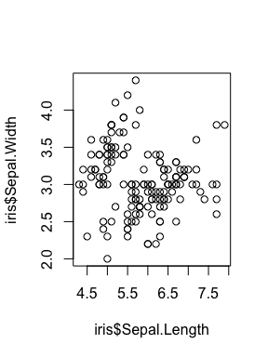

Figure 1: Scatterplot of sepal length vs sepal width for 150 iris plants from 3 species

## Question 3

Be sure to practice knitting your document once you have completed a question or two.