CSC 316
Functional Programming
Project: 2.2 Composition of Activity Triples
Project Report

Authors

Name Matricule

Kuna Fomboh________________________________ SC14A602
Tchassem Borel Guemte________________________ SC14B182
Mukah Mukah Ispahani________________________ SC14B369
Esibe Roy Ngu _______________________________ SC14B396

Course Instructor: Dr Shu Williams.

Part 2

PROJECT DEVELOPMENT REPORT
a) Analysis
The project requires the provision of a ternary tree data structure that effectively provides a search space for possible triples of activities to be investigated. To solve the problem, a ternary tree is provided with each node holding :
- Number of child nodes ( which is 3 per the project requirements )
- Number of function component ( which is 3 per the project requirements ),
- Deferred operations ( keeping functions to apply later )
- A triple of singlexes (which holds the function component xj,instantiation argument , and it's result )
- Composition function
- A tuple of results (holding each result of the function operation contained in the singlex )
In this structure ,functions are operated on these nodes and their results are used to generate future children nodes which would be inserted in the tree .
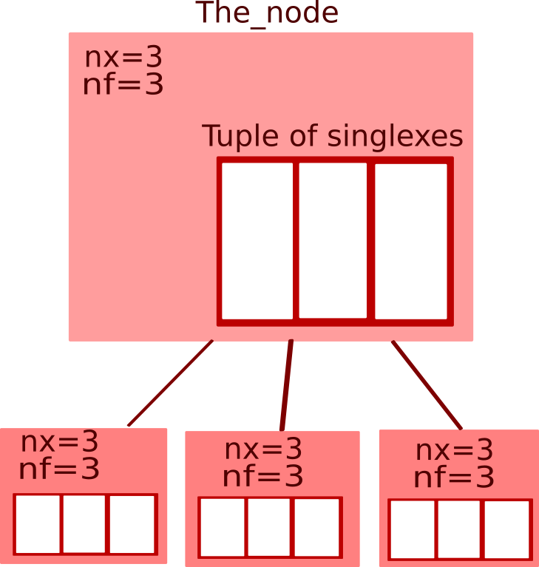
The diagram on the right illustrates
the parent node which
contains a triple of singlex structures
and the generated child nodes
are of this same type too

The project required that we use an array to hold a value of a node made up of three elements. The tuple data structure is used since it can hold few elements and elements of any type. We defined a singlex_type structure to hold the function components and created singlex_type with variables (s1,s2,s3) which we put in a tuple.
For the main data structure ( the ternary tree ) we used the Ocaml tree defined type provided by the language, which simplified the tasks than if done otherwise.

We had some difficulties accessing directly the function components which were in each singlex found in the node , so we defined tuple variables (x1,x2,x3) of type singlex to which we returned the different singlex (s1,s2,s3) and we could then access them easily . e.g. by doing x1.component.

We had some lacunae with the fact that ocaml doesn’t deal directly with variables as in imperative paradigms, but with functions so we had to use the functional way of defining a variable by writing a function that takes no parameter but returns a value (the value we wanted to kept in the variable ) , as such we could use a function identifier as a variable and pass it to other functions.

We also observed that ocaml doesn't have pointers hence the functions couldn't be defined in ocaml structures ,so we discarded some aspects ( like the singlex that had to hold a pointer to a its child node ), generated the children nodes and insert them without the parent singlex pointing to them.

We explored the use of ocaml pattern matching, trees, union types.
Also because ocaml's variables are different from variables in imperative programming, we wrote functions that return whatever parameter they take( for instance: → let f n = n ;; )
b) Design Process
In designing the program, we first wrote algorithms to perform the operations and represent the major data structures. We made diagrammatic representations of the data structures and how we intended for the data to 'sit' in the data structures. From this representation and careful analysis we were able to come up with the data structures we have used. We also performed these operations manually, checking out for constraints, clarity and the outcomes.
We did a dry run of the algorithm several times. In the first instance nothing seemed to come out quite clearly, that is the results didn't match with what we imagined for instance, we imagined a node of the ternary tree being made up of a tuple of values (xj components) and the following questions arose:
- Where were the functions going to 'sit'?
- What about the function applications, where would they sit? .In or out of the tree, considering efficiency and ease of computation(with respect to our thinking)?
- How would composition be done?
- How do we intend to perform function applications that will generate nodes for the structure?
To answer the questions we considered creating a separate data structure called singlex, composed of the xj component, the instantiation argument, composition function, a new node and the results. We also had a data structure for the node composed of the function application, the function to be applied, composition function, a tuple of singlex's (a triple) and the result. We used a record data structure for both the singlex and the node.
In the algorithm analysis we observed that the node contained a singlex structure (tuple of singlex's) and the singlex contained the node structure. This was recursion so we made use of Ocaml's syntax (type...and…) to handle this situation.
We later on as said earlier had difficulties performing operations so we removed some of the components of the singlex data structure and were left only with the xj component and the function result
For the operations we wrote algorithms as well and did a dry run of the operations and then translated it into Ocaml language. Just as with the data structures we had some questions to answer such as;
- How would we perform the function application given that in a node we have a Singlex type.
- How would we generate new tree nodes after the function application.
We decided to use a reference type to access the function applications from the node.The program uses a ternary tree to hold a triple of singlexes(explained above), and a dashboard that displays the operations used that is the function application, the number of tree levels to be generated the order of composition.
c) Implementation Process
We had discussions with other groups when we suffered a bug in the code or had difficulties translating the algorithms to ocaml code.
We used the ocaml debuging facility to debug or code. We had to study many concepts for instance pattern matching, trees, reference and union types over and over again, discuss with other persons (or groups ) in order to understand better how to use the tools and fine tune them to suit the project (for instance the book teaches binary trees and our project makes use of ternary trees).
We channeled our misunderstandings to the instructor who enlightened us better. By coaching and directing us to do a better design process and diagrams to picture out better the requirements as well as giving us clues in translating the corresponding “c” implementation of our program.
We tested each function as we progressed, since most of our functions return entities which are used by other functions ( e.g. let (a,b,c) = retFxnResult ( applyMatch ( f1,f2 ,f3 ) (x1, x2 ,x3) );;).
The variable “choice” holds a randomly generated number ; the number which determines what function to operate on the node. This number is theb passed to “ dashBoardChoice “ call the function that was chosen and applies it “ like : applymatch (f1,f2,f3) (x1,x2,x3) ” ,the chosen applymatch function then returns results to to “ retFxnResult “ which in turn returns the results in some variables (a,b,c) which are passed to the “ doChild node functions “ who return structure of type nodes and initialise them with the values (a,b,c) . These node are finally passed to the “insert function” and inserted in the node . Some thing like this :
let (a,b,c) =( applyMatch ( dashBoardChoice ( choice) ) ) and finally insert ( doLeftChild (a) )
So for success , each function had to be tested with care.
We had do tell other persons what the project is about and run the code and ask them their opinion of the program and what they think about the program what should be eliminated or modified.Used Ocaml trees lectures

Part 3:

USE OF PROGRAM

a)User documentation

How to use this software:

Linux users:
-Open the linux terminal.
-Change the directory to the files location.
-Open the ocamlc compiler by typing the keyword ocaml.
-Type the command ocamlc -o output file_name input file.ml.
-Type the command ./output file to run the program.

b)Program demonstration
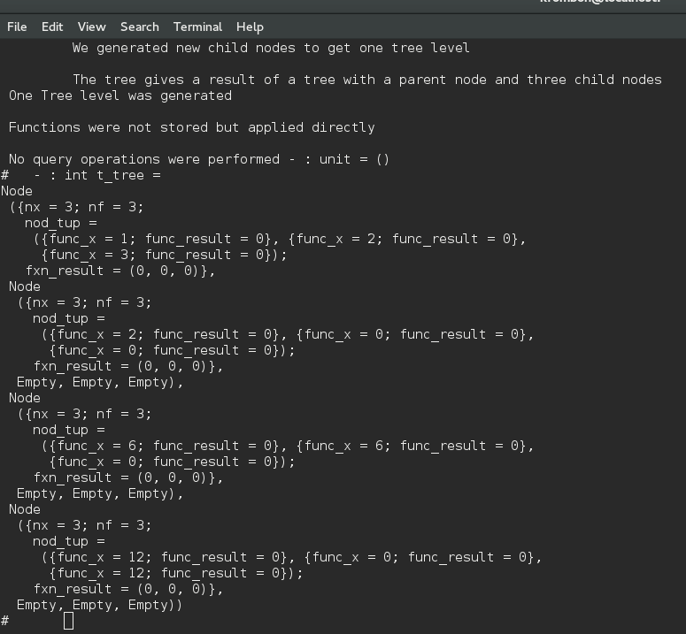

the result above shows the Ternary tree.

Part 4::

ADMINISTRATIVE REPORT

a)Operations

Kuna Fomboh

-operations.
-function operation record.
-Ternary tree creation
-Apply functions
-program documentation

Tchassem Borel

-operations
-Ternary Tree creation
-Ternary Tree node insertion functional
-Apply functions
-program documentation

b)Data structures

Mukah Ispahani

-Tree traversal function.
-Dashboard record data structure.
-node insertion function.
-singlex data structure.
-Node data structure.
-program documentation.

Esibe Roy Ngu

-Analysis of certain data structures.
-Choice of data structure such as Singlex.
-program documentation.

