Max current: 0.68 A

Max voltage: 25V

Max power dissipation : 0.35 W

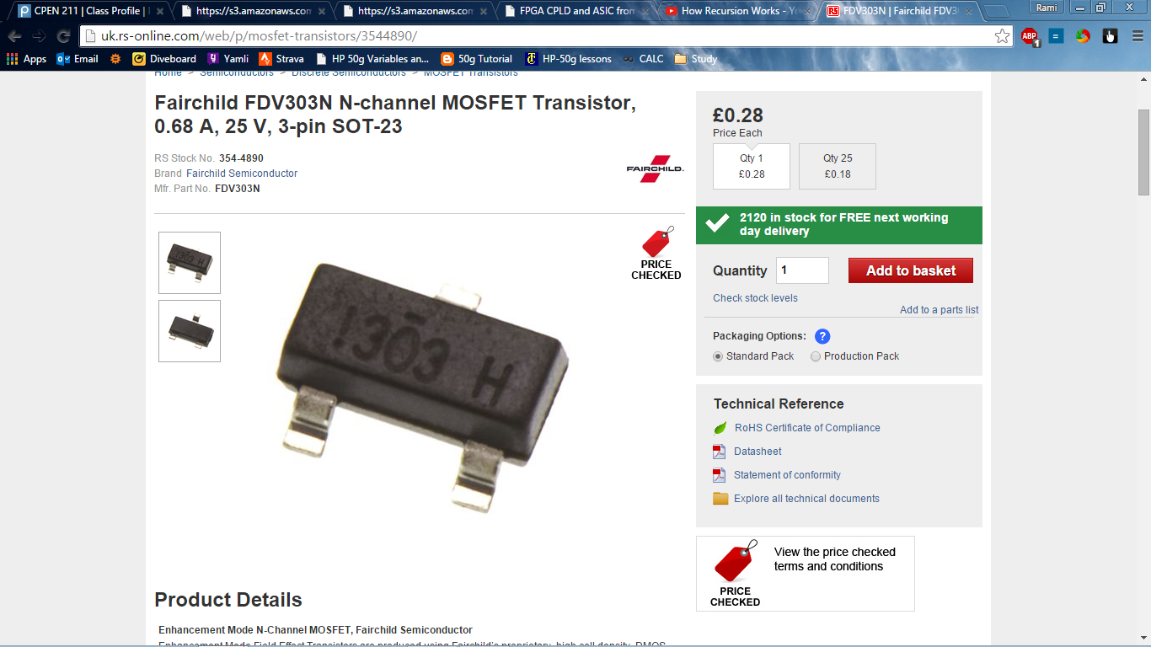

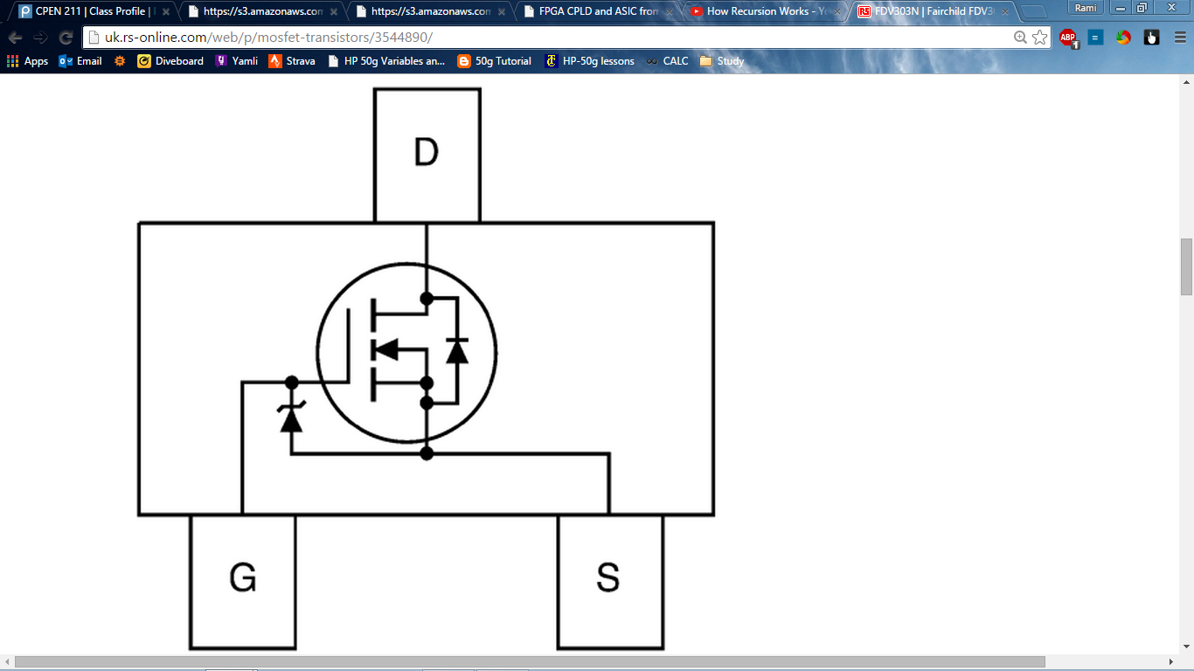

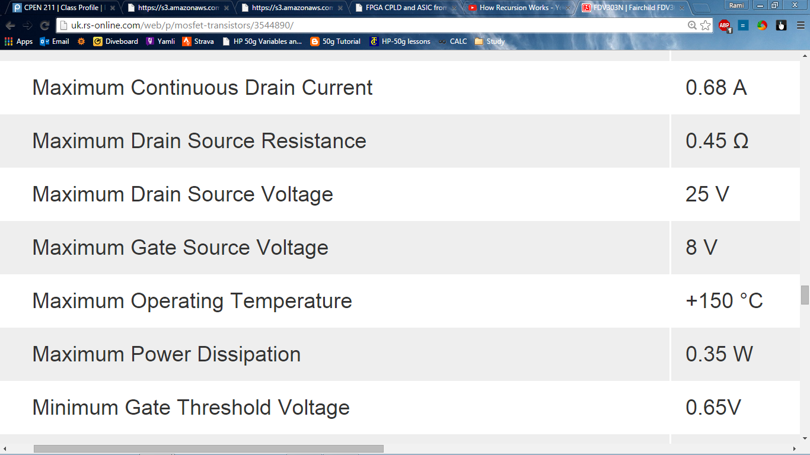

We need at add a resistor to lower the voltage on gave from 12V to V< 8.

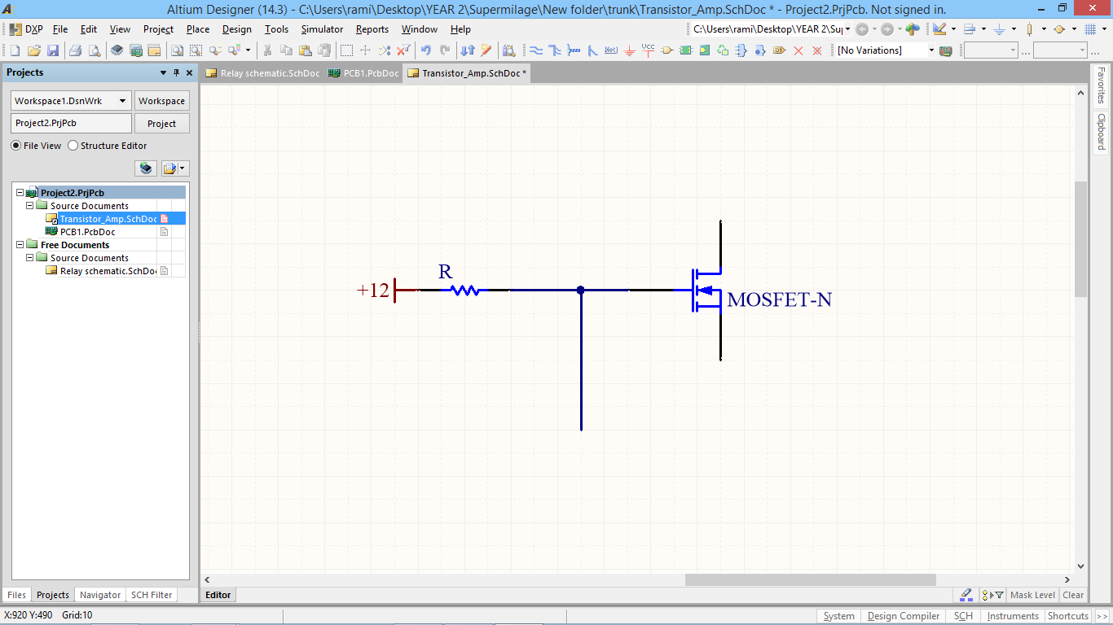

**Devices**

**Switches**