Max current: 0.68 A

Max voltage: 25V

Max power dissipation : 0.35 W

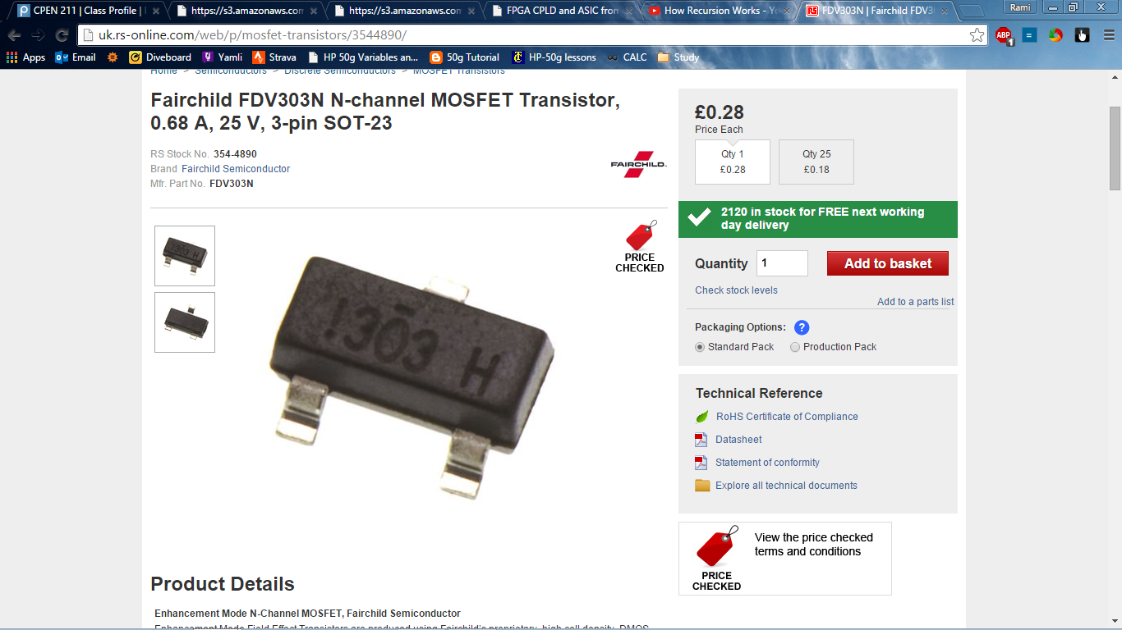

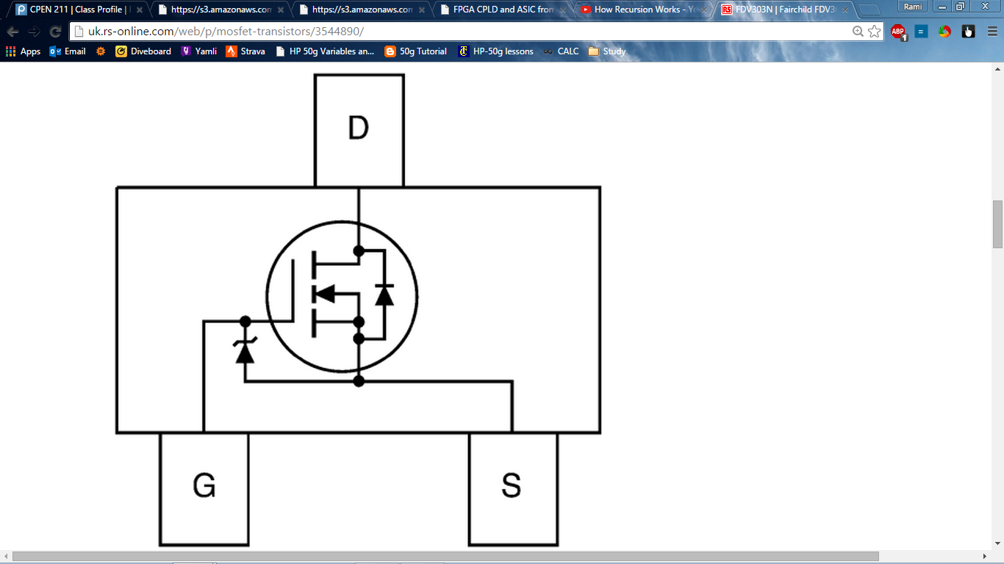

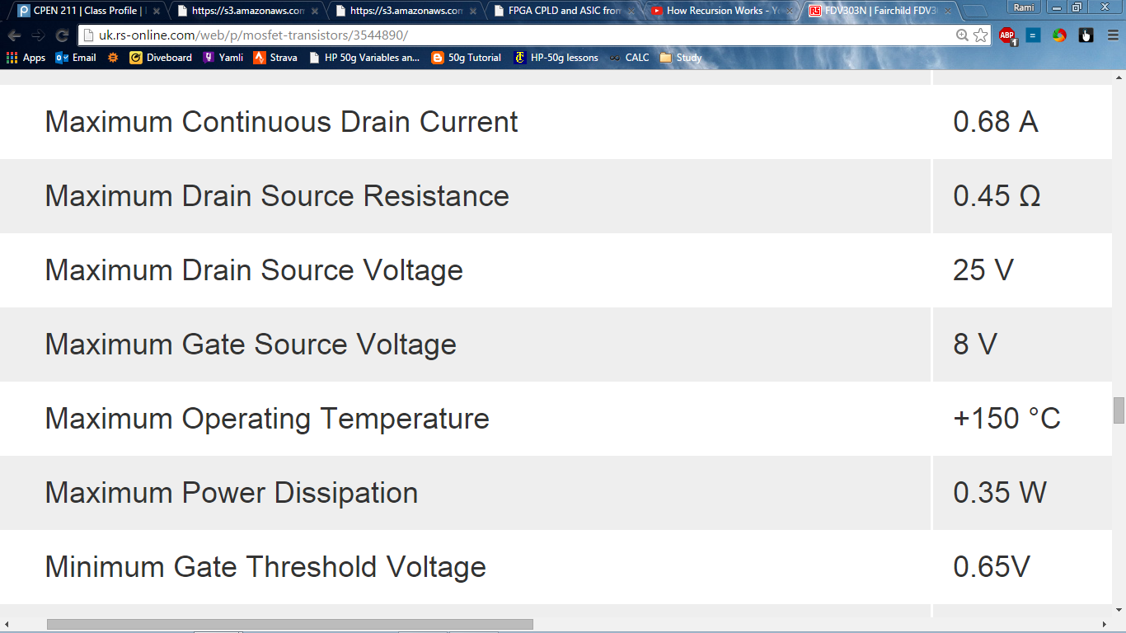

We need at add a resistor to lower the voltage on gave from 12V to V< 8.

**Devices**

**Switches**

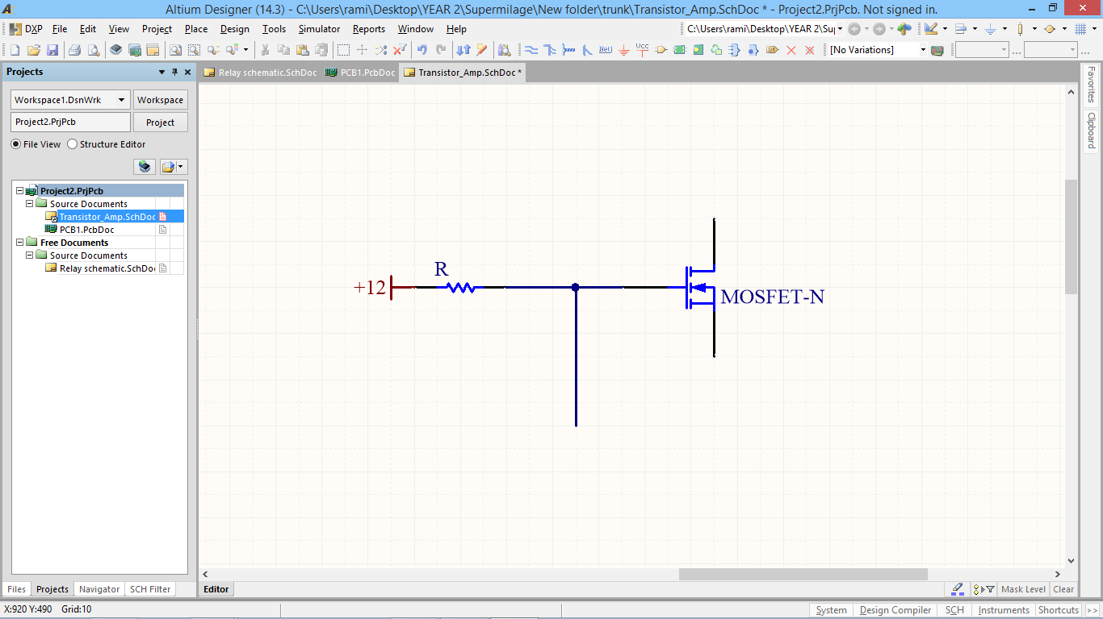

Option 2: D2 pak from nxp

<http://www.nxp.com/documents/selection_guide/75017357.pdf>

Details:

<http://www.nxp.com/products/mosfets/standard_mosfets/PSMN1R5-30BLE.html#overview>

Dimensions:

<http://www.nxp.com/documents/outline_drawing/sot404a_po.pdf>

<http://www.nxp.com/documents/data_sheet/PSMN1R5-30BLE.pdf>

<http://www.nxp.com/documents/outline_drawing/sot404_po.pdf>