# CREDIT RISK MODELING PROJECT REPORT

**Yule Jin**

Abstract  
Our primary objective is to price and build a credit derivatives products portfolio and then analyze the counterparty credit exposure by calculating its CVA

Table of Contents

**Summary3**

**Introduction3**

**Theory3**

**Methodology5**

**Results & Conclusion8**

**1. Summary:**

Our primary objective is to price and build a portfolio of several credit derivatives products such as IRS (Interest Rate Swap), CDS (Credit Default Swap), risky bond and riskless bond. For the pricing of these products, we need to initially use the spread available from BB rated bonds to calibrate hazard rate using Monte Carlo simulations. This hazard rate is used to calculate the survival function. We have considered OIS (Overnight Indexed Swap) as the zero coupon discount factor required to calculate the survival function. The optimal solutions for each PDE (interest rate and hazard rate) are interpolated using least squares method. With all the required tools, we price all the credit derivative products (using Vasicek Model) and then build an arbitrarily weighted portfolio.

CVA (Credit Value Adjustment) is the amount by which the value needs to be adjusted because of the counterparty credit risk. The future prices calculated for the products are then discounted to calculate respective present values and ultimately calculate the CVA. We have successfully completed the above process and calculated the CVA for a portfolio containing 10 year credit derivative as 0.2597.

**2. Introduction:**

Our idea is to use the theoretical concepts learned in class to actually price credit derivatives such as IRS, CDS, risky bond and riskless bond. Once, we have the prices for all the credit derivatives, we intend to build a portfolio comprising the aforementioned products and then calculate the CVA (Credit Value Adjustment) of our portfolio. CVA is defined as s the amount by which the value of a credit security is adjusted downward because of the counterparty credit risk.

We have split our project report into five parts. The first part gives you the summary, the second part gives you a brief introduction about our project, the third part gives you the literature review related to the project, the fourth part talks about the methodology used and the reason behind it and the fifth part talks about the results and conclusion and what we would like to build upon this project in the near future.

**3. Theory**

Credit derivatives are instruments that transfer credit risk related to any entity from one party to another. The project includes various credit derivatives which are explained in this section.

1. IRS (Interest Rate Swap): IRS is an agreement between two parties in which one exchanges fixed payment for a floating payment that is linked to an interest rate.

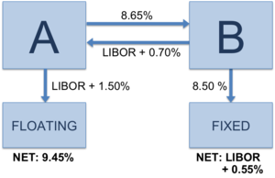

1. CDS (Credit Default Swap): The main reason behind the creation of the CDS is to create an insurance against the risk of a default of a particular company. On the other hand, from the business side, a CDS in fact provides a continued business relation of a bank/lender with a company/client which issues bonds or borrows money. While lending money to its long-term client, a bank continues its business with its client but at the same time, it takes the risk that the amount of the money it lent may not be paid back by its client. Therefore, the bank buys a CDS contract and obtains insurance. This gives then bank then the chance of continuing its business with its client and securing itself with the risk-free rate.

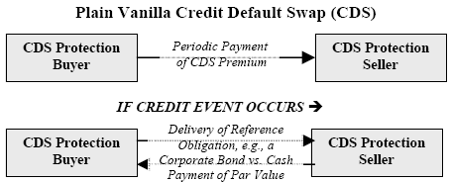

1. Bonds: Bonds are debt securities in which the buyer lends money to an issuer (e.g government, corporate, municipality etc.) and in turn receives a specified rate of interest during the life of the bond and face value in the end. Bonds can be classified as risky or riskless bonds. Riskless bonds are also referred to as government bonds because they are least likely to default. Corporate bonds and other kinds are called risky bonds.
2. Hazard rate & Survival probabilities: One of the key tasks in the valuation of credit derivatives is the estimation of default/survival probabilities for individual names. The term structure of such probabilities, known as credit curve, is a fundamental input to the valuation of a portfolio of credit derivatives. The key driver of a single name credit derivative is the time of default (τ, assumed to be stopping time). The default probability up to time *t* is defined as cumulative probability distribution function of τ ($F\left(t\right)=Prob(τ≤t)$. The corresponding survival probability, i.e no default until time *t* is given as:

$$Q\left(t\right)=1-F\left(t\right)=Prob(τ>t)$$

The hazard rate (λ) corresponding to τ is a deterministic function and is given as:

$$Q\left(t\right)=exp⁡(-\int_{0}^{t}{λ\left(u\right)du}$$

1. Spread: Here, we used the spread of BB rated bonds. This spread is required to calibrate hazard rate and survival function.
2. OIS (Overnight Indexed Swap): OIS is an interest rate swap where the periodic floating payment is based on the return calculated from a daily compounded interest investment. The reference for a daily compounded rate is an overnight rate.
3. Vasicek model: This is a one factor short rate model. The model specifies that the instantaneous interest rate follows the stochastic differential equation:

$${dr}_{t}=a\left(b-r_{t}\right)dt+σ{dW}_{t}$$

Therefore, the interest rate is given as:

$$r_{t}=r_{0}e^{-at}+\frac{b}{a}\left(1-e^{-at}\right)+σ\int_{0}^{t}{e^{-a(t-s)}}{dw}_{s}$$

In the project we have used Vasicek model to calibrate the interest rate.

**4. Methodology:**

We have a portfolio of credit derivatives and our aim is to calculate CVA of the portfolio. Our first task was to price each product in the portfolio and then calculate their future prices. For pricing we first calibrate survival probabilities and interest rate using Vasicek model. We built two Monte Carlo Simulations in excel, one for hazard rate (λ) and the other for interest rate ($r_{t}$).

The PDE for both the rates can be solved and we get the affine solutions for both. The solved hazard rate and interest rate are functions of a, b and σ.

We know that the short rate dynamics is given as:

$${dr}_{t}=a\left(b-r_{t}\right)dt+σ{dW}_{t}$$

$$r_{t}=r_{0}e^{-at}+\frac{b}{a}\left(1-e^{-at}\right)+σ\int_{0}^{t}{e^{-a(t-s)}}{dw}_{s}$$

We know that $r_{t}∼N(e^{-at}\left[r_{0}+b\left(e^{at}-1\right)\right],σ^{2}\left(\frac{1-e^{-2at}}{2a}\right))$

Solving the equations, we get affine solutions and the price of a bond is given as:

$$P\left(t,T,r_{t}\right)=exp⁡(-A\left(t,T\right)r_{t}+B\left(t,T\right))$$

Where A and B are given as:

$$A\left(t,T\right)=\frac{1-e^{-a\left(T,t\right)}}{a}$$

$$B\left(t,T\right)=\left(b-\frac{σ^{2}}{{2a}^{2}}\right)\left[A\left(t,T\right)-\left(T-t\right)\right]-\frac{σ^{2}{A(t,T)}^{2}}{4a}$$

Now, we need to find the optimal solutions for both the rates. For finding the optimal rates, we first find the optimal solution for these parameters (a,b,σ) by using OIS and Spread from the market. OIS is used to calibrate parameters for interest rate and Spread from the market is used to calibrate hazard rate. Hence, we get:

$$r_{t}=f\left(\hat{a},\hat{b},\hat{σ}\right)and λ_{t}=f({\hat{a}}_{1},{\hat{b}}_{1},{\hat{σ}}_{1})$$

From the calculated optimal parameter, we can find the optimal solution for hazard rate and interest rate. ${\hat{r}}_{t} and {\hat{λ}}_{t}$ are the optimal interest and hazard rate respectively.

Once we get all the calibrated rates, we need to interpolate interest rates as the market data has interest rates for 1, 3, 6, 9 months etc and we need the continuous rates. We used least squares method ($min⁡(r_{t}-{\hat{r}}_{t})^{2}$) to interpolate the rates.

Once we have the continuous hazard and interest rate, we can price each product in our portfolio. Our group has used CCC rated bond.

We know that survival probability is a function of hazard rate and is given as:

$$Q\left(t\right)=exp⁡(-\int_{0}^{t}{λ\left(u\right)du}$$

We represent recovery rate as R ($0≤R≤1$) and Zero coupon discount factor as Z ($Z=exp⁡(-\int_{0}^{t}{r_{t}dt})$)

**Pricing by Monte Carlo Simulation:**

We use law of iterated expectations –

$$\hat{Z}\left(0,T\right)=E\left[exp\left(-\int_{0}^{T}{r\left(s\right)ds}\right)1_{\left\{τ>T\right\}}\right] \\ =E\left[E\left[exp\left(-\int_{0}^{T}{r\left(s\right)ds}\right)1_{\left\{τ>T\right\}}|\{λ_{t}\}_{tϵ[0,T]}\right]\right]$$

which yields

$$\hat{Z}\left(0,T\right)=E\left[exp\left(-\int_{0}^{T}{r\left(t\right)+λ(t)dt}\right)\right]$$

Implied Default probabilities are given as:

$$Q_{n}=\frac{Z_{n}\left(1-R\right)Q_{n-1}-\sum_{i=1}^{n-1}{Z_{i}[Q_{i}δ_{i}S_{n}-\left(1-R\right)\left(Q_{i-1}-Q_{i}\right)]}}{Z_{n}(δ_{n}S_{n}+1-R)}$$

**Pricing bonds with recovery** –

If the bond defaults, the present value of the recovery payment is given as:

$$D\left(0,T\right)=\int_{0}^{T}{Z\left(t\right)\left(-Q^{'}\left(t\right)\right)dt}$$

Where $Q^{'}\left(t\right)$ is the first derivative of survival function Q with respect to t.

The Price of a coupon bond with non zero recovery is given as:

$$P\left(0,T\right)=c\int_{0}^{T}{Z\left(0,t\right)Q\left(0,t\right)dt}+Z\left(0,T\right)Q\left(0,T\right)+R\int_{0}^{T}{Z\left(t\right)\left(-Q^{'}\left(t\right)\right)dt}$$

**Pricing CDS** –

To price the CDS we consider two legs separately

* Contingent/protection/default leg – Pays nothing is no default, Pays (1-R)N at τ if τ<T
* Coupon/premium/fee leg – pays coupon ($Δ$ T)F each coupon payment date before default, at default pays the accrual on default: the amount of coupon that has accrued over the portion of the last period the name was alive

N is the notional and F is the fee/premium

Default Leg:

$$DL\left(t,T\right)=-\left(1-R\right)N\int_{0}^{T}{Z(t,s)\frac{dQ(t,s)}{ds}ds}$$

Fee leg:

$$FL\left(t,T\right)=F.RA\left(t,T\right)$$

Where RA(t,T) is the risky annuity and is given as:

$$RA\left(t,T\right)=\int_{t}^{T}{Z\left(t,s\right)Q\left(t,s\right)ds}$$

$$CDS\left(t,T\right)=DL\left(t,T\right)-FL\left(t,T\right)=DL\left(t,T\right)-F.RA(t,T)$$

Once we have interpolated the rates, we can simulate hazard rate $\left(λ_{t}\right)and$ interest rate $(r_{t})$ to calculate future rates and thus we can calculate the future prices of our products.

**Pricing Forward CDS** –

We use the following notations:

S(t,T) – Spot CDS rate for a contract that starts now (t) and matures at T

S(t, $t_{F}$,T) – Spread of a forward CDS with forward date $t_{F}$

S($t_{F}$,T) – Spot CDS spread observed at t= $t_{F}$ for a contract that matures at T

Fee Leg

$$FL=S\left(t,t_{F},T\right)RA\left(t,t_{F},T\right)$$

where

$$RA\left(t,t_{F},T\right)=\frac{1}{2}\sum_{n=1}^{N}{Δ\left(t_{n-1},t_{n}\right)Z\left(t,t_{n}\right)(Q\left(t_{n-1},t_{n}\right)+Q\left(t,t_{n}\right))}$$

Default Leg

$$DL=\left(1-R\right)N\int_{t_{F}}^{T}{Z\left(t,s\right)(-dQ\left(t,s\right))}$$

Par spread DL = FL

$$S\left(t,t_{F},T\right)=\frac{\left(1-R\right)N\int_{t_{F}}^{T}{Z\left(t,s\right)(-dQ\left(t,s\right))}}{RA(t,t_{F},T)}$$

The future prices of all the products are then discounted to get their respective EPE (expected positive exposure). EPE is the present value of discounted cash flows. This EPE is then used to calculate CVA.

**Credit Valuation exposure** –

The CVA in terms of EPE is given as follows:

$$CVA={PV}_{riskless}-{PV}_{risky}$$

$${CVA}_{i}\left(t\right)=\sum_{k=1}^{N}{{EPE}_{i}\left(t_{k}\right)zcdf\left(t_{k}\right)(1-R)\frac{∂Q}{∂t}Δt_{k}}$$

**5. Results & Conclusion:**

Given below is a screenshot of the Monte Carlo simulator used in our project:

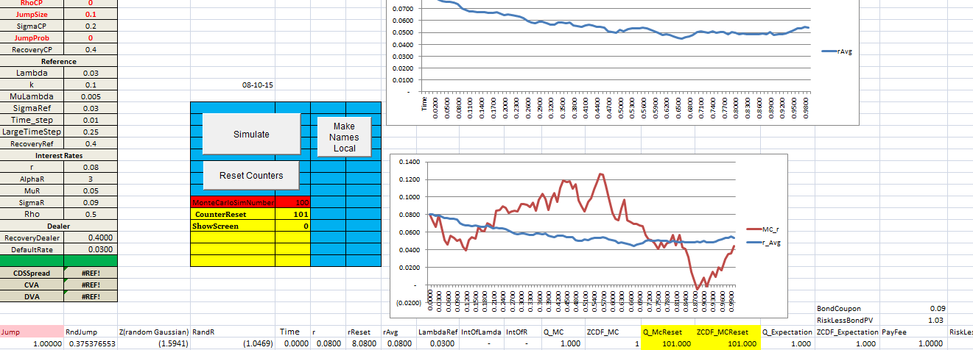

We get the calibrated hazard rate and interest rates as shown in the figure below:

|  |  |  |  |  |
| --- | --- | --- | --- | --- |
| Hazard Rate | Parameter |  | Interest Rate | Parameter |
| Initial Hazard Rate | 0.07998644 |  | Initial Interest Rate | 0.02534056 |
| Sigma Lambda | 0.04994759 |  | Sigma Interest Rate | 0.00971563 |
| Mu Lambda | 0.05002043 |  | Mu Interest Rate | 0.05098966 |
| Alpha Lambda | 3.00005858 |  | Alpha Interest Rate | 0.13351371 |

There were two separate Monte Carlo simulations. One was for hazard rate and the other for interest rate. The values for hazard rate, lambda, initial interest rate etc. are all given in the above table. As stated in the methodology, we have used these values to price the credit derivatives products.

On completion of the process, we have calculated the bond price as 1.0813. This means that the 10 years par CDS spread for each quarter is given in the screenshot below:

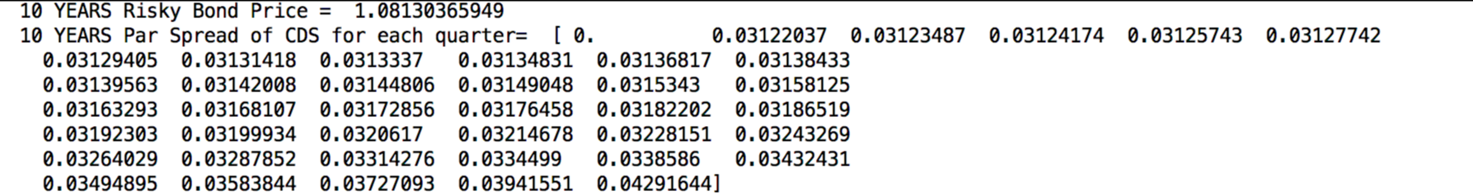

The calculated 10 years mark to market value of CDS for each quarter is:

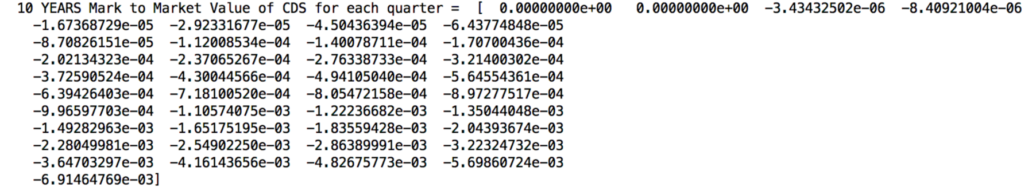

The calculated present value of an IRS, present value of the portfolio and the portfolio CVA are:



The portfolio CVA is calculated as 0.2597.

In the future, we are interested in extending our project to pricing and including CDOs in our project. Also, we would like to price credit derivatives products using a different model such as CIR in the near future.