Measurement of nuclear excitation functions for proton induced reactions (Ep = 40–90 MeV) on natural Nb

Andrew S. Voyles

Lee A. Bernstein

Eva R. Birnbaum

Jonathan W. Engle

Stephen A. Graves

Toshihiko ??? Kawano

Amanda M. Lewis

Francois M. Nortier

Intermediate-energy proton beams are used to produce a wide range of radionuclides for use in medical treatments and research. However, reaction modeling in this energy range remains largely untested, and there is a paucity of monitor reactions needed to establish beam characteristics in this energy range needed to perform quantitative cross section measurements. To address this need, a target stack consisting of thin Nb, Cu, and Al monitor foils using a 100 MeV proton beam at the Los Alamos National Laboratory’s Isotope Production Facility was irradiated in order to establish (p,4n) as a reaction monitor for intermediate energy protons and to benchmark state-of-the-art reaction model codes in this energy region. A set of 38 measurements of cross sections for the (p,x) and (p,x) reactions between 40–90 MeV are presented in this work, as well as 5 independent measurements of isomer branching ratios. Cross sections were measured using the well-characterized (p,x), (p,x), and (p,x) monitor reactions for accurate proton fluence determination, with all activities quantified using high-purity germanium spectroscopy. Variance minimization techniques were employed to reduce systematic uncertainties in proton energy and fluence, improving the reliability of these measurements. The measured cross sections are shown to be in excellent agreement with literature values, and have been measured with improved precision compared with previous measurements. This work reports the first measurements of the (p,x) reaction, as well as the first measurement of the independent cross sections for (p,x) and (p,x) in the 40–90 MeV region. Comparisons against the reaction modeling codes CoH, EMPIRE, and TALYS are used to explore the impact of pre-equilibrium particle emission in the reaction dynamics for 40–90 MeV (p,x) and (p,x) reactions. Due to (p,x) contamination by activation of the silicone adhesive used for sealing foil packets, the (p,x) and (p,x) monitor reactions were excluded, in the interest of surety, from proton fluence determination. To avoid inadvertently reporting enhanced proton fluence, the use of silicone adhesives for aluminum monitor foils is strongly discouraged.

Keywords: Nb+p ,Cu+p ,Niobium ,Copper,Aluminum , ,Nuclear cross sections ,Proton activation ,Proton transport ,Stacked target activation ,Monitor reactions ,Monitor foils ,Medical isotope production ,Isomer branching ratios ,Nuclear spin distributions ,MCNP ,LANL

# Introduction

Every year, approximately 17 million nuclear medicine procedures (both diagnostic and therapeutic) are performed in the U.S. alone, which has made incredible strides in improving our ability to detect and treat a variety of life-threatening diseases . The vast majority of the radioisotopes currently used for these procedures are produced in the field’s array of low- (E < 30 MeV / A) and intermediate-energy (30 < E < 200 MeV / A) accelerator capabilities, which routinely produce many of the staple medical radionuclides, such as , , , , and , as well as many non-medical radioisotopes of commercial value, such as , , , and . The future of nuclear medicine would appear to be the paradigm of personalized medicine — targeted radionuclide therapy to spare healthy tissue , and theranostic medicine, which pairs an imaging isotope with a therapeutic isotope (frequently, of the same element), to provide simultaneous, real-time dose delivery and verification, leading to drastic reductions in prescribed patient dose . Other variants of theranostic medicine exist, including pre-imaging for treatment planning, or delivery of a single compound with different radioelements for imaging/therapy where the inter-element biodistribution has been validated. Candidate isotopes to meet these needs have been identified based on their chemical and radioactive decay properties , and a series of campaigns are underway to perform targeted, high-priority measurements of thin-target cross sections and thick-target integral yields. These studies will serve to facilitate the production of pre-clinical quantities of radioactivity.

One significant obstacle to both high-fidelity measurements of production cross sections for emerging medical radionuclides, as well as conventional isotope production, is a lack of well-characterized monitor reaction standards. This is particularly true for higher-energy charged particle beams, where there is currently a paucity of such data. Indeed, the development of new monitor reaction standards and the improved evaluation of existing standards is one of the areas of greatest cross-cutting need for nuclear data . Charged particle monitor reaction data currently exists for several low-to-intermediate energy charged particle beams (E < 50 MeV / A), but even the experimental data used for this evaluation are sparse above approximately 30 MeV / A and uncertainties in experimental cross sections are large (6–15%) . While work is needed to improve upon existing monitor reaction data, the development of new reactions can expand the available range of options for the monitoring of charged particle beams. This work in particular seeks to improve this range of options by characterizing a new monitor reaction for proton beams in excess of 40 MeV, for possible use at isotope production facilities such as BLIP, IPF, or iThemba LABS.

Activation analysis is one of the most fundamental measurement techniques in experimental nuclear physics, as it is a simple and straightforward method to probe the structure and behavior of nuclear matter, dating back to the infancy of the field . Monitor reactions have historically been part of such activation experiments, and serve two valuable purposes for charged particle-induced reactions, depending upon the energy regime. Between the reaction’s energetic threshold and the end of its compound peak, the magnitude and shape of the excitation function changes rapidly with increasing energy, making it useful for determining the energy distribution of particles which have traversed a thin irradiated target. This is particularly the case when comparing monitor reactions leading to two distinct residual nuclei from the same target, such as the Cu(p,x) and Cu(p,x) reactions . This is extremely valuable, as it allows the screening and minimization of systematic errors based on energy determination, though this energy sensitivity precludes their reliability as a beam current monitor. In the higher energy of the reaction’s pre-equilibrium tail, the excitation function becomes smooth and generally flat as a function of energy. This offers little-to-no energy sensitivity, but is extremely useful for determining the integral beam current. While cross section measurements often use external beam current monitors (such as an inductive pickup upstream of a target, or an electrically-isolated target in a Faraday cup), these measure the integrated current incident upon the “front” (upstream) of the target assembly. A series of monitor foils at each energy position allows one to indirectly measure the integral current at each position within the stack, reducing systematic errors in observed cross section magnitude, but with reduced precision compared to direct measurement using a well-characterized suppressed Faraday cup. Both of these purposes make well-characterized monitor reactions an invaluable asset to any activation experiment.

In theory, nearly any radioisotope can serve as a reaction monitor, but those desired to be classified as a monitor reaction standard possess several hallmark characteristics. Primarily, this means selecting a radionuclide with a number of distinct gamma-rays with high intensities, which can be used to uniquely identify it during post-activation assay. Care should be taken to avoid cases where two radionuclides which are produced by two different reactions on the same monitor foil lead to states in the same daughter nuclide. For example, ( = 15.97 d, to ) and ( = 43.67 h, to ) can both be formed via Ti(p,x) reactions, yielding the same 983.52 keV transition in . Ideally, the nucleus has a lifetime which is comparable to that of the reaction products being studied, and sufficiently long-lived to ensure that it may be quantified conveniently following end-of-beam. For proper quantification, it is also of vital importance that the proposed monitor nucleus have well-characterized decay data. This includes a precise and well-established half-life, needed to correct for decay losses, as well as well-characterized decay gamma-ray intensities. From a targetry perspective, it is preferable to use a naturally mono-isotopic target that is readily available generally chemically inert — any significant chemical changes during target preparation (significant oxidation, etc.) will affect the target’s areal density, systematically changing the measured integral current. Thickness selection will be subject to the context of an experiment, seeking to maximize thickness without overly perturbing the energy uncertainty of measurements. Lastly, and perhaps most importantly for high-energy monitor reaction applications, it is of utmost importance to choose a reaction channel which cannot be populated via secondary particles incident upon the monitor target. Typically, this is mostly a concern for secondary neutrons produced through (z,xn) reactions, but any monitor reaction channel which can be populated by anything other than the primary beam should be avoided, as it is often a laborious task to separate out the fraction of secondary particles contributing to the total activation.

One reaction which satisfies these requirements is that of a new, intermediate-energy proton monitor reaction standard based on (p,4n). Niobium is naturally mono-isotopic, readily available commercially in high purity, is chemically inert, and can easily be rolled down to foils as thin as 1 $\micro$m. also has excellent decay properties — its fairly long-lived lifetime ( h) allows it to be counted at leisure without fear of the product decaying away excessively between end-of-beam and the start of counting, and it possesses seven strong, distinct gamma lines (notably its 122.370 keV () and 257.34 keV () lines) which can be used to uniquely and easily quantify production . In addition, is completely immune from (n,x) production on , being produced only via the primary proton beam, and the decay lines can only be observed in its decay, as its daughter, , is also unstable and decays via to stable .

The purpose of the present work is to measure the production of the long-lived radionuclide ( h ) via the Nb(p,x) reaction. In addition to the Nb(p,x) measurement, this experiment has also yielded measurements of 37 other (p,x) production cross sections between 40–90 MeV for a number of additional reaction products, including several emerging radionuclides with medical applications. These include the non-standard positron emission tomography (PET) agent ( h ), ( h ), ( h ), ( h ), ( h ), and the diagnostic agent ( h ).

In addition to being a potentially highly-valuable beam monitor, the Nb(p,x) reactions offer an opportunity to study the angular momentum deposition via pre-equilibrium reactions and the spin distribution in g subshell nuclei via the observation of isomer-to-ground state ratios. Measurements of isomer-to-ground state ratios have been used for over 20 years to probe the spin distribution of excited nuclear states in the A 190 region . These include the ( m; J) to ( d; J), ( h; J) to ( d; J), ( h; J$^\pi=\sfrac{9}{2}^+$) to ( h; J$^\pi=\sfrac{1}{2}^-$), ( h; J$^\pi=\sfrac{9}{2}^+$) to ( h; J$^\pi=\sfrac{1}{2}^-$), and ( m; J$^\pi=\sfrac{1}{2}^-$) to ( h; J$^\pi=\sfrac{9}{2}^+$) ratios .

The measurements described in this paper involve the use of multiple monitor reactions in conjunction with statistical calculations and proton transport simulations to reduce systematic uncertainties in beam energy assignments, leading to some of the first and most precise measurements for many of the excitation functions reported here. By expanding the available set of monitor reaction standards and well-characterized isotope production excitation functions, this work should help optimize medical isotope production modalities, making more options available for modern medical imaging and cancer therapy.

# Experimental methods and materials

While the reactions and mass region being explored in this work differ from the recent work of Graves *et al.*, much of the analysis described in the present work follows their established methods for the measurement of cross sections in stacked target irradiations .

## Stacked-target design

A stacked-target design was utilized for this work in order that the (p,x) cross sections for each reaction channel could be measured at multiple energy positions in a single irradiation . For targets, a series of nominal 25 m foils (99.8%, lot #T23A035), 25 m foils (99.999%, lot #M06C032), and 50 m foils (99.9999%, lot #N26B062) were used (all from Alfa Aesar, Ward Hill, MA, 01835, USA). Six foils of each metal were cut down to 2.5 x 2.5 cm squares and characterized — for each foil, length and width measurements were taken at four different locations using a digital caliper (Mitutoyo America Corp.), thickness measurements were taken at four different locations using a digital micrometer (Mitutoyo America Corp.), and four mass measurements were taken using an analytical balance after cleaning the foils with isopropyl alcohol. Using these length, width, and mass readings, the areal density (in mg/cm) for each foil was calculated, along with the propagated uncertainty in areal density. The foils were tightly sealed into “packets” using two pieces of 3M 5413-Series Kapton polyimide film tape — each piece of tape consists of 43.2 m of a silicone adhesive (nominal 4.79 mg/cm) on 25.4 m of a polyimide backing (nominal 3.61 mg/cm). The sealed foils were mounted over the hollow center of a 1.575 mm-thick plastic frame. One , one , and mounted foil were bundled together using baling wire for each energy position. These foil packet bundles were lowered into the beamline by inserting them into a water-cooled production target box. The box, seen in , is machined from 6061 aluminum alloy, has a thin (0.64 mm) Inconel beam entrance window, and contains 6 “energy positions” for targets, formed by 5 slabs of 6061 aluminum alloy (previously characterized) which serve as proton energy degraders between energy positions. At both the front and rear of the target stack’s foils, a 316 stainless steel foil is inserted to serve as a beam profile monitor — after end-of-beam (EoB), decay radiation emitted from these activated stainless steel foils may be used to develop radiochromic film (Gafchromic EBT3), revealing the spatial profile of the beam entering and exiting the stack. After loading all targets in the stack, the lid of the target box is sealed in place, using an inset o-ring to create a water-tight seal, and the box is lowered through a hot cell into the beamline, where it sits electrically isolated. The specifications of the target stack design for this work is presented in .

This target stack was assembled and irradiated at the Isotope Production Facility (IPF) at the Los Alamos National Laboratory (LANL), using the LANSCE linear accelerator. The stack was irradiated for approximately 2 hours with a nominal current of 1 mA, using a 50 s pulse at a frequency of 2 Hz, for an anticipated integral current of 205.9 nAh. The beam current, measured using an inductive pickup, remained stable under these conditions for the duration of the irradiation, with the exception of approximately 70 s of downtime, which occurred approximately 3 minutes into irradiation. The proton beam incident upon the stack’s Inconel beam entrance window had an average energy of 100 MeV determined via time-of-flight, with an approximately Gaussian energy distribution width of 0.1 MeV — this energy profile was used for all later analysis. At the end of the irradiation, the target stack was withdrawn from the beamline into the IPF hot cell, where it was disassembled and the activated foils removed using robotic manipulators. The activated foils were cleaned of all surface contamination, and transported to a counting lab for gamma spectroscopy, which started approximately 6 hours following end-of-beam.

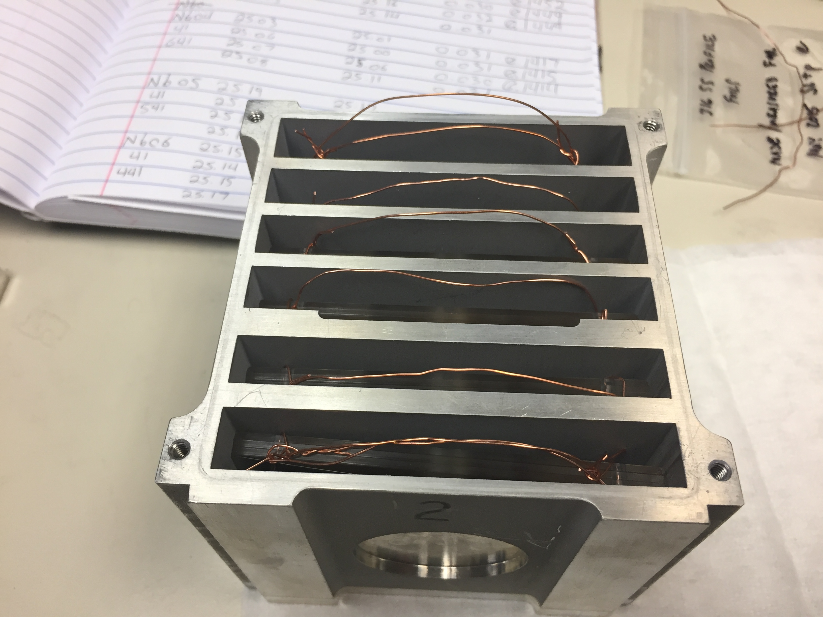

[fig:target_stack]Photograph of the assembled IPF target stack, before the stack’s o-ring lid was sealed in place. The baling wire handles affixed to each bunch of Al+Cu+Nb foils are visible in each energy position, to facilitate removal of activated foils via robotic manipulators in the IPF hot cell. The circular Inconel beam entrance aperture is visible in the bottom center of the photograph.

Table 1. Specifications of the target stack design in the present work. The proton beam enters the stack upstream of the

249.8 μm SS profile monitor, and is transported through the stack in the order presented here. The 6061 aluminum degraders

have a measured density of approximately 2.80 g/cm 3 . Their areal densities were determined using the variance minimization

techniques described in this work and the earlier paper by Graves et al.[27]

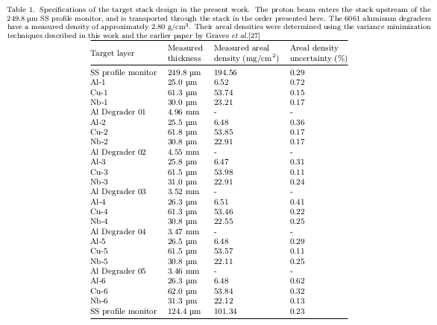

## Measurement of induced activities

For consistency, a single detector was used in this measurement, an ORTEC GEM Series (model #GEM10P4-70) High-Purity Germanium (HPGe) detector. The detector is a mechanically-cooled coaxial p-type HPGe with a 1 mm aluminum window, and a 49.2 mm diameter, 27.9 mm long crystal. Samples were counted at fixed positions ranging 4.5–83.5 cm (5% maximum permissible dead-time) from the front face of the detector, with a series of standard calibration sources used to determine energy, efficiency, and pileup calibrations for each position. The foils were counted for a period of 2 weeks following EoB, to accurately quantify all induced activities, with dead time never exceeding 5%. An example gamma-ray spectrum collected in such a fashion is shown in . For all spectra collected, net peak areas were fitted using the gamma spectroscopy analysis code UNISAMPO , which has been shown to perform best in comparisons with other common analysis codes .

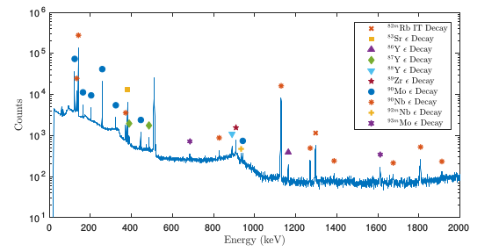

A gamma spectrum, collected from an activated Nb foil at approximately 80 MeV. While the majority of observed reaction products are visible in this spectrum, the decay lines, which form the basis of the (p,x) monitor reaction, are high in intensity and clearly isolated from surrounding peaks.

Following acquisition, the decaying product nuclei corresponding to each observed peak in the collected spectra were identified. The calibrated detector efficiencies, along with gamma-ray intensities for each transition and corrections for gamma-ray attenuation within each foil packet, were used to convert the net counts in each fitted gamma-ray photopeak into an activity for the decay of the activation products. For reference, the nuclear decay data used in this work is tabulated in and of 6. Data for photon attenuation coefficients are taken from the XCOM photon cross sections database . As nearly all of the product nuclei have multiple high-intensity gamma-rays, decay gamma-rays from the product nuclei were measured at multiple points in time (up to 2 weeks after EoB), as well as multiple independent activity measurements at each time point, based on each of its observed gamma-rays. The measured activity for each gamma-ray possesses a total propagated uncertainty which is the quadrature sum of the uncertainty in fitted peak areas, uncertainty in detector efficiency calibration, and uncertainty in the gamma-ray branching ratio data.

Since many of the reaction products populated by energetic protons are more than one decay off of stability, many of these are produced not only directly by reactions, but also indirectly by decay down a mass chain. To this end, it is useful to differentiate between the types of cross sections reported in this work. For the first observable product nuclei in a mass chain, its (p,x) cross section will be reported as a cumulative cross section (), which is the sum of direct production of that nucleus, as well as decay of its decay precursors and any other independent cross sections leading to that nucleus. In addition, cumulative cross sections will be reported whenever it is impossible to use decay spectroscopy to distinguish direct production of a nucleus from decay feeding. For all remaining observed reaction products in the mass chain, and cases where no decay precursors exist, independent cross sections () will be reported, allowing for determination of the direct production via subtraction.

To convert these activities into cross sections, corrections must be made for the decay of the various reaction products during the time between EoB and the spectrum acquisition, in order to calculate , the initial activity at EoB. The use of multiple gamma-rays at multiple points after EoB to calculate initial activities for each observed product nucleus allows for a more accurate determination of than simply basing its calculation off of a single gamma-ray observation. For the case of cumulative cross sections, EoB activities were quantified by fitting the activities observed at multiple time points (since EoB) to the well-known radioactive decay law. Nonlinear regression was used for this fitting process, minimizing on / degree of freedom, so that not only would the uncertainty-weighted EoB activities be fitted, but that a 1- confidence interval in would be reported as as well. As with the gamma-ray intensities, all lifetimes used in this work are tabulated in and of 6. In the case of independent cross sections, a similar process was followed, quantifying , the EoB activity of nuclide , by instead regressing to the solutions to the Bateman equation :

where refers to a precursor nucleus populating a specific end-product. While higher-order terms were added if needed, typically for an isomeric state in a particular mass chain, the second-order expansion () was often sufficient to quantify EoB activities in a mass chain, simplifying to:

In these cases, the previously-quantified EoB activities from decay precursors (, etc) would be substituted in, so that the feeding contributions from decay could be separated and an independent cross section reported. After quantifying the cumulative EoB activities at the top of a mass chain and all subsequent independent EoB activities, these will be later used to report the various cross sections for all observed reaction products and isomeric states.

## Proton fluence determination

An accurate integrated proton current is one of the most important factors in performing high-fidelity cross section measurements. At the time of this work, the nondestructive beam current monitors in the LANSCE-IPF beamline had a resolution of 100 nAh. For a low-current irradiation such as this work, where a nominal fluence of 200 nAh is desired, additional fluence sensitivity is thus needed to accurately normalize quantified EoB activities into cross sections. To this end, thin and foils were included along with the targets at each energy position, to provide another beam current monitor. These foils have been recommended for use as proton monitor foils in the 30 < E < 100 MeV regime by the IAEA, as the (p,x), (p,x), (p,x), (p,x), and (p,x) monitor reactions have been well-characterized for accurate proton fluence measurement . The recommended cross section values for each of these reactions were used in all calculations of proton fluence for the above monitor reactions. Due to the large energy degradation between the front and back of the target stack, a non-trivial broadening of the proton energy distribution is expected for all monitor and target foils. As a result, the integral form of the well-known activation equation is used to accurately determine proton fluence () in each monitor foil:

where is the EoB activity for the monitor reaction product, is the proton current, is the foil’s areal density, is the monitor reaction product’s decay constant, is the length of irradiation, is the IAEA recommended cross section at energy , and is the differential proton fluence. Using this formalism, the quantified EoB activities for each monitor reaction may be converted into a measured proton fluence at each energy position.

The propagated uncertainty in proton fluence is calculated as the quadrature sum of the uncertainty in quantified EoB activity, uncertainty in the duration of irradiation (conservatively estimated at 60 s, to account for any transient changes in beam current), uncertainty in foil areal density, uncertainty in monitor product half-life (included, but normally negligible), uncertainty in IAEA recommended cross section, and uncertainty in differential proton fluence. Of these, the first four contributions are all easily quantified in the preparation and execution of a stacked target irradiation; the last two contributions prove to be more nuanced, however. The uncertainty in proton fluence for irradiated monitor foils is derived from statistical uncertainty in the modeling of proton transport in the stack irradiation, discussed in . The uncertainty in IAEA recommended cross section values must be estimated indirectly, as no uncertainty in the recommended cross sections is provided in the current IAEA evaluation. Fortunately, the recommended cross section values for each monitor reaction tend to closely match one of the selected experimental data sets used in their evaluation. Since these data sets have listed uncertainties in the original manuscripts, uncertainties in IAEA recommended cross section values have been estimated by the uncertainty in the data set most closely matching the IAEA recommended values. For the monitor reactions employed in this work, these data sets are G. Steyn (1990) for (p,x) , M. Uddin (2004) for (p,x) , and S. Mills (1992) for (p,x), (p,x), and (p,x) .

## Proton transport calculations

Initial estimates of the proton beam energy in all foils were calculated using the Anderson & Ziegler (A&Z) stopping power formalism . These estimates of average beam energy in each foil are useful for the preliminary stack design, as the A&Z calculations provide reasonable approximations of 1-D proton transport due to treatment of ionization and multiple Coulomb scattering. However, for final energy and fluence determinations, a more rigorous method of proton transport is needed. The Monte Carlo N-Particle transport code MCNP6.1 was used for simulation of the full 3-D target stack, including determination of the full proton energy distribution for each stack position . In addition, MCNP6 provides a far more robust method of proton transport, as it is able to account for beam losses due to scattering and reactions, as well as production of secondary particles. As it is a Monte Carlo-based code, the uncertainty in energy distribution scales inversely with the number of source protons simulated. source protons were used for all simulations, which places the statistical uncertainty in proton energy distributions at less than 0.01%.

The ability to model the full energy distribution in each target position is vital for stacked target irradiations, due to the progressively larger energy straggling towards the rear of the stack. The initial proton beam has a finite energy spread (an approximately 0.1 MeV Gaussian width at 100 MeV), and since stopping power for charged particles is inversely proportional to their energy, the low-energy tail of the energy distribution is degraded more in each stack element than the high-energy tail. This effect compounds towards the rear of the stack, creating a significantly broadened low-energy tail, and a progressively larger net shift of the centroid to a lower energy. To account for this increasing energy uncertainty, a suitably representative energy must be established for each foil in the target stack. In this work, the flux-weighted average proton energy in each foil, , represents the energy centroid for protons in a target stack component, calculated using the energy distributions from MCNP6 modeling of proton transport:

Likewise, to represent the energy uncertainty for each stack position, the full width at half maximum (FWHM) of the MCNP6-modeled energy distribution is chosen for each energy position reported. While most experimental uncertainties are reported at the 1 level, the FWHM is used here to ensure at the 98% confidence interval that this width includes the “true” energy centroid value.

The “variance minimization” techniques described by Graves *et al.* have been employed here to further reduce the uncertainty in proton energy assignments . This method is based on the assumption that the independent measurements of proton fluence from the 5 monitor reactions used in this work should all be consistent at each energy position. If the monitor reaction cross sections and MCNP6-modeled energy distributions are both accurate, then any disagreement in the observed proton fluences is due to a systematic uncertainty in the stack design, namely, the areal densities of the stack components . This disagreement is minor at the front of the stack, and gets progressively worse as the beam is degraded, due to the compounded effect of systematic uncertainties in stack areal densities.

Variance minimization techniques were employed to correct for uncertainties in the characterization of the stack components, the largest cause of uncertainties in energy and fluence assignments. Due to the difficulty of characterizing uncertainty in areal density in the Kapton tape, the areal density of these layers were varied uniformly in MCNP6 simulations by up to 25% of nominal values. This had negligible impact on improving monitor reaction disagreement due to the small effect that their areal density has on beam degradation relative to the thick 6061 aluminum degraders (nominal 3–5 mg/cm, relative to nominal 1000–1400 mg/cm). As such, the areal density of each of the 6061 aluminum degraders were varied uniformly in MCNP6 simulations by a factor of up to 25% of nominal values, to find the effective density which minimized variance in the measured proton fluence at the lowest energy position (Al-6, Cu-6). This lowest energy position was chosen as a minimization candidate, as it is most sensitive to systematic uncertainties in stack design. The results of this minimization technique, shown in , indicate a clear minimum in proton fluence variance for flux-weighted average 41.34 MeV protons entering the last energy position. This is approximately 2 MeV lower than the nominal MCNP6 simulations, and approximately 3 MeV lower than nominal A&Z calculations, both of which used the nominal 2.80 g/cm measured density of the 6061 aluminum degraders. This energy corresponds to a 6061 aluminum areal density of 2.52% greater than nominal measurements, and serves as a lump correction for other minor systematic uncertainties in stack design, including stack areal densities and incident beam energy.

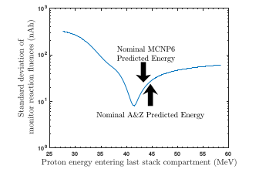

Result of the variance minimization performed by adjusting the degrader density in MCNP6 simulations of the target stack. A flux-weighted average proton energy of 41.34 MeV entering the last energy position creates a clear minimum in observed reaction fluence variance, corresponding to an areal density 2.52% greater than nominal. The variance minimum occurring at a lower incident energy than nominal MCNP6 and A&Z calculations indicates that there exists an additional systematic beam degradation not accounted for in modeling of proton transport in the stack design.

Figure 4. Results of variance minimization through enhancement of the effective areal density of the 6061 aluminum degraders by 2.52%. A noticeable reduction of variance in measured proton fluence is seen, particularly at the rear stack positions. Following minimization, additional apparent fluence is observed in the nat Al(p,x) 22 Na and nat Al(p,x) 24 Na monitor channels, due to contamination from nat Si(p,x) 22,24 Na on the silicone adhesive used for sealing foil packets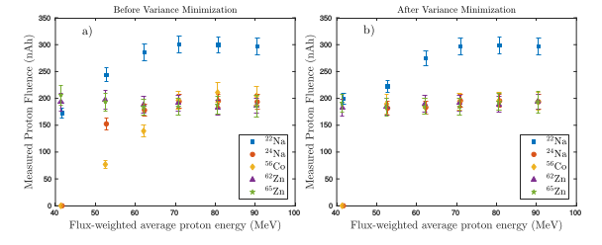

Figure 5. Estimates of EoB nat Al(p,x) 22,24 Na and nat Si(p,x) 22,24 Na activities using TENDL-2015 cross sections, in comparison with the IAEA recommended nat Al(p,x) 22,24 Na cross sections. At low energies, experimentally observed apparent 22,24 Na activities in each Al foil packet are consistent with IAEA recommendations, but diverge at higher energies as the nat Si(p,x) 22 Na exit channels begin to open up. 22,24 Na activities consistent with TENDL-2015 estimates are observed in each Nb and Cu foil packet as well, confirming that contamination may be attributed to activation of silicone adhesives.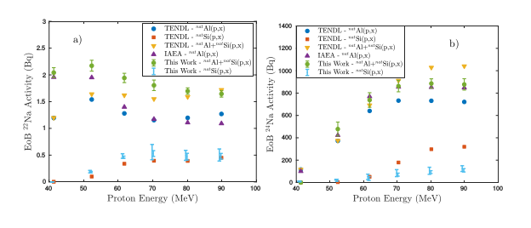

Figure 6. The “extra fluence” observed in the nat Al(p,x) 22 Na and nat Al(p,x) 24 Na monitor channels is caused by contamination from nat Si(p,x) 22,24 Na on the silicone adhesive used for sealing foil packets. Following subtraction of 22,24 Na activities observed in the silicone adhesive of Nb and Cu foils in the same energy “compartment”, the consistency of the nat Al(p,x) 22 Na monitor reaction improves dramatically. By excluding these contaminated channels, the remaining 3 independent monitor reactions serve to minimize uncertainty in stack energy assignments and incident fluence.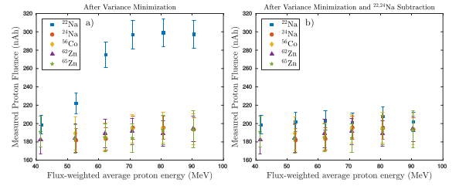

The impact of this variance minimization may clearly be seen in . As expected, the 2.52% increase in 6061 aluminum areal density has an almost negligible impact on the higher-energy positions, but causes a progressively larger downshift in proton energies at the later energy positions. In addition, as one moves to the rear positions, the disagreement in the independent proton fluence measurements is reduced. It is worth noting that the proton fluence measured by the (p,x) monitor reaction (threshold 21.0 MeV) is consistently higher in magnitude than all other monitor channels, with an increasing disparity at higher energies. This phenomenon is observed for the (p,x) monitor reaction as well (threshold 24.6 MeV), though to a much smaller degree. In both cases, this disparity is caused by the fact that the Kapton tape used for sealing foil packets (comprised of a silicone adhesive layer on a polyimide backing) contains a significant amount of silicon, making up approximately 10% of the silicone on a stoichiometric basis. and , the residual nuclei used as monitors, can also be populated off of natural silicon (92.2% ), predominantly via (p,2pn) (threshold 35.3 MeV) and (p,4pn) (threshold 44.6 MeV). and are also potential targets for (p,x), albeit with higher energetic thresholds and smaller cross sections. In addition, each aluminum foil packet contains approximately 6.5 mg/cm of Al, as well as approximately 9.6 mg/cm of silicone. The attribution of excess Al(p,x) activity to the silicone adhesive is confirmed by the observation of and activities in all Cu and Nb foil positions.

These compensating factors contribute to (p,2pn) production being competitive with the (p,x) production route. This is made made obvious when comparing the total measured activities of and in each Al foil packet (which combines both Al- and Si-based production routes), relative to the expected EoB activities for each reaction channel, presented in . Since no evaluated cross section data exists in this energy region for (p,x) (and only minimal data exists), the TENDL-2015 library is used to estimate the expected relative EoB activities for (p,x) and (p,x), in comparison with the IAEA recommended (p,x) cross sections. Several observations are immediately obvious. At lower energies, the magnitude of (p,x) is large compared to (p,x), which is why the (p,x) monitor agrees in fluence at the 40 (and almost at the 50) MeV position. At higher energies, the apparent (p,x) activity begins to diverge from the IAEA expected activities as (p,x) production begins to open up, which accounts for the nearly 50% apparent excess fluence in between 60–90 MeV. For the production, we see a similar behavior, though since the observed (p,x) yield remains consistently low in magnitude, only a minor increase in apparent activity is seen. The measured EoB and activities seen in all Cu and Nb foil positions are also shown here, which are seen to be consistent with the TENDL-2015 (p,x) yields. The observed activities also follow the shape of the TENDL-2015 (p,x) yields, albeit smaller in magnitude at the higher energy positions.

While these TENDL cross sections simply provide approximate (p,x) yields, there are several important conclusions to be drawn from this quick estimate. The observation of the activities in Cu and Nb foils represents an indirect measurement of the (p,x) cross sections, but they will not be reported due to the number of assumptions involved in such a calculation. The EoB activities have been measured directly, but to convert these into absolute cross sections, accurate knowledge of the precise silicone composition and areal density are required. These have been taken as 10% (stoichiometric basis) and 4.79 mg/cm (based on bulk density), respectively, for the purposes of transport calculations, but this level of confidence is insufficient for the reporting of a cross section. In principle, it would be possible to subtract out the measured activity at each Nb and Cu foil position (correcting for the minor difference in proton energy between adjacent foils) from the total apparent activities observed in each Al foil packet, in order to obtain the “true” or uncontaminated fluence via the aluminum monitor reactions. The results of this may be seen in — following subtraction, the fluences become consistent with other monitor reaction channels, within a mere 3–4% spread. While this would circumvent the assumptions needed for reporting (p,x) cross sections, subtraction of inaccurately quantified activity in each Nb and Cu foil would propagate into the final fluence determination at each energy position, shifting the magnitude of all reported cross sections. Even following subtraction, the fluence remains 3–6% higher than the weighted mean of the remaining monitor reaction channels. While the dramatic improvement in monitor reaction consistency builds confidence, in the interest of surety and because they are consistent, only the (p,x), (p,x), and (p,x) monitor reaction channels will be used for fluence determination for the reported cross sections. This serves as a pointed example of the importance of selecting monitor reaction products inaccessible through channels aside from the primary reaction ((p,x), in this case ), as noted previously.

Using this variance minimized degrader density, the final incident proton energy energy distributions from MCNP6 simulation are shown for the 6 irradiated Nb foils in . As expected, the energy distribution becomes increasingly more broadened at the lower energy positions, as a result of the beam energy degradation. In addition, as the beam becomes more degraded, the magnitude of the peak of each energy distribution (as well as the integral of each distribution) is reduced in magnitude, as beam fluence is lost due to scattering, and the peak-to-low-energy-tail ratio increases as more secondary protons are produced upstream. As with the monitor foils, these distributions were used to calculate the energy centroid (as the flux-weighted average proton energy) and uncertainty (as the FWHM of the distribution) for the final proton energy assignment of each Nb foil.

An enhanced version of the final monitor reaction fluences may be seen in , which shows the observed fluence of the (p,x), (p,x), and (p,x) monitor reaction channels. Without the reliable use of the (p,x) and (p,x) monitor channels, local interpolation cannot be used for fluence assignment to the Nb foils, and global interpolation is reliant upon a validated model for fluence loss. In the interest of surety of because they are consistent, the uncertainty-weighted mean for the three (p,x) monitor channels was calculated at each energy position, to determine the final fluence assignments for the Nb and Cu foils. Uncertainty in proton fluence is likewise calculated as the error propagation of the fluence values at each energy position. These weighted-mean fluences are also plotted in in , along with the estimated fluence according to both the MCNP6 transport model, as well as an uncertainty-weighted linear fit to the individual fluence measurements in each monitor channel. Both models reproduce the observed fluence data consistently within uncertainty, with the MCNP6 model predicting a slightly more aggressive fluence loss throughout the stack. These models are used purely to provide an extrapolation from the 90 MeV energy position back to the “front” of the stack at 100 MeV, to compare with the nominal fluence measured by the IPF upstream current monitors.

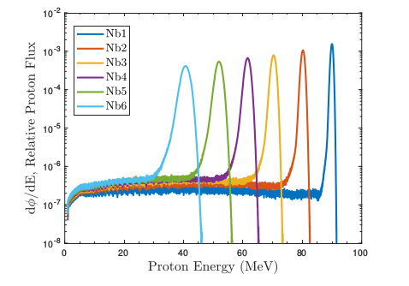

Final variance minimized incident proton energy distributions for the Nb foils, as simulated in MCNP6. The distribution tallies in each foil are all normalized to be per source proton, which was in all simulations. As the beam is degraded, proton energy distributions become visibly broadened due to straggling, and drop in magnitude due to scattering losses.

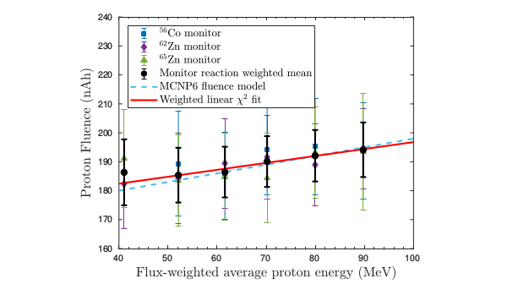

Final uncertainty-weighted mean proton fluences throughout the target stack, based on the variance-minimized observed fluence from the the (p,x), (p,x), and (p,x) monitor reactions. A clear loss of fluence is visible, dropping by approximately 7.2–8.9% from the incident fluence of 196.9–198.8 nAh over the length of the target stack, based on fluence loss models from MCNP6 simulations and an empirical fit to fluence measurements. This is due to a combination of beam utilization, as well as scattering.

## Calculation of measured cross sections

Using the quantified EoB activities along with the variance-minimized proton fluence, it is possible to calculate the final cross sections for the various observed Nb(p,x) reactions. While thin ( 22 mg/cm) Nb foils were irradiated to minimize the energy width of these cross section measurements, it is important to note that all cross sections reported here are flux-averaged cross sections, over the energy distribution subtended by each foil, as seen in . For both the cumulative and independent activities quantified, cross sections were calculated as:

where is the EoB activity for the monitor reaction product, is the proton current, is the foil’s areal density, is the monitor reaction product’s decay constant, and is the length of irradiation. The beam current, measured using an inductive pickup, remained stable for the duration of the irradiation, with the exception of approximately 70 s of downtime, occurring approximately 3 minutes into irradiation. The propagated uncertainty in cross section is calculated as the quadrature sum of the uncertainty in quantified EoB activity (which includes uncertainty in detector efficiencies), uncertainty in the duration of irradiation (conservatively estimated at 60 s, to account for any transient changes in beam current), uncertainty in foil areal density, uncertainty in monitor product half-life (included, but normally negligible), and uncertainty in proton current (quantified by error propagation of the monitor reaction fluence values at each energy position, as seen in ).

# Results

After irradiation, all foils were confirmed to still be sealed inside their Kapton packets, verifying that no activation products were lost due to packet failure and dispersal. In addition, each activated foil had a small “blister” under the Kapton tape layer, caused by a combination of thermal swelling and the formation of short-lived beta activities. This blister shows the location where the primary proton beam was incident upon the foil. The (p,x), (p,x), and (p,x) monitor reactions were used to determine the uncertainty-weighted mean fluence at each energy position (seen in ). A fluence of 198.86.7 nAh was calculated to be incident upon the target stack using the MCNP6 fluence model, and a fluence of 196.911.3 nAh using the linear fit model, both of which are consistent with the nominal fluence of 205.9 nAh based on IPF upstream current monitors. As fluence loss in the target box’s entrance window scales with , it is expected that an extrapolation back to the stack entrance will underestimate the nominal fluence incident upon the box. This incident fluence dropped by approximately 8.9% to 180.95.4 nAh (and by 7.2% to 182.713.5 nAh using the linear fit model) over the length of the target stack, which is consistent with similar measurements at IPF in the past . This loss of fluence is due to a combination of beam utilization for the various (p,x) reactions throughout the target stack, as well as large-angle deflections (primarily in the aluminum degraders) from scattering of the beam.

Using the final proton fluence at each energy position, cross sections for 51 Cr, 52g Mn, 52m Mn, 54 Mn, 55Co, 56 Ni, 57 Ni, 57 Co, 58g Co, 58m Co, 59 Fe, 60 Co, 61 Cu, and 64 Cuand were extracted for (p,x) reactions on foils in the 40–90 MeV region, as recorded in . For (p,x) reactions on foils, the (p,x) cross sections for 82m Rb, 83 Sr, 85g Y, 85m Y, 86 Zr, 86 Y, 87 Zr, 87g Y, 87m Y, 88 Zr, 88 Y, 89g Nb, 89m Nb, 89 Zr, 90Mo, 90 Nb, 91m Nb, 92m Nb, and 93m Mo and were extracted, as recorded in . In addition, as there exist a number of isomers with radioactive ground states in these mass regions, independent measurements of isomer-to-ground-state branching ratios for 52m/g Mn, 58m/g Co, 85m/g Y, 87m/g Y, and 89m/g Nb and were extracted and are recorded in . Comparisons of the measured cross sections and isomer branching ratios with literature data (retrieved from EXFOR ) are seen in the figures of 7 and 8. The propagated uncertainty in these cross sections varies widely based on the reaction product in question, with the major components arising from uncertainty in EoB activity (3–7%), proton fluence (4–6%), and foil areal density (0.1–0.6%).

Measured cross sections for the various (p,x) reaction products observed in this work. Cumulative cross sections are designated as , independent cross sections are designated as .

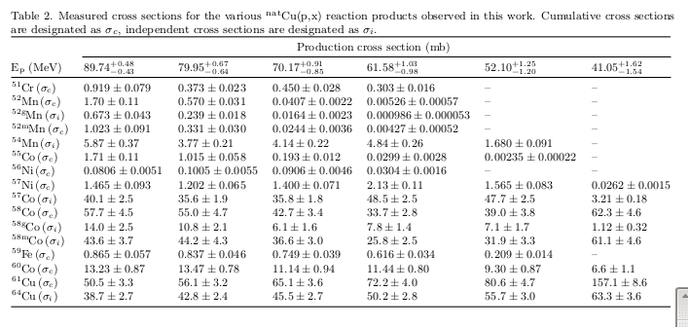

Table 3. Measured cross sections for the various nat Nb(p,x) reaction products observed in this work. Cumulative cross sections

are designated as σ c , independent cross sections are designated as σ i .

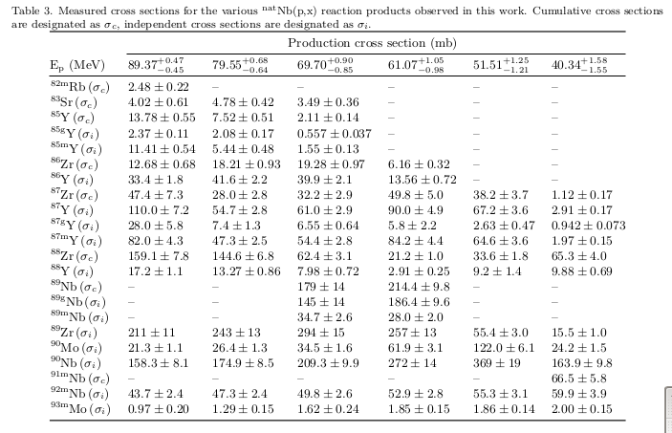

These results have several notable takeaways. The various (p,x) cross sections measured here are in excellent agreement with the body of measurements in the literature, but have been measured nearly exclusively with the highest precision to date. Similarly, the various (p,x) cross sections measured here are in excellent agreement with literature data, which is far more sparse in the 40–90 MeV region than for (p,x) — less than 3 existing measurements have been performed for the majority of the reactions presented here. Indeed, the (p,x), (p,x), (p,x), (p,x), (p,x), and (p,x) reactions each possess no more than a total of 3 data points in this energy region. Not only do the (p,x) measurements in this work fill in the sparse data in this energy region, but they have been measured with the highest precision relative to existing literature data.

Furthermore, this work presents the first measurements of several observables in these mass regions. This work reports the first experimental measurement of the (p,x) reaction in the 40–90 MeV region. It also represents the first measurement of the independent cross section for (p,x), as well as the () / () isomer branching ratio via (p,x). The cumulative cross sections from these data are also consistent with existing measurements of the cumulative (p,x) cross section. Similarly, this work offers the first measurement of the independent cross sections for (p,x), as well as the first measurement of the ($\sfrac{9}{2}^+$) / ($\sfrac{1}{2}^-$) isomer branching ratio via (p,x).

Notably, this work serves as the most well-characterized measurement of the (p,x) reaction below 100 MeV to date, with cross sections measured at the 4–6% uncertainty level. This is important, as it presents the first step towards characterizing this reaction for use as a proton monitor reaction standard below 100 MeV. The quantification of activity proved to be one of the most straightforward of all reaction products observed in this work. (p,x) can only be populated through the (p,4n) reaction channel, so no corrections for (n,x) contamination channels or decay down the A=90 isobar are needed, which makes activity quantification trivial. In addition, possesses seven strong, distinct gamma lines which can easily be used for its identification and quantification. Finally, the production of in the 40–90 MeV region is quite strong, with a peak cross section of approximately 120 mb. Combining the reaction yield and gamma abundance, the use of approximately 23 mg/cm Nb targets easily provided sufficient counting statistics for activity quantification in the 40–90 MeV region. This result presents the first step towards the use of as a clean and precise charged particle monitor reaction standard in irradiations up to approximately 24 hours in duration.

In addition to the Nb(p,x) measurement, this experiment has also yielded measurements of a number of additional emerging radionuclides with medical applications. These include the non-standard positron emitters , , , , the -therapy agent , and the Auger-therapy agent .

( h, =100% to ), while useful on its own as a positron emitter, stands poised as a particularly promising candidate for theranostic pairing with the soft emitter ( h, =100% to ) . (p,x) would seem to be an intriguing production pathway, due to the ready availability of Cu metal as target, combined with the fact that production in this pathway strongly favors over — indeed, the / ratio of production rates is approximately 290 at 61.58 MeV, and varies from 45–75 at the 70–90 MeV positions. The traditional route for production is via (p,3n), but at moderate energies, suffers from more contamination than (p,x) ( 10 at maximum). Lower-energy production via (p,3n) at 24–40 MeV is below threshold for , but has a peak cross section of approximately 10 mb, making (p,x) the superior production route for moderate-energy accelerators .

( h, =100% to ) is another novel emerging PET isotope, whose longer half-life has poised it for applications as a tracer for slower metabolic processes, as well as in pharmacokinetics studies . In particular, it is highly desired to form a theranostic pair with the widely-employed therapy agent ( h, =100% to ), which can be produced from a long-lived cow and emits no discrete observable gamma-rays or x-rays though decay . Although a weak positron branch exists and bremsstrahlung scintigraphy is commonly used for clinical imaging of the biodistribution, theranostics necessitate an imaging isotope to be paired for quantification of its uptake and biodistribution . Conventional production of proceeds through low-energy (7–14 MeV) irradiation via (p,n), which requires an enriched target (9.86% natural abundance), in order to eliminate contamination from (p,n) on the other stable isotopes . Alternatively, production at 33–43 MeV via (p,3n) has been proposed — this pathway also requires an enriched target (82.58% natural abundance) for the same reason, but contamination with other Y co-activities will be even more pronounced than via (p,n), due to the opening of (p,n) and (p,2n) channels on all stable Sr isotopes . Minimizing activity from other isotopes of the element in question is essential for producing radionuclides in high specific activity, as these competing isotopes are often impractical to separate out by radiochemical means. As a result, it would appear that (p,x) is a poor route for production in this respect, as it only reaches a maximum of approximately 35% radioisotopic purity. The dominant yttrium radioisotope produced by (p,x) in the 40–90 MeV region is ( h, =100% to ). However, itself has application as a generator for ( h, IT=99.70% to ), which is used for imaging studies of metastatic bone cancers, especially when in a theranostic pair with the established therapy agent ( d, =100% to ) .

( h, =100% to ) is a long-lived positron emitter useful as a tracer for slow biological processes, immune studies, and imaging of liver and breast cancers . Current production focuses on (p,n) between 9–14 MeV, which offers an extremely high-purity route on a mono-isotopic target and a strong population of , with a peak cross section of nearly 800 mb . Due to co-production of additional radio-zirconium, (p,x) is clearly inferior to (p,n), as the Nb route has a smaller peak cross section of approximately 290 mb, and achieves only 10–20% radioisotopic purity in the 50–90 MeV region.

( h, =100% to ) is an emerging PET emitter with a moderate lifetime, making it suited for immune and tumor uptake studies . It is typically produced using 8–15 MeV protons via (p,n), using an enriched target (51.45% natural abundance) for high radioisotopic purity, and produces a product with minimal contamination and a peak cross section of approximately 750 mb . (p,x) offers a possible alternative pathway using a natural target, at the expense of a smaller peak cross section. may be produced directly with an approximately 370 mb peak cross section and 99% radioisotopic purity, or could be produced as a / generator, which would have nearly 100% radioisotopic purity by using protons below the (p,5n) threshold of 45.76 MeV. However, the greatest problem with using the (p,x) reaction to produce is the inability to separate the radioisotope from the target itself, rendering the production of a high-specific activity product impossible.

( = 12.7 h) undergoes decay (61.5% branching ratio) to or decay (38.5% branching ratio) to . The emitted short-range 190-keV particle makes this an attractive therapeutic radionuclide, and the PET branch gives the possibility for real-time dose monitoring and verification . Several production routes currently exist: (p,n) uses 8–14 MeV protons on the expensive enriched target (0.9255% natural abundance), but offers a high radioisotopic purity assuming a highly enriched target . (p,n) requires more energetic 20–30 MeV protons, and necessitates an enriched target (18.45% natural abundance) to avoid the co-production of radio-copper impurities . More recently, the use of compact DD neutron generators for (n,p) production has been proposed, with the promise of mCi-scale production with high specific activity .

Finally, ( h, =100% to ) is a diagnostic and emerging Auger-therapy agent, typically seen as a contaminant in / generators . It is commonly produced via (p,n) at 10–15 MeV, using an enriched gaseous target, with a peak cross section of approximately 400 mb at 12 MeV . Production via (p,x) offers the use of metallic, natural abundance targetry, but requires significantly higher energy (>80 MeV) protons, peaking at approximately 20 mb near 600 MeV . It is clear that this production route offers no advantage over existing (p,n) routes for in-house production.

In this work, cumulative cross sections are reported for the first observable product nuclei in a mass chain, or whenever it is impossible to use decay spectroscopy to distinguish direct production of a nucleus from decay feeding. For all remaining observed reaction products in the mass chain, and cases where no decay precursors exist, independent cross sections are reported, allowing for determination of the direct production via subtraction. This, in turn, offers the opportunity to use these data to gain insight into the predictive capabilities of modern nuclear models used in the reaction evaluation process. The reaction channels with independent cross sections were compared to calculations with the reaction modeling codes EMPIRE, TALYS, and CoH, run with the default settings. The default optical models and E1 gamma strength function models for each code are presented in Table [tab:defaults]. The large energy range covered by many of the exit channels, which extends significantly beyond the range of pure compound nuclear/evaporation, allows the data to be used to study pre-equilibrium reaction mechanisms. All three codes use a two-exciton phenomenological model to calculate the pre-equilibrium cross section, but the specific implementation differs between the codes.

The default level density in both CoH and TALYS is the Gilbert-Cameron model, which uses a Constant Temperature model below a critical energy and Fermi Gas model above it. The default level density in EMPIRE is the Enhanced Generalized Superfluid Model (EGSM) which uses the Generalized Superfluid model below a critical energy, and Fermi Gas model above it . The EGSM densities are normalized to and the discrete levels, but in such a way that only the level density below the neutron separation energy is effected by the discrete levels chosen for the normalization.

Given the large number of exit channels in this data set, we will limit our discussion to cross sections for the production of a specific residual nucleus with experimental data through the full rise and fall of the peak, and at least 1% of the total reaction cross section. Exit channel cross sections that do not exhibit the full rise and fall of the peak, which is identified as being dominated by the formation of a compound nucleus, do not provide enough information to analyze the calculations. Residual nuclei like that can be produced by multiple reaction channels, such as (p,2n) and by (p,2n4n) are also not discussed in depth. We exclude reactions with cross sections with peak values less than 1% of the total reaction cross section because their behavior is extremely sensitive to more dominant channels. The three residual nuclei that meet all of the above criteria for which there is an independent measurement of the residual production cross section are , , and .

The (p,p3n) reaction channel, which peaks at approximately , is well within the compound regime for the entire energy region of this experiment. The data collected on this residual is consistent with the one other data set available, taken in 1997 by Michel *et al.* . The (p,4n) and (p,p3n) channels both peak early in the energy region, around 50 MeV, and the data clearly show the full rise, peak, and fall of the compound cross section. In both of these channels, this data is consistent with the data by Titarenko *et al.* in 2011.

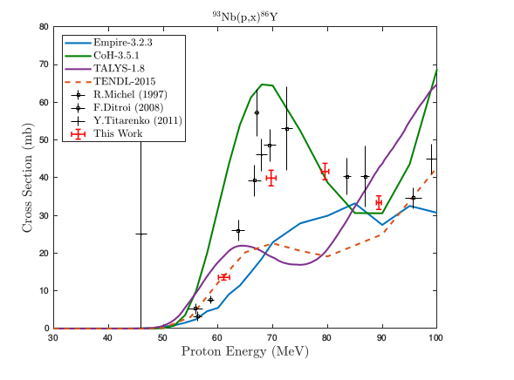

Measured (p,x) cross section, with the (p,p3n) reaction channel visibly peaking at approximately .

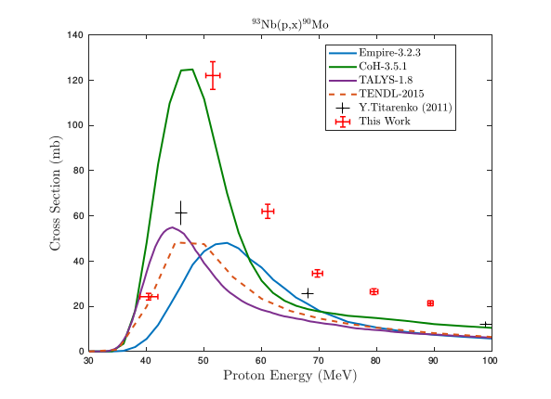

Measured (p,x) cross section, with the (p,4n) reaction channel visibly peaking at approximately .

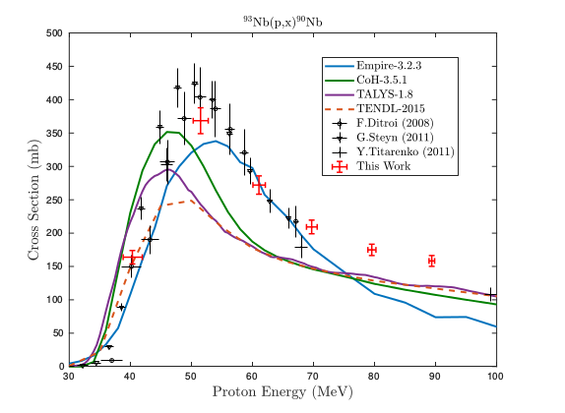

Measured (p,x) cross section, with the (p,p3n) reaction channel visibly peaking at approximately .

In all three channels, the TALYS, TENDL, and CoH calculations rise, peak, and fall at lower energies than the data, while EMPIRE calculates the peak to occur at higher energies. For , the EMPIRE peak is representative of the data. For and , the peak is missed by all three of the codes.

The magnitudes of the TALYS and TENDL calculations are consistently too low in the three channels studied here. For , CoH and EMPIRE also predict smaller cross sections than the data would suggest, which may be influenced by incorrect modeling of other, stronger, channels. The magnitude of the peak in the CoH calculation for is consistent with the data, while EMPIRE predicts a cross section that is approximately the same magnitude as that of TALYS. is one of the strongest measured channels, approximately 10% of the total reaction cross section, and the three codes are all consistent, but too small, in magnitude.

The production cross section exhibits a persistent pre-equilibrium “tail” that keeps the channel open well after the compound cross section has fallen away. TALYS, TENDL, and CoH seem to have the correct shape for this pre-equilibrium cross section, with magnitudes that are just slightly too low. EMPIRE, however, does not level off as much as the data and the other codes are seen to, and misses the high-energy data points.

Finally, we wish to urge caution in future stacked-target activation experiments by avoiding the use of silicone adhesive-based tapes for foil containment, especially when paired with the use of Al monitor foils. Acrylic-based tape options are commercially available, and are immune from (p,x) production of activities, due to being of too low-Z for these reaction channels to be possible. Even with subtraction of activities though irradiating a Kapton tape “blank” or similar, we observe the Al monitor channels to measure consistently higher proton fluence than via Cu monitor channels, by 5–8%. If Al monitors are used in conjunction with silicone-based tapes, even with subtraction of excess activities, a systematically enhanced fluence may be determined, leading to cross sections reported with inaccurately diminished magnitude. Furthermore, since data for monitor reactions are often self-referencing, the propagated impact of this systematic enhancement in fluence may have far-reaching consequences for both medical isotope production, as well as for the evaluated nuclear data libraries, which use these proton activation experiments as input.

# Conclusions

We present here a set of 38 measurements of cross sections for the (p,x) and (p,x) reactions between 40–90 MeV, as well as 5 independent measurements of isomer branching ratios. Nearly all cross sections have been reported with higher precision than previous measurements. We report the first measurements of the (p,x) reaction, as well as the first measurement of the independent cross sections for (p,x), (p,x), and (p,x) in the 40–90 MeV region. We also use these measurements to illustrate the impact of pre-equilibrium particle emission in the reaction dynamics for 40–90 MeV (p,x) and (p,x) reactions. We advise that future activation experiments avoid the use of silicone-based adhesives, particularly in conjunction with aluminum monitor foils, to avoid reporting an enhanced fluence due to contamination. Finally, this work provides another example of the usefulness of the recently-described variance minimization techniques for reducing energy uncertainties in stacked target charged particle irradiation experiments.

# Acknowledgements

The authors would like to particularly acknowledge the assistance and support of Michael Gallegos and Don Dry in the LANL C-NR Countroom, David Reass and Mike Connors at LANSCE-IPF, and the LANSCE Accelerator Operations staff.

We gratefully acknowledge support for this work from the United States Department of Energy, Office of Science via the Isotope Development and Production for Research and Applications subprogram in the Office of Nuclear Physics. This work has been carried out under the auspices of the U.S. Department of Energy by Lawrence Berkeley National Laboratory and the U.S. Nuclear Data Program under contract # DE-AC02-05CH11231. This research was performed under appointment to the Rickover Fellowship Program in Nuclear Engineering, sponsored by the Naval Reactors Division of the U.S. Department of Energy Additional support has been provided by the U.S. Nuclear Regulatory Commission.

This research used the Savio computational cluster resource provided by the Berkeley Research Computing program at the University of California, Berkeley (supported by the UC Berkeley Chancellor, Vice Chancellor for Research, and Chief Information Officer).

# Decay data

The lifetimes and gamma-ray branching ratios listed in these tables were used for all calculations of measured cross sections reported in this work, and have been taken from the most recent edition of Nuclear Data Sheets for each mass chain .

Decay data for gamma-rays observed in (p,x) and (p,x).

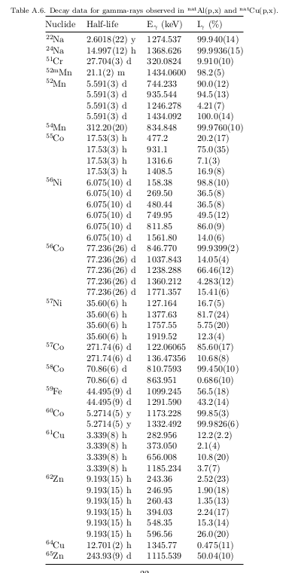

Decay data for gamma-rays observed in (p,x).

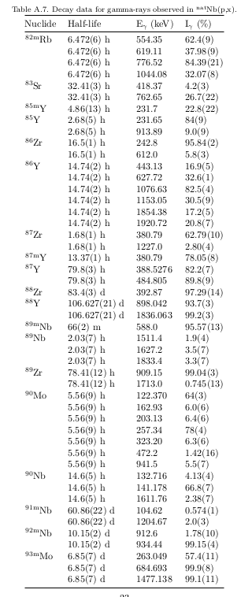

# Measured excitation functions

Figures of the cross sections measured in this work are presented here, in comparison with literature data , the TENDL-2015 data library , and the reaction modeling codes CoH-3.5.1, EMPIRE-3.2.3, and TALYS-1.8 .

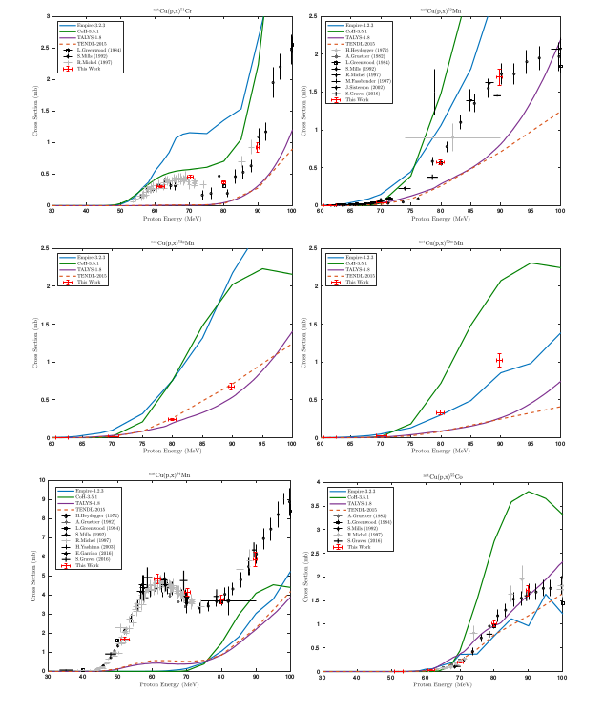

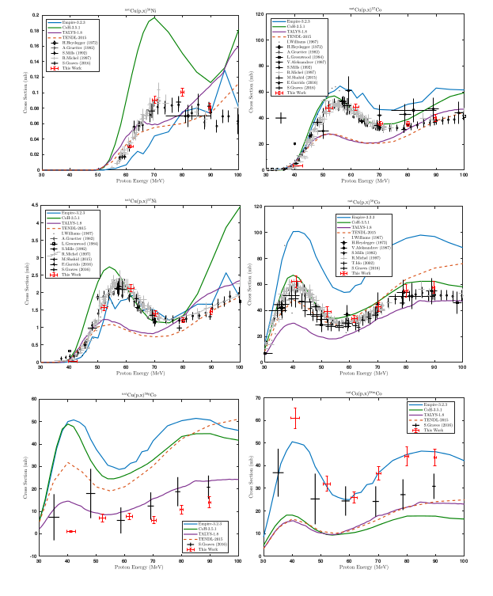

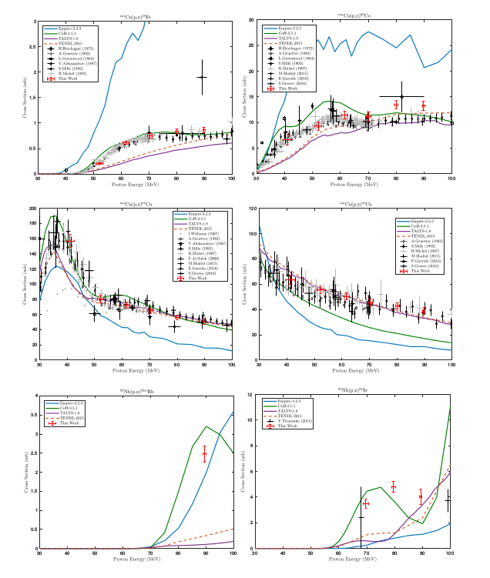

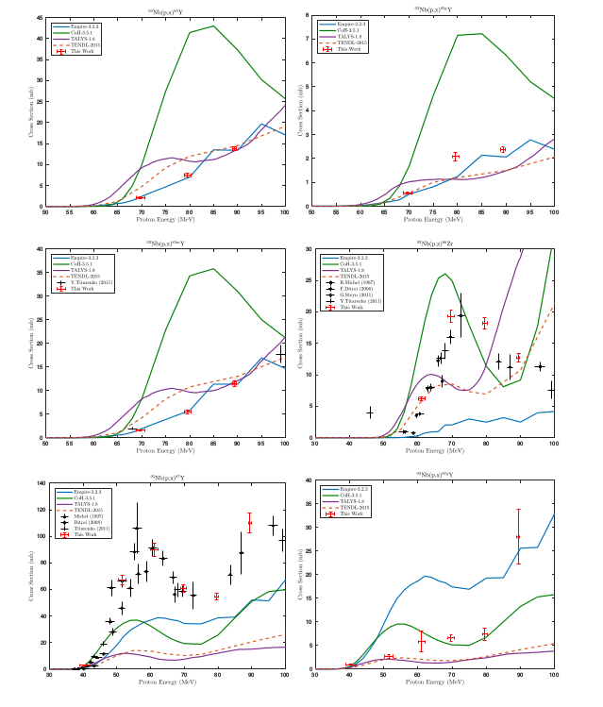

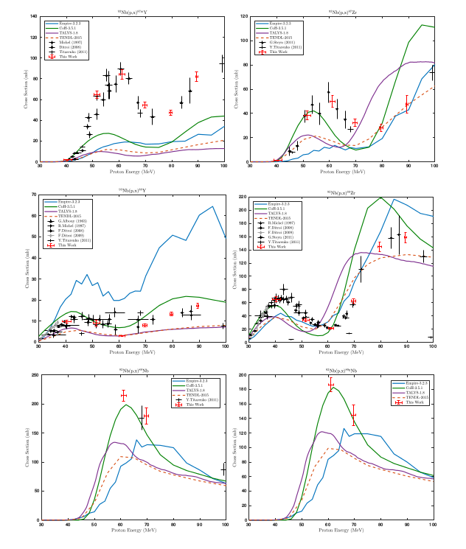

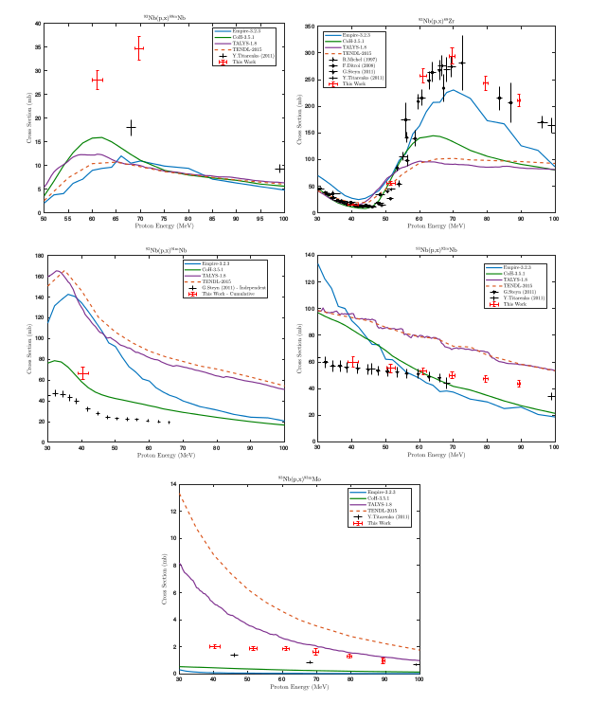

# Measured isomer-to-ground state branching ratios

Plots of the isomer-to-ground state ratios measured in this work are presented here, in comparison with literature data and reaction modeling codes .