**HW#5 (CSC390); Turn in your code on the Blackboard by** 03/25/2016 by 5:00PM

**Q1.** Write a MIPS assembly program to calculate the area of a rectangle using the floating point data (length and width of the rectangle) supplied from the keyboard. Your program should also display the results on the MIPS editor.

Hints: use “syscall” function discussed in our last class and example codes posted on the blackboard.

Q2. The following program (as shown in fig. 4. The code is also posted on the blackboard) performs the matrix operation, X=X+Y*Z, and display the results on the MIPS editor as shown in Figure 5. Please note that X, Y, and Z are square matrixes of size **4x4** and the elements of the matrixes are double precision floating point number.

1. Now, modify the program such that it would perform:

X = X+Y*Z; where X, Y, and Z are **8x8 matrixes** (as shown in fig 1) and each element is represented by double precision number. Your program should also display the result as shown in figure 2.

(Note that results are verified using Matlab)

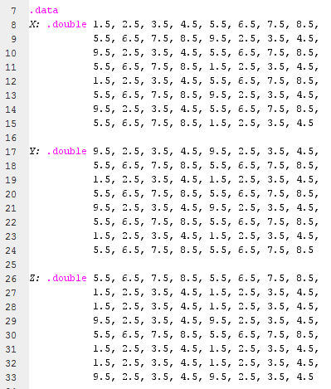

**Figure 1**

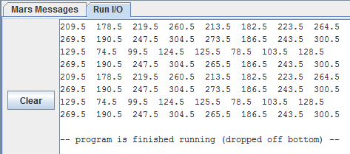

**Figure 2**

1. Also, modify the program such that it would perform:

**Z = X*Y-Z**; where X, Y, and Z are 8x8 matrixes (as shown in fig 1) and each element is represented by double precision number. Your program should also display the result as shown in figure 3.

(Note that this part would be more challenging than the first part. Please go through the pages 215-217 of your book. Pay attention to the Indexed operation and how the multiplication is done. You may need to use an extra instruction sub.d in addition to the add.d instruction. Add.d would be used to find each element of X*Y and sub.d would be used for X*Y-Z. Recall the Matrix multiplication operation. You may also need to use an extra floating point register to hold the X*Y value temporarily)

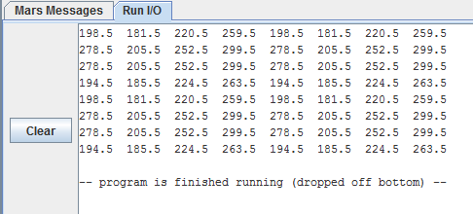

**Figure 3**

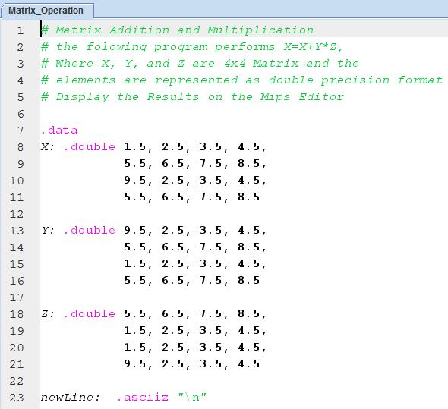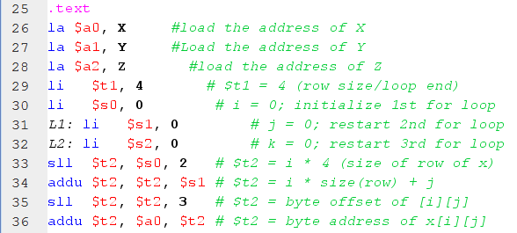

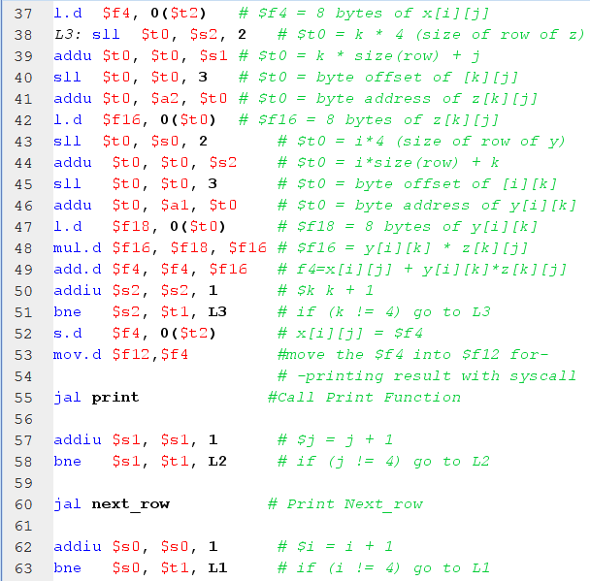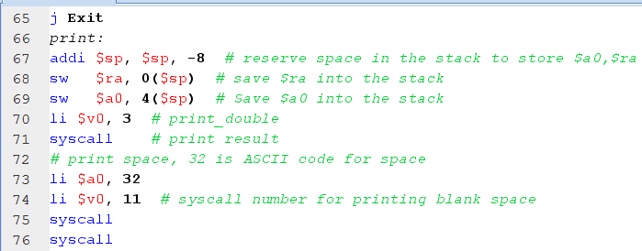

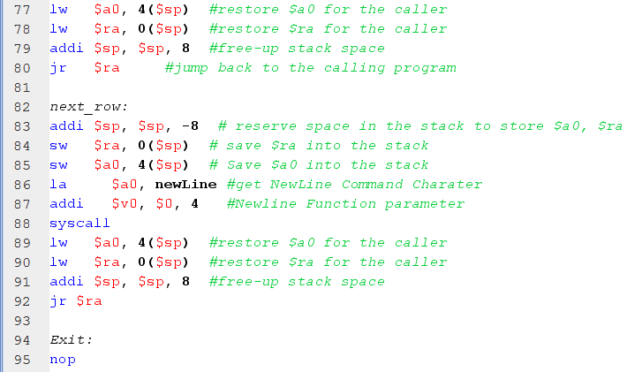

Figure

Results:

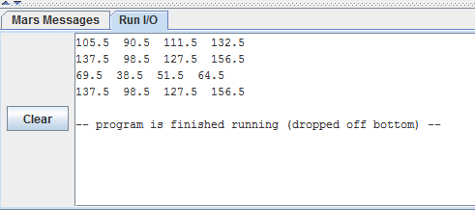

Figure