**HW#5 (CSC390)**

Due: 02/19/2018 (**Monday**) by **11:00PM**

(**Please turn in your code on the Blackboard**)

**#Q1.**

Convert the C function below to MIPS assembly language. Also write a MIPS assembly code to call the function with some initial value of n=5 and store the result in a suitable memory location, labeled as **F**. Consider $S0 will have the base address to store the result into F memory location. Also consider, the procedure uses $S0 to store the final result (i.e. 5+4+3+2+1) before it returns the results to the main program through $V0. Make sure that your assembly language code could be called from a standard C program (that is to say, make sure that you follow the MIPS calling conventions).

**unsigned int sum(unsigned int n)**

**{**

**if (n == 0) return 0;**

**else return (n + sum(n-1));**

**}**

***Note down and explain the value of $PC, $ra, $Sp, and the content of stack memory location every time you call the procedure.***

The stack grows downward (toward lower memory addresses). The following registers are used in the calling convention:

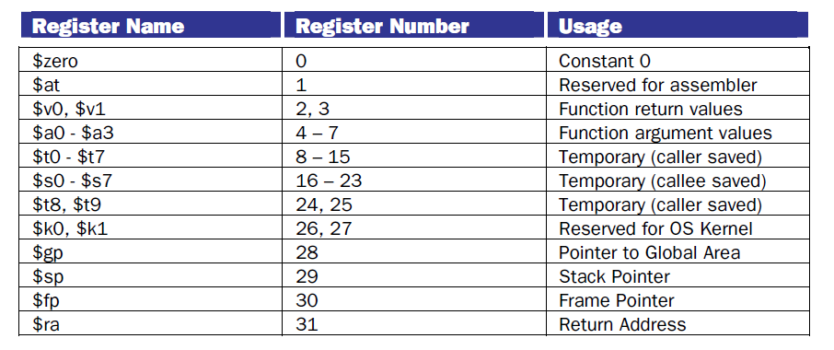

**Q2. [Q2.26 of your text book];**

