**Solution: HW#5 CSC390**

HW#5_Q1:

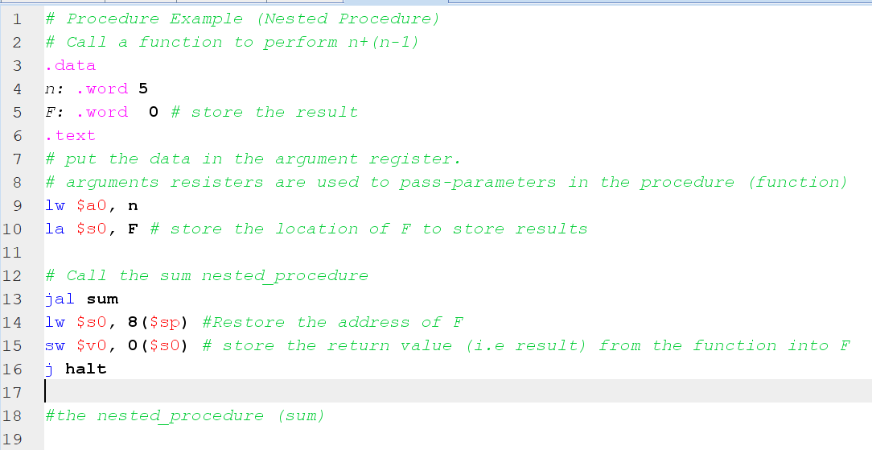

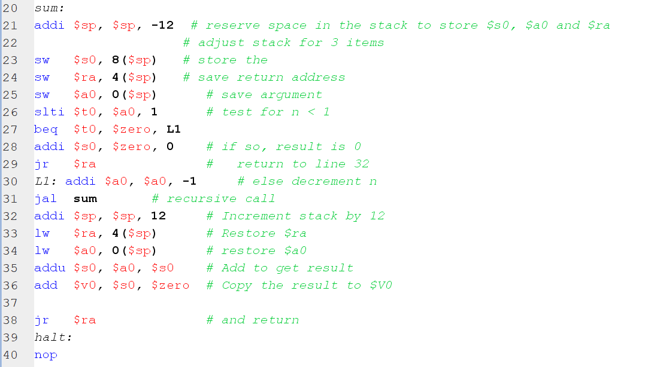

Word version of the code is also attached below:

# Call a function to perform n+(n-1)

.data

n: .word 5

F: .word 0 # store the result

.text

# put the data in the argument register.

# arguments resisters are used to pass-parameters in the procedure (function)

lw $a0, n

la $s0, F # store the location of F to store results

# Call the sum nested_procedure

jal sum

lw $s0, 8($sp) #Restore the address of F

sw $v0, 0($s0) # store the return value (i.e result) from the function into F

j halt

#the nested_procedure (sum)

sum:

addi $sp, $sp, -12 # reserve space in the stack to store $s0, $a0 and $ra

# adjust stack for 3 items

sw $s0, 8($sp) # store the

sw $ra, 4($sp) # save return address

sw $a0, 0($sp) # save argument

slti $t0, $a0, 1 # test for n < 1

beq $t0, $zero, L1

addi $s0, $zero, 0 # if so, result is 0

jr $ra # return to line 32

L1: addi $a0, $a0, -1 # else decrement n

jal sum # recursive call

addi $sp, $sp, 12 # Increment stack by 12

lw $ra, 4($sp) # Restore $ra

lw $a0, 0($sp) # restore $a0

addu $s0, $a0, $s0 # Add to get result

add $v0, $s0, $zero # Copy the result to $V0

jr $ra # and return

halt:

nop

Sum is called for the first time:

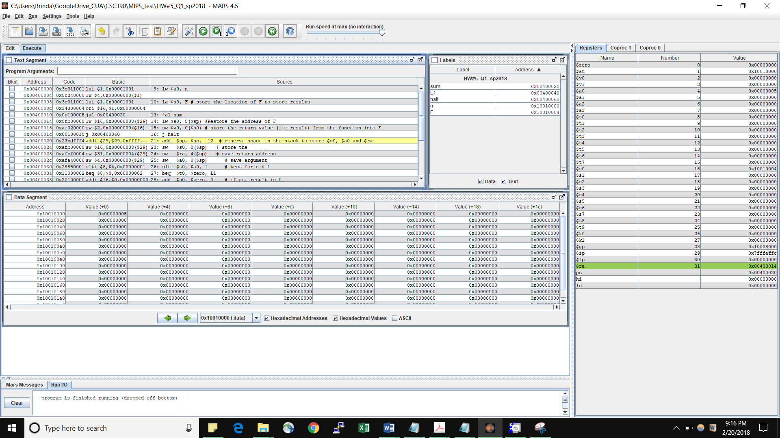

$pc has the current location, $ra contains the return address to the main program and $sp has the highest location of the memory.

During the execution of sum procedure (1st iteration), the stack memory location is loaded the values of return address ($ra) to the main program and the current valu of n ($a0).

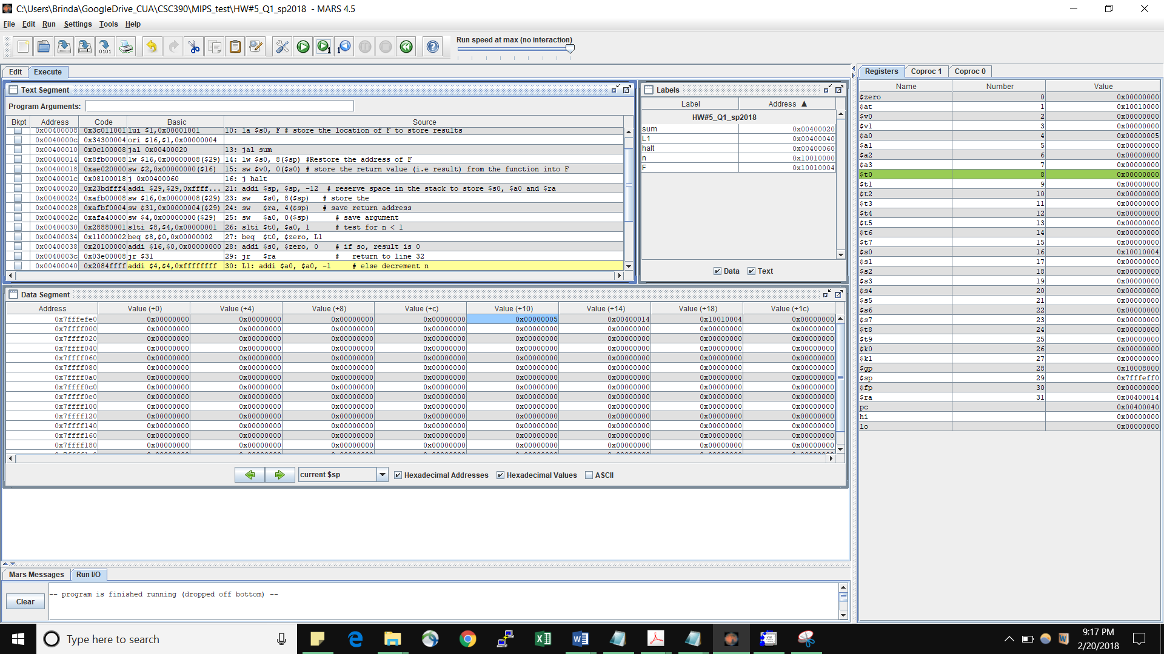

2nd Iteration: $ra has now the return address to the sum procedure location (recursive operation). $sp has the value decremented by 12.

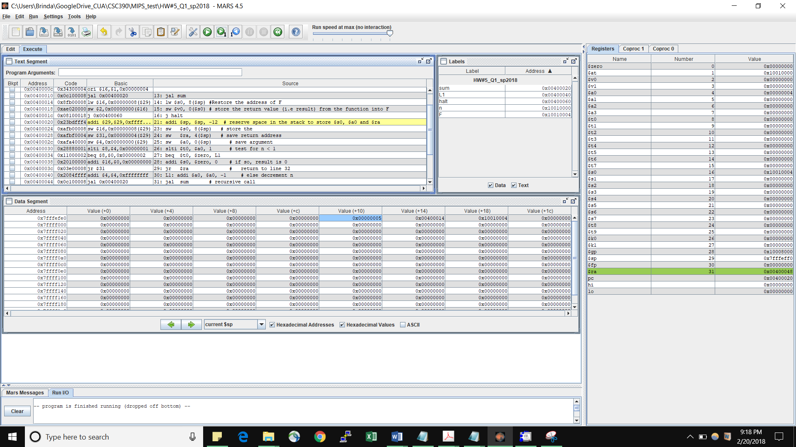

After 5 iterations: the stack memory locations showing the return addresses and the decremented values of n.

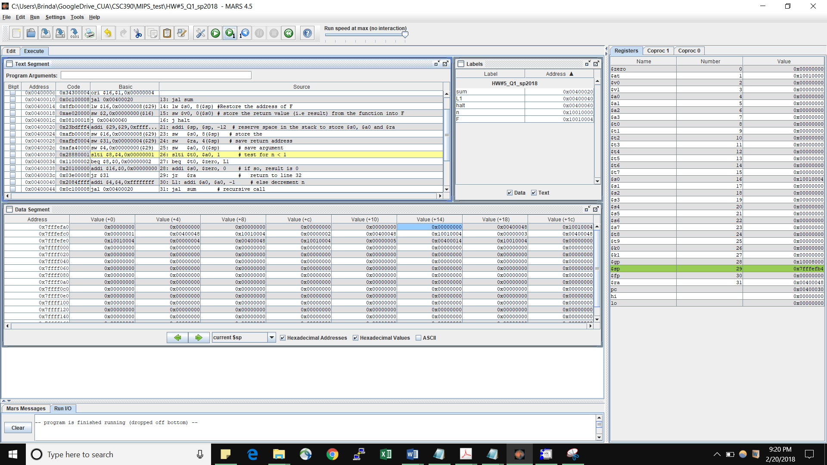

Values of the stack memory location when n decremented to 0

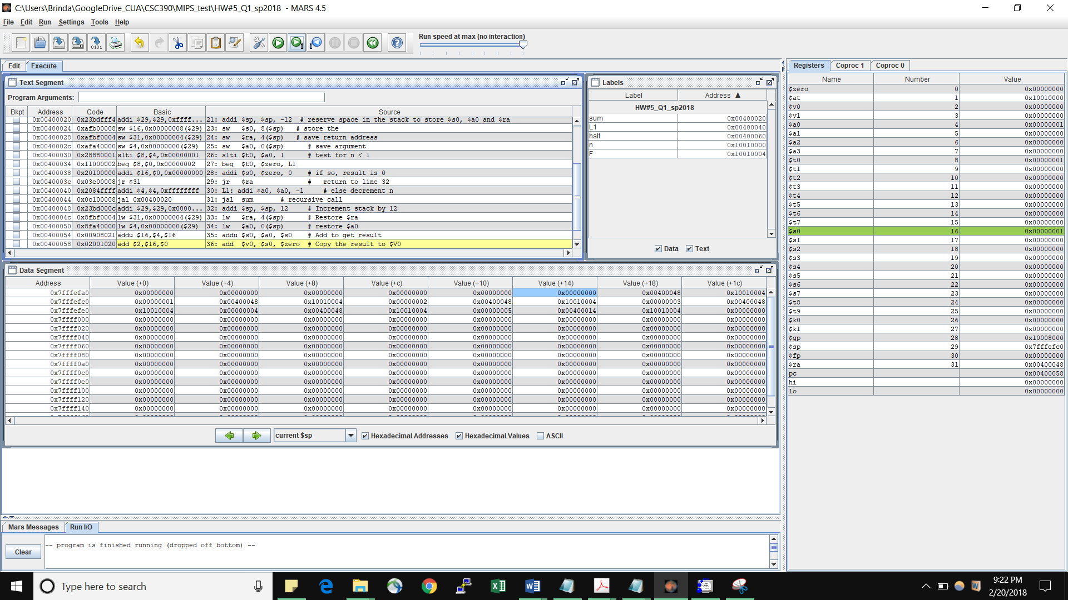

Contents of $ra, $pc, and $sp before returning to the main program:

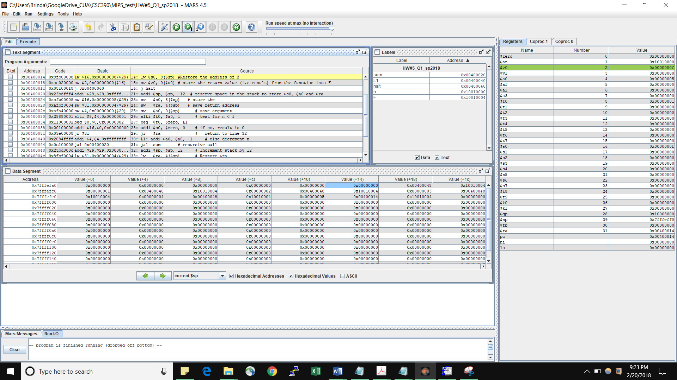

After result is stored into the memory location of F. check that the memory location indicated by $S0 has the correct results 15 (i.e. f in Hex).

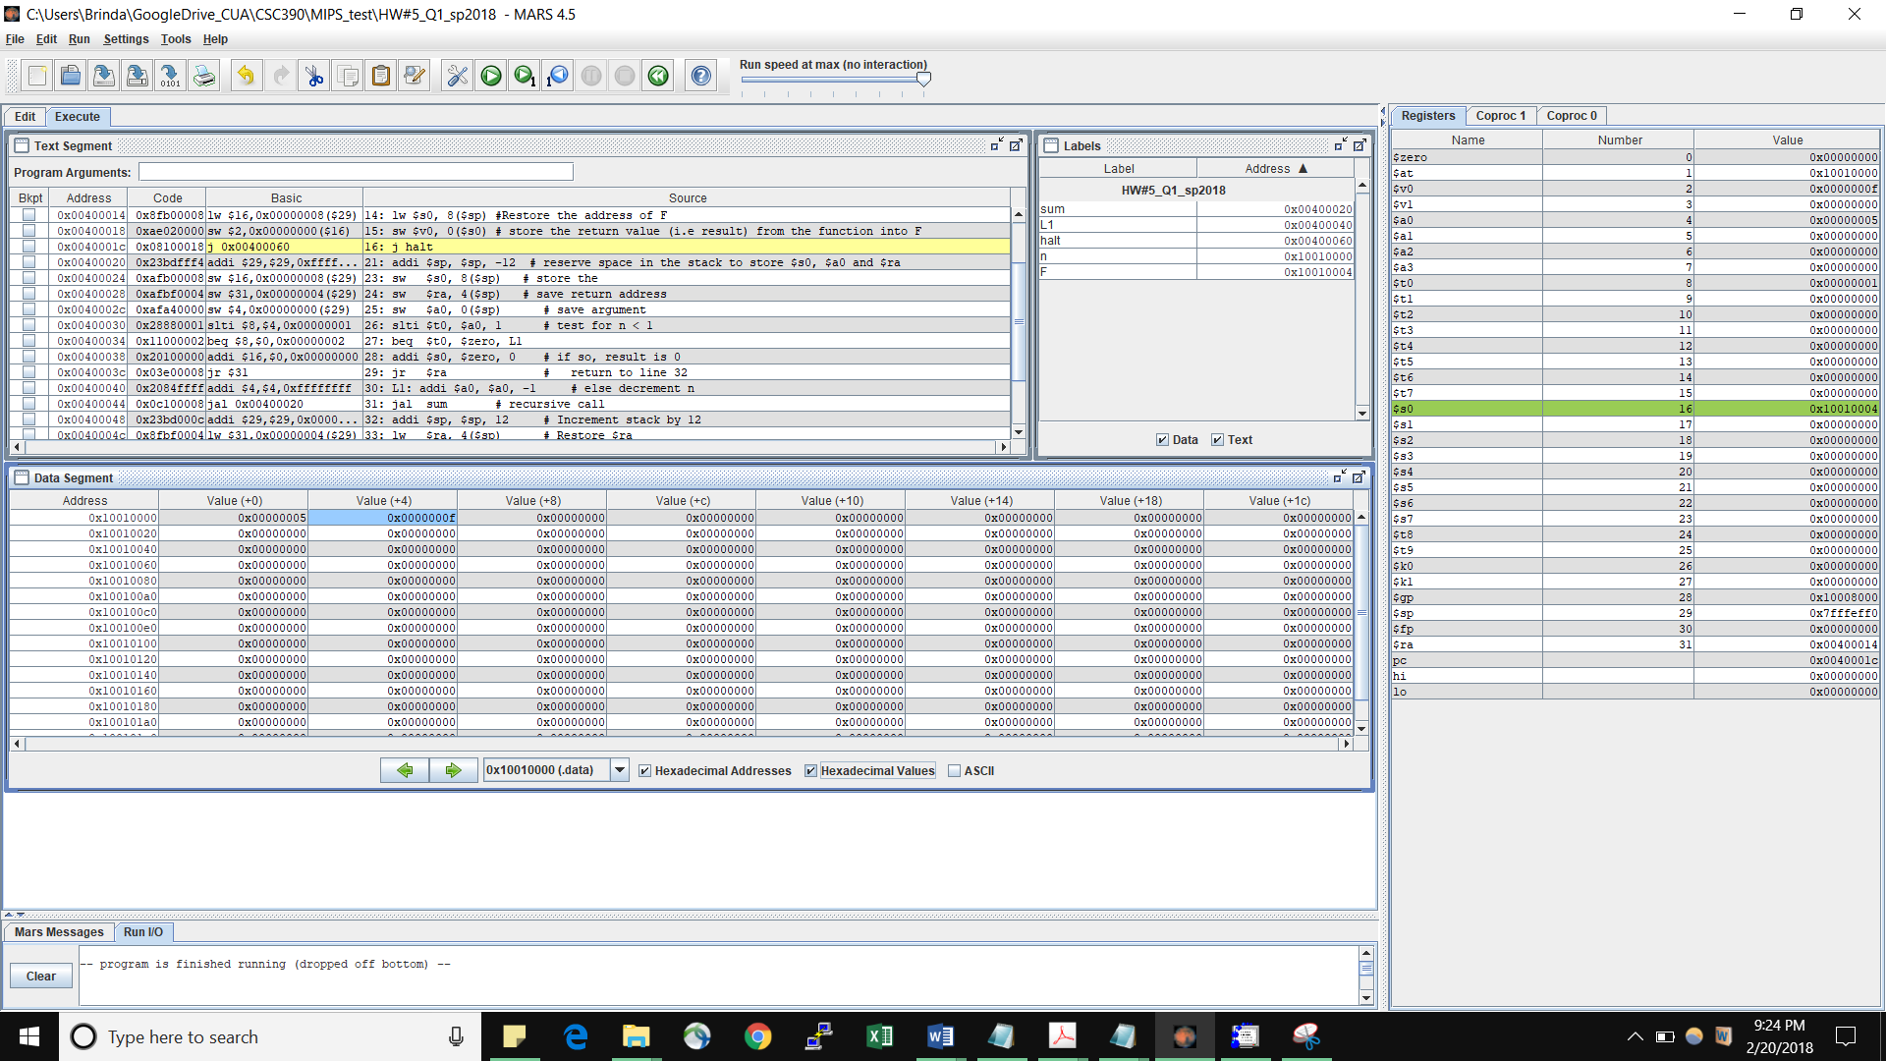

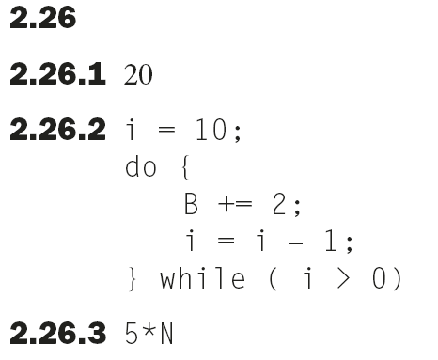

**5*N+2**