**Q1.** The following Circuit performs the division of two 32-bit unsigned binary numbers and produces the Quotient and Remainder in the respective registers. Figure 1 shows the three steps division algorithm that the circuit performs to produce the result. Suppose, you are assigned to design a 5-bit division circuit that will perform the division of the two 5-bit unsigned numbers A=(11011)2 and B=(00101)2 and produce the Quotient and Remainder of the division. Draw the necessary hardware and show the results produced in each iteration of your algorithm. Hints: see figure 3.10 (page 192) of our text book.

**HW#8 (CSC 390): SOLUTION**

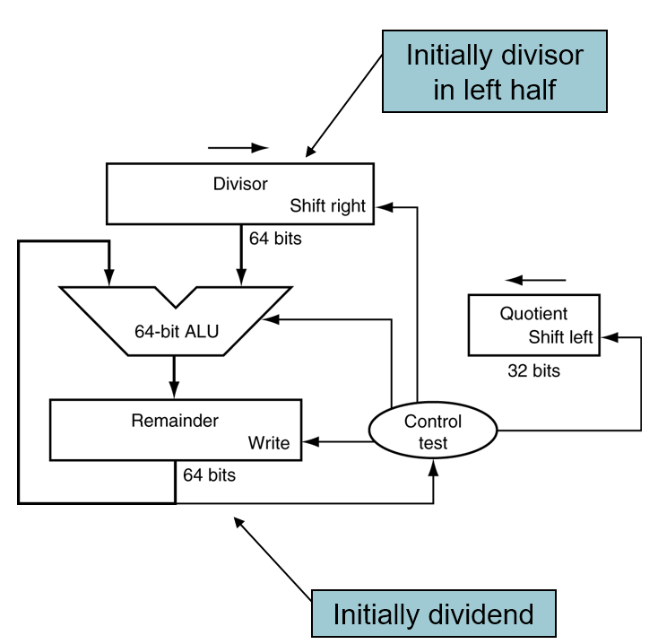

10 bits

10 bits

5 bits

10 bits

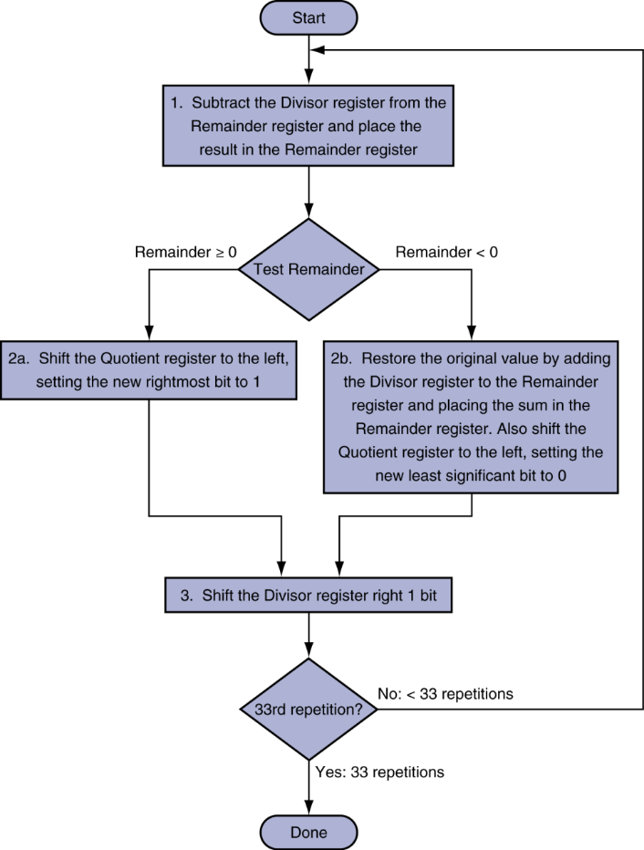

6 repetitions

6 repetitions

Figure 1

|  |  |  |  |  |
| --- | --- | --- | --- | --- |
| **Iteration** | **Step** | **Quotient** | **Divisor** | **Remainder** |
| **0** | **Initial Value** | **00000** | **0010100000** | **0000011011** |
| **1** | 1: Rem = Rem - Div | **00000** | **0010100000** | **1101111011** |
| 2b : Rem < 0 => +Div, sll Q, Q0 = 0 | **00000** | **0010100000** | **0000011011** |
| 3: Shift Div right | **00000** | **0001010000** | **0000011011** |
| **2** | 1: Rem = Rem - Div | **00000** | **0001010000** | **1111001011** |
| 2b : Rem < 0 => +Div, sll Q, Q0 = 0 | **00000** | **0001010000** | **0000011011** |
| 3: Shift Div right | **00000** | **0000101000** | **0000011011** |
| **3** | 1: Rem = Rem - Div | **00000** | **0000101000** | **1111110011** |
| 2b : Rem < 0 => +Div, sll Q, Q0 = 0 | **00000** | **0000101000** | **0000011011** |
| 3: Shift Div right | **00000** | **0000010100** | **0000011011** |
| **4** | 1: Rem = Rem - Div | **00000** | **0000010100** | **0000000111** |
| 2a : Rem ≥ 0 => sll Q, Q0 = 1 | **00001** | **0000010100** | **0000000111** |
| 3: Shift Div right | **00001** | **0000001010** | **0000000111** |
| **5** | 1: Rem = Rem - Div | **00001** | **0000001010** | **1111111101** |
| 2b : Rem < 0 => +Div, sll Q, Q0 = 0 | **00010** | **0000001010** | **0000000111** |
| 3: Shift Div right | **00010** | **0000000101** | **0000000111** |
| **6** | 1: Rem = Rem - Div | **00010** | **0000000101** | **0000000010** |
| 2a : Rem ≥ 0 => sll Q, Q0 = 1 | **00101** | **0000000101** | **0000000010** |
| 3: Shift Div right | **00101** | **0000000010** | **0000000010** |

A=(11011)2 🡺 27 ; B=(00101)2 = 5 ; A/B = 27/5 🡺

Quotient = 5 🡪 **000101** and

Remainder = 2 🡪 **00010**