**HW#1 (CSC390-Spring 2018)**

**SOLUTION**

**Q1.** Computer A has an overall CPI of 1.3 and can be run at a clock rate of 600MHz. Computer B has a CPI of 2.5 and can be run at a clock rate of 750 Mhz. We have a particular program we wish to run. When compiled for computer A, this program has exactly 100,000 instructions. How many instructions would the program need to have when compiled for Computer B, in order for the two computers to have exactly the same execution time for this program?

Sol:

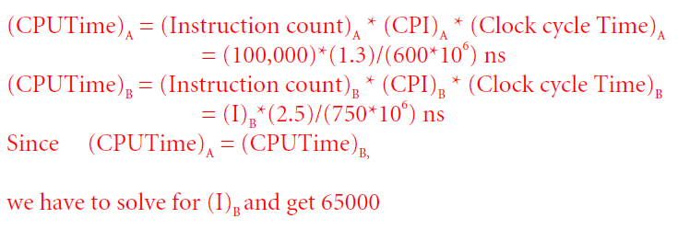

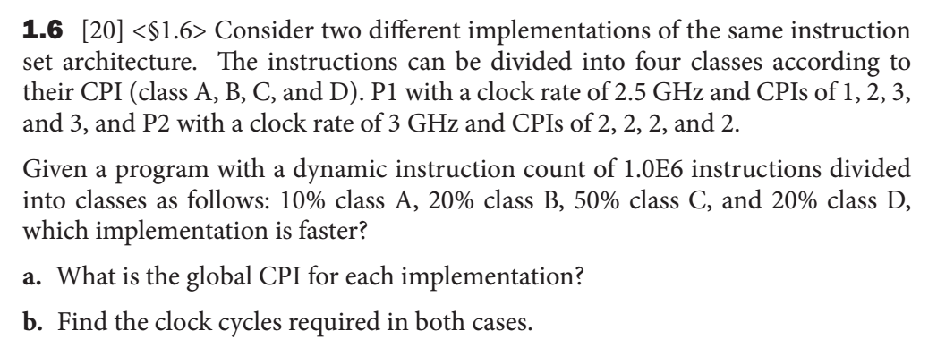

Solution:

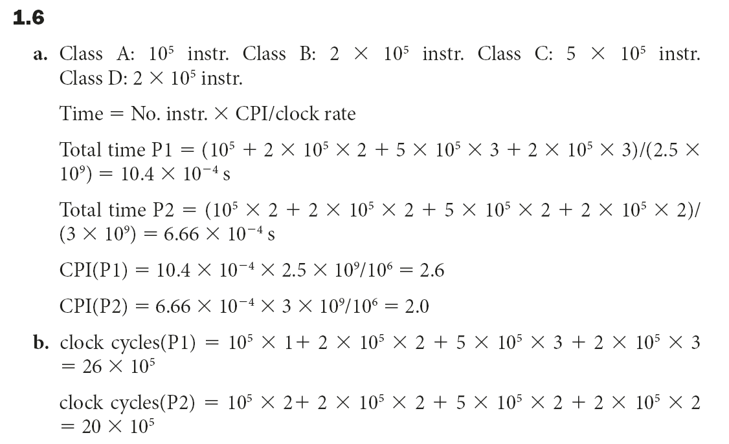

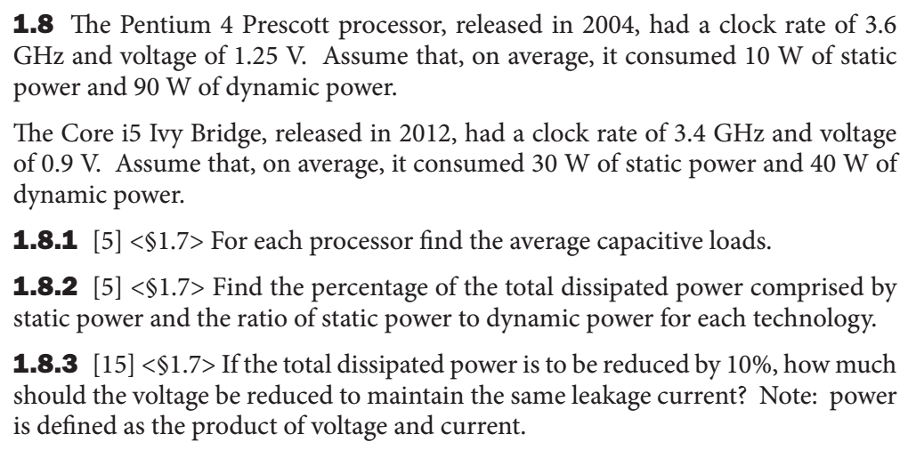

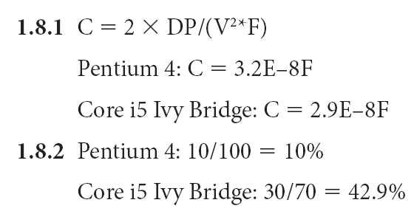

**1.8.3**

(SP_new +DP_new)/(SP_old + DP_old) = 0.90

DP_new = ½ x C x V_new2 x F

SP_old = V_old x I

SP_new = V_new x I

Therefor,

V_new = [2 x DP_new / (CxF)]1/2

DP_new = 0.9 x (S_old +D_old) – S_new

SP_new = V_new x (SP_old/V_old)

**For Pentium 4:**

SP_new = V_new x (10/1.25) = V_new x 8

DP_new = 0.90x100 – V_newx8 = 90 – V_new X 8

V_new = [2x(90-V_new X 8)/(3.2E-08 X 3.6E9)]1/2

V_new = 1.182 Volts

**For Core i5:**

SP_new = V_new x (30/0.9) = V_new x 33.3

DP_new = 0.90 x 70 – V_new x 33.3 = 63 – V_new x 33.3

V_new = [2x(63-V_new X 33.3)/(2.9E-08 X 3.4E9)]1/2

V_new = 0.84Volts

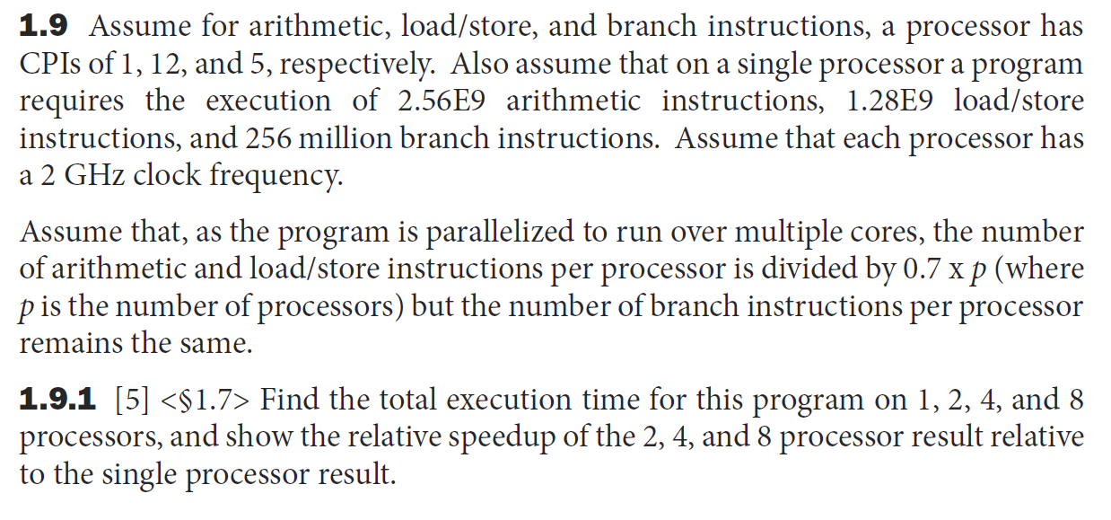

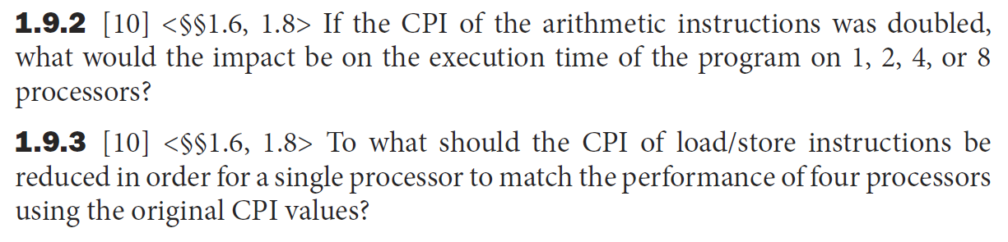

Sol:

