**CSC390 (Computer Org. & Arch.)**

**Exam#1- Spring 2018**



**Name:**

**Student ID:**

(There are four questions. All Questions have equal weights)

**Q1.** Suppose a program requires the execution of 110 million Floating Point (FP) instructions,   
 200 million Integer (INT) instructions, 80 million Load/Store (L/S) instructions, and 30   
 million Branch instructions. The CPI for each type of instruction is 4, 3, 12, and 8,   
 respectively. Also assume that the processor executing the program has a 2.8 GHz clock   
 rate.

1. Find the execution time of the program. [5 pts]
2. By how much is the execution time of the program improved if the CPI of INT and FP instruction is reduced by 30%, the CPI of L/S instructions is reduced by 40% and the CPI of Branch instructions is reduced by 20%. [5 pts]
3. By how much must we improve the CPI of only Branch instructions if we want the program to run two times faster? [5 pts]
4. Suppose we are trying to reduce the execution time by 25% but this leads to an increase of 15% in the CPI of all instructions. What clock rate should we have to get this time reduction? [5 pts]

**Q2.** Assume that the program in Q1 is parallelized to run over 6 cores, the number of FP, INT,   
 and L/S instructions per processor is divided by 1.8 but the branch instruction per   
 processor remains the same. Find the relative speed up of the 6 processors result relative   
 to the single processor result. [10 pts]

**Q3.** Consider the following MIPS assembly code which calls a leaf_procedure to perform an arithmetic series operation, n+(n-1)+(n-2)+……..+1, where n is a positive number. The result of this operation will be stored in the variable “sum”, as defined in line 6. [30 pts]

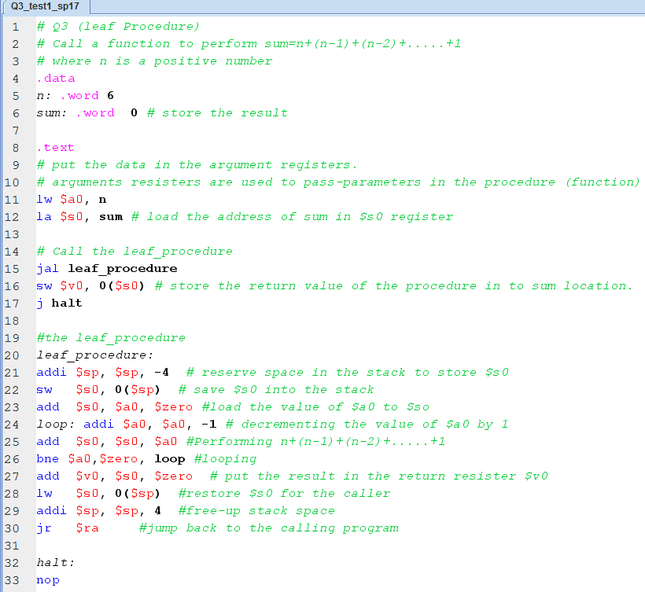

Figure

After assembling the program, the MIPS simulator shows the necessary information, as shown in figure 2, regarding system resources (data segment, text segment, stack-pointer and other registers) used in the program. Observe figure 2 carefully and answer the following question:

1. What would be content of registers $a0 and $s0 after executing line 11 and 12 of figure 1.
2. What would be the content of program-counter (pc) and the register $ra, after executing line 15 of figure 1.
3. Observe that the instruction in line 21 of figure 1 (i.e. addi $sp, $sp, -4) is converted to “addi $29, $29,0xfffffffc” as shown in the Basic Column of figure 2. Explain what do these numbers 29 and 0xfffffffc represent?
4. Observe the current value of the stack-pointer ($sp), as shown in figure 2, and tell me what would be the new value of $sp after executing line 21 of figure 1.
5. After executing line 22 of figure 1, the content of $s0 will be stored in the stack memory location. Is it necessary to store $s0 in the stack for this program? What would happen if you do not do that operation?
6. Write down the machine code of the instruction in line 23 of figure 1. Show all the MIPS fields of the instruction clearly and verify your machine with figure 2.

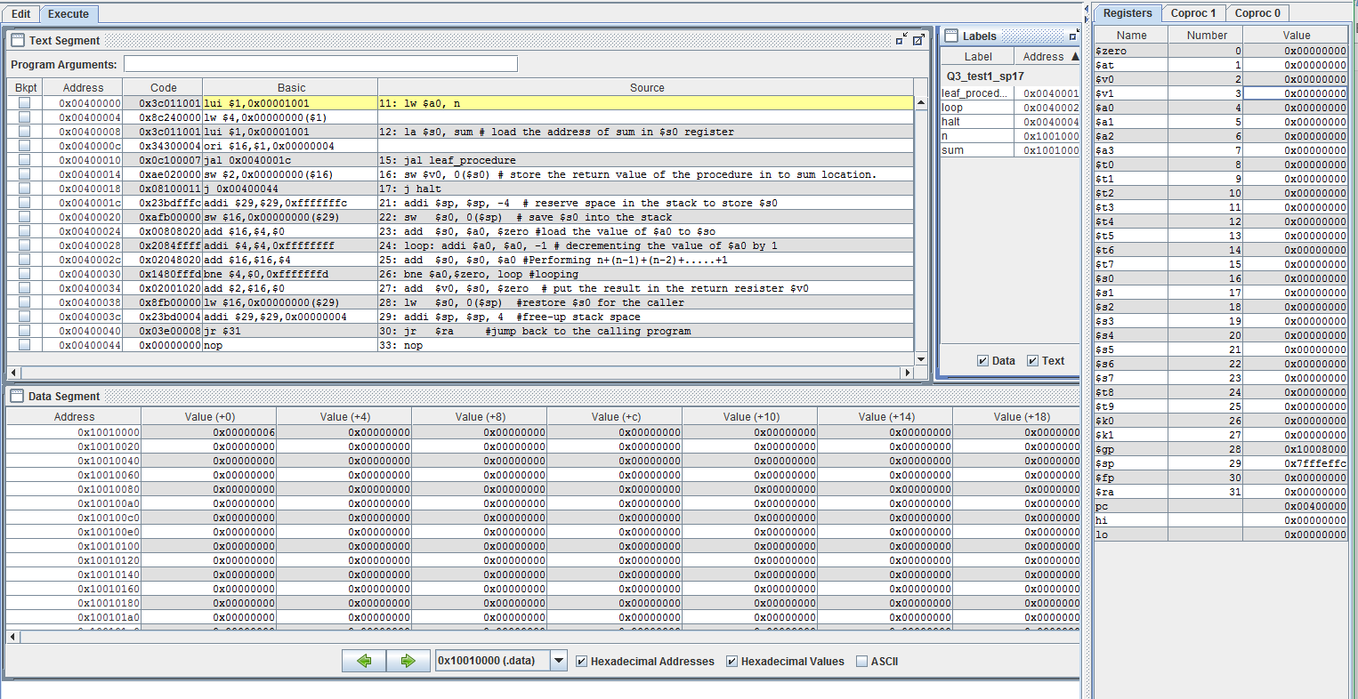

Figure (the larger version of this picture is also attached with this exam)

1. The leaf_procedure starts a loop operation in line 24 of figure 1. Given the value of n=6, how many times the loop will be executed?
2. Observe that the instruction in line 26 of figure 1 (i.e. bne $a0, $zero, loop) is converted to “bne $4, $0, 0xfffffffd” as shown in Basic Column of figure 2. Explain what do these numbers 4, 0 and 0xfffffffd represent?
3. What would be the content of the program-counter (pc), if the condition in line 26 of figure 1 **is satisfied**?
4. What would be the content of the program-counter (pc), if the condition in line 26 of figure 1 is **not satisfied**?
5. What would be the content of register, $so, **before and after** executing line 28 of figure 1?
6. What is purpose of incrementing stack-pointer in line 29? What would happen if you do not do that operation?
7. What would be the content of the program-counter(pc) after executing line 30?
8. Calculate the physical location of the data segment where the result ($v0) will be stored.
9. What would be the content of the program-counter after executing line 17 of figure 1?