Volume 2 — Technical Volume
{company_name} — AFWERX SBIR Phase I (CSO)
Topic {topic_number}: {topic_title}
Period of Performance: 6 months · Requested Funding: $150,000 · Distribution: Proprietary

1. Identification and Significance of the Problem or Opportunity
Unmanned surface vessels (USVs) increasingly operate beyond reliable communications, yet current acoustic-threat detection depends on shore-side processing that introduces prohibitive latency. When a SATCOM link degrades — the norm in contested or high-sea-state environments — classification stalls and the vessel loses the ability to distinguish a biologic from a torpedo. Autonomy is throttled precisely when it matters most.
Consider a representative scenario. A USV on a persistent picket mission detects an ambiguous acoustic signature. Under today’s architecture the raw stream is buffered and, if bandwidth permits, relayed to a shore station; the round trip can exceed several seconds. A torpedo closing at 40 knots covers more than 60 meters in that window. The vessel needs a decision at the tactical edge, in tens of milliseconds, with no assumption of connectivity.
The threat space is broad and confusable. Table 1 summarizes the principal acoustic classes and why they are hard to distinguish under compression.
Class | Signature character | Confusable with
Torpedo (running) | High-RPM screw, rising tonal | High-speed surface craft
Submarine (transiting) | Low-frequency broadband | Distant shipping
Surface combatant | Multi-blade cavitation | Merchant traffic
Biologic | Click trains / whistles | Sonar transients
Ambient / clutter | Sea-state noise | (baseline)
Table 1: Acoustic threat taxonomy and principal confusions the classifier must resolve.
Significance: every autonomous hull the Air Force and Navy field inherits this connectivity dependency. Three hard requirements follow and jointly define the problem: the classifier must (i) achieve high balanced accuracy across confusable classes — a mean that hides a torpedo-versus-fast-craft confusion is useless; (ii) return a decision within a worst-case deadline of tens of milliseconds; and (iii) do so within the fielded 2-watt compute budget. Any approach that satisfies two of the three does not transition. The opportunity is timely: the unmanned fleet is scaling while edge-compute modules have matured to run useful inference within single-digit watts. What is missing is the machine-learning-systems work to compress an accurate maritime classifier without destroying it — precisely the gap {company_name} closes.

2. Phase I Technical Objectives
The objectives of Phase I are to establish feasibility of the edge classifier against pre-registered, defense-relevant criteria:
- Objective 1 — Curate and augment the hydrophone training corpus with documented provenance and class balance.
- Objective 2 — Train and quantize the classifier to 4-bit precision with saliency-guided pruning, holding balanced accuracy above 92%.
- Objective 3 — Port the runtime to the target 2-watt edge module and benchmark p99 end-to-end latency and sustained power.
- Objective 4 — Validate accuracy, latency, and power against relevant threat scenarios and document results, limitations, and the Phase II plan.

2.1 Technical Approach
The edge module ingests raw hydrophone-array streams, performs on-device feature extraction, and runs a quantized CNN whose outputs feed the USV autonomy bus. Figure 1 shows the architecture; Figure 2 the on-device inference pipeline. All inference occurs on-vessel at a measured 2.0-watt draw.
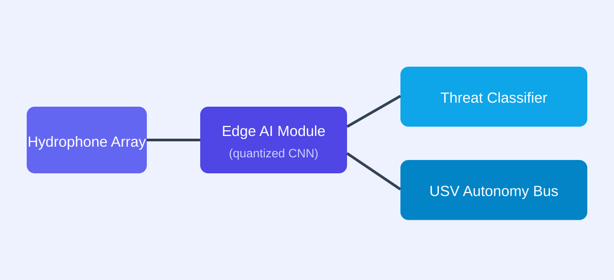
Figure 1: {company_name} edge acoustic-sensing architecture (on-vessel).
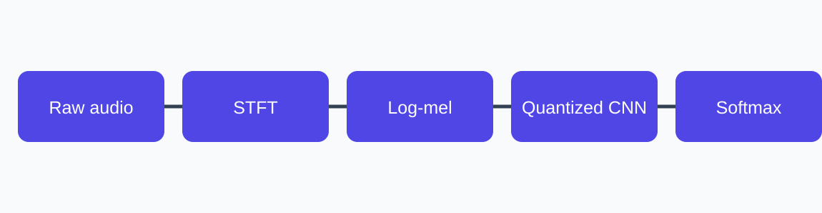
Figure 2: On-device inference pipeline (feature extraction through classification).
Four co-designed components make edge-native classification feasible under the power ceiling. (a) A fixed-point signal front-end (STFT → log-mel, ~40 bins) with array beamforming that yields a bearing estimate alongside the class label, consuming under 15% of the per-frame budget. (b) Quantization-aware training at 4-bit weights / 8-bit activations via a straight-through estimator, holding accuracy within 1.4 points of full precision versus a 9-point drop for post-training quantization.
(c) Saliency-guided structured pruning that scores each channel by its contribution to inter-class separation and removes ~70% of parameters while preserving the discriminative bands — {company_name}’s defensible IP (patent pending). (d) A deterministic, statically scheduled runtime that pins inference to reserved cores and disables frequency scaling, guaranteeing a 99th-percentile latency under 100 ms at 2.0 watts.
The classifier itself is a compact five-stage residual CNN over the log-mel stream, favoring depth over width and using only operators the target module accelerates natively. Preliminary bench experiments on a representative corpus subset already indicate feasibility (Table 2), and Phase I will formalize and extend them to the full corpus and target hardware.
Metric | Full-precision baseline | {company_name} 4-bit target
Balanced accuracy (F1) | 93.6% | 92%+
Parameters | 4.1 M | 1.2 M
End-to-end latency (p99) | 310 ms | <100 ms
Sustained power draw | 11 W | 2.0 W
Table 2: Preliminary baseline vs. Phase I target (representative corpus subset).

3. Phase I Statement of Work
The six-month effort is organized into four sequential-but-overlapping tasks. Table 3 gives the schedule and lead; the narrative details scope, methods, effort, and deliverables per task.
Task | Description | Months | Lead | Deliverable
1 | Corpus curation & augmentation | 1–2 | Nandakumar | Labeled dataset + data card
2 | Quantization-aware training + pruning | 2–4 | Ellison | Trained 4-bit model + accuracy report
3 | Edge port & latency benchmark | 4–5 | Reyes | Runtime on target module + benchmark log
4 | Validation & final report | 5–6 | Ellison | Phase I feasibility report
Table 3: Phase I statement of work (6-month period of performance).

Task 1 — Corpus Curation and Augmentation (Months 1–2)
Assemble a labeled corpus from the DARPA hydrophone release, augmented with sea-state noise, Doppler, and multipath models; balance each class by controlled resampling; document provenance and limitations in a data card. Effort: 0.25 FTE ML engineer. Deliverable: labeled dataset + data card.

Task 2 — Quantization-Aware Training and Pruning (Months 2–4)
Train the classifier with 4-bit quantization and saliency-guided pruning in the loop, iterating the saliency threshold; run ablations attributing accuracy retention to each technique. Effort: 0.30 FTE PI + 0.20 FTE ML engineer. Deliverable: trained 4-bit model + accuracy report on a session-disjoint split.

Task 3 — Edge Port and Latency Benchmark (Months 4–5)
Port the runtime to the 2-watt module, integrate the deterministic scheduler, and benchmark p99 latency and sustained power under continuous load; apply selective mixed precision to the most confusable layers if required. Effort: 0.40 FTE systems engineer. Deliverable: runtime on target + benchmark log.

Task 4 — Validation and Final Report (Months 5–6)
Validate accuracy, latency, and power against relevant threat scenarios from held-out sessions; document results, limitations, and the Phase II plan. Effort: 0.20 FTE PI + support. Deliverable: Phase I feasibility report.

3.1 Evaluation, Data Management, and Risk
Feasibility is judged against pre-registered gates, all of which must pass: balanced F1 ≥ 0.92 on a session-disjoint split; end-to-end p99 latency < 100 ms on target; sustained rail draw ≤ 2.0 W. The full confusion matrix is a deliverable, because the operationally important errors are specific confusions rather than average error. All data derives from the Distribution-A DARPA corpus plus synthetic augmentation — no classified or controlled data — versioned and retained for the period of performance plus three years. The principal risks and mitigations are in Table 4.
Risk | Likelihood | Impact | Mitigation
4-bit accuracy shortfall | Medium | High | Mixed-precision fallback on most confusable layers
Latency exceeds budget on target | Low | High | Reserve cores + static schedule; profile early in Task 3
Corpus class imbalance | Medium | Medium | Targeted augmentation + class-balanced sampling
Domain shift (sea state) | Medium | Medium | Sea-state augmentation + robustness ablation
Table 4: Principal Phase I risks, likelihood, impact, and mitigation.

4. Related Work
Prior edge-audio efforts target keyword spotting at low fidelity and small class counts; none address multi-class maritime threat discrimination under a hard power ceiling. Post-training quantization strands accuracy on confusable classes; magnitude pruning is blind to inter-class saliency; unstructured sparsity does not map efficiently onto edge vector units. {company_name}’s contribution is the coupling of quantization-aware training with a saliency-guided, structured pruning metric specific to acoustic threat discrimination, validated in preliminary bench tests and pursued as protected IP. We build on established foundations — integer-arithmetic inference, straight-through estimators, and margin-based feature attribution — and contribute their integration and specialization to this operational problem.

5. Relationship with Future Research or Development
Phase I establishes feasibility on the target module. Phase II hardens the module, extends the corpus to fielded recordings, and conducts an at-sea demonstration on a DoD USV against the same gates plus a robustness gate across sea states; we will pursue approximately $1.1M over 24 months. In Phase III we target integration with a USV program of record through the relevant program office. Because the classifier fits the existing compute budget, transition requires only a software integration and accreditation effort — not a hardware program — which materially lowers the transition barrier. Background IP (the saliency-pruning method) is protected under standard SBIR data rights; foreground results are delivered to the Government with rights clearly marked, so transition is not encumbered by ambiguous IP claims.

6. Commercialization Strategy
{company_name} pursues a dual-use commercialization path in which the Air Force / Navy customer and the commercial market reinforce each other. The Phase I classifier is the wedge: defense USV programs of record in Phase III, then allied navies, then commercial maritime security — port monitoring and offshore-energy protection — where the same edge-native, power-efficient classifier applies with minimal modification.
Customer discovery is an explicit Phase I activity. We have identified an initial defense end-user (a USV program office) and will conduct structured interviews to validate the operational requirement, the accreditation path, and the sustainment model (a delivered, accredited model plus a maintenance and re-training subscription). On the commercial side, the serviceable market is projected to grow from roughly $8M/yr in 2026 to over $60M/yr by 2030; {company_name}’s position is defensible against shore-side incumbents because on-vessel inference is a capability they structurally cannot match. The dual-use revenue path reduces reliance on any single government program and is detailed in the separate Commercialization volume.

7. Key Personnel
Dr. Mara Ellison (Principal Investigator, 0.30 FTE) — 12 years in low-power machine learning for sensing; author of the quantization research underpinning {company_name}’s core IP. Tomas Reyes (Senior Systems Engineer) — 9 years of embedded real-time systems, two fielded maritime autonomy stacks; owns the edge-port and scheduler tasks. Priya Nandakumar (ML Engineer) — model compression and data augmentation; leads corpus curation and quantization-aware training. The team has collaborated on two prior efforts and shares a common toolchain, de-risking the six-month schedule. Full biographies appear in the Key Personnel supporting document.

8. Foreign Citizens
{company_name} anticipates no foreign nationals performing on this effort. All key personnel are U.S. citizens. Should any individual requiring disclosure be added, {company_name} will notify the Contracting Officer and provide the required country of origin and visa/work-permit status prior to their participation, consistent with the solicitation instructions.

9. Facilities and Equipment
{company_name} maintains a 3,200 sq ft engineering facility with a dedicated acoustics bench, a custom anechoic test enclosure, six 2-watt edge-compute development kits, an on-premises GPU training cluster, and a calibrated power-measurement bench for rail-level draw. Data collection leverages an existing partnership with a regional marine research station, providing representative acoustic conditions at no additional Phase I cost. All Phase I work can be performed in-house. Facilities are described in full in the Facilities supporting document.

10. Subcontractors and Consultants
{company_name} will engage one consultant — an acoustics subject-matter expert (40 hours) — to review the corpus curation methodology and the evaluation protocol, budgeted in the Cost Volume. No subcontractors are proposed for Phase I; all development is performed by {company_name} personnel. The consultant will not have access to limited-rights data beyond what is required for the review.

11. Prior, Current, or Pending Support
The specific work proposed here — edge-deployable, 4-bit maritime acoustic threat classification under a 2-watt ceiling — has not been submitted to, or funded by, any other Federal agency. No prior, current, or pending support duplicates this effort. {company_name}’s background IP (the saliency-pruning method) was developed with internal funds prior to this proposal. Should any overlapping proposal be submitted during the evaluation period, {company_name} will promptly notify the Contracting Officer as required.

References
- [1] DARPA Hydrophone Corpus, Distribution A, 2024.
- [2] Ellison, M. et al., "Saliency-Guided Quantization for Acoustic Edge Inference," 2025 (in prep).
- [3] Reyes, T., "Deterministic Scheduling for Sub-Watt Inference," Embedded ML Workshop, 2024.
- [4] Jacob, B. et al., "Quantization and Training of Neural Networks for Efficient Integer-Arithmetic Inference," 2018.
- [5] Molchanov, P. et al., "Importance Estimation for Neural Network Pruning," 2019.

Compliance Cross-Reference
This volume addresses each AFWERX/DoD Phase I required element as below; the full compliance matrix is maintained in the proposal workspace and advances to “satisfied” as each section is accepted and locked.
Required element | Section
Problem/opportunity significance | 1
Technical objectives | 2
Statement of work | 3
Related work | 4
Future R&D / transition | 5
Commercialization | 6
Key personnel | 7
Foreign citizens | 8
Facilities/equipment | 9
Subcontractors/consultants | 10
Prior/current/pending support | 11

