**Ideas of Group #4: Both doors & first puzzle**

**Puzzle:**

A wooden cylinder is physically given with a cord which is wound exactly four times around the cylinder. Thereby one end of the cord must touch one end of the cylinder so that the cord extends over the entire cylinder (see figure).

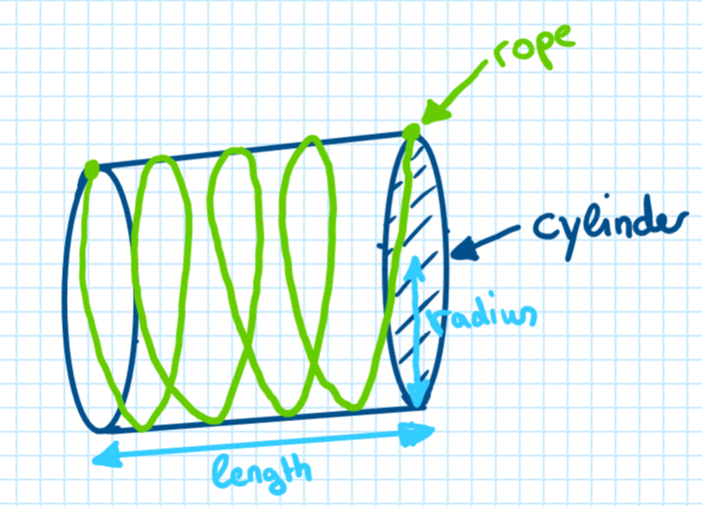

The task is to calculate the length of the cord. Given parameters are the radius and the length of the cylinder.

The result must then be entered into a keypad (binary or decimal system). If the result is correct the first door will open and the participants will get access for the lab room.

-Mario-

**Doors:**

1) Mechanism

-Sarah-

2) Detection of objects in closing area

Concept: Use infrared emitter and sensors to detect if the door area is free in order to close the door

3) Detection of participants in Lab Room:

* Concept: Dead-man-switches spread across lab room have to be activated 🡪 1st door closes and adventure continues
* Hardware: Plasma globe / simple switch, current sensor (shunt resistor), uC/ relais, wiring
* Current flow through plasma globe changes when touched by hands 🡪 measure current flow with shunt resistor and close door when each plasma globe is touched (make sure by positioning that no person can reach more than one plasma globe simultaneously)
* Remark: Reliability of “plasma globe switch” has to be tested and in worst case exchanged by simple button switches