Most influential 8-bit Games of the 90s

# Super Mario Bros 3

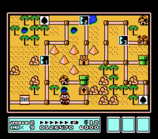I mean .. what else to say? Everyone knows Mario.

# Ducktales

Also known from the TV series featuring Scrooge McDuck, Poe, Bubba, Baggy Beagle, BigtimeBeagle, …

# Kirbys Adventure

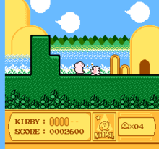You like eating? So does Kirby. That’s why that cute pink thing got so fat.

# Mega Man Series

# Bubble Bobble

Everything is better when there is a cute little dragon .. right?

# Blaster Master

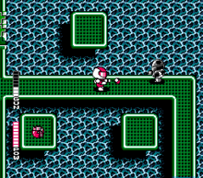 So anyway .. I started blasting.

# Maybe more to not make it too obvious…

Maybe the game character idea is not the best anyways, so maybe do something more obvious – some base knowledge makes this document nearly unnecessary?  
OR keep it and hide this document?  
OR make something even more strange and hide the symbols somewhere else?