LMS PowerShell Script to Semi-automate the Process for Pulling RPE Scores

Table of Contents

Purpose of the PowerShell Script 1

Current Scenario 1

Proposed System 8

Steps to run PS script 8

Prerequisites: 10

Future Scope: 11

# Purpose of the PowerShell Script

Currently pulling RPE scores is done through some manual steps which is time consuming also. Purpose of this script is to minimize the steps and reduce the time consuming.

# Current Scenario

At present, we are following 13 steps to pull score:

Step1: Copy runtime log and paste it in the notepad++.

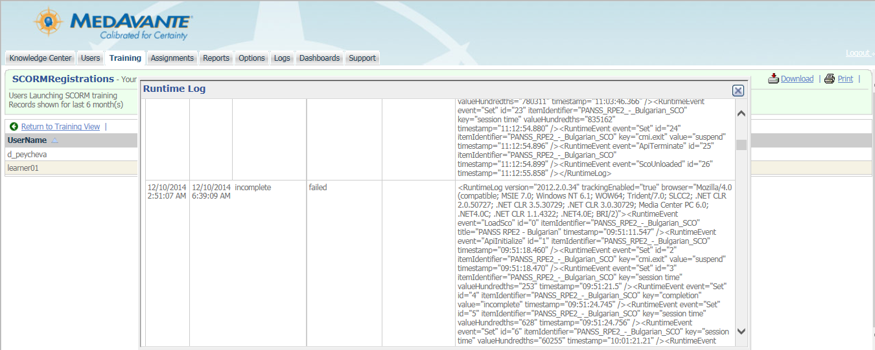

Step2: Before paste the runtime log here, uncheck the ‘Word wrap’ if it is already checked.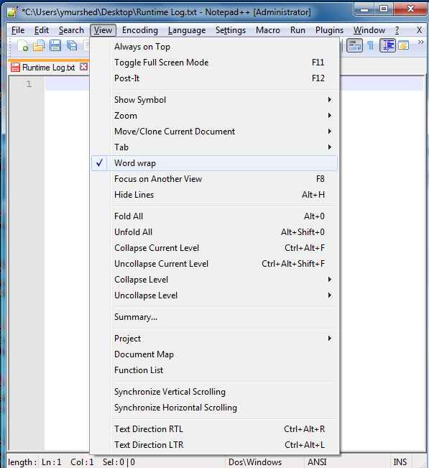

Step 3: Find out the longer lines, those are contain the rater’s scores and remove the other lines.

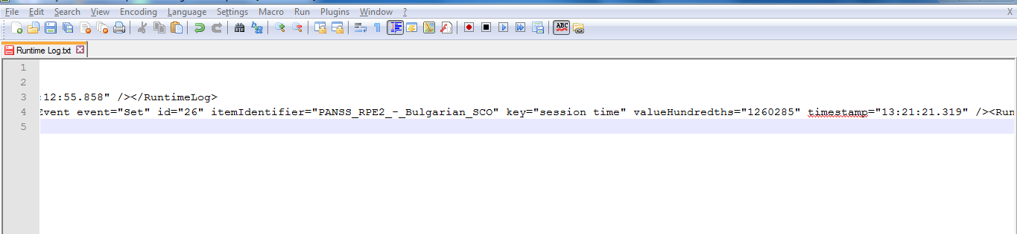

Step 4: After removing the other lines, remove the texts before ‘<RuntimeLog’ of the longest line.



Step 5: Check the ‘Word wrap’ again to wrap the single line.

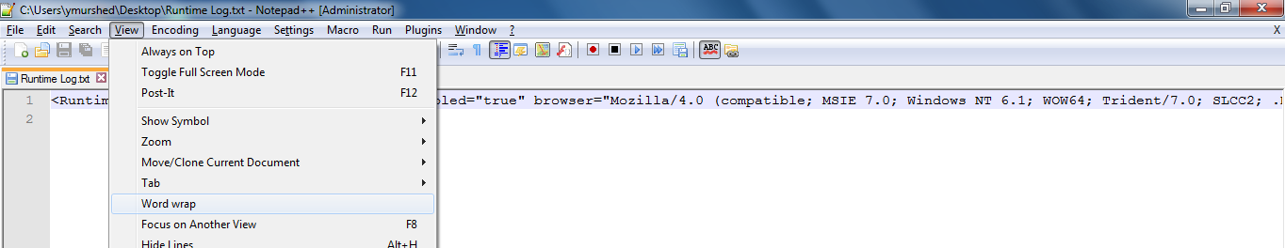

Step 6: Select ‘XML’ as a language.

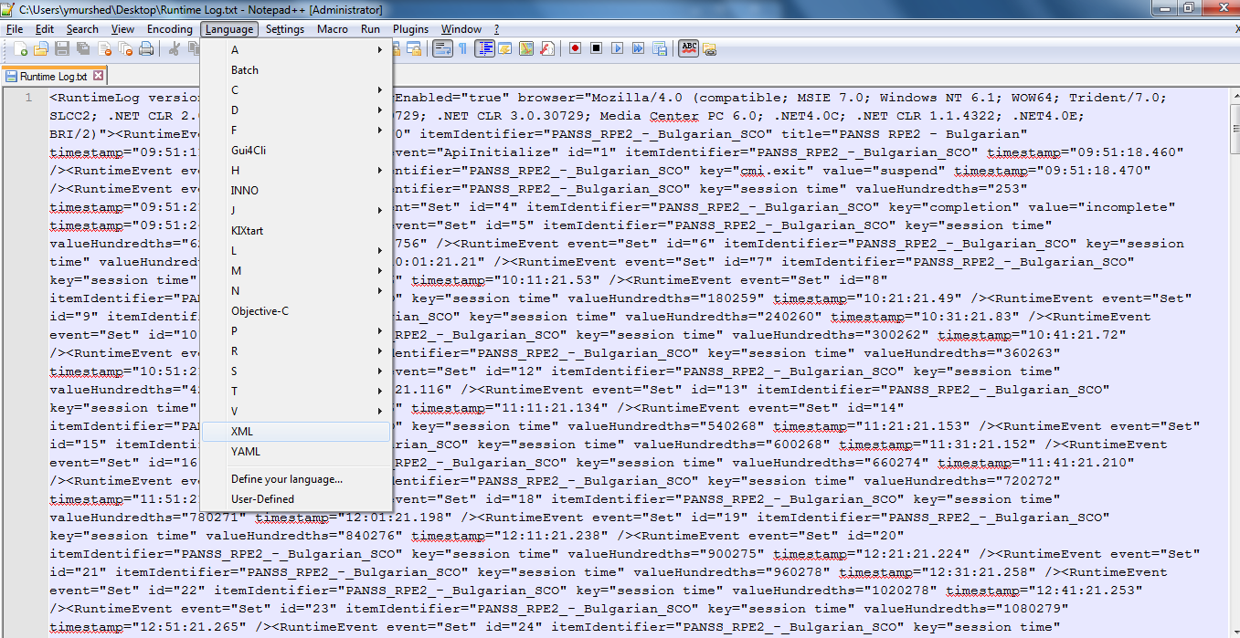

Step 7: Press (Ctrl + Alt + Shift + B) to well format the xml.

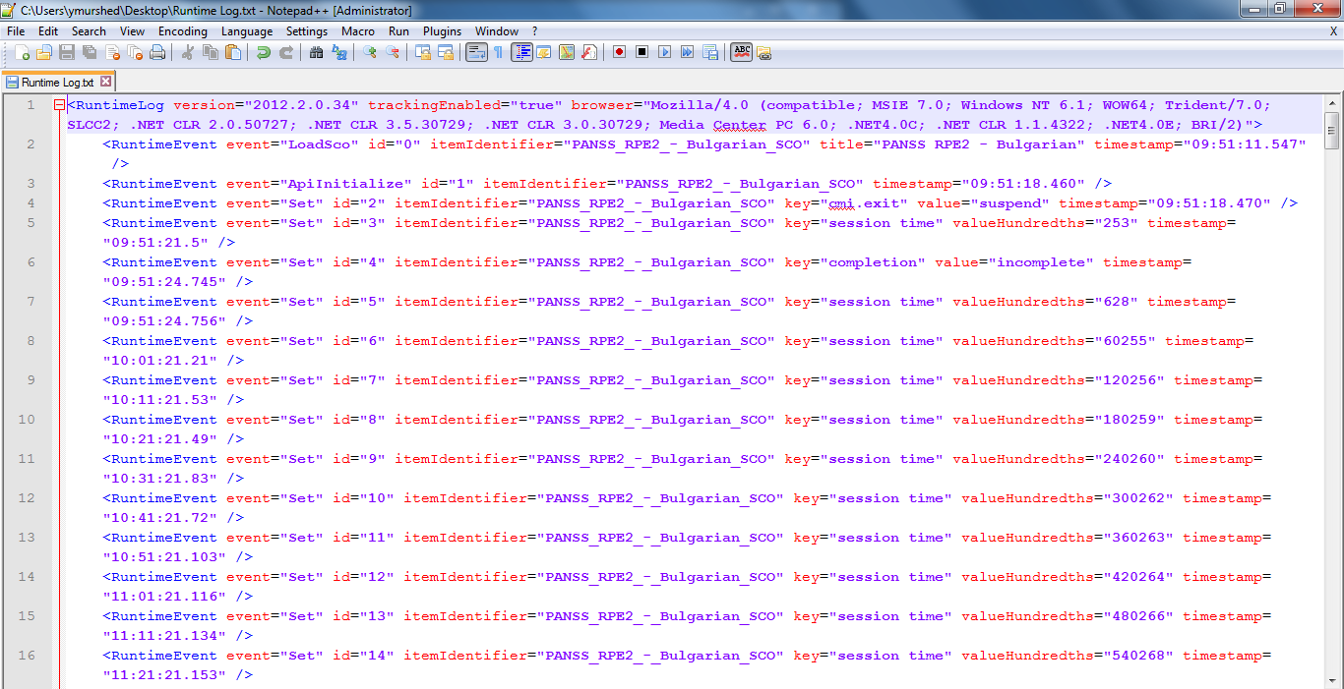

Step 8: Search using the key word “interactions learner_response” and Copy the values of “value” attribute.

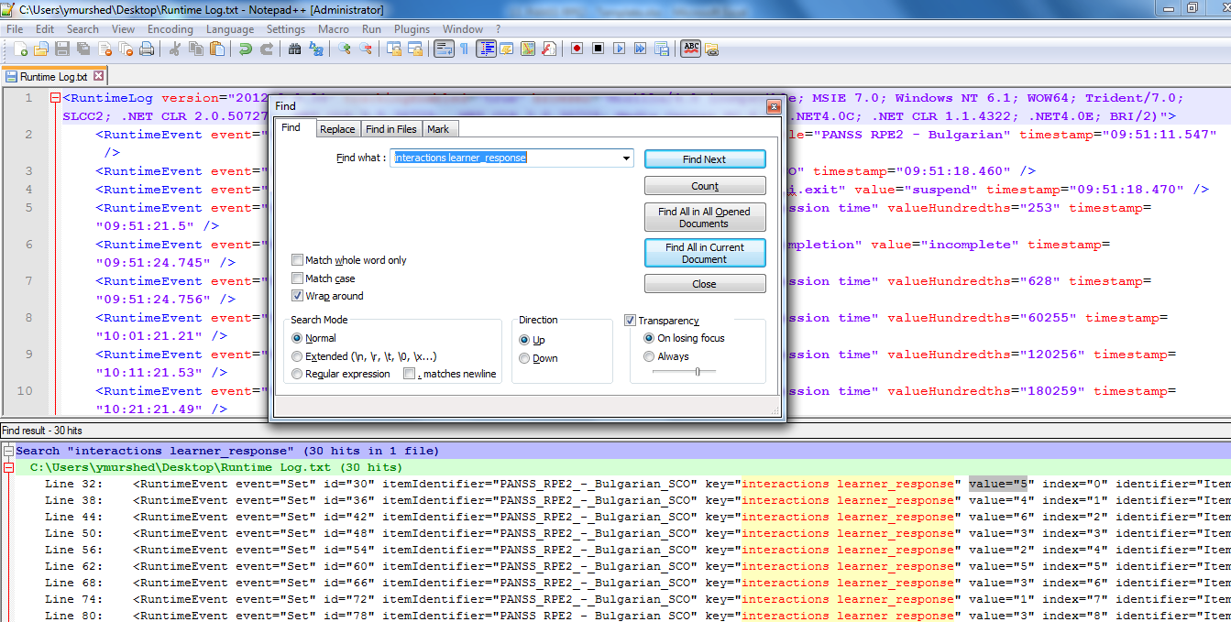

Step 9: Paste all the values of “interactions learner_response” in the “Rater Answer” column in the appropriate training score template.

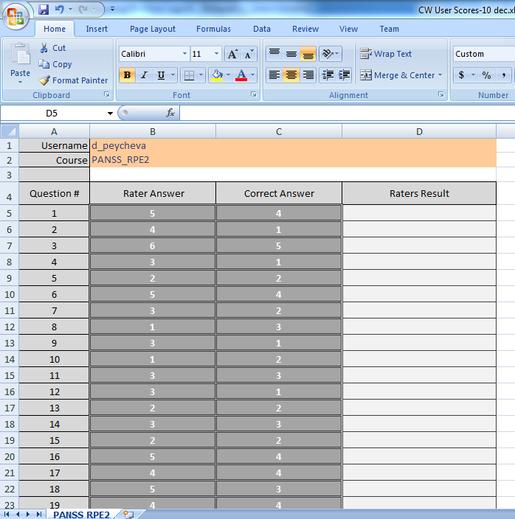

Step 10: Search using the key word “interactions correct_responses” and Copy the values of “value” attribute.

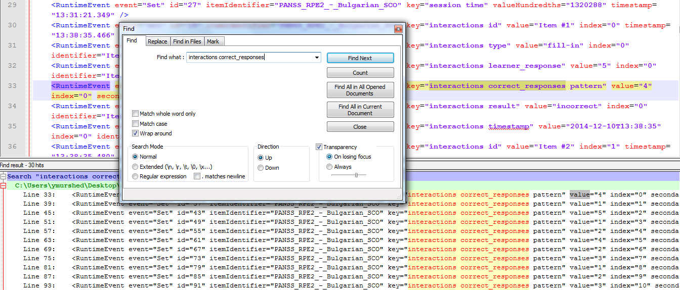

Step 11: Paste all the values of “interactions correct_response” in the “Correct Answer” column.



Step 12: Search using the key word “interactions result” and copy the valuesof “value” attribute.

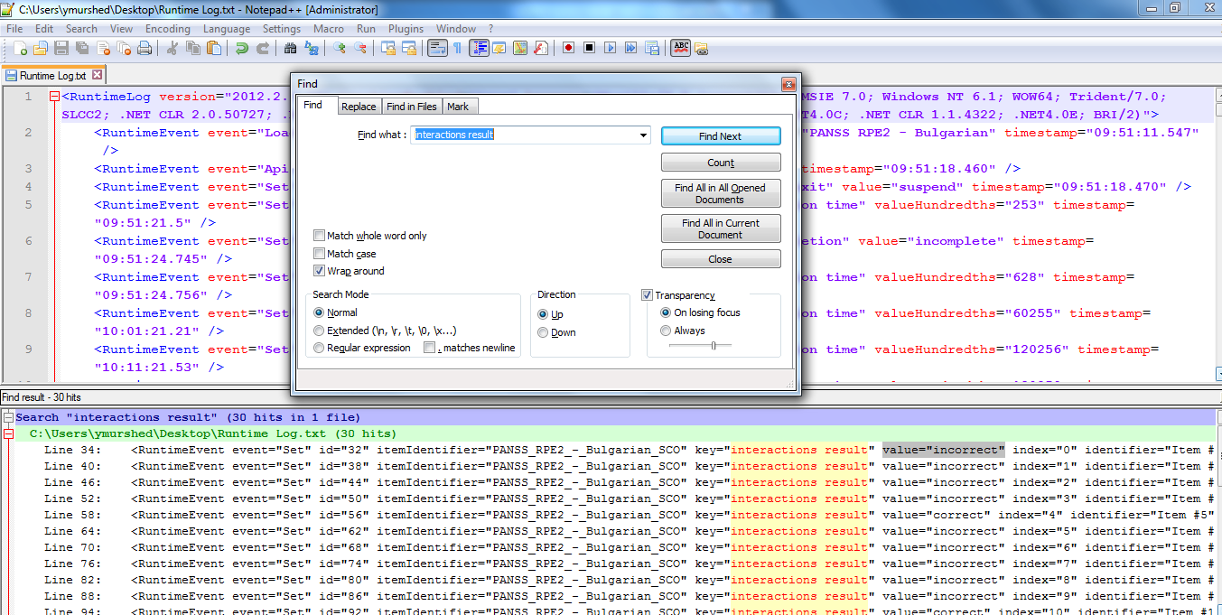

Step 13: Paste all the values of “interactions result” in the “Raters Result” column and Update the username and save the excel file template.

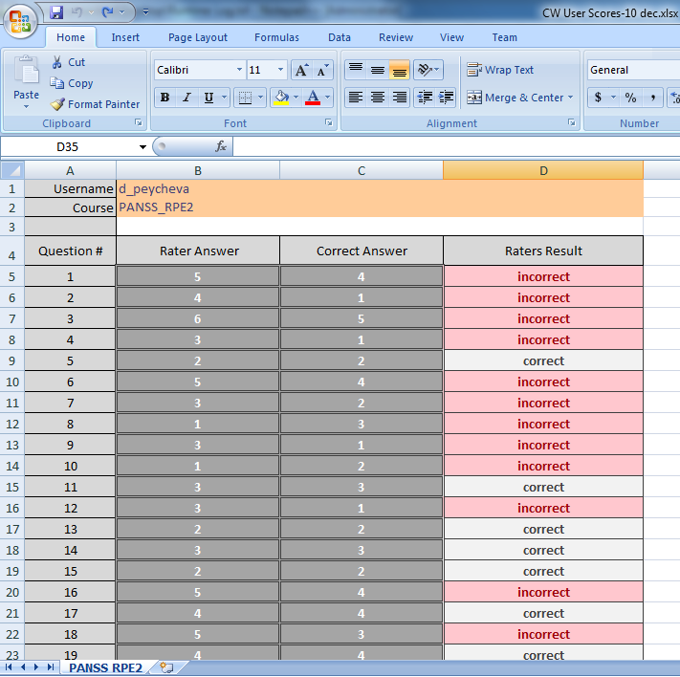

# Proposed System

No need to do the above 13 steps.We can do the same task by following 5-6 steps only.

To do that, we have designed a Power shell script which will do the same task within only approx.1-3 minutes.

### Steps to run PS script

###### Prepare xml file by following below 1-6 steps to complete the task.

Step# 1: Copy runtime log and paste it in the notepad++.



Step# 2: Before paste the runtime log here, uncheck the ‘Word wrap’ if it is already checked.

Step# 3: Find out the longer lines, those are contain the rater’s scores and remove the other lines.



Step# 4: After removing the other lines, remove the texts before ‘<RuntimeLog’ of the longest line.



Step# 5: Check the ‘Word wrap’ again to wrap the single line.

###### Step#6: Open notepad++. Add <xml> at start position, then paste actual run time log and then add </xml> at last position like below image and save this file as anyname.xml

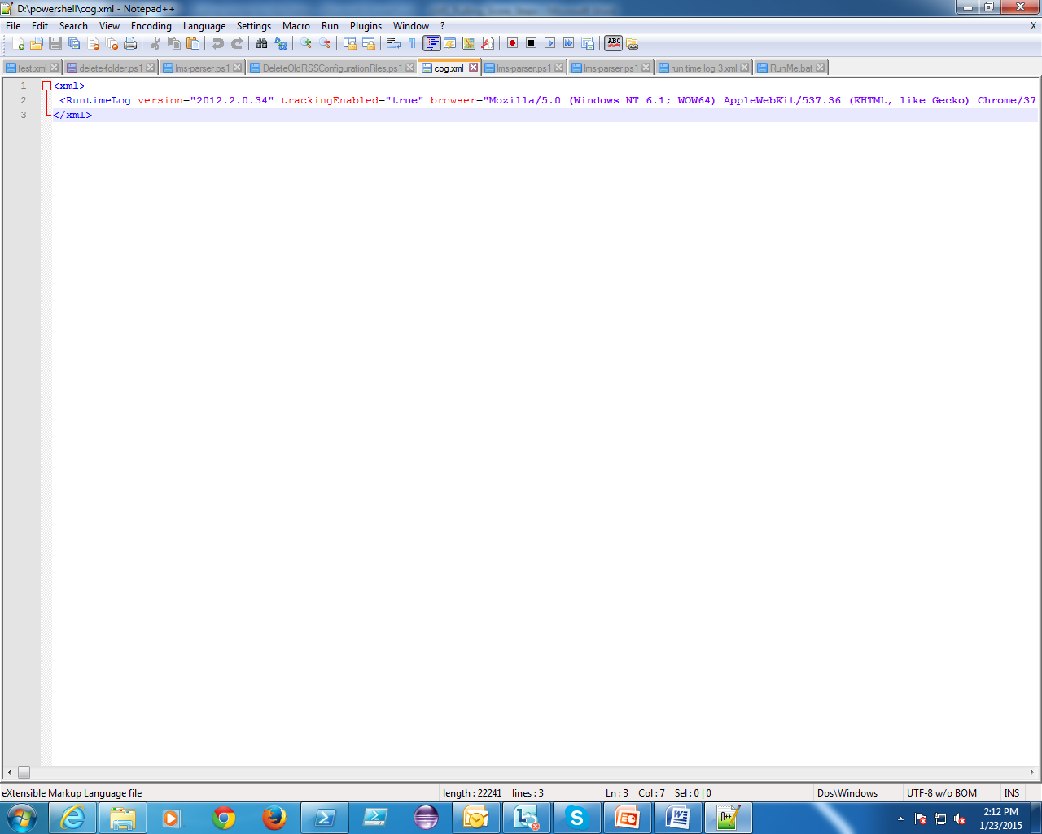

###### Step#2: Copy the script folder to any location (for example: Desktop).

###### Step#3: Go to the script folder and click on RunMe.bat file.

###### Step#4: Browse your desired Excel template and then locate this XML file correctly.

###### Step#5: Wait for few seconds to get the result.

*Step#6: Go to .\PowerShell script\OutputFiles folder and find your excel document.*

*Step#7: Open the excel file and update the user name and rename the excel file as required.*

### Prerequisites:

1. OS: Windows 7, Power shell version greater than 2.0 or 2.0
2. XML files
3. Microsoft Excel 2007 or greater
4. Excel file templates

# Future Scope:

We can improve our script by taking below functionalities for pulling RPE score:

1. Login to compliancewire
2. Select training for desired user
3. Copy the runtime log into notepad

Same way we can use script for other admin tasks like:

1. Adding user
2. Adding assignment
3. Remove user from user group
4. Remove assignment