DOCUMENTATION:

Eye Tracker Setup Instructions:
- Physically connect the Tobii Eye Tracker to your system using the provided USB cable.
- Go to microsoft store→ search Tobii experience and install→ Open Tobii Experience→ Go to setting→ Calibration. Follow the on-screen instructions to calibrate the eye tracker for your eyes.
- Visit the official Tobii Gaming page:
- https://gaming.tobii.com/getstarted
- Download and install the Tobii Ghost software.
- Launch Tobii Ghost.
- Go to Settings:
- Turn Preview → ON
- Set Shape → Solid
- Set Color → #CC10F61F
4. Final Output:
- A green solid circle (gaze bubble) will now be displayed on your screen wherever your eyes are focused.
- This helps visualize real-time gaze position for debugging, analysis, or confusion detection.
(Note: Please refer to the "Enable_green_bubble" video in the project folder for a step-by-step demo of the complete setup.)

Popup-Based Confusion Detection & Label/Comic Generation:
“A saccade is a quick, high-velocity eye movement from one point to another (in code: A rapid eye movement (saccade) with velocity > 450 pixels/second).”
“A fixation is when the eyes remain relatively still, focusing on a single point for a short duration (in code : Held for at least 0.25 seconds (GAZE_HOLD_TIME = 0.25 seconds).”
“ Fixation clusters help detect confusion when the user stares too long in a small region, often re-fixating on the same chunk of text.”

Before starting, make sure the eye tracker setup is completed:
➡️ Refer to the section: “📝 Eye Tracker Setup Instructions”

- How to Run the Popup System:
- Navigate to the POPUP folder in project directory.
- Open a terminal or command prompt.
- Run the main Python script: main_label.py or main_comic.py
- How It Works:
- Visit any story webpage and begin reading naturally
- The system continuously monitors your eye movement behavior using:
  - Regression saccades (when eyes move backward)
  - Fixation clusters (when eyes stay too long in one area)
- A confusion event is triggered if:
  - You make 3 or more regression saccades on the same line
OR
  - There are 7 or more fixation points in the same small area (same text line)

- When confusion is detected:
  - A popup window appears, showing:
    - Your confused text image
    - The confusing text segment
    - A question: “Summarize this text?”
- If you click "Yes":
  - A popup appears showing the summarized version of the text.
  - Simultaneously, a label image or 4-panel comic is generated using ChatGPT and displayed visually
(Note: Refer to the "LabeIimage_popup" or “ComicScript_popup” video to see the popup and image generation in action)

AOI (Area of Interest) Extraction for Reading Text Page:
The script aoi.py is designed to automatically detect and save Area of Interest (AOI) regions corresponding to each text line from a reading page or document shown on the screen.
This step is essential for tasks such as eye-tracking data collection, gaze-based interaction, or confusion detection during reading tasks.
Workflow:
- Navigate to the Confusion folder in project directory→ Open a terminal or command prompt→ Run the main Python script: aoi.py.
- Required libraries:Python 3.x,OpenCV (cv2),PyTesseract,pyautogui ,numpy
- Immediately after running the command, switch focus to the reading text page you want to analyze (the page must be visible on your screen when the script takes a screenshot).
- What Happens Behind the Scenes:
  - aoi.py captures a full-screen screenshot.
  - It uses PyTesseract OCR to detect text blocks, paragraphs, and lines.
  - It groups text by lines and calculates bounding box coordinates (x1, y1, x2, y2) for each line.
  - It draws rectangles and AOI labels over the screenshot for visual debugging.
  - It saves two files:
    - Image with AOI Overlays:
Saved in demo_debug/story_from_screenshot_with_aoistest2.png
    - AOI Coordinates File:
Saved in demo_video_logs/aoi_lines_111.csv
Format:
| AOI_ID | x1 | y1 | x2 | y2 |

- Output Folder and File Structure
confusion/
├── aoi.py
├── demo_debug/
│ └── story_from_screenshot_with_aoistest2.png
├── demo_video_logs/
│ └── aoi_lines_111.csv
Note:
- You must switch to the reading text page immediately after running aoi.py. It does not wait for user confirmation—it captures the first active screen.
- OCR accuracy depends on text clarity and contrast.
- Make sure Tesseract OCR is installed and configured in your system PATH.
(Note: Refer to the "DataCollection_of_Confusion” video to see how it should be performed)

Gaze, Fixation, and Confusion Data Collection to make Dataset :
This process captures gaze and fixation data while a user reads text on a webpage, with the goal of labeling moments of confusion. The system uses a green bubble gaze marker, logs fixation and gaze points, and generates labeled scanpath images to train a confusion detection model.
Workflow :
- Prerequisite: Extract AOI Regions
  - Make sure aoi.py has already been executed.
  - Ensure aoi_lines_111.csv exists in the demo_video_logs folder.
- Update Directory in cnn.py
If the AOI CSV file is in a custom path, update this line in cnn.py:
aoi_file_path = os.path.join(output_dir, "aoi_lines_111.csv")
(Ensure output_dir points to the folder containing aoi_lines_111.csv.)
- How to Run cnn.py:
  - Open a terminal or command prompt.
  - Navigate to the directory where cnn.py is stored.
  - Run: python cnn.py
  - Immediately after running the script:
    - Go to the webpage or application window where you will read the text.
  - Popup Behavior:
    - A popup window titled "Gaze Capture" appears with a button labeled “Yes (Confused)”.
    - The popup stays on top and can be dragged anywhere on the screen.
  - While Reading:
    - Reading begins automatically once you press ESC.
    - Gaze and fixation data are recorded continuously.
    - If you feel confused while reading, click the “Yes (Confused)” button in the popup window.
→ This marks the last 15 seconds of gaze data as a confusion segment.
  - Stop Recording:
    - Press the q key at any time to stop the recording.

- What Files Are Generated
In the folder demo_video_logs, you will find:
- gaze.csv
Format:| gaze_x | gaze_y | timestamp |
- fixation.csv
Includes gaze-based fixation details, like start/end time, duration, dispersion, regression flags, and AOI association.
- yes_click_log1.csv
Stores timestamps and gaze coordinates and AOI_ID where the user clicked “Yes (Confused)”.
- scanpath_segments/ (Folder)
Stores scanpath images saved every 15 seconds:
  - 0_*.png = Non-confused segments.
  - 1_*.png = Confusion segments marked by the user via popup.
Folder Structure:
├── confusion/
│ ├── aoi.py
│ ├── cnn.py
│ ├── demo_video_logs/
│ ├── gaze.csv
│ ├── fixation.csv
│ ├── popup_yes_clicks/
│ └── yes_click_log1.csv
│ ├── scanpath_segments/
│ ├── 0_*.png
│ ├── 1_*.png

Notes:
- Ensure Python libraries (opencv, matplotlib, pyautogui, tkinter, etc.) are installed.
- Run everything on the same screen resolution to maintain AOI consistency.
- Do not close the popup while recording; use q key to properly exit.
(Note: Refer to the "DataCollection_of_Confusion” video to see how it should be performed)

Fixation Labeling and Model Training for Confusion Detection:
To create a labeled dataset using gaze fixation data and confusion events (yes_click log), then train machine learning models like Random Forest and XGBoost to detect confusion based on gaze behavior.

Prepare the Labeling Script:
  - Ensure the following files are available:
    - fixation.csv — generated by cnn.py
    - popup_yes_clicks/yes_click_log1.csv — contains timestamps and AOI_ID where confusion was marked.
  - Open label.py file. Confirm paths match your file locations.
- Labeling Logic:
  - label.py reads fixation.csv and yes_click_log1.csv.
  - It creates a new column called label in fixation.csv.
  - For each AOI_ID found in yes_click logs:
    - It checks if that AOI_ID has value "True" in fixation.csv.
    - If yes, the fixation row gets labeled 1 (confused).
    - Otherwise, rows stay with label 0 by default.

Manual Setup:
- Before running label.py, initialize the label column to 0 for all rows.
Example:
fixation_df['label'] = 0
- Run the label.py and contain the label dataset to train the model.
- Model Training:
  - Preparing the Data
    - Open fixation_label.csv using pandas or similar tools.
    - Drop the following non-feature columns:
  - start_time, end_time, fix_start_ts, label (label is moved to target variable Y).
  - Train the model Random Forest Classifier and XGBoost classifier.Save the model to test it in real time.
(Note: Refer to the "Label_train_test_model” video to see how it should be performed)

Confusion Detection Model Testing Using test.py:

Pre-requisites Checklist
- AOI (Area of Interest) CSV for the test page is ready:
Example: test_data_logs/aoi_lines_test2.csv.
- Trained model file available:
Example: confusion_model_xgb_new.pkl and feature_names_order_xgb_new.pkl
- Python libraries installed: pip install opencv-python matplotlib pandas pyautogui joblib keyboard

Step-by-Step Instructions

AOI Region Preparation (Pre-requisite)
Before testing, you must collect AOI regions:
- Use the same method as in the section “AOI (Area of Interest) Extraction for Reading Text Page.”
- Save the AOI regions file as aoi_lines_test2.csv inside the folder test_data_logs/.

- Running test.py

What Happens:

A popup window titled “Confusion Prediction” will appear.

It will say “Waiting for prediction...” initially.

Starting Detection:
- Press the ESC key once:
  - Gaze tracking and prediction start.
- While the green bubble moves on the reading page:
  - The system detects fixations.
  - It predicts confusion using the pre-trained model.
  - Prediction result is shown in the popup window:
    - “AOI: AOI_X 😕 Confused”
or
    - “AOI: AOI_X waiting”

Stopping: Press q key any time to stop the session.

Notes
- Make sure your screen resolution and reading page layout match the AOI region file collected earlier.
- If AOI coordinates or model files change, update:
  - aoi_file_path in test.py.
  - Model and feature_order pickle file paths.
- The popup window can be dragged and positioned freely while testing.
- Only start reading after pressing ESC and seeing that the popup has started showing AOI predictions.
(Note: Refer to the "Label_train_test_model and then Test_model” video to see how it should be performed)

Web-Based AOI Data Collection System:
This system collects Area of Interest (AOI) data including eye fixations, mouse movement, and paragraph-level helpfulness annotations while a user reads a Wikipedia article. It combines a Chrome extension, Tobii eye tracker, and Python scripts to generate a final JSON dataset and visual analysis plots.
Prerequisites:You have a Tobii Eye Tracker set up and working with the green bubble enabled.
✅ Follow the “📝 Eye Tracker Setup Instructions” section.
Step
- Load the Chrome Extension
(Note: This extension works only on Wikipedia pages)
- Open Chrome → Go to chrome://extensions
- Enable Developer Mode (top right).
- Click “Load unpacked” and select the folder “extension”.
- Visit any Wikipedia article and refresh the page.

- How the Extension Works
  - It places bounding boxes around all <p>, <h1>, <h2>, <h3>, img, and table elements.
  - Each block is annotated with buttons 0–3, allowing the user to rate how helpful the block was.
  - While you scroll and read:
    - The extension logs mouse movements, clicks, and scrolls
    - All annotations and logs are stored in memory

3.Export Mouse + Annotation Logs
- After reading and annotating, use the sidebar injected by the extension.
- Click the “Export Logs” button in the sidebar.
- This downloads:
  - annotations.csv
  - Mouse_log.csv
[Note:Save these files to the same folder where your fixation.csv is being saved by the Python script (next step).]
4.How to Run to collect web_based data:
- Open a terminal or command prompt in the folder “web”.
- Navigate to the directory where cnn.py is stored.
- Run: python main.py
- GO to the webpage(i.e wikipedia page where extension is already loaded) and refresh the page first.
- The main.py script waits until you press ESC key to start recording gaze data(i.e green bubble fixation,gaze data)
- While reading on the Wikipedia page:
  - Gaze positions and fixations are recorded
  - Saccades are computed between fixations
  - Data saved in:fixation.csv,saccade.csv,Gaze.csv
  - During reading,please annotate the block with 0-3 helpfulness.After annotation of the block,it will display in the sidebar.
  - After completion of the full one page annotation/reading ,press ‘q’ to stop the main.py program.
  - Download the annotation.csv and mouse_log.csv by clicking on ‘Export csv’ in the sidebar.
  - Finally,move the annotation.csv and mouse_log.csv to the same folder where your fixation.csv is being saved by the Python script(main.py).
5. Build Final JSON Dataset (final.py)
Once all logs are collected:
- Make sure the following files are present in the demodata_logs2/ or similar folder:
  - annotations.csv
  - mouse_log.csv
  - fixation.csv
  - saccade.csv

- Load all the above files in final.py .
- Open terminal and run:final.py
- This will generate a rich, block-level behavioral dataset in:
  - dataset_demo3.json
Each block includes:
- Structural features (text density, height, etc.)
- Mouse and fixation sequences
- Behavioral statistics (fixation count, hover time)
- Dynamic behavior (saccade speed, mouse speed)
- Output: dataset_demo3.json
6. Visual Analysis
- Graph of Eye + Mouse Movement Distributions (graph2.py)
  - Open graph2.py
  - Update the line with the json file which is generated by the final.py:
plot_saccade_distributions("dataset_demo3.json")
  - Run:python graph2.py
This will generate 6 KDE plots:
- Saccade distance/velocity
- Mouse movement and velocity (X/Y)
- Grouped by helpfulness level (0–3)

- Boxplot of Fixation & Mouse Features vs Helpfulness (plot_help.py)
  - Update the path :
with open("dataset_demo3.json", "r") as f:
  - Run: python plot_help.py
This generates boxplots for:
- Fixation count, duration
- Mouse hover time
- Avg fixation position
- Saccade velocity
Each box is grouped by paragraph helpfulness level (0 to 3), with annotated medians and quartiles.

Folder Organization Example (web/)
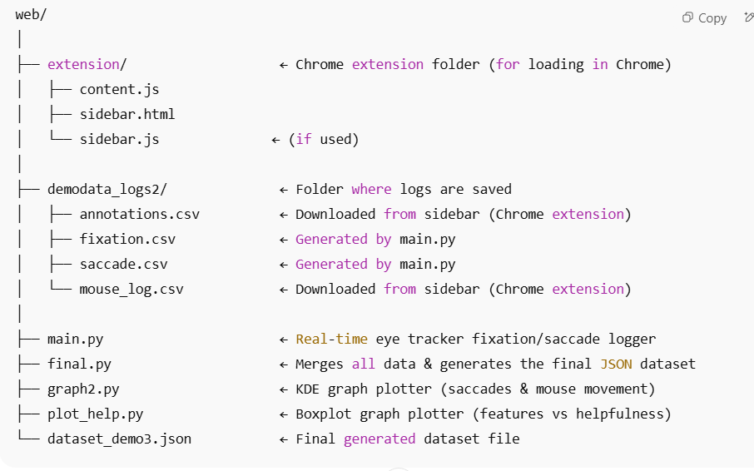
(Note: Refer to the "web_based_annotation" video to see how it should be performed)

