Arduino Mega 2560

|  |  |
| --- | --- |
| Microcontroller | [ATmega2560](http://www.atmel.com/Images/Atmel-2549-8-bit-AVR-Microcontroller-ATmega640-1280-1281-2560-2561_datasheet.pdf) |
| Operating Voltage | 5V |
| Input Voltage (recommended) | 7-12V |
| Input Voltage (limit) | 6-20V |
| Digital I/O Pins | 54 (of which 15 provide PWM output) |
| Analog Input Pins | 16 |
| DC Current per I/O Pin | 20 mA |
| DC Current for 3.3V Pin | 50 mA |
| Flash Memory | 256 KB of which 8 KB used by bootloader |
| SRAM | 8 KB |
| EEPROM | 4 KB |
| Clock Speed | 16 MHz |
| LED_BUILTIN | 13 |
| Length | 101.52 mm |
| Width | 53.3 mm |
| Weight | 37 g |

Source: [https://www.arduino.cc/en/Main/arduinoBoardMega2560#techspecs](https://www.arduino.cc/en/Main/arduinoBoardMega2560%23techspecs)

Freaduino Mega 2560

Top of Form

**Features**

* Inherits all of Arduino MEGA2560's features.
* Compatible to Arduino MEGA2560's pin layout, screw hole and dimensions.
* 3.3V or 5v Operating Voltage selecable
* More visible location of Indicator LEDs
* Wide range external input from 7~23V DC
* Evolved with SMD components

Changes vs. original Arduino Mega 2560  
  
[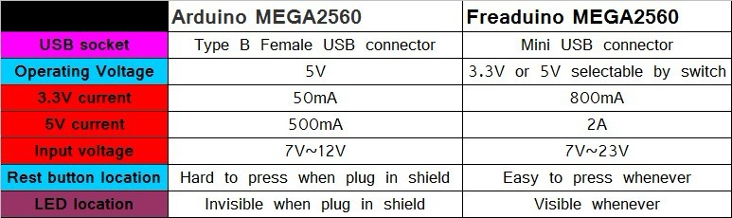](http://www.elecfreaks.com/store/images/product_images/arduino/FreaduinoMEGA2560_10.jpg)

Bottom of Form

 MiniUSB changed to Type B USB

Source: <https://www.elecfreaks.com/wiki/index.php?title=Freaduino_Mega2560>