Data Carrier Generation

FPGA based DVB-T transmitter

| Revision | Date | Description | Author |
| --- | --- | --- | --- |
| 0.1 | 06/2010 | Initial Draft | Juan Gago |
| 0.2 | 07/2010 | Functional RTL simulations | Juan Gago |
| 1.0 | 09/2010 | Gate Level simulations | Juan Gago |
|  |  |  |  |
|  |  |  |  |
|  |  |  |  |
|  |  |  |  |
|  |  |  |  |
|  |  |  |  |
|  |  |  |  |

Table 1: Revision history.

Contents

1. Introduction 3

2. RTL Design 4

**Bit Interleaver = F (QAM, OFDM)** 4

**Symbol Interleaver = F (QAM, OFDM)** 5

**QAM mapper = F (QAM)** 8

# Introduction

* bit interleaver = f(QAM,OFDM)
* symbol interleaver= f(OFDM)
* qam mapper = f(QAM)
  + fft_rdy = used as chip enable of the data carrier generation

Data Carrier Gen  
OFDM, QAM, Hierarchy

qam_im (16)

(lp_sink_byte)

hp_sink_byte

qam_re (16)

ce

valid

valid

sop,eop

sop,eop

# RTL Design

## **Bit Interleaver = F (QAM, OFDM)**

Bit Interleaver

sinkword

sourceword

valid

valid

#### Implementation

* Back pressure is not used in this component (bypass)

Interleaver 0

Delay (105 - offset)

Delay (126 + 105 - offset)

Delay (105)

A

B

Others

Table 2 Bit-wise Interleaver

|  |  |  |  |
| --- | --- | --- | --- |
| **e** | **Offset** | **A** | **B** |
| **1** | 63 | 105 - 63 = 42 | 126 – 42 = 84 |
| **2** | 105 | 105 - 105 = 0 | 126 – 0 = 126 |
| **3** | 42 | 105 - 42 = 63 | 126 – 63 = 63 |
| **4** | 21 | 105 - 21 = 84 | 126 – 84 = 42 |
| **5** | 81 | 105 - 81 = 24 | 126 – 24 = 102 |

Table 3 Interleaver for e = 2

|  |  |
| --- | --- |
| **w** | **H(w) = w + 105** |
| 1 : 21 | 106 : 126 |
| 22 : 126 | 1 : 105 |

## **Symbol Interleaver = F (QAM, OFDM)**

Symbol Interleaver

sinkword

sourceword

indx_ofdm(13)

start_pulses(5)

indx_flags (3)

valid

valid

sop,eop

#### Implementation

* Back pressure is not used in this component (bypass)
* Y’ = (y’0 y’1 … y’6047)    -->      Y = (y0 y1 … y6047)
* Counters and double buffering

Table 4 Flags indx_flags

|  |  |
| --- | --- |
| **bit** | **description** |
| 2 | Current index corresponds to a tps carrier |
| 1 | Current index corresponds to a pilot carrier |
| 0 | Current index corresponds to a zero carrier |

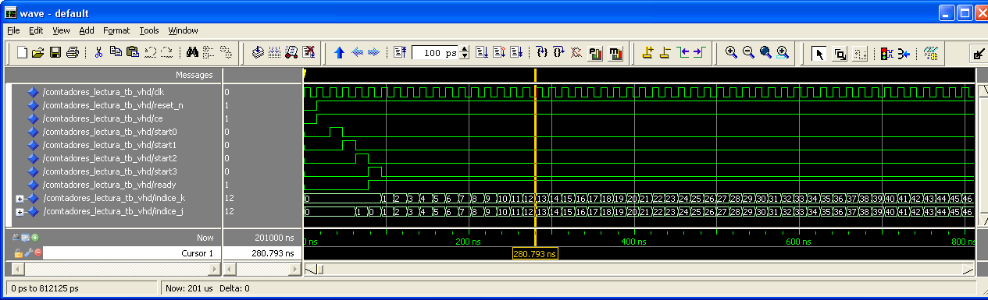

Ilustración 2 Contador Lectura 2k (cont_start = start0 )

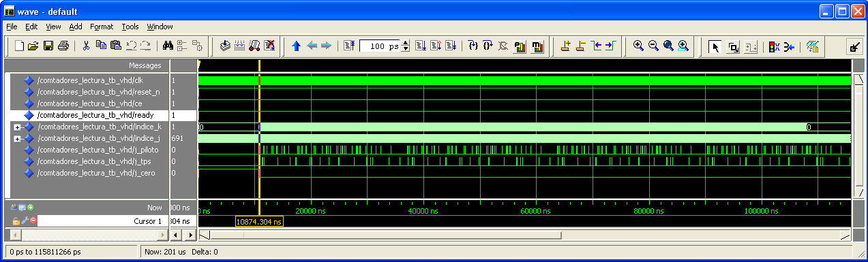

Ilustración 3 Contador Lectura 8k (con pilotos y tps)

indx_flags (3)

indx_ofdm(13)

symbol_int.vhd

sinkword(6)

sink_val

sourceword(6)

**Símbolos  
Impares**  
  
we  
  
Ain Ao

**Símbolos  
Pares**

we  
  
  
Ain Ao

Hq_8k  
Impares

Hq_8k  
Pares

Contador  
Escritura

símbolo_par

i=0:6047

Contador  
Lectura

source_val

2

start_pulses(5)

## **QAM mapper = F (QAM)**

QAM mapper

qam_re(16)

sinkbyte

qam_im(16)

#### Implementation

* Back pressure is not used in this component (bypass)
* 2x ROM - 64 x 16 bits words
* 1.0.15
* QAM constellation

Table 4 QAM Constellation

|  |  |  |  |
| --- | --- | --- | --- |
| **Constellation** | **Input Bits** | **Output Bits (I)** | **Output Bits (Q)** |
| 64 QAM | y0,q y1,q y2,q y3,q y4,q y5,q | y0,q y2,q y4,q | y1,q y3,q y5,q |

Table 5 Normalization of constellations

|  |  |  |  |  |
| --- | --- | --- | --- | --- |
|  | **Scale Factor** | **BPSK (tps)** | **BPSK  (pilots)** | **64-QAM (data)** |
| **None** | 1 | 6.48 | 8.64 | 7 + 7i |
| **E(c, c*) = 1** | 6.48 | 1 | 8.64/6.48 | 1.08 + 1.08i |
| **E(c, c*) = 16/9** | 8.64 | 0.75 | 1 | 0.81 + 0.81i |

qam64_re

qam64

2

2