

**Usability in User Generated Learning Spaces**

An initial project background report submitted to The University of Manchester for the degree of MSc in Advanced Computer Science & Information Technology Management, in the Faculty of Engineering and Physical Sciences

May, 2011

**Author**: UDOISANG, Blessing Sunday (ACS& ITM, 7588349)

**Supervisor**: Dr. Mark Van Harmelen

School of Computer Science,  
The University of Manchester

Table of Contents

List of Figures 3

List of Tables 3

Abstract 4

Chapter 1: Introduction 5

1.1 Project Objectives 5

1.2 Project Scope 6

1.3 Report Structure 6

Chapter 2: Background 7

2.1 Basic Terminologies 7

2.1.1 Learning 7

2.1.2 Cognition 7

2.1.3 Theory 7

2.2 Learning Theories 7

2.2.1 Behaviorist Theories 8

2.2.2 Behaviorism in Learning 8

2.2.3 Cognitivist Theories 9

2.2.4 Cognitivism in Learning 9

2.2.5 Constructivist Theories 9

2.2.6 Constructivism in Learning 9

2.2.7 Social Constructivism 10

2.3 Comparison of Learning Theories 10

2.5 Learning Space 11

2.5.1 Trends in Learning Space Design 11

2.5.2 Virtual Learning Spaces 13

2.5.3 Usability of Learning Spaces 14

2.9 Summary 15

Chapter 3: Research Methods 16

3.1 Project Description, Delivery Strategy & Evaluation 16

3.1.1 Project Description 16

3.1.2 Research Methodology 17

3.1.3 Project Plan 18

3.1.4 Evaluation Plan 19

3.2 Project Tools 19

3.2.1 Development Tools 19

3.2.2 Communication & Collaboration Tools 20

3.3 Project Management 21

3.3.1 Agile Project Management 21

3.3.2 Risk Management & Issue Resolution Plan 21

Chapter 4: Summary 22

List of References 23

Appendix A: Project Plan Gantt Chart 26

# List of Figures

Figure 1 - Behaviourist Model 9

Figure 2 - Continuum of Learning Theories 11

Figure 3 - Linear Arrangement vs. Collaborative Arrangement 13

Figure 4 - Attributes of System Acceptability 15

Figure 5 - Research Methodology Flow 19

# List of Tables

# Abstract

The effective design of learning spaces whether physical or virtual can enhance the way learning takes place and consequently the outcome. It can encourage learning passively and actively, as well as discourage it too. The way we define learning and what we believe about the way learning occurs has important implications for how we perceive the environment in which learning occurs. Long established Learning Theories provide verified strategies for defining and facilitating learning, however, the environment where this learning takes place and the learners themselves continue to evolve with the times. Technology continues to change not only the way we learn but also where we do. Consequently, the focus is shifting from physical learning spaces (built with brick-and-mortar) to virtual learning spaces (built with bits-and-bytes). This dissertation focuses on Learning Spaces that are built on “bits-and-bytes” with a view to improving usability in these learning spaces. Usability is the extent to which a product can be used by specified users to achieve specified goals with effectiveness, efficiency, and satisfaction in a specified context of use. In this pedagogical context, it is important to measure the learner’s satisfaction, not only in the product but also with regards to the learning goals. How do we draw upon the principles of instructional theory to improve the usability of user generated learning spaces? This is the question, we (myself and my supervisor) attempt to answer.

# Chapter 1: Introduction

Space according to Oblinger (2006a), “is an agent of change”, change is the goal of learning (Illeris 2007, LTKB 2011), learning is imperative for survival in the complexity called humanity. The challenge however is that learners as well as styles of learning change from time to time. The learners of today are in many ways different from those of 1950. Additionally, technology has redefined our concept of time and space. Presently, learning is not restricted to a fixed location anymore, it happens anywhere, at anytime in many different styles. Consequently, the term “Learning Spaces” has been coined to describe places where learning occurs.

Learning spaces “encompass the full range of places in which learning occurs, from real to virtual; classroom to chat room” (Brown, 2005). The effective design of learning spaces whether physical or virtual can enhance the way learning takes place and consequently the outcome. With the advancements in technology leading to convergence of platforms and proliferation of high capacity mobile devices, learners are increasingly shifting their preferences for learning environments from the physical to the virtual. For any interactive system that implements virtual learning spaces, usability is a key determinant in uptake. Usability is defined by the International Organization for Standardization (ISO 9241) as "the extent to which a product can be used by specified users to achieve specified goals with effectiveness, efficiency, and satisfaction in a specified context of use".

PLEs are designed to support learning. Designing for learning requires an understanding of how learners construct knowledge. Significant learning theories need to be explored and applied within the learners' context to capture the learning activity in a way "natural" to the learners. Theories such as Social constructivism, Constructionism, Self-directed Learning, Communities of Practice, etc have existed for a long time. However, the context of learning keeps evolving. It is therefore important to re-examine these theories with a view to adapting them to the prevailing contexts in which learning occurs. This is even more challenging when viewed from the virtual learning perspective. Interestingly enough, ICT presents a lot of tools that can help us realise our objectives. These ICT tools have been applied in various ways but the question is how usable are they?

This project is concerned with improving usability in user generated learning spaces. User generated learning spaces are “(learning) spaces which are populated with content by one or more learners” (Harmelen, 2011). This content according to Harmelen “might be learner generated, or co-opted from elsewhere and used unchanged, or modified, or mixed with other content”. Whatever the case might be, the purpose remains the same, “to help the user(s) learn about a particular topic area, or fulfill one or more learning goals” (Harmelen, 2011).

## 1.1 Project Objectives

The main objective of the project is to investigate usability in user generated learning spaces. The findings would then be applied in improving the usability of virtual learning spaces in a Personal Learning Environments (PLE). As part of this I would be working on improving the User Interface of the learning space in the Manchester PLE; performing development in FLEX® 4 and complementary technologies.

The main objective has been decomposed into mini targets that would act as guiding posts to achieving the main objective. They are as follows:

* To understand the application of relevant Learning Theories to the design of learning spaces
* To improve active knowledge construction via User Generated Learning Spaces
* To improve self-directed as well as collaborative learning via PLEs
* To Investigate by User Evaluation the Usability of current Learning Spaces in the PLE
* To develop improved user interfaces (that are being tested by users) for the current Learning Spaces in the PLE
* To assess by user testing the Usability of the developed user interfaces

## 1.2 Project Scope

The project scope includes investigating the usability of learning spaces. This would involve the use of testing and formative evaluation in iterative process of design & implementation. A careful comparison of various frameworks for usability testing would be made and the most appropriate one that can be applied selected. Usability evaluation for pedagogical applications comprises two parts namely: technical/functional usability evaluation and pedagogical usability evaluation. The selected evaluation framework would need to encompass both aspects as much as possible. Where this is not the case, the framework would be adapted to fit in using established theoretical principles from learning and instructional theory. Web usability is also within the scope of the project. This is because virtual learning spaces are mostly implemented on web pages. Consequentially principles of web usability design would be incorporated in the design and implementation of the improved learning space. Finally, evaluation of the improved learning interface would be carried out and reported. Some innovative features of the proposed learning space are as follows:

* The ability to track and highlight changes in the space both in private and collaborative mode
* The ability to undo actions in collaborative mode, considering the fact that some other actions might have been performed based on the action to be un-done.
* The transfer of desirable classroom and informal space characteristics into the virtual learning space such as ambience, immersion principle, attention and motivation theories, layout reconfigurability, knowledge discovery, etc.

The project scope does not cover large scale testing and usability evaluation. Expert evaluation would be mostly used.

## 1.3 Report Structure

The project has been introduced, the objective and scope defined. The remaining part of this report is structured as follows:

**Chapter 2 – Background**

This section discusses relevant background materials with the aim of situating the project into a wider research theme. Relevant learning theories and how they apply to learning are discussed. Current trends in learning space design are examined and then finally, usability in learning spaces design with focus on usable virtual learning spaces.

**Chapter 3 – Research Method**

This section gives a clear description of the project. I present a concise delivery strategy; a 3-phase research methodology; description of proposed tools to be used; project plan and finally a project management plan. Some of the questions answered in this section include (but are not limited to) “What will be done”, “How it will be done”, “which tools will be used”, “what will be delivered” and “how will be evaluated”.

# Chapter 2: Background

This chapter explains the background behind this project. Significant learning theories are introduced which generally specify ideal ways to learn and teach. This is followed by discussion on Virtual Learning Spaces. We then turn to the importance of usability in virtual learning spaces and finally conclude with reviewing related work in this area of research.

## 2.1 Basic Terminologies

### 2.1.1 Learning

I would “attempt” to define the term “Learning”. Being a complex process, it is not easy to define learning. According to Domjan & Burkhard (1993), “Learning is such a common experience that we hardly ever reflect on exactly what we mean when we say that something has been learnt”. They went ahead to confirm that “a universally acceptable definition for learning does not exist” (Domjan & Burkhard, 1993). However, in the following definition, they attempted to capture many critical aspects of the concept of learning:

“Learning is an enduring change in the mechanisms of behaviour involving specific stimuli and/or responses that result from prior experience with those stimuli and responses”

In this definition, Domjan & Burkhard view learning from a behavioural perspective which is usually inadequate in defining learning when considered in isolation. The following definition (commonly used but source cannot be traced yet) provide the missing link by defining learning as “a process that brings together cognitive, emotional, and environmental influences and experiences for acquiring, enhancing, or making changes in one's knowledge, skills, values, and world views”. This definition attempts to capture the process as well as the product. A noteworthy fact in the definition is that learning is a product of the interplay between the cognitive, the emotional and the environmental. However, the environment can affect both emotion and cognition, positively or otherwise. It therefore becomes a very important factor in learning.

### 2.1.2 Cognition

Cognition has to do with “how our brain works or how our mind works” (Leonard, Noh, & Orey, 2007). Cognition is the psychological result of perception, learning and reasoning. To put it in simpler terms, it is the act of knowing. Cognition can also refer to the process of knowing. So in my own words, cognition can be a “process” as well as a “product”. To clarify any ambiguity, when we talk about how the brain works, we are not making a biological reference to the brain, “most cognitive theories are more conceptual and therefore it might be more accurate to talk about how the mind works rather than a biological reference to the brain” (Leonard, Noh, and Orey, 2007).

### 2.1.3 Theory

The term theory is a frequently used word in everyday vocabulary. However, the meaning of a theory in science is not the same as the colloquial use of the word. Marx (1970) defines a theory as “a provisional explanatory proposition, or set of propositions, concerning some natural phenomena”. Leonard, Noh, and Orey (2007) share this “explanatory” perspective. According to them, a theory is “a hypothesis that describes, speculates, or defines a relationship between a set of facts or phenomena through a body of principles, policies, beliefs, or assumptions”. It follows from both definitions that there exists a subtle tone of assumption in every theory. A theory is quite different from a strategy in that while the former is descriptive; the latter is prescriptive, (suggesting steps to be followed).

## 

## 2.2 Learning Theories

A Learning theory attempts to help us understand the complex process of learning by describing how people (and animals) learn. Learning theories have two chief values:

* Providing a vocabulary and a conceptual framework for interpreting the examples of learning we observe.
* Suggesting where to look for solutions to practical problems.

Interestingly, the theories do not provide solutions to practical problems. However, it should be noted that they do direct our attention to important variables that are crucial in finding solutions. The meaning of “Learning” has been discussed in a previous section above. Learning theories are generally categorized under three philosophical frameworks namely:

* Behaviourism
* Cognitivism and
* Constructivism

### 2.2.1 Behaviorist Theories

Behaviorism is a learning theory based on the idea that all behaviors are acquired through conditioning which occurs through interaction with the environment. J. B Watson, widely regarded as the father of Behaviorism, defined learning as “a sequence of stimulus and response actions in observable cause and effect relationships” (Chowdhury, 2006). Thus behaviourism assumes that the learner is essentially passive, responding to environmental stimuli. According to LTKB (2011), “the learner starts off as a clean slate (i.e. *tabula rasa*) and behavior is shaped through positive reinforcement or negative reinforcement.” Positive indicates the application of a stimulus while negative indicates withholding of a stimulus, thus learning is observable by the “change in the behavior of the learner” in response to the stimuli (LTKB, 2011). There are basically two kinds of conditioning in Behaviorism namely classical conditioning and operant conditioning.

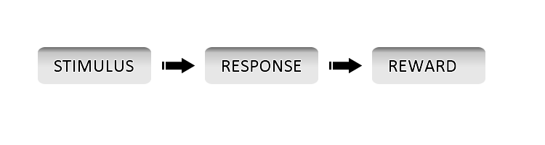

Figure - Behaviourist Model

Behaviorism has been applied in the fields of psychology and medicine but here we are more interested in its application in learning improvement. Educational approaches such as applied behaviour analysis, curriculum based measurement, and direct instruction have emerged from this model (Kim & Axelrod, 2005). The original theory of behaviorism is now more commonly referred to as “classical behaviorism”. New lines of thought have been extracted from classical behaviorism thus giving rise to Neo-Behaviourism (second Generation) and Social-Behaviorism (Third Generation). Of these two, Social Behaviorism focuses more on learning. It considers learning as a relatively stable behavior modification arising from experience.

### 2.2.2 Behaviorism in Learning

In Behaviourist approaches, learning is centred on the teacher. The teacher is given the role of transferring his knowledge to the learner which is confirmed done by observing a relative permanent change in the behavior of the learner. This approached is marked by reinforced and programmed learning (LTKB, 2011). According to Standridge (2002), “Behaviorist techniques have long been employed in education to promote behavior that is desirable and discourage that which is not”.

Below is a summary of some features of a behaviourist learning model:

* Learning is done in small, concrete, progressively sequenced tasks
* Learning is marked by repetition in order to increase retention and speed of learning.
* Consistent use of reinforcements during the teaching-learning process. For instance, with verbal acts such as congratulatory remarks and non verbal acts such as medallions.

### 2.2.3 Cognitivist Theories

Cognitivism as a learning theory looks beyond behaviour to explain “brain” based learning. In other words Cognitivism attempts to improve learning by considering how the human memory works. Cognitivism shares a similarity with behaviourism on the basis that both view knowledge as “given” and “absolute” (LTKB, 2011). However, Cognitivism is based on the basic assumption that human beings are logical beings and thus make choices that are most sensible to them. Pure cognitive theory largely rejects behaviourism on the basis that behaviorism reduces complex human behavior to simple cause and effect (Fritscher, 2011). Current trends in past decades have been towards merging the two into a comprehensive “cognitive-behavioural theory” (Fritscher, 2011).

### 2.2.4 Cognitivism in Learning

Cognitivism approaches learning from a learner-centred perspective. From this perspective, learners need to develop deeper understandings, not just produce the right behaviors (Wortham, 2003). Since these deeper understandings cannot be imposed on learners, they must construct their own mental models with sufficient guide from the teacher. Cognitivism views learning as a change in the learner’s understanding, hence the focus is on elaboration. The teacher plays the role of a coach or a facilitator. As a facilitator, he has to provide clues and teach mnemonic strategies (Fortin & Rousseau, 1989), to introduce context. As a coach, he has to constantly evaluate the learner’s knowledge to keep the learner as active as possible. Tardif (1992) lists some basic principles that characterize the cognitive learning approach as follows:

* Learning is an active and constructive
* Prior knowledge a crucial factor in learning and believes that knowledge is essentially cumulative.
* Learning permits a link between the new pieces of information and the information already in memory.

### 2.2.5 Constructivist Theories

Constructivism as a learning theory views knowledge as a “constructed” entity (LTKB, 2011). This totally contradicts the view that knowledge is absolute and given. According to the constructivism paradigm, human learning is an active attempt to construct knowledge based on previous knowledge and the present context. Therefore, every person will construct their own unique set of knowledge. In other words, no two people will start with exactly the same knowledge base, and no two people will construct exactly the same knowledge structures from given experiences or information. Knowledge is seen as a constructed entity and by reflecting on our experiences, we construct our own understanding of the world we live in (LTKB, 2011).

### 2.2.6 Constructivism in Learning

Constructivism approaches learning from a learner-centred perspective also. However, learning to the constructivist is “discovery and construction of meaning”. In the constructivist view, knowledge cannot be poured in, from one person to another. It holds also, that knowledge does not become part of the learner after memorisation of external objective information but is continuously built as the learner interacts with the outside world thus producing his own interpretations about it. According to DeVries et al. (2002), in most pedagogy based on constructivism, “the teacher's role is not only to observe and assess but to also engage with the students while they are completing activities, wondering aloud and posing questions to the students for promotion of reasoning”. This promotes learning by experimentation and exploration, not by being told what will happen. The constructivist pedagogy involves the following characteristics as presented by Richardson (2003):

* Student-centredness, evident in attention to the individual and respect for students' backgrounds
* Facilitation of group dialogue that explores an element of the domain with the purpose of leading to the creation and shared understanding of a topic
* Provision of opportunities for students to determine, challenge, change or add to existing beliefs and understandings through engagement in tasks structured for this purpose

### 2.2.7 Social Constructivism

Social constructivism proceeds from Vygotsky’s social development theory. In summary Social Development Theory argues that social interaction precedes development; consciousness and cognition are the end product of socialization and social behavior (LTKB, 2011a). Vygotsky focused on the connections between people and the socio-cultural context in which they act and interact in shared experiences (Crawford, 1996). It follows from the ideas of Vygotsky and others that learning occurs as a result of a social activity. This is why the environment within which learning occurs plays a very important role in social constructivism.

Social constructivism emphasizes the benefits of collaborative learning (Fruchter and Emery, 1999). The role of the educator in this context is to provide what is known as “scaffolding”. Scaffolding refers to guidelines and hints which help the learner build strong, complex and relevant ideas (Vygotsky and Cole, 1978). The learner progressively removes this scaffolding and tends towards self-directed learning replacing it with his own ideas and plans.

## 2.3 Comparison of Learning Theories

The learning theories discussed thus far have based their views on different assumptions and focused on different perspectives of explaining learning. Nevertheless, they bear close relationship to one another. Learning styles and behaviours may be viewed as existing on a continuum as shown in figure 2 below. While it may be said that most educational models in use today combine concepts majorly from cognitivism and constructivism, that does not mean that the behaviourist theories are not still applicable. For example according to Perraudeau (1996 cited in Ughade et al, 2007), “to develop high intellectual level abilities such as analysis or problem resolution, the teacher will tend to privilege constructivist and cognitivist approaches, whereas for information memorization, a behaviorist approach can be better”. See appendix xx.xx [@TODO Put Exact Number] for a tabular comparison of learning theories.

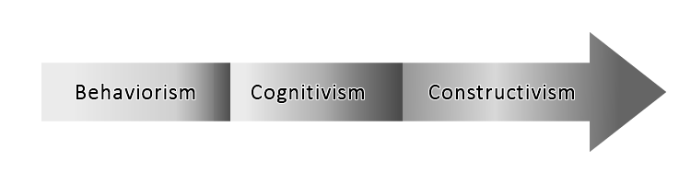

Figure - Continuum of Learning Theories

## 2.5 Learning Space

In defining the term “learning spaces”, Malcolm Brown, started out with a question. I would borrow a leaf from him in this regards. “What does the term learning space mean? Why not use classroom instead?” (Brown, 2005). Learning spaces as defined by Brown (2005) “encompass the full range of places in which learning occurs, from real to virtual; classroom to chat room”. According to Brown,

“Just a decade ago, classrooms were the primary locus for learning in higher education. Other spaces included the library, the faculty office (for individual mentoring), and perhaps the café in town. But classrooms were by far the single most important space for learning.”

However, a great deal has changed over the years with regards to learning theories, styles and activities. Advancements in learning theories have led to a rethink in designing learning environment. The word “room” (as in classroom, lecture room, etc) are no longer descriptive enough as learning can now happen everywhere. As a result of this the term “Learning Space” is increasingly being used to describe places where learning occurs. Information and Communication Technology has also contributed to changing the notion and location of learning as we shall discuss later, thus leading to the evolution of not only modern physical learning spaces but also virtual spaces.

### 2.5.1 Trends in Learning Space Design

“Learning Spaces often reflect the people and learning approach of the times, so spaces designed in 1956 are not likely to fit perfectly with students in 2006” (Oblinger, 2006a). Consequently, there have been moves to redesign learning spaces not only to conform to the advancements in learning theories but to also conform to the new generation of learners which Oblinger and other choose to call the “Net Generation Learners” (Oblinger & Oblinger, 2005). According to Oblinger (2006a), there are 3 driving forces behind the move to redesign learning spaces viz:

* Changes in students
* Information Technology and
* Our understanding of learning

This view is also corroborated by Brown and Long (2006). According to them, “Three major trends inform current learning space design” viz:

* Design based on **learning** **principles** (Theories), resulting in intentional support for social and active learning strategies.
* An emphasis on **human-centered** design and
* Increasing ownership of **diverse devices** that enrich learning.

Obviously these agree with Oblinger’s views. These trends according to Brown and Long, “have been catalyzed by constructivism, digital technology, and a holistic view of learning”.

The constructivist learning paradigm as earlier discussed focuses on the learner rather than teacher. Thus in constructivism, we drop the “transmitter-centric” mode of learning in favour of the “active construction of knowledge” by the learner. We drop the focus on “teaching” in favour of the focus on “learning”. This emphasis on learning according to Brown and Long (2006), means that we must also “think about the learner” in designing learning spaces. Learning Spaces, according to them, “are not mere containers for a few, approved activities; instead they provide environments for people”.

Consequently, it would be wise to design learning spaces not as an architectural master-piece alone but also bearing in mind how these spaces accentuate the needful learning requirements of today’s learners. This must be what Torin Monahan had in mind when he used the term “**built pedagogy**” to refer to “architectural embodiments of educational philosophies”. In other words, “the ways in which a space is designed shape the learning that happens in that space (Chism, 2006). Consider the following examples from Chism:

* A room with rows of tablet arm chairs facing an instructor’s desk in front of chalkboards conveys the pedagogical approach “I talk or demonstrate; you listen or observe.”
* A room of square tables with a chair on each side conveys the importance of teamwork and interaction to learning.

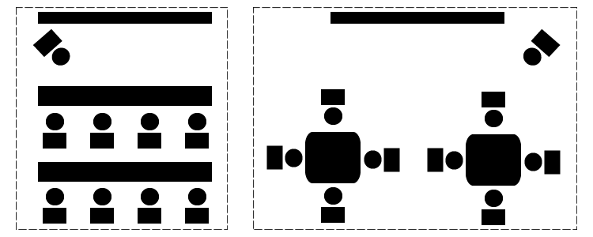

Figure - Linear Arrangement vs. Collaborative Arrangement

Present day students do not like the idea of sitting in front of an instructor like dummies and listening “attentively” to the teaching. Their attention quickly shift from the instructor to other items such as their mobile devices, course mates, etc. Such learners would definitely not fancy the first example given by Chism above. Oblinger (2006a) describes this kind of learners as favouring “active, participatory and experiential learning”. This kind of learning according to Neill & Etheridge (2008), “requires a flexible space”, and as such the second example would appeal to them since it is more natural to the learning styles they exhibit in their personal lives.

Information Technology is also another very potent factor shaping the trends in learning space designs. Trends in Information and Communication Technology continuously redefine the meaning, boundaries and styles of learning. The recent proliferation of low-cost devices as well as the integration of platforms has given learners a whole new universe of learning – learning that is distributed in “time” and “space”. We focus on this in the next section when we discuss virtual learning spaces. One big problem with technology is the pace of change. The unrelenting pace of technology change, according to Brown and Long (2006) “can make IT decisions rapidly obsolete”. Interestingly, “While platforms and applications come and go, the psychology of how people learn does not” (Brown & Long, 2006). This is why the field of “Instructional Technology” focuses on adapting the changing technology to fit the psychology of learning. According to Jonassen & Land (2000), “Technology foundations determine what is technologically possible, but grounded practice requires determination of how capabilities should be exploited”. Rather than designing learning to suit the technology, the trends with regards to technology focuses on:

* Designing Technology to support Learning
* Adapting Technology (new and existing) to encourage active, collaborative and experiential learning such as the use of Web 2.0 tools, podcasting, mobile devices, Social Networks, etc.

Current trends in learning space design show the following desired characteristics (Chism, 2006):

* Flexibility
* Comfort
* Sensory Simulation – Colours, Lighting, Ambience
* Technology Support and
* Decentredness

A flexible learning space “better enables innovative approaches to teaching and learning when compared to the traditional classroom” (Neill & Etheridge, 2008). With the right approach, “the entire campus can become a learning space” (Mitchell, 2004). The 3 trends discussed here underlie this emerging reality (Brown & Long, 2006) while the desired characteristics stated above are the features these trends would produce to support active, participatory and experiential learning.

### 2.5.2 Virtual Learning Spaces

While physical spaces are tangible and fixed in time and space, virtual learning space is the direct opposite. Also, whereas physical spaces exist around us, virtual spaces exist on machines and devices. Arguably, for the modern day learner, more learning happens on virtual spaces than on physical spaces.

To eliminate all doubts, the term “Virtual Learning Space” doesn’t in any way suggest that the “learning” is virtual and not original or authentic. I personally would like to call it “Virtual Spaces for Learning” but for purposes of consistency with the literature stick with “Virtual Learning Spaces”. It is the “environment” that is virtual, not the learning. Virtual Learning Space is more commonly known as Virtual Learning Environment (VLE). While there is no single definition for a virtual learning space, most writers define them by specifying their purpose, components and characteristics. This is not surprising considering the fact that virtual learning spaces are relatively new and changing rapidly, expanding to include new concepts and triggering the discovery of new concepts themselves. Most writers agree that virtual learning spaces are “**designed**” to support and enhance learning through the use of computers, multi-media devices, mobile devices and other technology based tools. According to Dillenbourg, Schneider & Synteta (2002):

* A virtual learning environment is a designed information space.
* A virtual learning environment is a social space: educational interactions occur in the environment, turning spaces into places.
* The virtual space is explicitly represented: the representation of this information/social space can vary from text to 3D immersive worlds.
* Students are not only active, but also actors: they co-construct the virtual space.
* Virtual learning environments are not restricted to distance education: they also enrich classroom activities.
* Virtual learning environments integrate heterogeneous technologies and multiple pedagogical approaches.
* Most virtual environments overlap with physical environments.

Virtual Spaces are continually being improved to support active, collaborative and experiential learning. The goal in improving virtual spaces is not to use them as replacements for physical spaces as some might wrongly envisage, rather both spaces are meant to be complementary.

### 2.5.3 Usability of Learning Spaces

Usability is defined as "the extent to which a product can be used by specified users to achieve specified goals with effectiveness, efficiency, and satisfaction in a specified context of use” (ISO 9241-151, 2008). Usability is a “Quality” attribute, therefore in order to define clearly what usability implies in any context, some form of concrete criteria or attributes must be defined through which usability can be measured. A popular model for doing this is based on five quality components or criteria namely learnability, efficiency, memorability, errors and satisfaction.

Jakob Nielsen is basically a household name when it comes to usability engineering so we turn to him to get a clear picture of what the five criteria listed above implies, briefly. However, before we focus on applying meaning to the attributes, we pause to note that usability itself is a “narrow concern compared to the larger issue of system acceptability” (Nielsen, 1993). The diagram below shows the position of usability with regards to system acceptability.

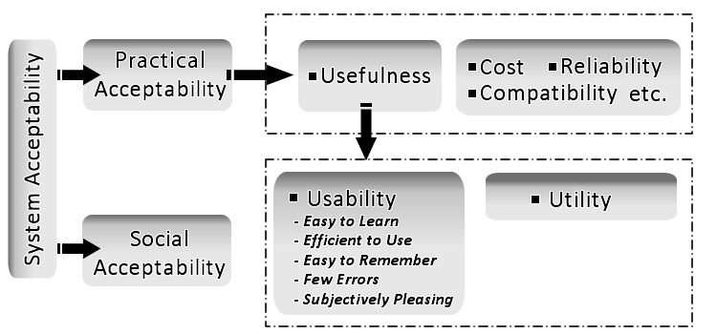

Figure - Attributes of System Acceptability

System acceptability according to Nielsen (1993) “is the question of whether the system is good enough to satisfy all the needs and requirements of the users and other potential stakeholders.” A system that would be able to “satisfy all” would be a utopia. Usually, there is an acceptable level of satisfaction that a system is required to meet. In the framework of social acceptability proposed by Nielsen and corroborated by Ben Shneiderman (1980), Usability, is a defining component of “Usefulness” and is composed of the five attributes identified above which are described below:

* LEARNABILITY: How easy it is for the user to accomplish the basic task on first attempt. According to Nielsen (1993), “The system should be easy to learn so that the user can rapidly start getting some work done with it”.
* EFFICIENCY: What is the level of productivity of the use after learning the basics of the system. In other words, how quickly can the user perform tasks? A high level of productivity in desired in this case.
* MEMORABILITY: The system according to Nielsen, “should be easy to remember”. This would enable the user return to the system after a period of not using it and re-establish proficiency without having to learn about the system from first principles again.
* ERRORS: The error rate of the system should be very low. This does not imply that errors may not occur but if and when they do, how severe are they and how easy it is for the user to recover “gracefully” from these errors. For Nielsen, “Catastrophic errors” is a taboo and must not occur.
* SATISFACTION: This is a measure of how “Pleasant” it is to use the system. Among all the criteria, this is the most subjective one and not quite easy to measure.

Nokelainen (2006) expanded Nielsen’s usability model by adding “Pedagogical Usability” to the “Utility” branch of the System Acceptability tree and renaming usability to “technical usability”. Nokelainen defines Pedagogical Usability as being “dependent on the goals set for a learning situation by the student and teacher”. It follows thus that evaluating the usability of a virtual learning space becomes more challenging since the technical usability alone is not enough, the environment must also meet the pedagogical demands in terms of achieving the set learning goals. How do we measure and ascertain that these learning goals have been achieved? Zaharias & Poylymenakou (2009) agree that “evaluating the usability of e-learning applications is not a trivial task”. In order to do a successful usability evaluation, the users, task and context must be identified. According to Zaharias and Poylymenakou, in terms of e-learning, “the main task for the user is to learn, which is rather tacit and abstract in nature”. I believe this is why most e-learning tools have poor usability records. They are either not being evaluated for usability at all or the evaluation is not properly done. To develop an effective usability evaluation framework for virtual learning spaces, the evaluator must familiarize himself with Learning Theories, Learning Styles and educational testing research (Zaharias & Poylymenakou, 2009). Three widely used methods for usability evaluation (Hertzum & Jacobsen, 2001) are

* Think Aloud (TA)
* Heuristic Evaluation (HE) and
* Cognitive Walkthrough (CW).

Other methods include Questionnaires, Direct Observation, Interviews, Focus Groups, etc. No matter the method applied however, all good usability should have 3 things – Visibility, Affordance & Feedback (Norman, 2000).

## 2.9 Summary

Learning spaces are where learning happens. Great spaces foster great learning whether on physical or virtual spaces. Learning spaces should be designed to promote learning. Doing this requires that the designers of these spaces understand the principles behind learning which are embodied in learning theories and styles.

# Chapter 3: Research Methods

## 3.1 Project Description, Delivery Strategy & Evaluation

This section identifies what the project involves, what will be done, how it will be done, what tools would be used and methodologies that would be applied. Expected deliverables and evaluation criteria are also discussed.

### 3.1.1 Project Description

This project involves “improving” the User Interface (UI) for a multimedia, multi-user, collaborative environment. The product to be improved is the “learning space” in a Personal Learning Environment (PLE). This approach would involve taking the existing system and evaluating it by gather user/expert feedbacks. These feedbacks would be used to improve the system. Additionally, the feedbacks gathered would be merged with:

* The Product Owner’s vision for the system
* My own visions for the system and
* Ideas from other domain experts where possible

This processed would then be repeated in a series of iterations that would lead to an improved and usable product to be delivered at the end of the project. Tests with user would be conducted to evaluate the “improved” product.

Improving the usability of any system is not a one off task. It is a process. It involves using a Usability Evaluation Method (UEM) to assess the usability of the system then applying Usability design principles and feedbacks to improve the system. In this case, technical/functional usability would measure aspects such as navigation, error handling and recovery, User Interface Layout, accessibility, etc. Pedagogical usability would require setting learning goals; performing several tasks, then attempting to verify if the set goals were achieved or otherwise.

Since learning spaces foster private construction of knowledge as well as collaborative learning, some interesting questions pop up with regards to making the system more usable. Some of which include:

* What is the best way to manage a user’s private space and shared space?
* In a shared space, how do we accommodate changes and undo requests given that several users may be working on the same learning resource.
* How do we place emphasis on relevant materials so that the user can immediately locate it on first visit?
* When a user visits a shared or private space and returns to it later, there’s a possibility that certain aspects or resources on the space have changed. How do we highlight these changes to the user?
* How do we make it possible for users to invent new components for use in the learning spaces?
* How do we improve the flexibility and adaptability of the learning space?

Another key area of consideration is re-configurability and adaptability. A learning space on the PLE would simply be a canvas with UI components for user generated content. However, the layout of the interface must enable the learner to interact with the space in ways native to his/her learning style. For instance, the learner should be able to use the space as a private classroom, a presentation wall, a resource aggregation platform, a mind map board, etc. Additionally, when in collaborative mode, tools that enable participatory learning should be made handy. It would be needless to display the chat widget or icon when the space is being used in private mode, on the other hand, such icon or widget should be readily available in social mode. Since the learning space is web based, aspect of web usability design principles would be applied to improve it.

One area I have been considering is transferring some nice classroom characteristics to the learning spaces. One good example of this is the principle of a “dimly lighted” room during presentation. This can be achieved for instance by applying a soft gradient overlay on the page, excluding the area where the presentation is being made. This gives the impression of a “dimly lighted” room and can be very effective. This has been applied on movie and other multimedia streaming websites such as seesaw (<http://seesaw.com>). Another characteristic is the principle of “immersion”, the ambience and other environmental properties usually repel the learner or immerse the learner in, thus making the learner relaxed in the learning space. This can be achieved by applying careful layout design principles and colour blending. The use of “full screen mode” also enhances this concept as it enables the user forget about every other part of the web page and be immersed into the learning space.

Instant feedback is another learning principle that enhances learning and is strongly tied to the motivation theory. Instant feedback can be a mirage on the web when the user has to wait for the page bearing the feedback to reload thus losing interest and motivation. Web Technologies such as Asynchronous JavaScript and XML (AJAX) are designed to handle this limitation.

In a social or collaborative environment, violation of “Personal Space” is always a consideration worth taking into account. In traditional classroom design, “designers are usually advised to pay attention to the degree to which students feel crowded in a classroom” (Graetz, 2006). Similar notion can be transferred to the design of the learning space by paying careful attention to the crowding of the user interface with widgets. The guiding principle should be, “if it is not needed at the moment, hide it!” Also, being a virtual space, there is no limitation to the amount of learners that can collaboratively share a social space. However, rather than place a hard limit on the number of learners that can share a space at a time, some other interface design principles can be applied. For example, in chat room comprising many people, it is needless to display the list of participants, instead a collapsible container can be used such that the user can expand it when he wishes to see the list and collapse it again thereafter.

Traditional X/HTML would greatly limit my ability to implement some of these features hence the choice of a Rich Internet Application platform for the job.

### 3.1.2 Research Methodology

I would follow a 3 phase methodology approach to ensure I achieve the goals of the project. These phases are as follows:

**PHASE 1**:

This is the “Preliminary Preparation” phase. It includes initial research leading to a broader understanding of the project; identification of related work and tools that can be used to achieve the goals of the project. This process has been ongoing for a period of time now and the submission of this background report would bring this phase to a logical conclusion, after which I would go into a brief period of reflection and evaluation to ascertain that the objectives at this stage has been met. Further discussions with my supervisor would also confirm this and together, we would set the path for progress. The most important artifacts produced in this phase are the project time-plan and the background report. The plan would help me manage the most limited resource which is time while the background report has enabled me to situate my project within a wider research theme thus giving me a broad familiarization with the topic.

**PHASE 2**:

This phase will officially begin after my exams, though some aspects of it are already in progress. I refer to it as the “Design, Development and Testing” phase. The understanding derived from phase 1 would be used as the basis for design and implementation of the specified software. In keeping up with the project time-plan, tools for the design have already been identified. Learning to use the tool is also in progress. I have already developed a very deep understanding of the proposed tools. The pending tasks in this phase include the system design, which would be done iteratively; implementation, testing and evaluation. To ensure a robust system is developed, Test Driven Development (TDD) would be applied to the development process. The Agile Project Management method would be used to ensure that this part of the project is delivered successfully as described in the next sections.

**PHASE 3**:

The third and final phase of the project which I refer to as the “Report, Review and Submission” phase would cover the writing of the dissertation report. The dissertation report would cover all aspects of the project including some aspects already covered in this background report. The report would also highlight the conclusions drawn from the project, contributions made, deliveries and areas for further research. The figure below presents a graphical overview of the phases and their relationship.

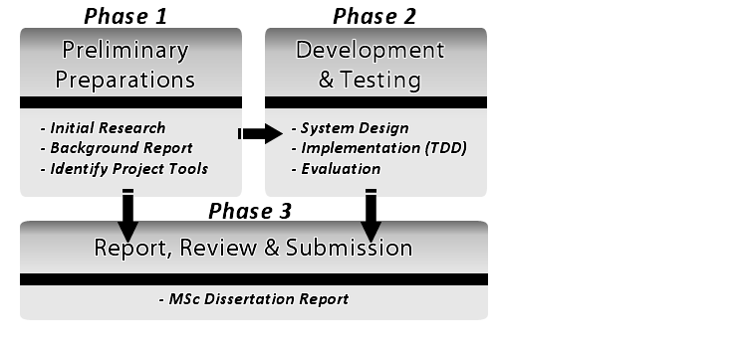

Figure - Research Methodology Flow

### 3.1.3 Project Plan

The project plan spans a period of 8 months starting from February 1st 2011 and ending September 9, 2011. This period also include the examinations between May 19th and June 8th. As at the time of submission of this report, 50% of this period would have already been gone. It is therefore very important that the tasks on the project plan progress as outlined in order to ensure I meet the deadline and also deliver a good product fit for a Masters’ Project. To effectively tackle the project, I have divided it into 3 phases as follows:

* Preliminary Preparation phase
* Design, Development and Testing phase
* Report, Review and Submission phase

Each phase is further split into “**Tasks**” and “**Milestone**”. At the end of major tasks, milestones are delivered. The successful delivery of these milestones on or before the deadline is a clear indication that the project is on course. A list of the milestones is presented below while the project Gantt chart can be found in the appendices (Appendix A).

**LIST OF MILESTONES**

* Project Summary Document (due February 17th, 2011)
* Project Website (due April 7th, 2011)
* Background Report (due May 9th, 2011)
* System Evaluation Report (due August 5th, 2011)
* Dissertation Report (due September 9th, 2011)

### 3.1.4 Evaluation Plan

This project would be considered successful if all the phases outlined in the research methodology section are completed within the specified time allocated to them. Generally, this would mean that the target goals have been achieved and the expected deliverables delivered. With regards to the system design and implementation, an evaluation involving testing with users would be carried out and reported accordingly. This evaluation will be based on the usability of the system produced. As discussed earlier, an evaluation framework would be designed such that the technical and pedagogical usability of the system can be evaluated.

The final report will be evaluated by applying the university research guidelines and regulations. The dissertation report is a very important artifact as it documents all aspects of the project and forms the core contribution to the literature. As a result, careful, repeated review must be done to ensure it meets the standards of the university, which are quite high. Allowances have been made for this in the project time allocation (see Appendix A – Project Plan Gantt Chart).

## 3.2 Project Tools

The project has been described, plans have been made but without the availability of the necessary tools, the expected deliverables cannot be met. This section takes a look at the tools that would be used in the project.

### 3.2.1 Development Tools

The development tools are technical tools that would be used to design, implement and test the software. They include but are not limited to:

**FLEX 4**

Flex is “an open source framework for developing intuitive web applications that can make it much easier for people to view and interpret data” (Adobe® Inc). I prefer to use the term Rich Internet Applications rather than intuitive web applications as there is usually a controversy as to whether a web application can actually be intuitive or not. Flex can also be used to build mobile and desktop applications. Applications are built in Flex using MXML tags and Action Script®. They can then be executed in the Adobe® Flash® runtime mostly for web environment and the Adobe® Air® runtime for desktop applications. The Flash runtime is widely available on all major internet browsers while, the Air runtime can be easily downloaded online. Flex applications running in web pages do not require a page reload to update information on the user interface. They connect to remote server side applications to retrieve data which are used to update the client interface as required. These features make Flex a very suitable candidate for designing learning spaces as required by this project. The latest version of Flex is version 4, this version features a lot of improvement over previous ones especially in enabling modular development. This is the version that would be used.

**Adobe ® Flash Builder**

Flash Builder is an integrated development environment for building Flex applications. It was formerly known as Flex Builder and is based on the Eclipse™ IDE Framework. A plug-in also exists that can be installed on any existing Eclipse™ based IDE, however, I prefer the fully functional studio. My supervisor has already obtained the studio for me which I am using to learn how to develop Flex applications.

**Server Side Scripting Languages**

Internet applications usually connect to back-end databases to retrieve and display dynamic information. A Flex application does not connect directly to a remote database. Instead, it is connected to a data service written in the developer’s favorite web language (PHP, ColdFusion, Java, or any other server-side web technology). This design ensures that Flex applications can be used in any scenario. It also makes it very easy to switch server side implementation without needing to change the front end. As at the time of this writing, I have explored Flex application development with PHP, ColdFusion and Java as the back end service. I propose to use PHP ultimately but this decision may likely change.

**Version Control System (VCS)**

Version Control also known as Revision control or Source control is a way of managing changes to documents, program source codes or other files. Source control is always very relevant in a collaborative environment where more than person may make changes to a file at the same time. Changes are usually marked by a unique code. The file or group of files being managed can be “branched”. This involves making a duplicate copy of the original document and continuing work on the copy while the original remains untouched. A VCS is very relevant in an Agile development environment as it enables majority of the agile methodology ideals to be achieved easily such as continuous testing, integration and release. I would be using **Git** which is a “free & open source, distributed version control system designed to handle everything from small to very large projects with speed and efficiency” (git-scm.com).

**PLE**

The learning space will not exist in isolation; it is integrated into a Personal Learning Environment. Both systems would thus share some APIs in common. The PLE is also being redesigned so the learning space would be designed to fit into both the old and new PLE. This would not be a major issue as the design of the PLE is well distributed and decentralized to accommodate such kind of integration.

### 3.2.2 Communication & Collaboration Tools

Communication is vital to the success of any project. Interaction and Collaboration are core values of agile and nothing fosters these more than communication. Communication tools have therefore been setup to enable uninterrupted flow of communication among all parties involved. The communication and collaboration media are as follows:

**Google Group**

A Google group (see <http://groups.google.com/>) called “newple” has been set up to enable discussion among all parties involved in the design and development of the PLE. This group ensures that everyone gets access to crucial information on time.

**Skype®**

Skype is a software application that allows users to make voice calls and chats over the Internet (see <http://www.skype.com/intl/en-gb/home>). Calls made between Skype® users are free. I can communicate with my supervisor and other people involved via Skype.

**Scratch Wiki**

The scratch wiki (<http://nymph.cs.man.ac.uk/scratch>) was used to produce my Project summary report, project website and a good part of this background report. The wiki enables me and my supervisor to collaboratively document the project as it progresses. Reports in the wiki can be viewed periodically and used as the basis for defining new pathways in the project.

## 3.3 Project Management

This section briefly describes plans put in place to properly manage the project in order to ensure its successful completion. A project management plan is relevant to ensure that the project is successful. The Agile Project Management Plan discussed below would be used.

### 3.3.1 Agile Project Management

Agile Project Management (APM) adapts the ideas from “Agile software development” into project management. According to the Agile Manifesto and as seen in practice during one of my course modules, Agile Methods generally promote collaborative development process that encourages interaction, individuality, stakeholder involvement, feedback, incremental and evolutionary development, periodic delivery of working products, effective control and quick response to change. Agile Project Management would ensure that the project is managed in an incremental and evolutionary manner until it is successfully completed. My supervisor has already setup the perfect environment for this to thrive as can be seen in the “PEVE” laboratory in Kilburn Building.

### 3.3.2 Risk Management & Issue Resolution Plan

Every project is prone to risk. Identifying, analyzing, prioritizing, and controlling project risks are important factors that must not be overlooked. Since I would be using the iterative development method, at the end of each iteration, I would be able to identify risks during the iteration review. The risks identified would be catalogued and plans developed to handle them. Risk control however, is more desirable than risk management. It is better to prevent risks than manage them. Agile Methodologies such as Scrum are designed to control risk as much as possible. Daily Scrums and Sprint Planning Meetings ensure that risks are reduced to the barest minimum.

# Chapter 4: Summary

In designing learning spaces, the architect uses the landscape as his canvas while the technologist uses electronic devices. What they do not seem to realise is that to the learner, the learning spaces so designed, becomes his own canvas upon which he constructs his learning. What makes a learning space useful and usable? This is the question to bear in mind as I progress in this research project.

The “Net Generation Learners” are evolving learning in very unpredictable ways. When creating learning spaces for this breed of learners, “you can’t be sure how these spaces will be used. You are just creating the opportunities for things to happen” (Tom Finnigan cited in JISC, 2006). Their fidelity to technology has become the norm rather than the exception. These learners “appear to have no fear of technology” (Oblinger, 2006a). “Mobile phones, digital cameras, and MP3 players constitute today’s backpack. Browsing, downloading, and messaging” is their way of life (Oblinger, 2006a).

According to Oblinger (2006b), “the Internet has changed our notion of place, time, and space” (Oblinger, 2006b). Nevertheless, the “students’ comfort with the Internet means it isn’t ‘technology’ to them—it may be a way of life” (Oblinger, 2006a). Consequently, learning spaces are no longer just physical, virtual spaces have come of age. Trends in Information and Communication Technology will continuously redefine the meaning, boundaries and styles of learning. But whereas technology come and goes, the psychology of how people learn is more persistent (Brown & Long, 2006). Therefore, we must return to the pedagogical roots (learning theories and styles) in order to be able to blend technology, learning goals and today’s learners’ in the right learning spaces.

Oblinger (2006b) recommends involving the users in learning space design. This includes “students, faculty, and staff”. This is a vital point because while architects see the complexities involved in realising a design, learners do not. What they see is the kind of learning they wish to have in the environment of their choice. Thus it becomes the challenge of the architect to bring to reality the wishes of the learners. In the case of this project, that architect is the software developer who creates virtual spaces for learners.”Exactly how we bring together space, technology, and pedagogy according to Oblinger (2006a) to create usable learning spaces is the focal point of this project. At the end, I hope to be able to contribute significantly to the literature of learning in the area of “usability in user generated learning spaces”.

# List of References

Adobe® Systems Incorporated, 2011. *What is Flex*? [online]. Available at: <http://www.adobe.com/products/flex/>. [Accessed 25 April, 2011].

Brown M., 2005. "Learning Spaces". In: D. Oblinger and J. Oblinger, eds. *Educating the Net Generation*. Boulder, Colo.: EDUCAUSE, 2005. Ch. 12.

Brown, M. and Long, P., 2006. "Trends in Learning Space Design". In: D. Oblinger, ed. 2006. *Learning Spaces.* Boulder, Colo.: EDUCAUSE. Ch. 9.

Chism N. V. N., 2006. "Challenging Traditional Assumptions and Rethinking Learning Spaces". In: D. Oblinger, ed. 2006. *Learning Spaces.* Boulder, Colo.: EDUCAUSE. Ch.2.

Chowdhury, M. S., 2006. Human Behavior In The Context of Training: An Overview Of The Role of Learning Theories as Applied to Training and Development. *Journal of Knowledge Management Practice*, 7(2).

Crawford, K., 1996. Vygotskian approaches to human development in the information era. *Educational Studies in Mathematics*, (31), pp. 43-62.

DeVries, R., 2002. *Developing Constructivist Early Childhood Curriculum: Practical Principles and Activities*. New York, Teachers College Press.

Dillenbourg, P., Schneider, D., and Synteta, V., 2002. “Virtual Learning Environments”. *Proceedings of the 3rd Congress on Information and Communication Technologies in Education*, Rhodes, Kastaniotis Editions, Greece, pp.3-18.

Domjan, M., and Burkhard, B., 1993. *Domjan and Burkhard's The principles of learning and behavior*. Pacific Grove, Calif, Brooks/Cole Pub. Co.

Fortin, C., & Rousseau, R. (1989). *Psychologie cognitive: une approche de traitement de l'information*. Sainte-Foy, Québec, Télé-université.

Fritscher, L., 2011. *Cognitive Theory - Definition of Cognitive Theory* (Reviewed by The Medical Review Board). [online]Available at: <http://phobias.about.com/od/glossary/g/cognitivethedef.htm> [Accessed 16 March 2010].

Fruchter, R. and Emery, K., 1999. Teamwork: assessing cross-disciplinary learning. In: C. M. Hoadley and J. Roschelle, eds. *Proceedings of the 1999 conference on Computer Support for Collaborative Learning (CSCL '99), International Society of the Learning Sciences,* Article 19.

Graetz K. A., 2006. "The Psychology of Learning Environments". In: D. Oblinger, ed. 2006. *Learning Spaces.* Boulder, Colo.: EDUCAUSE. Ch. 6.

Harmelen, M. V., 2011. *Discussion on Usability in User Generated Learning Spaces*. [email] (Personal communication, 27 April 2011).

Hertzum, M., and Jacobsen, N. E., 2001. The Evaluator Effect: A Chilling Fact about Usability Evaluation Methods. *International Journal of Human-Computer Interaction*, 13(4), pp. 421-443.

Illeris, K., 2007. *How we learn: learning and non-learning in school and beyond*. London, Routledge.

International Organization for Standardization, 2008. *ISO 9241-151: Ergonomics of human-system interaction - Part 151: Guidance on World Wide Web user interfaces*. Geneva: ISO.

Joint Information Systems Committee (JISC), 2006. *Designing Space for Effective Learning: A Guide to 21st Century Learning Space Design* (Bristol, U.K.: Higher Education Funding Council for England, 2006), Available at: <http://www.jisc.ac.uk/uploaded_documents/JISClearningspaces.pdf> [Accessed 15 March, 2011]

Jonassen, D. H., and Land, S. M., 2000. *Theoretical foundations of learning environments*. Mahwah, N.J., L. Erlbaum Associates.

Kim, T. and Axelrod, S., 2005. Direct Instruction: An Educators’ Guide and a Plea for Action. *The Behavior Analyst Today*, 6(2), p. 111.

Learning Theories Knowledgebase (LTKB), 2011. *Behaviorism.* [online] Avaliable at: <<http://www.learning-theories.com/behaviorism.html>> [Accessed 14 April 2011].

Learning Theories Knowledgebase (LTKB), 2011a. *Social Development Theory (Vygotsky).* [online] Avaliable at: <<http://www.learning-theories.com/vygotskys-social-learning-theory.html>> [Accessed 14 April 2011].

Leonard, K., Noh, E.K., and Orey, M., 2007. “Introduction to Emerging Perspectives on Learning, Teaching, and Technology”. In: M. Orey, ed. *Emerging Perspectives on Learning, Teaching, and Technology*. [online] Available at: <http://projects.coe.uga.edu/epltt/> [Accessed 15 March 2011].

Marx, M. H., 1970. *Learning: Theories*. New York, Macmillan Co.

Neill, S., and Etheridge, R., 2008. Flexible Learning Spaces: The Integration of Pedagogy, Physical Design, and Instructional Technology. *Marketing Education Review*, 18(1), pp.47-53., Available via Business Source Premier, EBSCOhost, [Accessed 17 April 2011].

Nielsen, J., 1993. *Usability engineering*. New York, Academic Press, Inc.

Nokelainen, P., 2006. An empirical assessment of pedagogical usability criteria for digital learning material with elementary school students. *Journal of Educational Technology & Society*, 9(2), pp.178–197.

Norman, D. A., 2000. *The Design of Everyday Things*. London, The MIT Press.

Oblinger D., 2006a. "Space as a Change Agent". In: D. Oblinger, ed. 2006. *Learning Spaces.* Boulder, Colo.: EDUCAUSE. Ch. 1.

Oblinger D., 2006b. "Learning How to See". In: D. Oblinger, ed. 2006. *Learning Spaces.* Boulder, Colo.: EDUCAUSE. Ch. 14.

Oblinger D., and Oblinger J., 2005. "Introduction". In: D. Oblinger and J. Oblinger, eds. *Educating the Net Generation*. Boulder, Colo.: EDUCAUSE, 2005. Ch. 1.

Richardson, V., 2003. Constructivist Pedagogy. *Teachers College Record*, 105(9), pp.1623 – 1640.

Shneiderman, B., 1980. *Software psychology: human factors in computer and information systems*. Cambridge, Mass, Winthrop Publishers.

Standridge, M., 2002. “Behaviorism”. In: M. Orey, ed. *Emerging Perspectives on Learning, Teaching, and Technology*. [online] Available at: <http://projects.coe.uga.edu/epltt/> [Accessed 15 March 2011].

Ughade A., Raffin E., Bouteiller G., Bell I., Cocon P., 2007.*Personal Learning Environment: Design Factors and Implementation*. Msc. The University of Manchester.

Vygotsky, L. S., and Cole, M., 1978. *Mind in society the development of higher psychological processes*. Cambridge, Mass. [u.a.], Harvard Univ. Press

Wortham, S., 2003. Learning in Education. *Encyclopedia of Cognitive Science*, Volume 1, Article 563, pp.1079-1082.

Zaharias, P, and Poylymenakou, A., 2009. Developing a Usability Evaluation Method for e-Learning Applications: Beyond Functional Usability. *International Journal of Human-Computer Interaction*, 25(1), pp. 75-98. Available via Business Source Premier, EBSCOhost, [Accessed 11 April 2011].

# Appendix A: Project Plan Gantt Chart

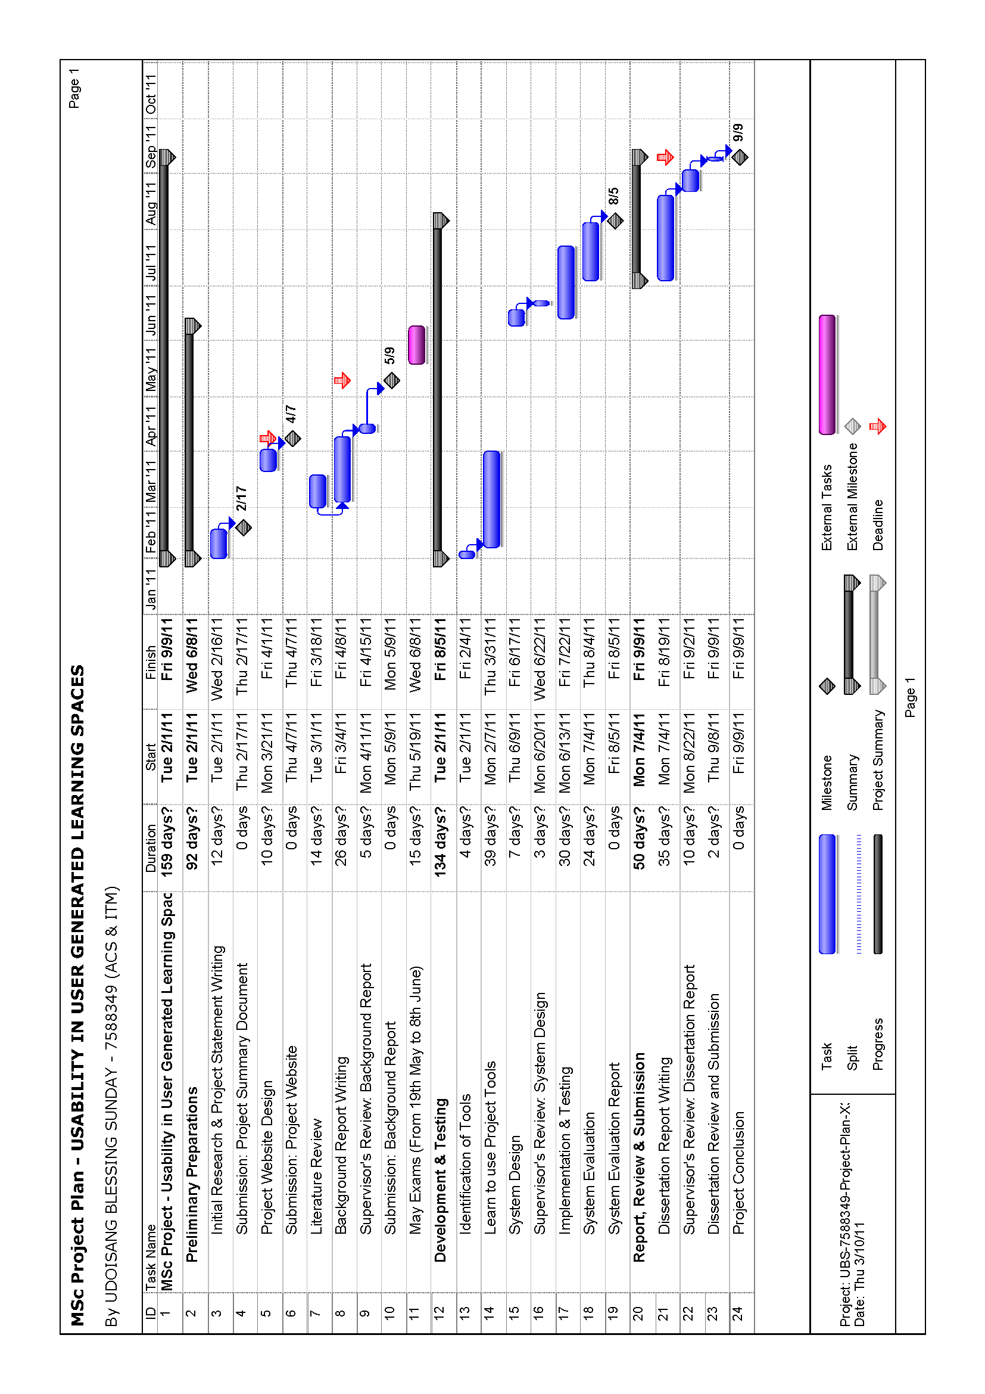

Hold Page

APPENDICES



[@TODO: Redraw this table in Fireworks: A comparison of learning Theories]