LEARNING SPACES DIANA G. OBLINGER (ED)
CH1
Spaces are themselves agents for change. Changed spaces will change practice. (Ref. JISC)

Learning is the central activity of colleges and universities. Sometimes that learning occurs in classrooms (formal learning); other times it results from serendipitous interactions among individuals (informal learning). Space—whether physical or virtual—can have an impact on learning. It can bring people together; it can encourage exploration, collaboration, and discussion. Or, space can carry an unspoken message of silence and disconnectedness. More and more we see the power of built pedagogy (the ability of space to define how one teaches) in colleges and universities.

Facets of learning space design:
- Learner expectations
- The principles and activities that facilitate learning, and
- The role of technology

Changes in our students (The Millennials), Information technology and our understanding of learning are the 3 driving forces behind the move to redesign learning spaces.

Today’s students—whether 18, 22, or 55—have attitudes, expectations, and constraints that differ from those of students even 10 years ago. Learning spaces often reflect the people and learning approach of the times, so spaces designed in 1956 are not likely to fit perfectly with students in 2006.

Many of today’s learners favor active, participatory, experiential learning—the learning style they exhibit in their personal lives. But their behavior may not match their self-expressed learning preferences when sitting in a large lecture hall with chairs bolted to the floor.

We have also come to understand that design is a process, not a product. Involving all stakeholders—particularly learners—is essential (Q: Is this not the basis of usability engineering?).

CH2
Emphasis: Active Construction of Knowledge by the Learner.

We can facilitate deeper and richer learning when we design spaces with learning in mind.

Learning takes place everywhere on a college campus. In fact, learning arguably happens everywhere—on city sidewalks, in airplanes, in restaurants, in bookstores, and on playgrounds. Human beings—wherever they are—have the capacity to learn through their experiences and reflections.

Torin Monahan used the term “built pedagogy” to refer to “architectural embodiments of educational philosophies.” In other words, the ways in which a space is designed shape the learning that happens in that space (@Ref). Examples surround us. A room with rows of tablet arm chairs facing an instructor’s desk in front of chalkboards conveys the pedagogical approach “I talk or demonstrate; you listen or observe.” A room of square tables with a chair on each side conveys the importance of teamwork and interaction to learning.

Strange and Banning (@Ref) asserted that “although features of the physical environment lend themselves theoretically to all possibilities, the layout, location, and arrangement of space and facilities render some behaviors much more likely, and thus more probable, than others.” Because we habitually take space arrangements for granted, we often fail to notice the ways in which space constrains or enhances what we intend to accomplish.

Chism and Bickford (@Ref) listed a number of typical assumptions on classroom, space and learning – See Page 18.

Environments that provide experience, stimulate the senses, encourage the exchange of information, and offer opportunities for rehearsal, feedback, application, and transfer are most likely to support learning.

@NOTE: The TRANSMITTER-CENTRIC Concept:
- Classes linked by straight corridors only (@NOTE: Corridor niches. No longer simply passageways)
- Faculty offices separated from classrooms
- Libraries without social areas?

The entry of large numbers of previously under-represented students—students from ethnic cultures that stress social interaction, older students, students blending work and learning—also calls for environments in which social interchange and experiential learning are valued. This demographic picture also favors standard adult furniture over juvenile tablet arm desks.

It makes better sense to construct spaces capable of quick reconfiguration to support different kinds of activity—moveable tables and chairs, for example (@NOTE: Drag and Drop Concept?).

Desired Characteristics of Learning Spaces:
- Flexibility
- Comfort
- Sensory Stimulation – Colours, Lighting, ambiance
- Decenteredness

We need basic research on the influence of the physical environment on creativity, attention, and critical thinking.

CH4
Community catalyzes deep learning and should be a critical consideration when planning physical and virtual learning spaces.

Were community not important for learning, colleges and universities would have little reason to exist—people could learn efficiently by reading and interacting with tutors.

Fostering community is critical to learning, regardless of whether an institution is primarily online, commuter, or residential.

We answer Boyatzis, Cowen, and Kolb’s challenge of finding ways to conduct education better by suggesting a focus on community and community building and by seeking ways in which community can enhance learning through three strategic levers:
- Improving the process of developing learning spaces
- Using information technology to enhance communication and collaboration
- Using community to improve pedagogical, curricular, and cocurricular environments

In conclusion, we explored three sets of strategic levers that can enhance learning through community processes: the design of spaces that support learning; the use of information technologies; and the design of structures for learning that encompass pedagogy, curriculum, and cocurricular programming.

Despite multiple theories about how people learn, they agree on one point: the critical role of interaction. In particular, social cognitive learning theory argues for a rich environment in which students and faculty share meaningful experiences that go beyond the one-way information flow characteristic of typical lectures in traditional classrooms (@Ref).

Some describe this as production-oriented education, with colleges and universities operating like manufacturing firms with students as throughput and graduates as the products (@Ref).

Community can and does form in the absence of significant faculty participation. However, faculty can have a tremendous positive impact on shaping, contributing to, and expanding the environment in which students learn.

In arguing that virtual learning (as well as spaces) should complement physical learning, use excerpt from page 52, In-class activities augmented by completing a significant amount of coursework online.

CH5
Today’s college students have been described as preferring learning experiences that are digital, connected, experiential, immediate, and social. Constantly connected, they seem to have no fear of technology or interacting with people they have not met face-to-face. Although they communicate a great deal online, they still want direct interaction with others. They appear to prefer learning-by-doing rather than learning-by-listening and often choose to study in groups. Much to the consternation of adults acculturated to lectures, they become impatient in situations where they don’t feel engaged.

Students’ comfort with the Internet means it isn’t “technology” to them—it may be a way of life.

See MIT’s Stream Café on Page 67, later.
See Stanford’s GroupSpace on page 70, later.

Neither learning nor socializing is one-dimensional; the physical complements the virtual, and vice versa. Since learning can occur any place and at any time, there are few—if any—locations where wireless is not valuable.

CH6
3 Fundamental Ideas from Environmental Psychology of Teaching and Learning
- First, all learning takes place in a physical environment with quantifiable and perceptible physical characteristics. Whether sitting in a large lecture hall, underneath a tree, or in front of a computer screen, students are engulfed by environmental information.
- Second, students do not touch, see, or hear passively; they feel, look, and listen actively. Students cannot attend to all the environmental information bombarding them at any given time; their ability to gather and understand incoming information is limited.
- Third, the physical characteristics of learning environments can affect learners emotionally, with important cognitive and behavioral consequences. Environments that produce positive emotional states can be expected to facilitate learning and the development of place attachment.

Specific targets within the environment draw the students’ attention, such as armchairs, scarves, and teacups, and they continuously monitor the ambient properties such as the light of the lamps, the smell of the kettle, and the warmth of the fire. In any learning environment students are awash in environmental information, only a small fraction of which constitutes the sights and sounds of instruction.
If I’m comparing the bold in terms of the virtual environment, one must note that such environmental information would be other activities on the device such as social networks, music, etc. Investigate more on this.

In any learning environment, students manage their limited cognitive resources by actively selecting environmental information for further consideration and by using existing knowledge structures to interpret this information in ways that have worked previously.

The 4 Amigos? The areas of psychology that relate most directly to classroom design and learning environments are environmental, educational, human factors (engineering), and social psychology. See ITIl-X1
@QUESTION: how has these (4 amigos) affected or will affect Virtual Learning Environments?

Previous research on the effects of such environment variables as light, temperature, and noise on learning has yielded some predictable results that are addressed through traditional classroom design. Learning appears to be affected adversely by inadequate light, extreme temperatures, and loud noises—variables maintained within acceptable ranges in most college classrooms.
@QUESTION: how can these findings help in designing Virtual Learning Environments? For example, can lighting be controlled in the Virtual Space such as the use of colours and the “Turn Down Lights Concept” where a faint gray gradient shades of the page background when watching videos in non-full screen mode. Temperature? Noise?
@NOTE: See Weistein for more. P76

Years of research on the impact of environmental variables on human thoughts, feelings, and behaviors indicate that other variables often moderate the effects of environmental variables.

Research on the impact of information technology on learning environments is not as voluminous. The presence and application of technology changes the learning environment, both directly and indirectly.
@THOUGHTS: If the presence & application of IT changes the environment, what happens when the environment is on the IT device itself?
@THOUGHTS: The sensory richness of Web sites and online games, what are those?

Today’s mobile devices convey social information, one of the most powerful targets of attention.

The Principles of ATTENTION:
Attention is perhaps best represented not as a single process but as an organized set of procedures through which we select specific environmental stimuli or inputs for cognitive processing.
It is commonly held that only one input is processed consciously. This could be called the attended input. All other environmental stimuli (for example, background noise, room temperature, etc) are processed unconsciously. These are the unattended inputs.
The attention controller determines which is currently being processed and switches attention by pushing other information into conscious awareness. See p78.
@THOUGHTS: Can we capture the attention controller in a virtual learning space and exploit it for good? For example the way changes are updated in the space, using subtle animation to steal the attention to the latest changes.

@THOUGHTS: The cocktail-party effect is very important here. How can we focus the Virtual user to the environment amidst the mixture of facebook conversations and skype ‘noises’ from friend? We can use the cock-tail party effect to capture users’ attention to particularly important events in the VLS. See 2nd to last paragraph on p79 for the classroom example.

@CRITIQUE: Some facts that hold true for physical learning spaces do not generally hold so for virtual ones. See this for example (p81):
The question of classroom density is an important one: Researchers have explored the psychological and educational effects of classroom density, both spatial (the size of the room) and social (the number of students). In their meta-analysis of 77 different studies on this issue, Glass and Smith concluded that higher social density results in lower student achievement.
@THOUGHT: I don’t think higher social density in VLS can lower achievement; rather, it should enhance collaboration, knowledge sharing and active participatory construction of knowledge. I need Literature proof mean-the-while.

Designers should also pay careful attention to the degree to which students feel crowded in a classroom. The experience of crowding in educational settings appears related to personal space violation.
@THOUGHT: how can this be translated into the design of the VLS?
And now, to the virtual side of life?
Today’s students spend an increasing amount of their time peering at computer screens. These virtual environments have physical characteristics that are just as real as those of a dormitory room or a brick-and-mortar classroom, and students can become just as attached to them.

A good example of a virtual world used as a classroom is Second Life, an online environment designed to support creativity, collaboration, commerce, and entertainment.
@INVESTIGATE: Second Life and usability. The usability designs and evaluations of Second Life Virtual 3D environment.

What impact does this have on classroom design?
First, campuses can expect the boundaries between virtual and brick-and-mortar learning environments to continue to blur. Students and instructors will need access to their virtual learning environments while seated in their brick-and-mortar classrooms.
Second, as campuses accept the notion that virtual spaces are actually classrooms, they can begin to apply the same care and consideration to decisions about course management systems and campus portals as they do to decisions about new construction and renovation. Of utmost importance is the usability of these virtual spaces. And this is where we, Blessing, come in! See p83.

As students enter a virtual or brick-and-mortar learning environment, they form a cognitive impression of that space and experience an associated emotional response, just as Harry Potter did when he entered his Divination classroom.

People’s preference for specific environments appears to depend on their cognitive impression. Kaplan and Kaplan22 suggested four cognitive determinants of environmental preference: Coherence, Complexity, Legibility, and Mystery.

It is possible to build learning environments from both brick-and-mortar and bits-and-bytes that draw students in and elicit a sense of mystery and enchantment. See p84. Good for concluding remarks.

CH8
Informal Learning Spaces
What are informal learning spaces? In Educating the Net Generation, Malcolm Brown defined them as “those outside the classrooms.” He observed that in a world where wireless connectivity is increasingly ubiquitous, and with wireless devices that enable navigating a proverbial sea of digital resources, practically anywhere but the classroom is an informal learning space.

More abstractly, informal learning spaces are those in which learners live and learn at their discretion. They choose the time and the place to address the work that flows from formal learning spaces.

In this environment, learners choose the locations where they feel most empowered—and most comfortable—to complete the work at hand. In places they see the best support for their way of working, they feel safe and so return frequently, knowing they can move through material and concepts on their terms. In places where they feel discomfort, a lack of connection to space and infrastructure, they leave.

CH9
TRENDS IN LEARNING SPACE DESIGN
This chapter examines significant trends in learning space design, both in new construction and in renovation, and relates them to learning theory and technological advances

Three major trends inform current learning space design:
- Design based on learning principles (Theories), resulting in intentional support for social and active learning strategies.
- An emphasis on human-centered design. (The subject of CH10)
- Increasing ownership of diverse devices that enrich learning.
These trends have been catalyzed by constructivism, digital technology, and a holistic view of learning.

The emergence of the constructivist learning paradigm has led to a focus on learning rather than teaching. It allows us to re-evaluate classrooms and to consider informal learning spaces as loci for learning.

The emphasis on learning means that we must also think about the learner. Learning spaces are not mere containers for a few, approved activities; instead, they provide environments for people.
@LINK: Can we link this to the environment factors in CH6?

The learning literature agrees that learning can be enhanced, deepened, and made more meaningful if the curriculum makes the learners active participants through interactivity, multiple roles (such as listener, critic, mentor, presenter), and social engagement (such as group work, discussion boards, wikis). Hence, it is no surprise that learning spaces—classrooms as well as informal spaces—have an increasingly important role in catalyzing this type of learning.

@NOTE:
While platforms and applications come and go, the psychology of how people learn does not.

Constructivist learning principles, specifically activities identified as encouraging learning, can be translated into design principles that guide tactical decisions, ensuring that the designs we build and the technology we deploy serve a clear educational purpose.

@NOTE: Human Centered Design
Faculty and students are the product experts, while the architect is the space development expert. Shifting the focus to users of the space links the process to the human-centered design outcome. It also emphasizes learning activities rather than resources as the driving factor: people and learning, not managing capital goods, must take precedence.

Creation of a systems design requirements document with input from a wide variety of faculty, students, teaching and learning professional staff, facilities staff, and security and maintenance professionals.

Systems Design Requirements An initial prerequisite to building a space that increases learning effectiveness is understanding what kinds of teaching and learning activities the space should enable. This entails identifying the demands for curriculum, learning, laboratory, and workshop activities that the space must meet.
@THOUGHT: Hope to see more of this in CH10
With a clear definition of the learning goals, space design becomes grounded.

Our growing understanding of how people learn affects the configuration of learning spaces and the technologies supporting them. The constructivist paradigm supplants knowledge transmission as the guide for learning spaces.

You can’t build effective spaces for learning without clearly understanding the learning activities intended for them.

@INMYOWNWORDS
In making design decisions for learning spaces, people, not the latest technology should be the focal point and determining factor. This is the focus of Human-Centered Design.

CH10: Human-Centered Design Guidelines
Current design standards begin with the premise that learning happens in a limited set of ways, thus a finite set of space configurations support them. This industrial, instruction focused approach arose from the necessity of accommodating large groups of students at the lowest cost.

Human-centered design guidelines build on the premise that learning happens in many ways and that the design possibilities supporting learning are equally numerous. Despite multiple design possibilities, however, there is just one desired outcome: to enrich learning and teaching. As a result, human-centered guidelines are predicated on universal human needs and learning principles.

Human-centered design concerns process as much as results. Traditional processes are often linear, meaning that with funding approved, the learning space development gets turned over to an architectural and design firm and/or facilities team, with little continued representation from educators.
@THOUGHT: This same viral issue has crept into the design of Virtual Learning Spaces. As soon as funds are approved, the designed is handed over to so-called 'Software Engineers' who are more after delivering cutting edge software than focusing on the usability of the product to the intended customers - the learners.

Foundations of the Guidelines: People are at the center of learning, so their needs should be at the heart of a human-centered design process.

The First Priority: Basic Human Needs
Humans seek both physical and psychological comfort. Judith Heerwagen talked about a person’s sense of well-being and how it influences productivity, creativity, and engagement. Her research has focused on four elements that must coexist to create positive and productive places:
- Cognitive effectiveness,
- Social support,
- Emotional functioning, and
- Physical function.
If people aren’t comfortable and don’t have a sense of well-being, they become distracted.

Diversity abounds; individuals learn in different ways. See p129 for more on this.
Variety Factor: Space should be fluid so that it can accommodate different learning and teaching styles effortlessly. See p 129

The 12 brain/mind learning principles articulated by Renatta Caine. See p130

@THOUGHT: Lori Gee Focuses on the classroom as the core of learning in outlining the guidelines, how can we relate these to the VLS?

This approach is holistic. Although I address each characteristic individually here, it is their interplay that creates human-centered learning spaces.

Guidelines (See from p131):
- Healthful
- Stimulating
- Balancing Community and Solitude
- Adaptable

We will know we have succeeded in human-centered design when spaces support learning and create a positive experience.

CH11
@NOTE: There exists a relationship between physical and virtual spaces
Figure 1 illustrates the point that physical context shapes the interface to virtual spaces; the experience of using virtual spaces changes depending on the nature of the physical space from which one or more people access it.
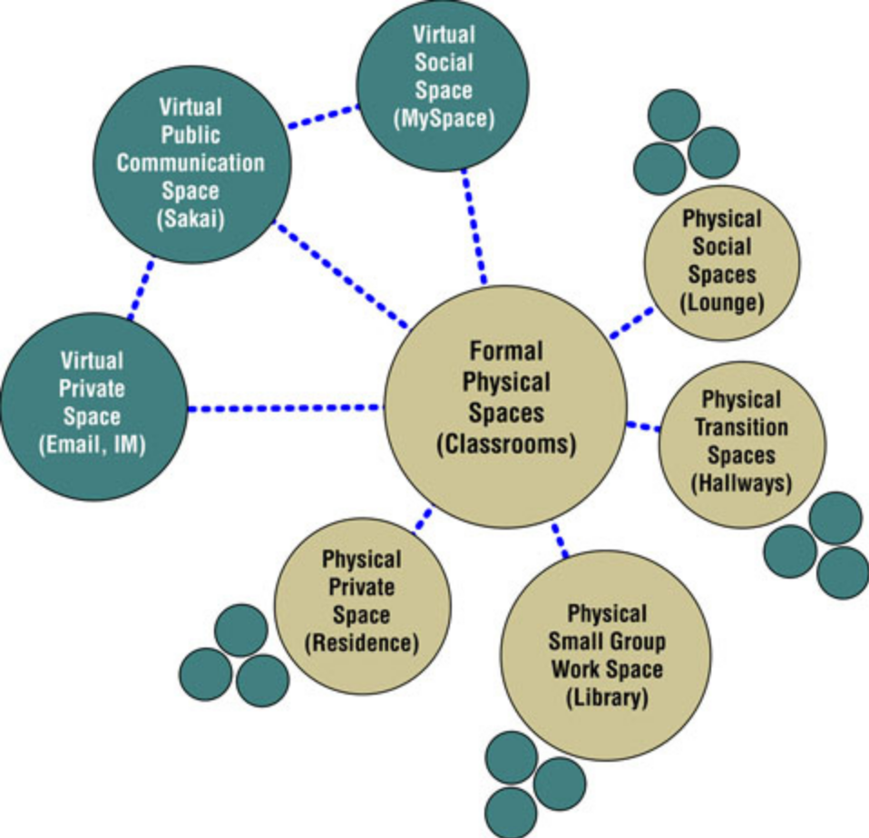

See p152 for more on the image below
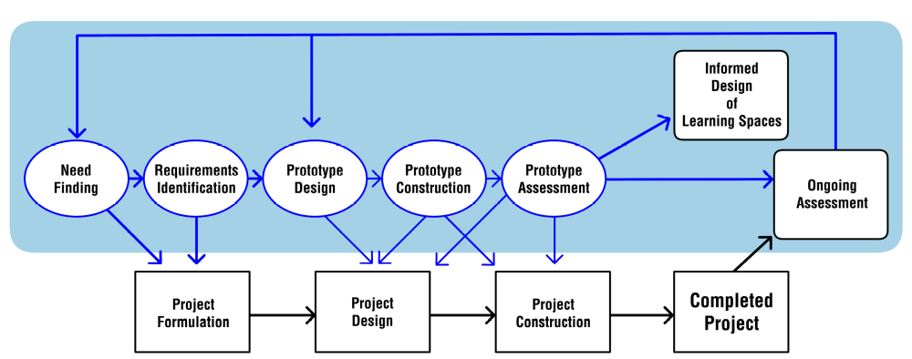

h

IMPORTANT THEMES IN LITERATURE
- Learning Theories
- Community Learning Theories (Learning Cm, Research Cm, Cm of Practice)
- Physical and Virtual Learning Spaces – Complementing or Distracting
- Personal Space (Personal Space Violation, Learning Spaces, p81)
- Social Spaces
- Formal Spaces – Classrooms, Labs Informal Spaces – Corridors
- The Environmental Psychology of Teaching and Learning
- Re-conceptualize learning spaces to facilitate active, social, and experiential learning.
- Enabling learning activities that are distributed in time and space (VLS).
- Effective Learning Spaces
- Literature on the influence of physical space on human activity (@Dig)
- Cognitive theory, and descriptions of the new student demographics (@Dig)
- Demographics of the Student Population (Older, disabled, social, tech-savvy, tech-null, etc)
- Community Learning Theories
- Student Practices and their impact on learning spaces
- The use of Physical Space Theory cognition to understand and improve Virtual Spaces
- I’ve noticed that while a lot of work has been done relating to the Psychology of Physical Learning Spaces, none or a few has been done with regards to Virtual Learning Spaces, so what do we do? Depend on user evaluation only? (ITIL-X1)
- The Role of Social Information (x2.0) in enhancing the usability of VL Spaces (See Learning Spaces, p77).
- The psychological and educational effects of classroom density (See Learning Spaces, p81).
- Investigate: The integration of Learning Commons with Virtual Learning Environments (Individually and Group Collaborations)
*******

MORE RESOURCES NEEDED
Diana G. Oblinger, “Boomers, Gen-Xers, and Millennials: Understanding the ‘New Students,’” EDUCAUSE Review, vol. 38, no. 4 (July/August 2003), pp. 37–47, <http://www.educause.edu/ir/library/pdf/erm0342.pdf>.

George D. Kuh et al., Student Success in College: Creating Conditions That Matter (San Francisco: Jossey-Bass, 2005).

Carol S. Weinstein, “The Physical Environment of School: A Review of the Research,” Review of Educational Research, vol. 49, no. 4 (Autumn 1979), pp. 577–610.
IBM Design Principles: https://www-01.ibm.com/software/ucd/designconcepts/designbasics.html

The difficult challenge is finding a balance between familiarity and usability when designing and developing objects that are meant to serve some sort of purpose within Second Life. http://www.virtuallearningworlds.com/?p=186

http://www.usernomics.com/user-experience.html

12 Brain/Mind Learning Principles in Action: Developing Executive Functions of the Human Brain
http://www.amazon.com/Brain-Mind-Learning-Principles-Action/dp/1412961076/ref=dp_ob_title_bk

SEMI FORM OF INTRODUCTION?
Three major trends inform current learning space design:
- Design based on learning principles, resulting in intentional support for social and active learning strategies.
- An emphasis on human-centered design.
- Increasing ownership of diverse devices that enrich learning.
These trends have been catalyzed by constructivism, digital technology, and a holistic view of learning.

It is interesting to note how old learning theories have been in existence. Over the years, people have always been interested in understanding the way people learn, the way knowledge is discovered, constructed, distributed and persisted in time and space.

http://www.seesaw.com/TV/Drama/p-9258-Episode-1

