RICH ALUCARD: BEFORE THE FAME

BLOOD MIRROR
Whole-Game UX, Voice & First-Walkthrough Giga Pack
FOR OVERLORD CURATION · 30 SEP 2026

SPOILER FIREWALL
Ube may read the MASTER DOCX, UX frames, Voice Bank, and Pre-Walkthrough Baseline.
Do not show Ube the sealed post-walkthrough file until he explicitly says FIRST PLAYTHROUGH COMPLETE.

Package thesis: Protect the weirdness. Verify the seams. Let the first walkthrough stay clean.

0. How to Use This Pack
What this is
A single handoff package combining spoiler-safe UX reference frames, exact OPEN-authored voice lines, AI-agent playtest synthesis, pre-walkthrough questions, a sealed post-walkthrough debrief, source attachments, and explicit Overlord curation authority.

Recommended reading order for OVERLORD:
- Read Sections 1–7 of this MASTER DOCX.
- Review the raw source attachments and the additional-agent compendium.
- Reproduce high-severity findings on the current accepted candidate before issuing repair tickets.
- Add any missing decision-support material using the Overlord Curation Brief.
- Give Ube only the spoiler-safe surfaces before his first uninterrupted walkthrough.
- After Ube explicitly says FIRST PLAYTHROUGH COMPLETE, open the sealed post-walkthrough debrief.

Packet Contents
Folder / File | Purpose
MASTER DOCX | This document: spoiler-safe frames, line bank, research synthesis, test strategy, pre-walkthrough baseline, evidence rules.
01_SPOILER_SAFE_UX_FRAMES | Six reconstructed non-story UX reference frames. They are schematic, not production screenshots.
02_VOICE_BANK | 20 exact OPEN-authored Rich Alucard lines/choices with context and voice signal.
03_UXR_EVIDENCE | Affinity map + additional agent compendium.
04_PRE_WALKTHROUGH | Questions Ube should answer before the first clean walkthrough.
05_POST_WALKTHROUGH_SEALED_DO_NOT_OPEN | Hidden debrief. Do not show Ube early.
06_OVERLORD_CURATION | Explicit authority for Overlord to add missing material and gate fixes.
07_SOURCE_ATTACHMENTS | Raw P1/P2 reports, current handoff, OPEN source docs, Underlord history export.

1. Evidence Rules & Research Hygiene
This pack deliberately separates findings by evidence type. AI-agent feedback is useful but uneven: some agents performed blind runtime playtests, some ran partial sessions, some used dev calls, and some did source/code audits. Do not flatten them into one fake sample.
OBSERVED — Directly experienced in runtime by an agent.
MULTI-TESTER — Independent agents converged on the same issue/strength.
CODE-AUDIT — Found in source or state logic; may not have been felt by a normal player.
CREATOR SELF-PLAY — Ube's own direct feel test; high taste authority, not independent validation.
CURRENT-STATE — Supported by the latest accepted handoff/branch.
SUPERSEDED — Observed on an older candidate and must be reproduced before action.
TASTE — Subjective preference. Never auto-convert to a bug ticket.
SOURCE_REQUIRED — Cannot be settled without authoritative authored source.
Critical current-state caveat
Most whole-game AI playtest evidence targets WHOLE-GAME CANDIDATE 001 at SHA 7a3c2ee8…. Later production state evolved. F01/THE PLAY and F06/Rainmaker have explicit feel locks in the latest handoff. Treat older findings as hypotheses until reproduced on the current candidate.

2. Critical Spoiler-Safe UX Frames
These six frames are intentionally reconstructed reference frames rather than literal production screenshots. They let Ube and Overlord discuss information architecture, hierarchy, interaction language, and feel without exposing story beats. OVERLORD should replace them with literal current-build captures only if the captures remain spoiler-safe.

Phone Home
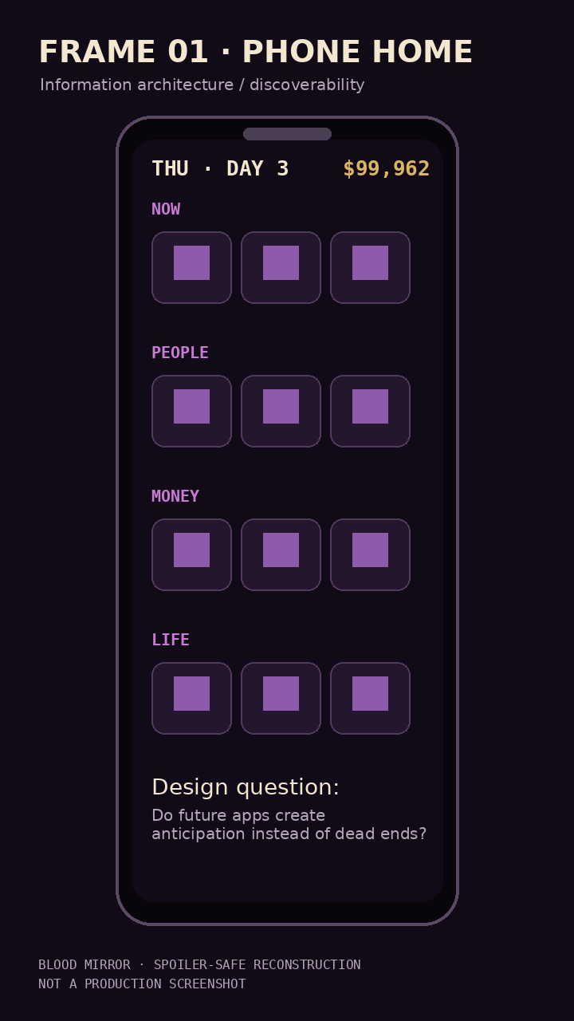
Core IA: NOW / PEOPLE / MONEY / LIFE, balance/date, future app discoverability. Review whether the phone feels like Rich's life rather than a menu.

Texts / Event State
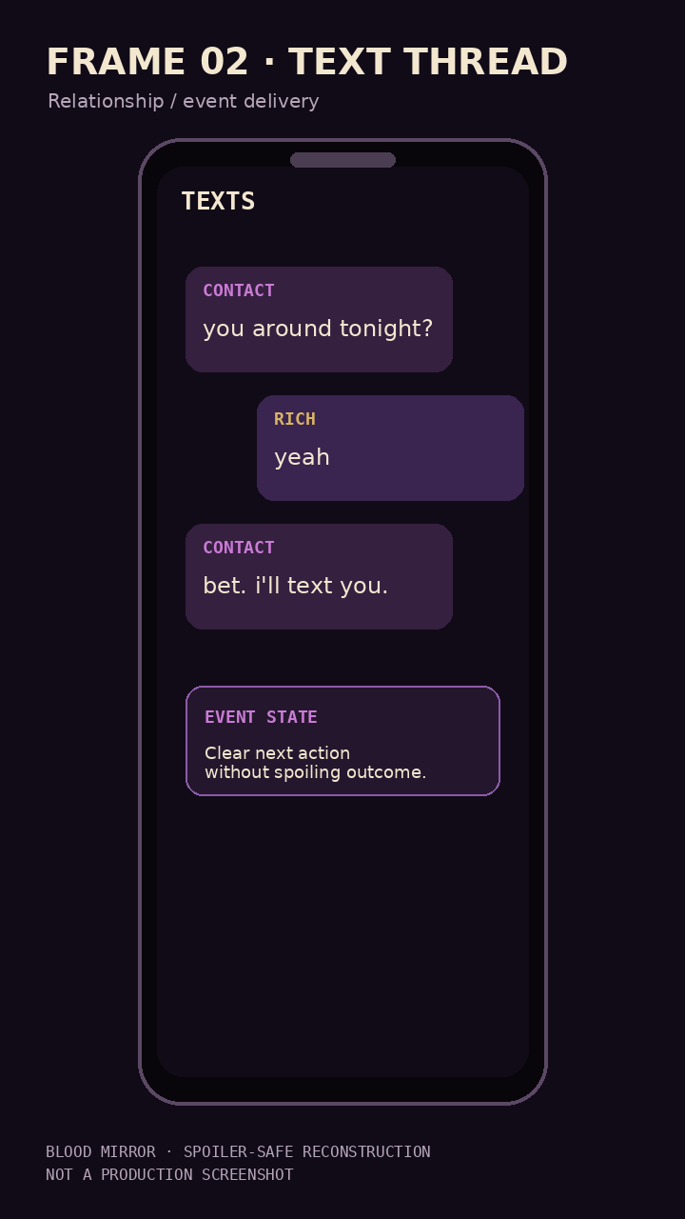
Event affordance without revealing the surprise. Review whether “tonight / later / available now” is clear while outcome remains unknown.

Non-story Combat HUD
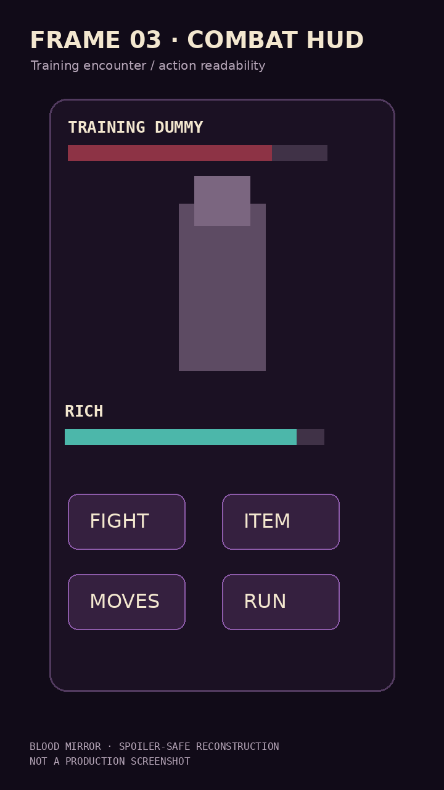
Training-only action readability. Review command hierarchy, state reset, touch targets, and whether combat looks trustworthy after transitions.

THE PLAY Live Feed
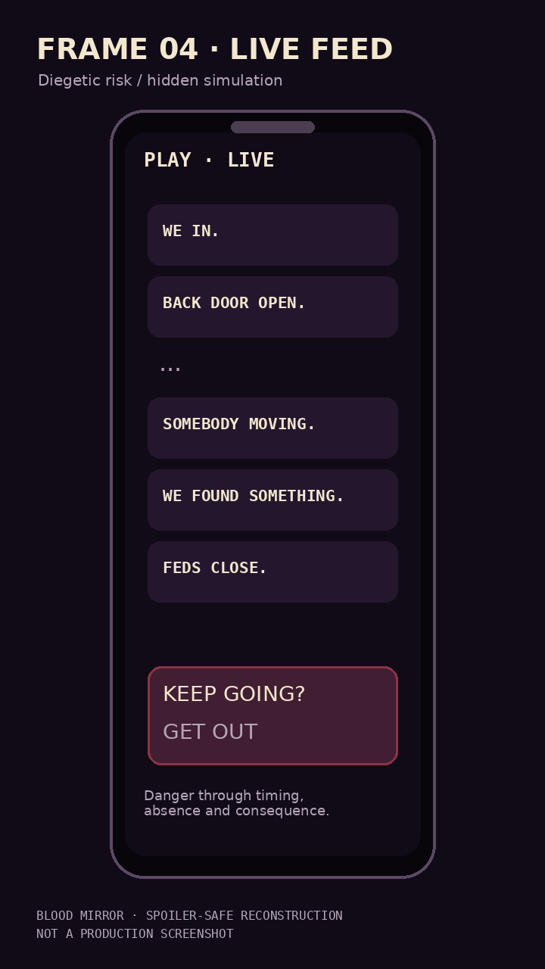
Sparse diegetic information. Review whether danger is felt through timing, absence, and consequence rather than visible simulation math.

Rainmaker
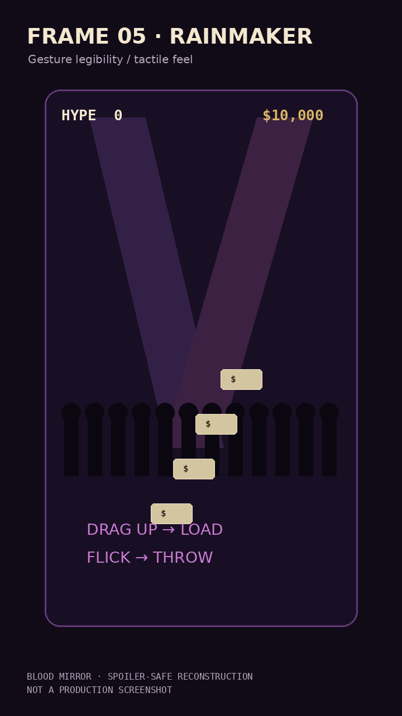
Gesture legibility and tactile money-as-object feel. F06 feel is already approved; use this frame for integration/accessibility discussion, not redesign.

Money / Property
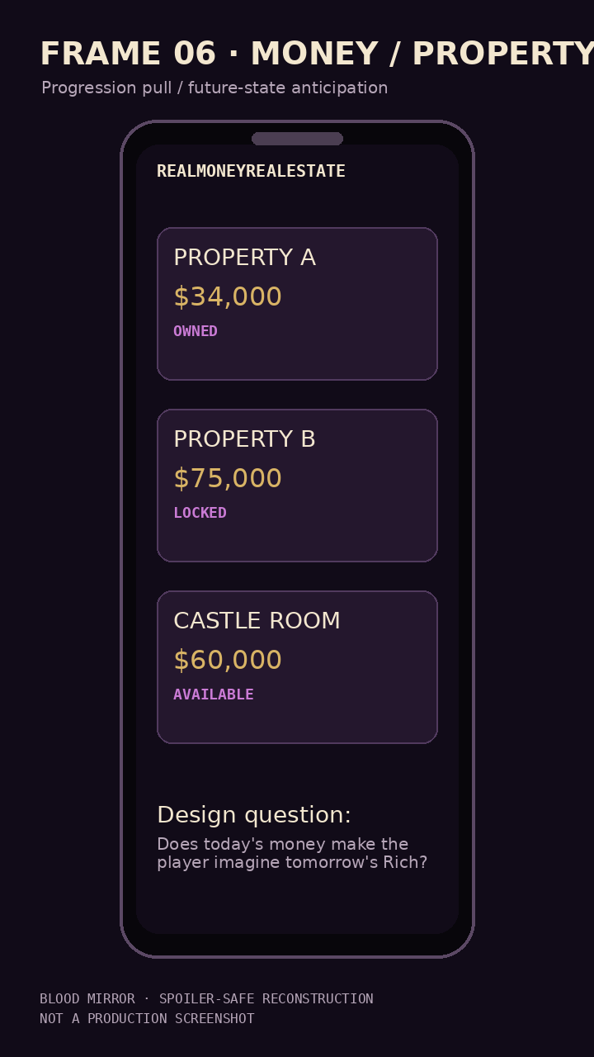
Forward-pull frame. Review whether the interface helps the player imagine tomorrow's Rich, not merely today's balance.

3. Voice Calibration — Exact OPEN Line Bank
Goal: give Ube material he can safely rewrite / react to in his own voice without reading story outcomes. These are exact lines from OPEN source. Some are authored source rather than verified current-runtime lines, so the implementation status must not be silently implied.
Exact line | Spoiler-light context | Voice signal | OPEN source
“shi. at least it's something.” | Frustrated persistence. | Understated; resignation is the joke. | Vol 1
“…oh. there's other ways out.” | A lateral solution clicks. | Short realization; no lore speech. | Vol 1
“this taste like a candle. i love it.” | Unexpectedly likes a drink. | Specific, dumb-sweet, sensory. | Vol 1
“this shit is crazy. i came in here for za.” | Ordinary errand turns bizarre. | Mundane motive vs supernatural escalation. | Vol 1
“blueberry mazda. that's your name. don't ask me why.” | Names something on instinct. | Arbitrary confidence + affection. | Vol 1
“i'm not looking at it. tell me when it's gone.” | Refuses to face something gross. | Cool façade cracks humanly. | Vol 1
“blood in my locs. this shit is crazy.” | Aftermath of a chaotic night. | Physical specificity; annoyance + swagger. | Vol 1
“…somebody gotta wash this.” | Messy aftermath. | Tiny domestic consequence; no over-writing. | Vol 1
“YOU DIED IN MY HALLWAY” | Combat roast. | Petty, personal, situational. | Vol 3
“ALL Y'ALL NAMED KEVIN?” | Combat roast. | Observational absurdity. | Vol 3
“GET FOOD WHILE HE CHARGES” | Lateral combat solution. | Practical, ridiculous, unheroic. | Vol 3
“YOU WANNA BE ON MY SQUAD?” | Recruit instead of fight. | Confidence treats danger like networking. | Vol 3
“IT'S BEEN THREE DAYS” | Calls out absurd commitment. | Dry observation. | Vol 3
“I DON'T EVEN DRINK COFFEE” | Character-specific roast. | Personal context is the punchline. | Vol 3
“YOU DON'T EVEN LIKE THEM” | Uses social knowledge. | Familiarity becomes leverage. | Vol 3
“CLOSE YOUR MOUTH” | Charisma response. | Authority through simplicity. | Vol 5
“WE CAN SEE YOUR FOOD.” | Roast. | Juvenile but situational, not generic. | Vol 5
“WHAT'S IT COST MY PEOPLE?” | Asks about human cost before danger. | Concern without moral monologue. | Vol 7
“…brother. This is crazy.” | Reaction to extreme proposition. | Minimal; lets situation carry weight. | Vol 7 — Ube may overwrite
“NAH.” | Declines an offer. | One-word confidence; no explanation. | Vol 7

Voice pattern
Rich tends to work best when he is shorter than a normal RPG protagonist, reacts to specific physical/social details, assumes confidence rather than announcing it, uses petty/deadpan/lateral humor, can care without becoming verbally earnest, and is allowed to use silence or one-word answers.

Ube Rewrite Test
- Would I say this out loud?
- Is it too explanatory?
- Is the joke specific to this exact situation?
- Could it be 30% shorter?
- Is Rich trying to sound cool, or is he simply cool?
- Does the line know something about the person/place/object in front of him?
- Would silence be better?

4. AI-Agent User Testing — Affinity Map
The full map lives in 03_UXR_EVIDENCE/AI_PLAYTEST_AFFINITY_MAP.md. Below is the master synthesis.
Affinity | Direct quote anchors | Disposition | Interpretation
Authored World / Distinctive Voice | “It never feels generic.” / “singular, unmistakable voice.” | PROTECT | Specificity is a product advantage, not ornamental flavor.
Cross-System Payoff | “this isn't just a visual gag” / exploration directly into combat survivability | EXPAND DEPTH | Jokes, people, places and purchases are strongest when they become mechanics/consequences.
Progression Creates Forward Pull | “Yes — with genuine enthusiasm.” / “one more day” | PROTECT | Money works when the player can imagine tomorrow's Rich.
Phone as Diegetic World Interface | “a genuine custom mobile OS” | PROTECT / CLARIFY | System information feels better when it arrives as Rich's life.
Discoverability / Mental Model | “A player on mobile would wonder if the game froze.” / `LOCKED · NO TAGS` | REWORK | Keep mystery about outcomes; remove uncertainty about what can be done.
Friction Interrupts Flow | “navigation bottlenecks” / repeated ladder clicks | TRIM | Curiosity is high enough that redundant clicks become expensive.
Visible Response = Polish | “exceptionally clever and expressive” / “felt visceral” | EXPAND RESPONSE | Physical reaction makes systems feel alive.
State / Transition Reliability | “CRITICAL SOFTLOCK” / false impression progress was lost | FIX FIRST | Broken seams destroy trust and make mystery look like malfunction.
Hidden Simulation / Visible Consequence | “hidden auto chess” / “tony got shot!” | F01 FEEL LOCK | Depth does not require visible complexity.

Top Product Insight
CORE UX THESIS
Rich Alucard is strongest when the player feels they are living Rich's life rather than operating a game system. The spell breaks when the player stops inhabiting the world and starts debugging the interface in their head.

5. How to Respond to What AI User Testing Learned
The research should change the order of work more than it changes the scope of the game.
Action | What it means | Why
Verify first | Re-run old P0/P1 findings on the current accepted candidate. | Do not repair a superseded bug.
Protect feel locks | F01/THE PLAY and F06/Rainmaker are already feel-approved in the latest handoff. | Integration can fix seams; it should not casually redesign feel.
Fix trust blockers | Softlocks, pointer interception, save/reload ambiguity, impossible routes, dev overlays. | These contaminate every later taste judgment.
Clarify without spoiling | Make available actions legible while outcomes remain mysterious. | Good mystery ≠ unclear controls.
Connect before expanding | Prefer existing-system reactions/callbacks over a new standalone feature. | Depth > width.
Delay taste repairs | Do not pre-fix one agent's pacing/joke preference before Ube's clean read. | Let Ube establish taste authority on the whole experience.
Capture rather than coach | Log Ube's session; do not explain or prompt unless a true blocker occurs. | Protect first-impression data.

Overlord suggestions before Ube's first walkthrough
- Freeze one first-walkthrough candidate and record its exact SHA/build ID.
- Run a spoiler-blind smoke focused only on boot, save/reload, input, navigation, required route reachability, and scene cleanup.
- Remove/collapse dev overlays from the surface Ube will play.
- Prepare a silent rescue protocol: if Ube hits a true blocker, fix/route it without explaining upcoming content.
- Do not show Ube the AI testers' story-specific favorite moments, surprises, or future-content wishlists.
- Do not turn the AI playtest into a pre-emptive polish marathon. Preserve a real first read.
- Record timestamps / screen capture if Ube is comfortable, so his natural pauses, replays, confusion, laughter and abandonment points are available afterward.
- After the run, open the sealed debrief before showing him the full spoiler-heavy research.

6. Pre-Walkthrough Questions for Ube
Ube should answer these before the first clean walkthrough. They are intentionally non-leading and create an expectation baseline.
- In the first 10 minutes, what do you most want to feel?
- What would make you think, “this is unmistakably Rich Alucard”?
- What would make you think, “this feels like an AI/prototype game”?
- How much explanation do you naturally want from a game before you prefer to discover things yourself?
- What kind of confusion is fun to you? What kind is immediately annoying?
- What would make you stop playing during the first hour?
- What would make you say “one more day” or “one more run”?
- How important is it that money visibly changes Rich’s life rather than only changing a number?
- How important is it that people / the world react later to things you did earlier?
- When you imagine the phone, should it feel more like a menu, a social world, a command center, or something else?
- When you imagine danger, what should make you nervous: losing money, people, possessions, status, time, something else?
- How much dead air / silence / waiting do you enjoy when it is building tension?
- How much repetition are you willing to tolerate for atmosphere?
- What kinds of jokes are most “you”? What kind immediately feels corny?
- What three existing Rich Alucard things are non-negotiable to preserve?
- What three things are you completely willing to cut if they do not earn their place?
- If you could only judge one thing in the first walkthrough, what would it be?
- What would “finished enough to share with somebody I care about” feel like?
- What do you want to forget before playing so the game can surprise you?
- Write one sentence completing: **“Rich Alucard should feel like…”**

7. First Walkthrough Protocol
Research objective
Do not test whether Ube can find the same issues the agents found. Test whether the integrated game produces the experience Ube intended when nobody is coaching him.

BEFORE: Confirm candidate SHA; fresh-save path; normal surface; dev clutter hidden; capture/log ready; pre-walkthrough baseline answered.
DURING: No questions from observers. No hints. No narration of what's supposed to happen. Only intervene if a blocker prevents continued play.
IF BLOCKED: Record exact moment, input, visible state, and last successful action. Apply the smallest rescue necessary. Do not reveal future route logic.
AFTER: Let Ube speak freely first. Only then open the sealed post-walkthrough questions and conduct structured debrief.
SYNTHESIS: Sort into KEEP / CUT / EXPAND / REWORK / DO NOT TOUCH, with BUG and SOURCE_REQUIRED tracked separately.

8. Overlord Discretion — Add What the Packet Still Needs
Ube explicitly authorizes OVERLORD to decide what else this pack needs. The curation brief in 06_OVERLORD_CURATION is the authority surface.
- Current-build verification matrix (old finding → current status).
- Pre-walkthrough P0/P1 blocker list.
- DO NOT TOUCH BEFORE UBE PLAYS list.
- Spoiler-safe acceptance criteria for phone/navigation/combat state.
- Voice-risk shortlist for any new Rich dialogue.
- Rescue protocol and logging plan.
- Evidence-confidence tag on every repair recommendation.
- Post-playthrough synthesis shell.
Overlord's highest-value question
What must be true so Ube's first walkthrough judges the game itself rather than the seams around it?

9. Source Inventory & Attachment Map
Attachment | Use
P1_WHOLE_GAME_400_TURN_REPORT.txt | 400-turn / 3-day evaluator; strongest progression and retention evidence.
P2_WHOLE_GAME_BLIND_REPORT.txt | Fresh-save blind evaluator; strongest discoverability / state-transition evidence.
AI_PLAYTEST_AFFINITY_MAP.md | Formal affinity clustering and synthesized insights.
ADDITIONAL_AGENT_PLAYTEST_COMPENDIUM.md | Combat spectacle, code audit, nostalgia, adult, skeptical-gamer, comedy and freedom/GTA lenses.
CURRENT_UNDERLORD_ONBOARDING_2026-09-30.docx | Latest production-state authority in this packet.
UNDERLORD_HISTORY_EXPORT_THROUGH_2026-09-30_0115.md | Large historical source for prior feel tests, decisions and prompts.
Rich_Alucard_BTF_Vol1_Master_Plan_OPEN.docx | OPEN source for voice, world loops, progression.
Rich_Alucard_BTF_Vol3_Numbers_OPEN.docx | OPEN numeric/combat source and exact lines.
Rich_Alucard_BTF_Vol5_Dragon_Maggi_Cube_OPEN.docx | OPEN world/character source and exact lines.
Rich_Alucard_BTF_Vol7_PLAYMAKERS_OPEN.docx | OPEN THE PLAY/War Room source and exact lines.
GRAND_OVERLORD_DOCUMENT_OPEN.docx | Project law, spoiler discipline, scope-control context.
SEALED_UNTIL_FIRST_PLAYTHROUGH_COMPLETE.md | Hidden post-playthrough interview guide.

10. Do-Not-Spoil Boundary
The MASTER DOCX deliberately avoids late-game story outcomes, hidden SEALED/HQ material, and post-playthrough prompts. The raw whole-game playtest attachments contain story specifics and should be treated as OVERLORD-only until Ube finishes his first walkthrough.
For Ube now
Safe: MASTER DOCX, reconstructed UX frames, exact OPEN Voice Bank, Pre-Walkthrough Baseline.
Not safe: raw agent reports, additional-agent compendium, Underlord history export, sealed post-walkthrough guide.

11. Final Operating Principle
PROTECT THE WEIRDNESS.
VERIFY THE SEAMS.
LET THE FIRST WALKTHROUGH STAY CLEAN.

Then: KEEP / CUT / EXPAND / REWORK / DO NOT TOUCH.

