UNDERLORD — CHARACTER RELATIONSHIP PACKET V0.1

Rich Alucard Character Routes (DRAFT)

Purpose
This packet is being sent to UNDERLORD / OVERLORD for brainstorming and polish.
Important:
• The ideas below are the creator's rough notes.
• Treat these as canon intent.
• Do not rewrite the personalities.
• Preserve the creator's voice.
• These routes exist independently of the main story. They are unlocked through the strip club system.
• The player chooses one of the three dancers to support. Throwing enough money to a specific dancer unlocks her 'She fw Me Levels.'
• These routes should require minimal interaction with the main game except where it naturally strengthens both stories.
• The creator's notebook is reference material. Polish pacing, dialogue, gameplay integration and emotional payoff while preserving the creator's vision.
The goal is for these characters to become people players genuinely care about, not simply attractive NPCs.

Creator Notes (VERBATIM)
The notebook pages are the primary creative source. Clean for readability only. Preserve intent.

🐺 Roxy (Final Design)
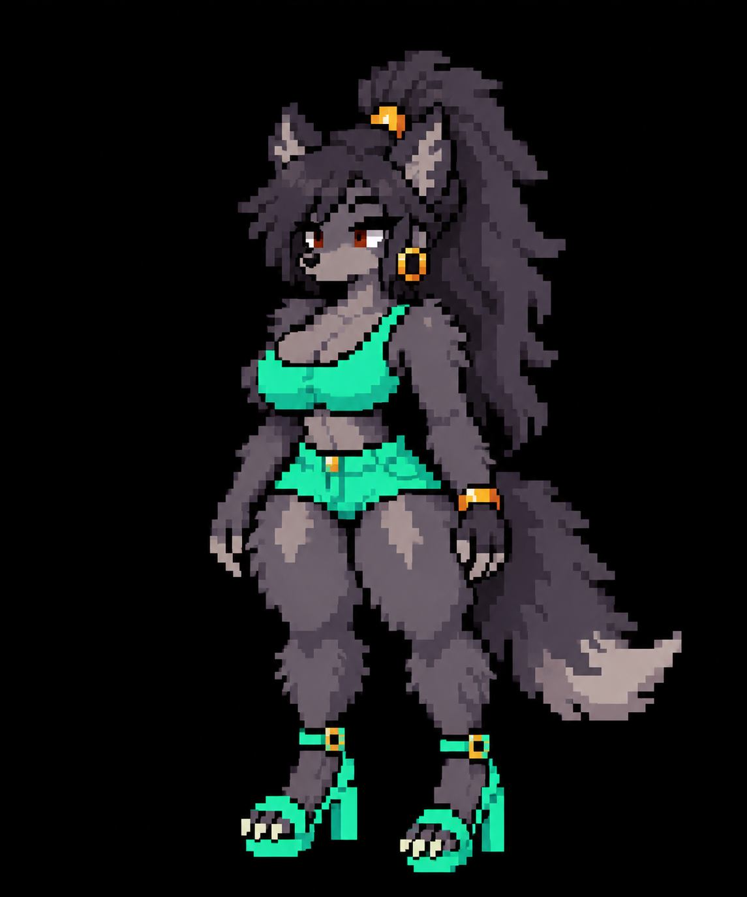

🌹 Rosalyn (Final Design)


🐉 Emerald (Final Design)
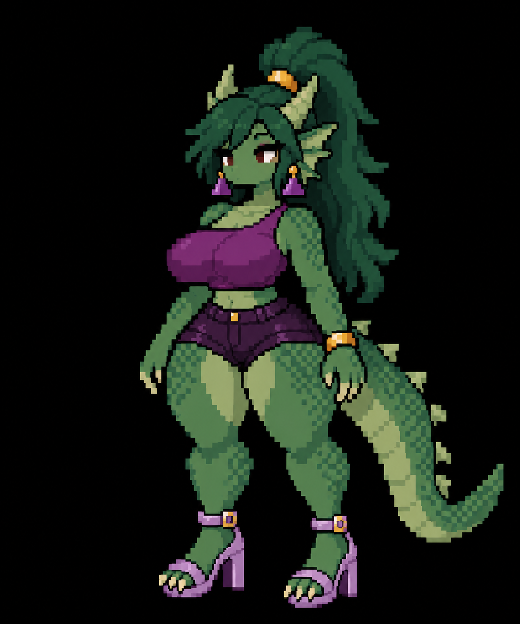
## 🐺 Roxy
### She fw Me Level 1
- Roxy is confident.
- She strips because she wants ownership over her own future.
- She's studying data science.
- She doesn't split the bill.
- She pays the whole thing.
- She gives Rich her number.
### She fw Me Level 2
- Boxing gym date.
- She's surprisingly competitive.
- Afterwards they eat ramen.
- Talks about loving animals.
- Says she hates cats.
### She fw Me Level 3
- Rich notices something feels different.
- During boxing she takes a hard hit.
- Rich asks if she's okay.
- She quietly says:
"...I've gotten used to it."
She immediately changes the subject.
Nothing is explicitly explained.
### She fw Me Level 4
- Roxy gets sick.
- Rich brings food over.
- They watch vampire movies together.
- Their relationship naturally becomes romantic.
Core Thought:
"If I rely on someone, I'll get hurt."
## 🐉 Emerald
### She fw Me Level 1
- Emerald asks Rich to help clean the castle.
- They bond while working.
- Afterwards they eat ramen.
### She fw Me Level 2
- Rich learns she's studying pre-med.
- She calls her father every day.
- Sends money home.
- She works because her family depends on her.
### She fw Me Level 3
- Emerald panics after losing something very important.
- She asks Rich for help.
- This is one of the first times she truly depends on someone else.
### She fw Me Level 4
- Emerald invites Rich to a recital.
- Rich discovers singing—not medicine—is her true passion.
- Rich encourages her to believe she deserves dreams of her own.
Core Thought:
"My responsibilities matter more than my dreams."
## 🌹 Rosalyn
### She fw Me Level 1
- Fancy restaurant.
- Rich offers to pay.
- She insists on splitting it exactly in half.
- She mirrors Rich's opinions.
"I like what you like."
Rich leaves thinking "...something felt off."
### She fw Me Level 2
- Boba date.
- Rich casually mentions Yuck Wars.
- Rosalyn lights up.
- Starts nerding out.
- Suddenly realizes she's exposing herself.
- Runs away embarrassed.
### She fw Me Level 3
- Rich accidentally finds her at a Yuck Wars convention.
- She's fully dressed in cosplay.
- Wearing glasses underneath.
- Completely different person.
- She notices Rich, freezes, then runs away.
### She fw Me Level 4
- Rosalyn calls Rich terrified because of a giant cockroach.
- Gameplay becomes a comedic boss battle.
- Rich visits her apartment.
- It's covered in Yuck Wars collectibles.
- They watch Yuck Wars together.
- Relationship naturally becomes romantic.
Core Thought:
"The real me isn't enough."
AI REVIEW SECTION
Please critique:
• pacing
• gameplay opportunities
• dialogue
• emotional payoff
• world integration
• side quest ideas
• comedy opportunities
• memorable moments
• callbacks
• relationship progression
• story placement
Preserve the creator's original vision.
WHAT WE CURRENTLY AGREE ON
1. Each character should have a completely different emotional journey.
2. The player should not "fix" these women. Rich simply becomes someone they feel safe growing around.
3. Show emotional moments through actions rather than exposition. Roxy's trauma is never explicitly explained. The "...I've gotten used to it." line is the model.
4. Each relationship should include gameplay, not just dialogue. Reuse existing locations whenever practical.
5. The visual designs attract attention. The personalities and stories should be what players remember.

