KENDRIYA VIDYALAYA SANGATHAN,BHUBANESWAR REGION
SESSION:2024-25
PRE BOARD-I (MARKING SCHEME)
MAHEMATICS-BASIC(241)

SECTION-A
 | (D) $xy^{2}$ | 1
 | (C) $∠$ B= $∠$ D | 1
 | (B)56 cm | 1
 | (B) 6 cm | 1
 | (A)1.5 | 1
 | (D) 12:1 | 1
 | (B) $-\frac{3}{2}$ | 1
 | (D) $\frac{12}{8}$ | 1
 | (B) ) $\frac{AD}{BD}=\frac{AE}{EC}$ | 1
 | (A) – 8 | 1
 | (B) 30 | 1
 | (C) $\tan{{90}^{0}}$ | 1
 | (B) $x={100}^{0} , y={85}^{0}$ | 1
 | (D)Both Intersecting and coincident | 1
 | (B)499 | 1
 | (A) 1 , 1 | 1
 | (C)2520 | 1
 | (B) 70° | 1
 | (a) Both Assertion (A) and Reason (R) are true and Reason (R) is the correct explanation of Assertion (A). | 1
 | (d) Assertion (A) is false but Reason (R) is true. | 1
 | SECTION-B
 | Substituting the correct value of T-ratios -  Finding answer = $\frac{7}{12}$ | 1  1
 | 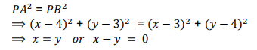  OR  $$x=\frac{2.3+3⋅\left(-2\right)}{2+3}=0$$  $$y=\frac{2⋅\left(-5\right)+3.5}{2+3}=1$$ | 1  1  1  1
23 | 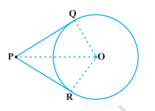  Correct figure  Given, To prove  Correct proof | ½  ½  1
24 | 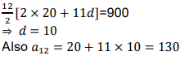  OR  We know that  $$a_{n}=a+\left(n-1\right)d$$  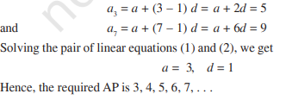 | ½  ½  1  ½  ½  ½  ½
25 | CI No of students Cumulative frequency  10-25 2 2  25-40 3 5  40-55 7 12  55-70 6 18  70-85 6 24  85-100 6 30  Finding correct value, n/2 =15 , median class-55-70 , l=55 , cf=12 ,f=6, h=15  Correct formula  Median=62.5 | ½  ½  1/2  ½
26 | 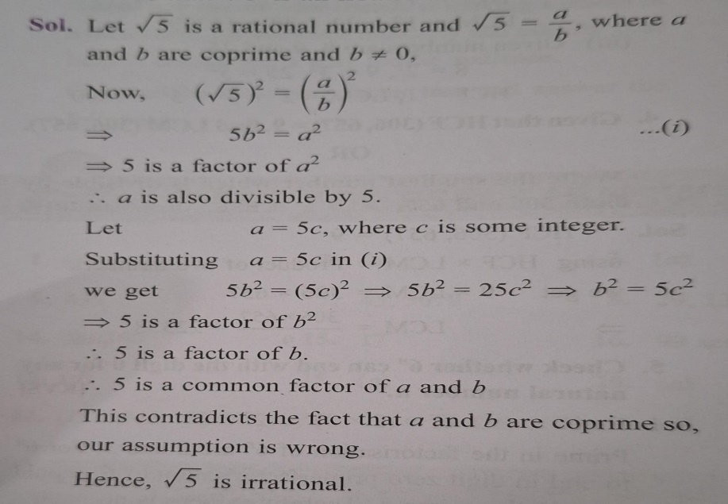 | 1  1  1
27 | 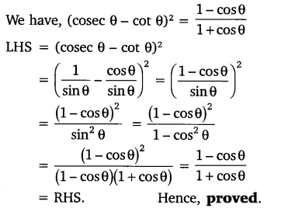 | 1  1  1
28 | 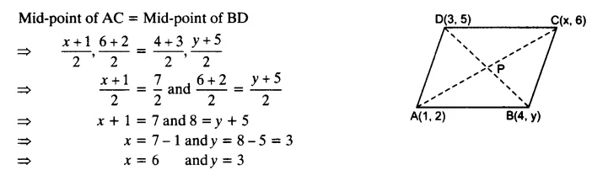  OR  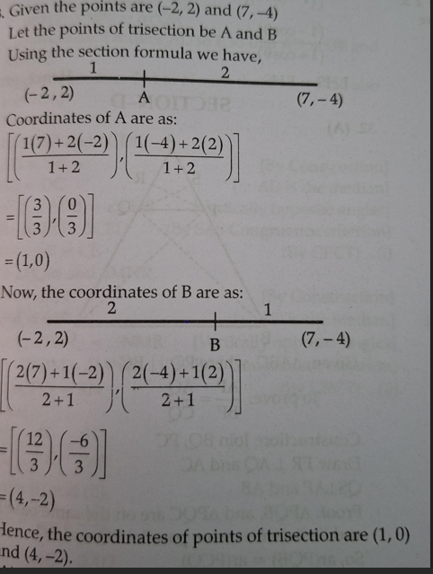 | ½  1  ½  1  ½  1  ½  1
29 | Solve x + 2y = 3 and write it as x = 3 – 2y  Substitute the value of x . We get 7(3 – 2y) – 15y = 2 i.e., 21 – 14y – 15y = 2 i.e., – 29y = –19  Therefore, y = 19 /29  Substituting this value of y , , we get x= 49/ 29  Therefore, the solution is x = 49/29 , y = 19/29 . | 1  1  1
30 | Choosing an appropriate method  Correct tabulation  Correct formula  FINDING CORRECT MEAN = 152.89 | 1 ½  ½  1
31 | Let the quadrilateral ABCD touches the circle at P, Q, R,S(CORRECT FIGURE)  AP=AS ------(i) (Tangents drawn from an external point to a circle are equal in BP=BQ -----(ii) length)  CR=CQ -----(iii)  DR=DS ------(iv)  On adding (i), (ii), (iii) and (iv)  AB+CD = AD + BC. (Hence Proved)  OR  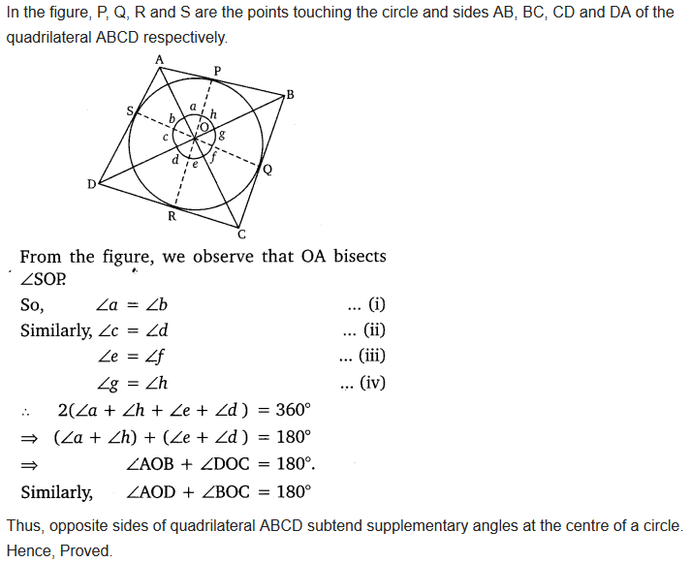 | 1  1  1  1  1  1
32 | 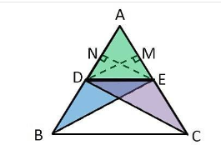  Correct figure  Given ,to prove, construction  Correct proof | 1  1  3
33 | . Let us say, the two consecutive positive integers be x and x + 1.  Therefore, as per the given statement,  x² + (x + 1)² = 365  ⇒ x² + x² + 1 + 2x = 365  ⇒ 2x² + 2x – 364 = 0  ⇒ x² + x – 182 = 0  ⇒ x² + 14x – 13x – 182 = 0  ⇒ x(x + 14) -13(x + 14) = 0  ⇒ (x + 14)(x – 13) = 0  Thus, either, x + 14 = 0 or x – 13 = 0,  ⇒ x = – 14 or x = 13  since, the integers are positive, so x can be 13, only.  So, x + 1 = 13 + 1 = 14  Therefore, the two consecutive positive integers will be 13 and 14.  OR  Let the speed of the stream be x km/hr.  Distance upstream = Distance downstream = 24 km  Speed of the boat going upstream=18 - x  Speed of the boat going downstream=18+x  Time taken going upstream = 24/18-x  Time taken going downstream = 24/18+x  Now as per question  $$\frac{24}{18-x}-\frac{24}{18+x}=1$$  ⇒$\frac{432+24x+432+24x}{\left(18-x\right)\left(18+x\right)}=1$  $${ ⇒x}^{2}+48x-324=0$$  ⇒$x^{2}+54x-6x-324-2$  ⇒x(x+54)−6(x+54)=0  ⇒(x+54)(x−6)=0  ⇒x+54=0orx−6=0  ⇒x=−54orx=6  ∴ x=6 (Speed of the stream cannot be negative)  Thus, the speed of stream is 6 km/hr. | 1  1  1  1  1  1  1  1  1  1
34 | As the horse is tied at one end of a square field, it will graze only a quarter (i.e. sector with θ = 90°) of the field with a radius 5 m.  Here, the length of the rope will be the radius of the circle, i.e. r = 5 m  It is also known that the side of the square field = 15 m  (i) Area of circle = πr² = 22/7 × 5² = 78.5 m²  Now, the area of the part of the field where the horse can graze = ¼ (the area of the circle) = 78.5/4 = 19.625 m²  (ii) If the rope is increased to 10 m,  Area of circle will be = πr² =22/7×10² = 314 m²  Now, the area of the part of the field where the horse can graze = ¼ (the area of the circle)  = 314/4 = 78.5 m²  ∴ increase in the grazing area = 78.5 m² – 19.625 m² = 58.875 m² | 1  1  1  1  1
35 | 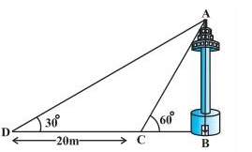  Given, AB is the height of the tower.  DC = 20 m (given)  As per given diagram, In right ΔABD,  tan 30° = AB/BD  1/√3 = AB/(20+BC)  AB = (20+BC)/√3 … (i)  Again,  In right ΔABC,  tan 60° = AB/BC  √3 = AB/BC  AB = √3 BC … (ii)  From equation (i) and (ii)  √3 BC = (20+BC)/√3  3 BC = 20 + BC  2 BC = 20  BC = 10  Putting the value of BC in equation (ii)  AB = 10√3  So, the height of the tower is 10√3 m and the width of the canal is 10 m.  OR  Let the initial position of the balloon be A and final position be B.  Height of balloon above the girl height = 88.2 m – 1.2 m = 87 m.  To Find: Distance travelled by the balloon = DE = CE – CD  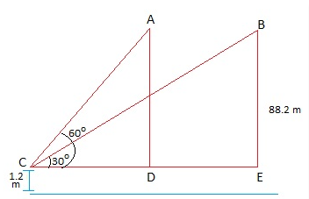  In right ΔBEC,  tan 30° = BE/CE  1/√3= 87/CE  CE = 87√3  In right ΔADC,  tan 60° = AD/CD  √3= 87/CD  CD = 87/√3 = 29√3  DE = CE – CD = (87√3 – 29√3) = 29√3(3 – 1) = 58√3  Distance travelled by the balloon = 58√3 m. | 1  ½  1  ½  1  1  ½  ½  1 ½  1 ½  1
 | SECTION-E
36 | - n(E)={(5,5) , (4,6) , (6,4)} =3  $P\left(E\right)=\frac{n\left(E\right)}{n\left(S\right)}$=$\frac{3}{36}=\frac{1}{12}$  - P(Getting same number on two dice) = $\frac{6}{36}=\frac{1}{6}$  P(Not Getting same number on two dice)= 1- P(Getting same number on two dice) = $1-\frac{1}{6}=\frac{5}{6}$  OR  n(E)={(2,2)(2,3),(2,5),(3,2),(3,3),(3,5),(5,2),(5,3),(5,5)} =9  P(Imran will get prime numbers on both the dice)= $\frac{9}{36}=\frac{1}{4}$  - (1,1), (1,3), (1,5), (3,1), (3,3), (3,5), (5,1), (5,3), (5,5).  n(getting odd numbers on both dice).=9  P(getting odd numbers on both dice) = $\frac{9}{36}=\frac{1}{4}$ | ½  ½  1  1  1  1  ½  ½
37 | - The height of the cylindrical part = 5 cm–(1.4+1.4) cm =2.2 cm  - the total volume of one gulab jamun = Volume of cylinder + Volume of two hemispheres  = πr²h+(4/3)πr³  = 4.312π+(10.976/3) π  = 25.05 cm³  Amount of sugar syrup in 1 gulab jamun= 30% of 25.05 = 7.515 cm³  So ,total sugar syrup in 45 gulab jamuns= 45 X 7.515= 338.175 cm³  OR  space will be occupied by all the 45 gulab jamuns = Volume of 45 gulab jamuns = πr²h+(4/3)πr³ X 45  = 4.312π+(10.976/3) π X 45  = 25.05 cm³ X 45  =1127.25 cm³  - Volume of ladoo= $\frac{4}{3}πr^{3}$  $$=\frac{4}{3}⋅\frac{22}{7}⋅1^{3}=\frac{88}{21}cm^{3}$$ | 1  1  ½  ½  1  ½  ½  ½  ½
38 | - $x^{2}-24x+128$  = $x^{2}-16x-8x+128$  = $\left(x-8\right)\left(x-16\right)$  So zeros are x=8 and x=16  - $α+2=3+2=5$  $$β-1=-2-1=-3$$  $$P\left(x\right)=x^{2}-\left(5+\left(-3\right)\right)x+5\left(-3\right)= x^{2}-2x-15$$  $$OR$$  $$P\left(-3\right)=9k-18+12=9k-6=0$$  - 9k=6  - K=6/9=2/3  - ${\left(α+β\right)}^{2}={\left(8+16\right)}^{2}={24}^{2}=576$ | ½  ½  ½  ½  1  1  1  1

