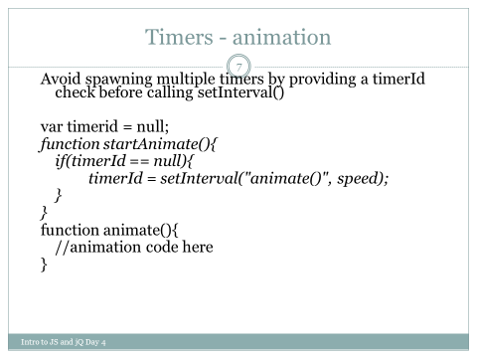

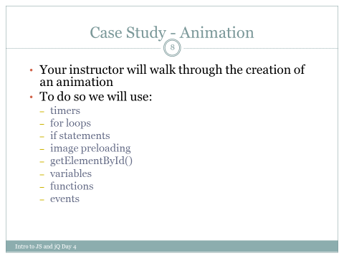

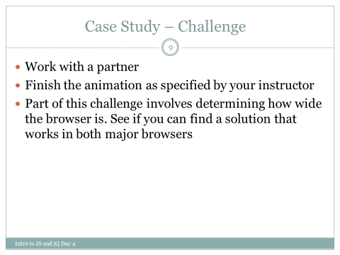

We will dynamically generate and manipulate the DOM using the objects, methods, and properties described at:

http://www.w3schools.com/jsref/dom_obj_all.asp

and

https://developer.mozilla.org/en-US/docs/Web/API/Node