|  |  |
| --- | --- |
|  |  |
| Due Date: | September 30, 6PM 20% deducted each day this is late. |
| Percentage mark: | 10% |
| Submission Location: | Assignment 1 Drop Box |
| Submission Details: | Submit an archive of your project files so your project is ready to run once it is extracted. |
| Late Penalty: | 20% deducted each day this assignment is late. |

TIPS:

* Use an IDE like PHP Storm / Web Storm / Sublime/ Visual Studio Community Edition which is free.
* **** Use debugging tools either in Firefox or Chrome. To use Chrome you need to deploy your application on an HTTP Server or through Brackets ****
* If data does not appear view your application with Firefox.
* Use the starter project.

# Weather application

In this assignment, you are to make a weather reporting application with the help of a properly architected AngluarJS application. Please note the following requirements. Your one-page AngularJS application:

* Provides functional sort options inside a select tag that work with an orderBy filter inside an ng-repeat directive. (3 marks)
* Implements working hyperlinks with the help of routing within the angular application. (3 marks)
* Selects appropriate controllers from application routing. (2 marks)
* Shows an about page. (1 marks)
* Displays your main logo, Celsius / Fahrenheit section option in the child view. (2 marks).
* Successfully toggles between Celsius and Fahrenheit displays. (5 marks)
* The main page dynamically shows the date taken from the data provided only once along with the current weather information for all cities. (2 marks)
* Shows a professional looking logo image for your application. (3 marks)

# Deductions

* Code duplication.
* Hard coded numbers.
* Un-descriptive naming.
* Poor alignment.
* Unprofessional appearance.
* Requested features are missing.

# Samples

Sample city and detail views are below.

## Sample Home Page Listing (All information shown is required)

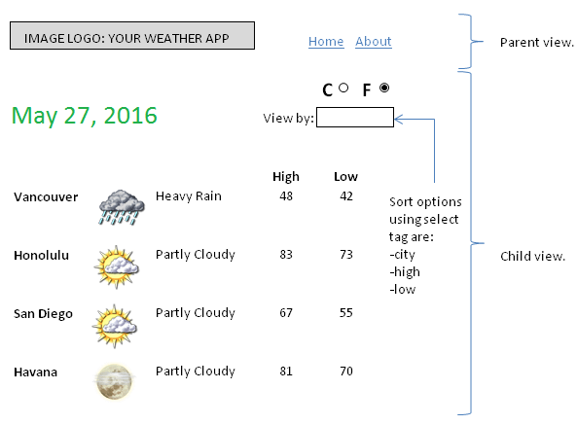

## Sample About Listing (All information shown is required)

