# Assignment 4

Worth 10%.

Due October 21st 6PM (6:01PM is late. Each consecutive late day will result in a 20% deduction)

This assignment must be coded using the AngularJS 2 framework.

**Submission Instructions:**

1. Submit all folders and files in your project but **do not include the node_modules directory**.
2. Use the same directory structure that was used for the day 4 examples.

(Omitting steps 1 and 2 will lead to a deduction of 20%)

In your application define a class named *FoodItem*. Then, later declare the following array of *FoodItem* objects in your application.

var FOODITEMS: FoodItem[] = [

{ id: 1, name: "Cucumbers", mfg: "Hot House", pkg: "10 KG", qty: 6 },

{ id: 2, name: "Carrots", mfg: "Hot House", pkg: "8 KG", qty: 14 },

{ id: 3, name: "Cheese", mfg: "Hot House", pkg: "5 KG", qty: 20 },

{ id: 4, name: "French Fries", mfg: "McCain", pkg: "15 KG", qty: 8 }

];

Build an Angular2 application that uses routing and that dynamically displays this data. The home page dynamically displays the summary if products. (2 marks)

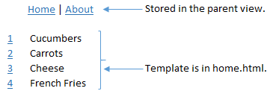

The user can select the id beside an item to display detail. Once again the detail must be populated dynamically based on the user’s selection. (3 marks)

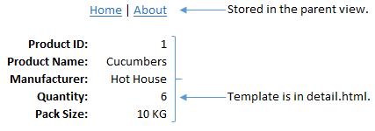

If the user selects the ‘About’ link the about.html partial view is displayed within the application. (1 mark)



**Hint:** Since routing with parameters is required I recommend you begin your project with example 8 from the day 4 notes. See example 4 for information on how to read JSON from within the component file.

Bonus:

Read the JSON asynchronously for 3 bonus marks on this assignment. I will discuss how to make asynchronous calls during day 5.