# OpenStack云硬盘的挂载和扩容

硬盘作为系统设备，是电脑主要的存储[媒介](https://baike.baidu.com/item/%E5%AA%92%E4%BB%8B" \t "_blank)之一。在使用之前需要对其进行一系列操作。而针对基于OpenStack（本次使用L版）的云平台中，我们使用的是云主机 + 云硬盘的组合方式。创建一个云主机，云主机的根分区的磁盘空间推荐尽量的小一些，空间不足可以通过挂载多块云硬盘的方式作为扩充磁盘的方式，这样会增加后期运维的灵活性。

将云硬盘挂载到云主机后，登录到云主机，进行以下操作即可完成对硬盘的初始化操作：

## 1、云硬盘初始化操作

首先，在操作界面创建一块云硬盘，将创建的云硬盘挂载到虚机disk-test上：

1. **创建云硬盘**

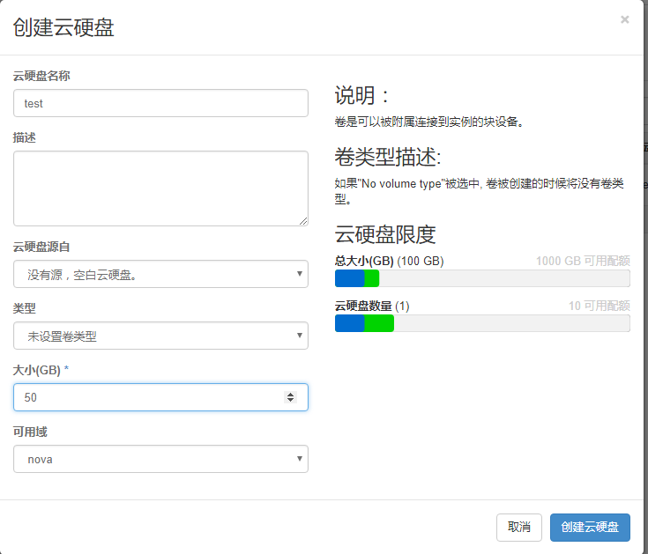

1. **云硬盘挂载到虚机**

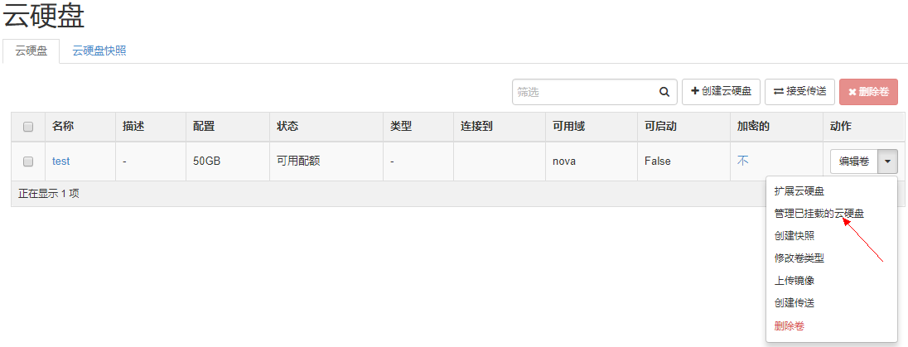

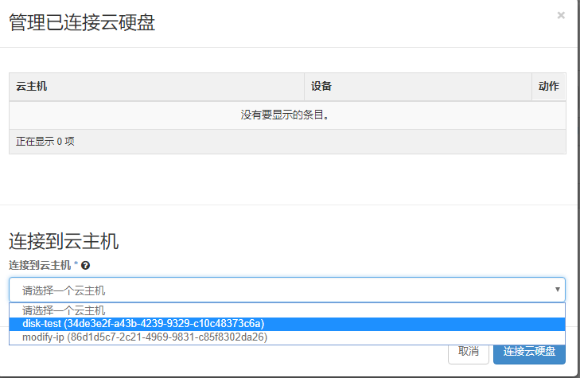

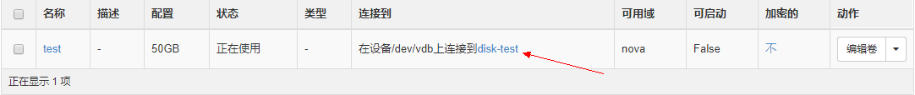

挂载完成，登录到虚机，查看磁盘信息：

[root@disk-test ~]# lsblk

NAME MAJ:MIN RM SIZE RO TYPE MOUNTPOINT

vda 253:0 0 40G 0 disk

└─vda1 253:1 0 40G 0 part /

vdb 253:16 0 50G 0 disk

vdb即为最新挂载的空间大小为50G的云硬盘。接下来对云硬盘进行两种类型的初始化操作（一种直接格式化，另一种分区后再格式化）：

1. **直接格式化（不推荐）**

[root@disk-test ~]# mkfs.ext3 /dev/vdb

[root@disk-test ~]# lsblk

NAME MAJ:MIN RM SIZE RO TYPE MOUNTPOINT

vda 253:0 0 20G 0 disk

└─vda1 253:1 0 20G 0 part /

vdb 253:16 0 50G 0 disk

[root@disk-test ~]# mount /dev/vdb test/

[root@disk-test ~]# lsblk #查看挂载

NAME MAJ:MIN RM SIZE RO TYPE MOUNTPOINT

vda 253:0 0 20G 0 disk

└─vda1 253:1 0 20G 0 part /

vdb 253:16 0 50G 0 disk /root/test

1. **分区后格式化（推荐）**

[root@disk-test ~]# fdisk /dev/vdb #分区

Welcome to fdisk (util-linux 2.23.2).

Changes will remain in memory only, until you decide to write them.

Be careful before using the write command.

Device does not contain a recognized partition table

Building a new DOS disklabel with disk identifier 0xe9128a79.

**Command (m for help): n**

Partition type:

p primary (0 primary, 0 extended, 4 free)

e extended

**Select (default p):**

Using default response p

**Partition number (1-4, default 1):**

**First sector (2048-104857599, default 2048):**

Using default value 2048

**Last sector, +sectors or +size{K,M,G} (2048-104857599, default 104857599):**

Using default value 104857599

Partition 1 of type Linux and of size 50 GiB is set

**Command (m for help): w**

The partition table has been altered!

Calling ioctl() to re-read partition table.

Syncing disks.

[root@disk-test ~]# mkfs.ext3 /dev/vdb1 #对所分分区进行格式化

mke2fs 1.42.9 (28-Dec-2013)

Filesystem label=

OS type: Linux

Block size=4096 (log=2)

Fragment size=4096 (log=2)

Stride=0 blocks, Stripe width=0 blocks

3276800 inodes, 13106944 blocks

655347 blocks (5.00%) reserved for the super user

First data block=0

Maximum filesystem blocks=4294967296

400 block groups

32768 blocks per group, 32768 fragments per group

8192 inodes per group

Superblock backups stored on blocks:

32768, 98304, 163840, 229376, 294912, 819200, 884736, 1605632, 2654208,

4096000, 7962624, 11239424

Allocating group tables: done

Writing inode tables: done

Creating journal (32768 blocks): done

Writing superblocks and filesystem accounting information: done

[root@disk-test ~]# mount /dev/vdb1 test/

[root@disk-test ~]# lsblk #查看挂载

NAME MAJ:MIN RM SIZE RO TYPE MOUNTPOINT

vda 253:0 0 40G 0 disk

└─vda1 253:1 0 40G 0 part /

vdb 253:16 0 50G 0 disk

└─vdb1 253:17 0 50G 0 part /root/test

云硬盘初始化的两种方式操作完成。

## 2、云硬盘扩容操作

对云硬盘扩容，需要将之前挂载到云主机上卸载，在调整完云硬盘大小后，再挂到虚机上，当然，基于云计算的灵活性，该云硬盘也可以挂载到其它虚机上使用。

[root@disk-test ~]# umount test/ #虚机操作系统层卸载操作

将上面步骤已对云硬盘初始化操作后的两块盘都扩容至100G，再挂载到虚机。

1. **卸载云硬盘**

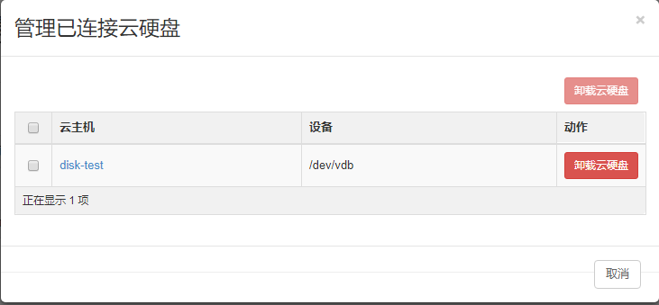

1. **扩容云硬盘**

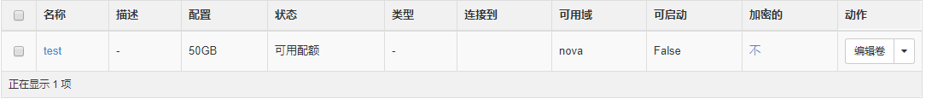

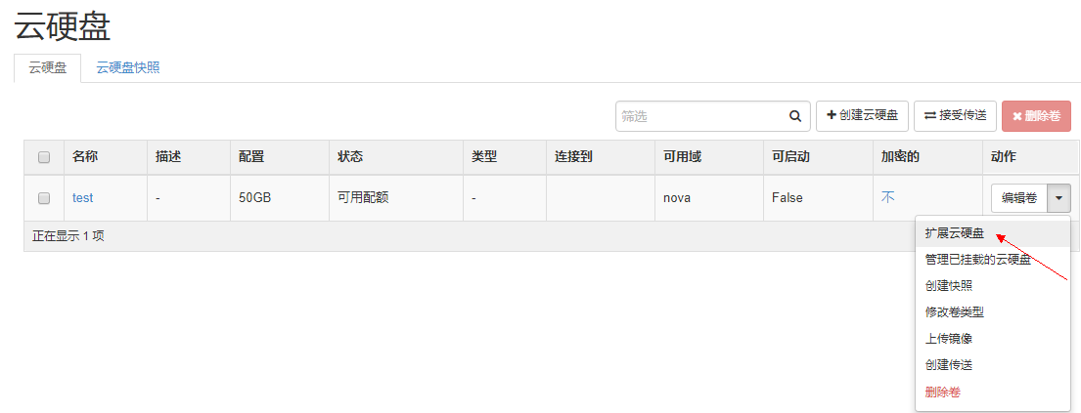

扩容到100G，再挂载到虚机。

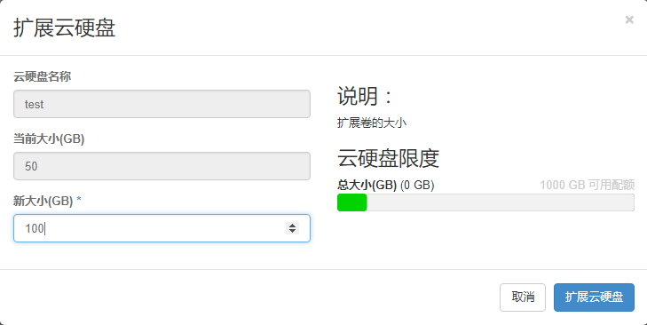

1. **分区重新格式化**

[root@disk-test ~]# lsblk

NAME MAJ:MIN RM SIZE RO TYPE MOUNTPOINT

vda 253:0 0 40G 0 disk

└─vda1 253:1 0 40G 0 part /

vdb 253:16 0 100G 0 disk

└─vdb1 253:17 0 100G 0 part

[root@disk-test ~]# fdisk -u /dev/vdb

Welcome to fdisk (util-linux 2.23.2).

Changes will remain in memory only, until you decide to write them.

Be careful before using the write command.

**Command (m for help): p**  #查看原始分区信息

Disk /dev/vdb: 107.4 GB, 107374182400 bytes, 209715200 sectors

Units = sectors of 1 \* 512 = 512 bytes

Sector size (logical/physical): 512 bytes / 512 bytes

I/O size (minimum/optimal): 512 bytes / 512 bytes

Disk label type: dos

Disk identifier: 0xe9128a79

Device Boot Start End Blocks Id System

/dev/vdb1 2048 104857599 52427776 83 Linux

注：记下start和end位置

**Command (m for help): d** #删除分区

Selected partition 1

Partition 1 is deleted

**Command (m for help): n** #新建分区

Partition type:

p primary (0 primary, 0 extended, 4 free)

e extended

Select (default p):

Using default response p

**Partition number (1-4, default 1):**

**First sector (2048-209715199, default 2048):** #此处大小应为上面的start值，一般默认为2048,

Using default value 2048

Last sector, +sectors or +size{K,M,G} (2048-209715199, default 209715199): #此处应大于上面end值，默认为所有

Using default value 209715199

Partition 1 of type Linux and of size 100 GiB is set

**Command (m for help): w**

The partition table has been altered!

Calling ioctl() to re-read partition table.

Syncing disks.

[root@disk-test ~]# e2fsck -f /dev/vdb1 #检查文件系统正确性

e2fsck 1.42.9 (28-Dec-2013)

Pass 1: Checking inodes, blocks, and sizes

Pass 2: Checking directory structure

Pass 3: Checking directory connectivity

Pass 4: Checking reference counts

Pass 5: Checking group summary information

/dev/vdb1: 11/3276800 files (0.0% non-contiguous), 251732/13106944 blocks

[root@disk-test ~]# resize2fs /dev/vdb1 #扩容

resize2fs 1.42.9 (28-Dec-2013)

Resizing the filesystem on /dev/vdb1 to 26214144 (4k) blocks.

The filesystem on /dev/vdb1 is now 26214144 blocks long.

[root@disk-test ~]# mount /dev/vdb1 test/

[root@disk-test ~]# df -h

Filesystem Size Used Avail Use% Mounted on

/dev/vda1 40G 864M 40G 3% /

/dev/vdb1 99G 60M 94G 1% /root/test

云硬盘扩容成功！之前写入云硬盘的数据也不会丢失，为了防止数据丢失，也可以针对云硬盘创建快照，针对快照新建云硬盘，然后在操作扩容操作。

对云硬盘的挂载使用和扩容操作的内容基本就是这些。