# Centos 7.4 openstack镜像制作步骤

## 安装包

yum install qemu-kvm libvirt virt-install **bridge-utils**

## 启动libvirt进程

systemctl enable libvirtd

systemctl start libvirtd

## 查看是否启动

[root@hcontroller2 ~]# virsh connect --name qemu:///system

//这是里空的，没有报错，说明启动成功了，

[root@hcontroller2 ~]# virsh list

Id Name State

----------------------------------------------------

## 创建硬盘

qemu-img create -f qcow2 centos.qcow2 2G

## 创建虚拟机

[root@hcontroller2 0]# virt-install --name centos --ram=6000 --vcpus=2 --disk path=centos.qcow2 --location=CentOS-7.0-1406-x86_64-Minimal.iso --network bridge=br1101 --vnc --vncport=5900 --vnclisten=0.0.0.0

## 查看虚拟机并通过vnc登录到该虚拟机

[root@compute1 ~]# virsh list

Id 名称 状态

----------------------------------------------------

2 controller1 running

37 centos running

[root@compute1 ~]# virsh vncdisplay 37

:2

[root@compute1 ~]#

## 进去后，并开始安装。

## 配置磁盘是，请看下图：

Device Type选择standard partition，file system选xfs或者ext4，并把所有的空间都给予根目录。

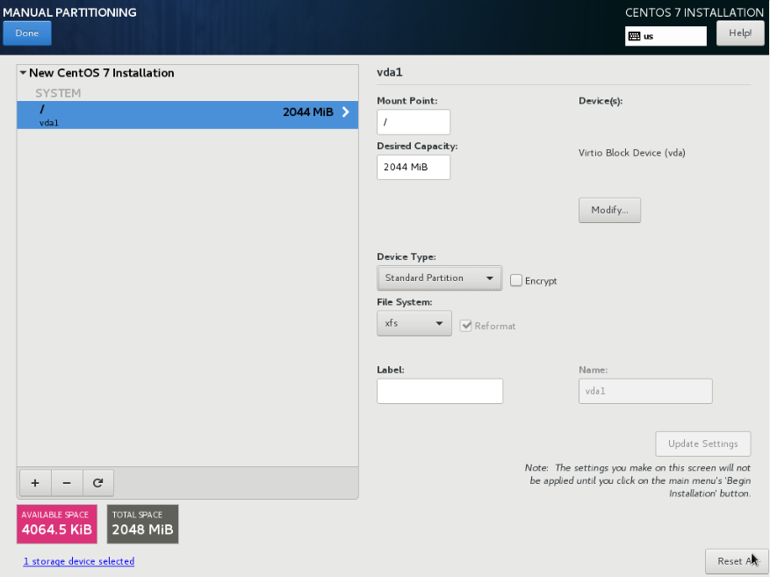

## 安装完配置网络，并ssh登录进去。

## Install the ACPI service

[root@test ~]# yum install acpid

[root@test ~]# systemctl enable acpid

[root@test ~]# yum install cloud-init cloud-utils-growpart -y

## Disable the zeroconf route

For the instance to access the metadata service, you must disable the default zeroconf route:

[root@test ~]# echo "NOZEROCONF=yes" >> /etc/sysconfig/network

[root@test ~]# cat /etc/sysconfig/network

# Created by anaconda

NOZEROCONF=yes

[root@test ~]#

## cloud-init的配置文件中，以下内容修改为：

## 允许root登录和禁止password验证

disable_root: 0

ssh_pwauth: 1

## Configure console

Edit the /etc/default/grub file and configure the GRUB_CMDLINE_LINUX option. Delete the rhgb quiet and add console=tty0 console=ttyS0,115200n8 to the option.

[root@test ~]# cat /etc/default/grub

GRUB_TIMEOUT=5

GRUB_DISTRIBUTOR="$(sed 's, release .*$,,g' /etc/system-release)"

GRUB_DEFAULT=saved

GRUB_DISABLE_SUBMENU=true

GRUB_TERMINAL_OUTPUT="console"

GRUB_CMDLINE_LINUX="crashkernel=auto **console=tty0 console=ttyS0,115200n8**"

GRUB_DISABLE_RECOVERY="true"

[root@test ~]#

## Run the following command to save the changes:

[root@test ~]# grub2-mkconfig -o /boot/grub2/grub.cfg

Generating grub configuration file ...

Found linux image: /boot/vmlinuz-3.10.0-693.el7.x86_64

Found initrd image: /boot/initramfs-3.10.0-693.el7.x86_64.img

Found linux image: /boot/vmlinuz-0-rescue-4db4dbd6c00441b481eae12b4a89fe55

Found initrd image: /boot/initramfs-0-rescue-4db4dbd6c00441b481eae12b4a89fe55.img

done

[root@test ~]#

## 清除eth0的配置：

***注意：此处操作在centos7.4中有问题。Openstack平台上建立虚拟机时，获取不到IP地址***

**安装完相关软件包后，清除UUID和MAC地址。**

## 注意：onboot=yes, bootproto=dhcp

[root@localhost ~]# cat /etc/sysconfig/network-scripts/ifcfg-eth0 ## 修改后的样子

TYPE=Ethernet

DEVICE=eth0

NAME=eth0

ONBOOT=**yes**

BOOTPROTO=**dhcp**

## 关机

## Clean up (remove MAC address details)

[root@compute1 ~]# **virt-sysprep -d centos**

[ 0.0] Examining the guest ...

[ 4.0] Performing "abrt-data" ...

[ 4.0] Performing "bash-history" ...

[ 4.0] Performing "blkid-tab" ...

[ 4.0] Performing "crash-data" ...

[ 4.0] Performing "cron-spool" ...

[ 4.0] Performing "dhcp-client-state" ...

[ 4.0] Performing "dhcp-server-state" ...

[ 4.0] Performing "dovecot-data" ...

[ 4.0] Performing "logfiles" ...

[ 4.0] Performing "machine-id" ...

[ 4.0] Performing "mail-spool" ...

[ 4.0] Performing "net-hostname" ...

[ 4.0] Performing "net-hwaddr" ...

[ 4.0] Performing "pacct-log" ...

[ 4.0] Performing "package-manager-cache" ...

[ 4.0] Performing "pam-data" ...

[ 4.0] Performing "puppet-data-log" ...

[ 4.0] Performing "rh-subscription-manager" ...

[ 4.0] Performing "rhn-systemid" ...

[ 4.0] Performing "rpm-db" ...

[ 4.0] Performing "samba-db-log" ...

[ 4.0] Performing "script" ...

[ 4.0] Performing "smolt-uuid" ...

[ 4.0] Performing "ssh-hostkeys" ...

[ 4.0] Performing "ssh-userdir" ...

[ 4.0] Performing "sssd-db-log" ...

[ 4.0] Performing "tmp-files" ...

[ 4.0] Performing "udev-persistent-net" ...

[ 4.0] Performing "utmp" ...

[ 4.0] Performing "yum-uuid" ...

[ 4.0] Performing "customize" ...

[ 4.0] Setting a random seed

[ 4.0] Performing "lvm-uuids" ...

[root@compute1 ~]#

## Undefine the libvirt domain

[root@compute1 ~]# virsh undefine centos

域 centos 已经被取消定义

[root@compute1 ~]#

## 镜像完毕并上传到glance服务中，并开始测试。

The underlying image file that you created with the qemu-img create command is ready to be uploaded. For example, you can upload the **/root/centos.qcow2** image to the Image service by using the openstack image create command.

[root@compute1 ~]# ll -lh

-rw-r--r-- 1 root root 1.1G 12月 12 10:31 centos.qcow2

[root@controller1 ~]# glance image-create --name "centos" --file centos.qcow2 --disk-format qcow2 --container-format bare --visibility public --progress

# Centos 6.9 openstack镜像制作步骤

## 创建KVM虚拟机

[root@compute1 ~]# qemu-img create -f qcow2 centos.qcow2 2G

[root@compute1 ~]# virt-install --name centos --ram=**2048** --vcpus=**2** --disk path=centos.qcow2 --location=CentOS-6.9-x86_64-minimal.iso --network bridge=br1101 --vnc --vncport=5905 --vnclisten=0.0.0.0

## 安装cloud-init

[root@localhost ~]# yum install -y epel-release

[root@localhost ~]# yum install cloud-init cloud-utils cloud-utils-growpart -y

## 配置cloud.cfg配置文件

允许root登录和禁止password验证

**disable_root: 0**

**ssh_pwauth: 1**

## 配置SSHD

[root@localhost ~]# egrep -v "^#|^$" /etc/ssh/sshd_config

PermitRootLogin yes

PasswordAuthentication yes

GSSAPIAuthentication no

[root@localhost ~]#

## 修改网络配置 Disable the zeroconf route：

[root@localhost ~]# echo "NOZEROCONF=yes" >> /etc/sysconfig/network

[root@localhost ~]# cat /etc/sysconfig/network

NETWORKING=yes

HOSTNAME=localhost.localdomain

**NOZEROCONF=yes**

[root@localhost ~]#

## 安装ACPI服务

[root@localhost ~]# yum install -y acpid

[root@localhost ~]# chkconfig acpid on

## 配置console

需要在**/boot/grub/menu.lst**文件下增加以下的内容：

Open /boot/grub/menu.lst and append the following parameters to the kernel line:

**console=tty0 console=ttyS0,115200n8**

In the same file on the same line remove any references to the following parameters: **rhgb quiet**

[root@localhost ~]# cat /boot/grub/menu.lst

# grub.conf generated by anaconda

#

# Note that you do not have to rerun grub after making changes to this file

# NOTICE: You do not have a /boot partition. This means that

# all kernel and initrd paths are relative to /, eg.

# root (hd0,0)

# kernel /boot/vmlinuz-version ro root=/dev/sda1

# initrd /boot/initrd-[generic-]version.img

#boot=/dev/sda

default=0

timeout=5

splashimage=(hd0,0)/boot/grub/splash.xpm.gz

hiddenmenu

title CentOS 6 (2.6.32-696.el6.x86_64)

root (hd0,0)

kernel /boot/vmlinuz-2.6.32-696.el6.x86_64 ro root=UUID=3ff198b2-6ac7-4f2e-8ce7-e3471396e851 rd_NO_LUKS rd_NO_LVM LANG=en_US.UTF-8 rd_NO_MD SYSFONT=latarcyrheb-sun16 crashkernel=auto KEYBOARDTYPE=pc KEYTABLE=us rd_NO_DM **console=tty0 console=ttyS0,115200n8**

initrd /boot/initramfs-2.6.32-696.el6.x86_64.img

[root@localhost ~]#

## 禁用selinux

[root@localhost ~]# cat /etc/selinux/config

# This file controls the state of SELinux on the system.

# SELINUX= can take one of these three values:

# enforcing - SELinux security policy is enforced.

# permissive - SELinux prints warnings instead of enforcing.

# disabled - No SELinux policy is loaded.

SELINUX=**disabled**

# SELINUXTYPE= can take one of these two values:

# targeted - Targeted processes are protected,

# mls - Multi Level Security protection.

SELINUXTYPE=targeted

[root@localhost ~]#

## 关闭防火墙

[root@localhost ~]# chkconfig iptables off

[root@localhost ~]# chkconfig ip6tables off

## 清楚UUID和MAC等信息

There are some hardcoded UUID and MAC addresses in the network configuration files and udev. Remove these entries with the following commands:

[root@localhost ~]# echo ''> /etc/udev/rules.d/70-persistent-net.rules

[root@localhost ~]# cat /etc/udev/rules.d/70-persistent-net.rules

[root@localhost ~]#

## 清除eth0的配置

**安装完相关软件包后，清除UUID和MAC地址。**

## 注意：onboot=yes, bootproto=dhcp

[root@localhost ~]# cat /etc/sysconfig/network-scripts/ifcfg-eth0 ## 修改后的样子

TYPE=Ethernet

DEVICE=eth0

ONBOOT=**yes**

BOOTPROTO=**dhcp**

NM_CONTROLLED=no

## 创建快照和恢复

*镜像创建快照，目的是可以让镜像创建多种环境版本，例如这个快照是集成LAMP，那个快照安装了Mysql等。恢复到指定的快照，可以修复完成发现的问题或创建另一种环境的快照，再发布打包成镜像。*

**创建快照**

[root@compute1 ~]# virsh snapshot-create-as --domain centos --name "centos-cloud-init" --description "cloud-init installed and configured"

已生成域快照 centos-cloud-init

[root@compute1 ~]#

**查看已有的快照**

[root@compute1 ~]# virsh snapshot-list centos

名称 生成时间 状态

------------------------------------------------------------

centos-cloud-init 2017-12-12 14:01:02 +0800 running

[root@compute1 ~]#

**恢复到指定的快照**

[root@compute1 ~]# virsh snapshot-revert --domain centos --snapshotname cloud-init

**删除指定的快照**

[root@compute1 ~]# virsh snapshot-delete --domain centos --snapshotname cloud-init

## 最重要的配置Attention

这个配置很重要，提升自己的知名度，修改**/etc/motd**，增加以下内容：

Welcome to Inner Mongolia Cloud Computing Technology Service Co.,Ltd

The CentOS Image Ulaanbaatar(ulaanbaatar@hotmail.com)

Please Visit The Website:http://www.cloudtds.com.cn

**当你ssh登录是就会显示如下内容：**

ulaanbaatar@ulaanbaatar:~$ ssh root@10.0.1.55

root@10.0.1.55's password:

Permission denied, please try again.

root@10.0.1.55's password:

Last login: Tue Dec 12 13:43:14 2017 from 222.74.205.218

**Welcome to Inner Mongolia Cloud Computing Technology Service**

**The CentOS Image Author:Ulaanbaatar(ulaanbaatar@hotmail.com)**

**Pls Visit The Website:http://www.cloudtds.com.cn**

[root@localhost ~]#

## 把镜像系统关机:

[root@localhost ~]# shutdown -h now

## 删除硬件信息

[root@compute1 ~]# virt-sysprep -d centos

[ 0.0] Examining the guest ...

[ 4.0] Performing "abrt-data" ...

[ 4.0] Performing "bash-history" ...

[ 4.0] Performing "blkid-tab" ...

[ 4.0] Performing "crash-data" ...

[ 4.0] Performing "cron-spool" ...

[ 4.0] Performing "dhcp-client-state" ...

[ 4.0] Performing "dhcp-server-state" ...

[ 4.0] Performing "dovecot-data" ...

[ 4.0] Performing "logfiles" ...

[ 4.0] Performing "machine-id" ...

[ 4.0] Performing "mail-spool" ...

[ 4.0] Performing "net-hostname" ...

[ 4.0] Performing "net-hwaddr" ...

[ 4.0] Performing "pacct-log" ...

[ 4.0] Performing "package-manager-cache" ...

[ 4.0] Performing "pam-data" ...

[ 4.0] Performing "puppet-data-log" ...

[ 4.0] Performing "rh-subscription-manager" ...

[ 4.0] Performing "rhn-systemid" ...

[ 4.0] Performing "rpm-db" ...

[ 4.0] Performing "samba-db-log" ...

[ 4.0] Performing "script" ...

[ 4.0] Performing "smolt-uuid" ...

[ 4.0] Performing "ssh-hostkeys" ...

[ 4.0] Performing "ssh-userdir" ...

[ 4.0] Performing "sssd-db-log" ...

[ 4.0] Performing "tmp-files" ...

[ 4.0] Performing "udev-persistent-net" ...

[ 4.0] Performing "utmp" ...

[ 4.0] Performing "yum-uuid" ...

[ 4.0] Performing "customize" ...

[ 4.0] Setting a random seed

[ 4.0] Performing "lvm-uuids" ...

[root@compute1 ~]#

## 压缩镜像，转换镜像格式

[root@compute1 ~]# virt-sparsify --tmp . --compress centos.qcow2 centos69.qcow2

Input disk virtual size = 1073741824 bytes (1.0G)

Create overlay file in . to protect source disk ...

Examine source disk ...

Fill free space in /dev/sda1 with zero ...

Copy to destination and make sparse ...

Sparsify operation completed with no errors. Before deleting the old disk,

carefully check that the target disk boots and works correctly.

[root@compute1 ~]#

## 上传到Glance服务

[root@compute1 ~]# ll -lh

-rw-r--r-- 1 root root 1.1G 12月 12 10:31 centos.qcow2

[root@controller1 ~]# glance image-create --name "centos" --file centos.qcow2 --disk-format qcow2 --container-format bare --visibility public --progress