USER AUTHENTICATION FLOW
Functional Requirements
- System shall allow the user to register using email and password using Laravel Backend
- System shall allow the user to login securely using Laravel Authentication Middleware
- System shall validate user credentials stored in PostgreSQL Database
- System shall generate JWT token upon successful login using Laravel JWT
- System shall restrict dashboard access to authenticated users
- System shall securely store user login credentials using encrypted hashing in PostgreSQL
Non-Functional Requirements
- Authentication response time should be less than 2 seconds
- Passwords must be encrypted using hashing algorithms (bcrypt)
- Session timeout should occur after inactivity using Laravel Session Management
- System must prevent unauthorized access using backend validation

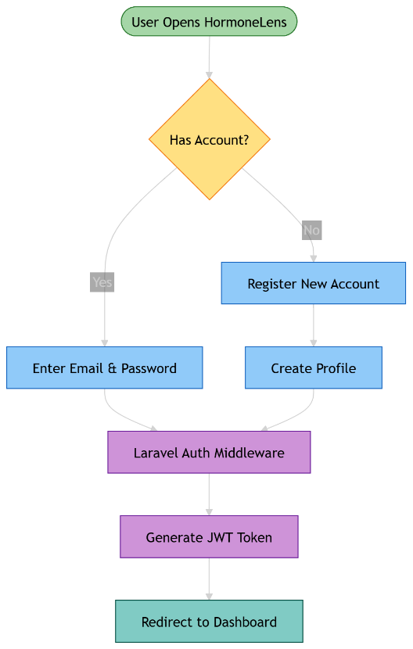

HEALTH PROFILE SETUP MODULE
Functional Requirements
- System shall collect user age and weight using Frontend Dashboard
- System shall collect PCOS or Diabetic status
- System shall collect sleep pattern and stress level inputs
- System shall collect menstrual cycle details
- System shall store user health profile using PostgreSQL
- System shall convert health logs into embeddings using Custom RAG Pipeline
- System shall store embeddings in ChromaDB Vector Database
- System shall allow profile editing through Laravel Backend
Non-Functional Requirements
- Profile data must be encrypted in PostgreSQL
- Embedding generation latency should be minimal
- System must ensure user data privacy
- Vector retrieval accuracy must remain high in ChromaDB
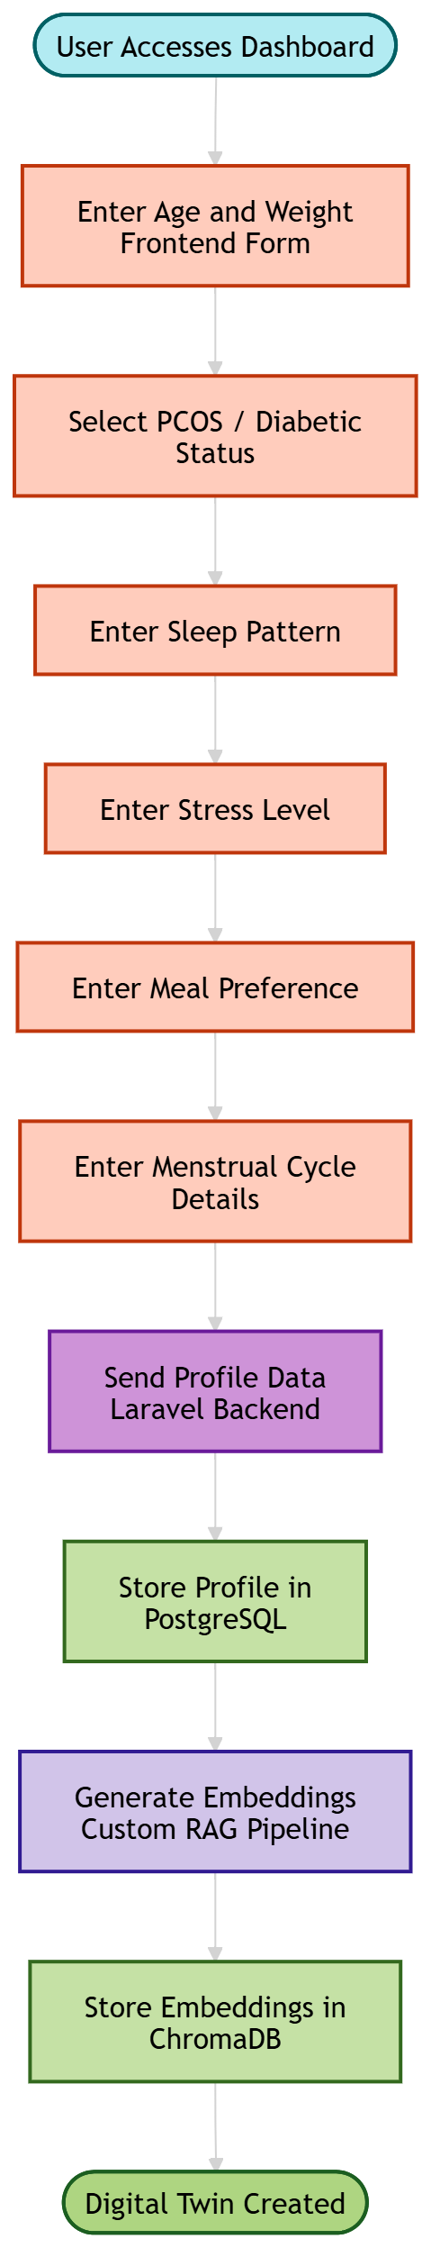
WHAT-IF SIMULATION INPUT MODULE
Functional Requirements
- System shall allow user to input planned meal using Frontend Dashboard
- System shall collect sleep hours and stress level
- System shall allow user to enter meal timing
- System shall validate simulation input using Laravel Backend
- System shall retrieve user historical context from ChromaDB
- System shall inject retrieved data into LLM prompt using Custom RAG Pipeline
Non-Functional Requirements
- Simulation request should be processed quickly
- Input validation must prevent invalid data
- Backend must maintain consistency in data retrieval
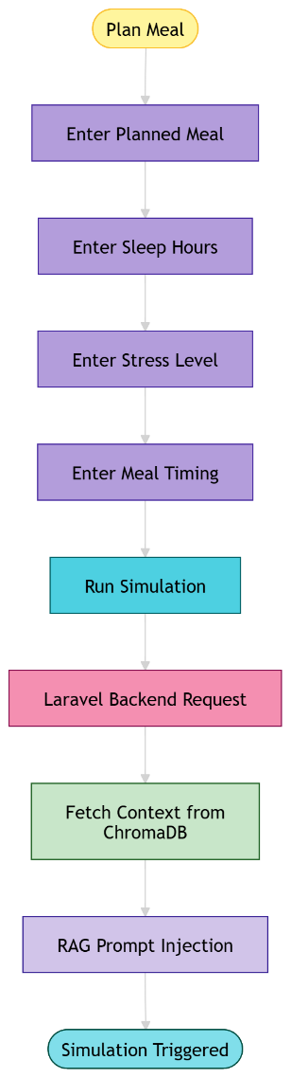

AI SIMULATION ENGINE MODULE
Functional Requirements
- System shall perform RAG-based prediction using Amazon Bedrock
- System shall predict insulin resistance risk
- System shall predict cortisol imbalance
- System shall predict ovulation stability
- System shall filter AI output using AWS Bedrock Guardrails
- System shall synthesize response using Claude 3.5 Sonnet
- System shall store simulation output in Redis Cache
- System shall generate metabolic risk score
Non-Functional Requirements
- Prediction accuracy should be high
- AI response time must be within limits
- System must be scalable using AWS Infrastructure
- AI output must be safe and reliable
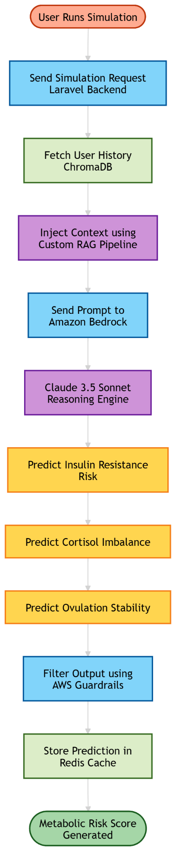

SIMULATION OUTPUT DASHBOARD MODULE
Functional Requirements
- System shall display metabolic risk score using Chart.js
- System shall display glucose spike probability graph
- System shall display ovulation stability score
- System shall render predicted graphs using Chart.js Visualization
- System shall provide explainable insights generated by Claude 3.5
- System shall save simulation logs in PostgreSQL
Non-Functional Requirements
- Dashboard should load quickly
- Graph rendering must be real-time
- UI must be responsive
- Logs must persist reliably
