使用微粒群优化的基于模糊层次分析法的多准则决策系统
摘要：
This paper presents a fuzzy optimization model to solve multicriteria decision making (MCDM) systems based on a fuzzy analytic hierarchy process (fuzzy AHP). To deal with the imprecise judgments of decision makers, a fuzzy AHP decision making model is proposed as an evaluation tool, where the expert’s comparison judgments are translated into fuzzy numbers. Unlike the conventional fuzzy AHP methods,the proposed method drives exact weights from consistent and inconsistent fuzzy comparison matrices,which eliminate the need of additional aggregation and ranking procedures. The proposed method transforms a fuzzy prioritization problem into a constrained nonlinear optimization model. An improved particle swarm optimization (PSO) is applied to solve the optimization model as a nonlinear system of equations. Several illustrative examples using existing fuzzy AHP methods are given to demonstratethe effectiveness of the proposed method.
本文提出了一种模糊优化模型来解决基于模糊层次分析法(fuzzy AHP)的多准则决策系统(MCDM)。为了解决决策者的不精确判断，一个模糊层次分析决策模型作为一个评估工具被提出，该模型将专家的比较判断转换成模糊数。不同于传统的模糊层次分析法算法，该算法从一致的和不一致的模糊对比矩阵中获得精确的权重，而不需要额外的聚合和排序过程。改进算法将一个模糊排序问题转化成约束非线优化问题。一种改进的微粒群优化算法（PSO）被用作非线性方程组以解决最优化模型问题。利用几个使用现存模糊层次分析法的示例来展示改进算法的有效性。
关键字：模糊层次分析法(Fuzzy AHP)，多准则决策(MCDM)，微粒群优化算法(PSO)
- 介绍
Decision making expert systems are often complex and multi-faceted. In recent years, tools for modeling decision making have improved significantly, and multicriteria decision making (MCDM) models are widely considered to be very useful in resolving conflicts related to the decision making process. Since Bellman and Zadeh (1970) developed the theory of decision behavior in a fuzzy environment, various methods have been developed for handling multicriteria decision making systems.
决策专家系统通常是复杂和多方面的。在近年来，模拟决策的工具取得了重大进步，并且多准则决策(MCDM)模型在解决有关决策过程中的冲突问题上是公认的非常有用的。自从Bellman和Zaden建立了模糊环境下的决策行为理论以来，人们发明了大量的方法来处理多目标决策系统。
Multicriteria decision making deals with the problem of choosing the best alternative, that is, the one with the highest degree of satisfaction for all the relevant criteria or goals. In order to obtain the best alternative a ranking process is required. Extensively adopted in MCDM, the analytic hierarchy process (AHP) has successfully been applied to the ranking process of decision making problems (Saaty, 1988 ). The main advantage of the AHP is its inherent ability to handle intangibles, which are present in any decision making process. Also, the AHP less cumbersome mathematical calculations and, it is more easily comprehended in comparison with other methods.
多准则决策处理的是选择最佳方案的问题，也就是说，对各个相关准则或者目标匹配度最高的一个方案。为了获得最佳可选方案，一个评价过程是必须的。层次分析法被成功应用到决策的问题的评价过程(Satty 1988)，并在多准则决策领域得到广泛使用。AHP的主要优点是它固有的解决不确定问题的能力，这种不确定问题存在于任何决策过程中。并且，AHP的计算不太繁琐，相比较其他方法更加容易理解。
Triantaphyllou and Lin (1996) and Duran and Aguilo (2007) summarized the following advantages for AHP: (1) it is the only known MCDM model that can measure the consistency in the decision maker’s judgments; (2) the AHP can also help decision makers to organize the critical aspects of a problem in a hierarchical structure, making the decision process easy to handle; (3) pairwise comparisons in the AHP are often preferred by the decision makers, allowing them to derive weights of criteria and scores of alternatives from comparison matrices rather than quantify weights/scores directly; (4) AHP can be combined with well-known operation research techniques to handle more difficult problems; (5) AHP is easier to understand and can effectively handle both qualitative and quantitative data.
Triantaphyllou and Lin (1996) and Duran and Aguilo (2007)总结了AHP的一下几个优点：(1) 它是已知的可以衡量决策者判断一致性的多准则决策模型；(2)AHP可以帮助决策者将一个问题的多个准则面组织在一个层次结构中，使得决策过程更加容易处理；(3)在AHP中决策者更加倾向于成对比较，这允许他们从成对比较获得准则的权重以及方案的得分，而不是直接确定权重/得分。(4)AHP可以和著名的操作研究技术相结合来处理更加复杂的问题。(5)AHP更加容易理解，并且可以有效处理定性的和定量的数据。
However,in many practical situations, the human preference model is uncertain and decision makers might be reluctant or unable to assign exact numerical values to the comparison judgments. Although the use of the discrete scale of 1–9 for performing pairwise comparative analysis has the advantage of simplicity, a decision maker may find it extremely difficult to express the strength of his preferences and to provide exact pairwise comparison judgments.AHP is thus ineffective when applied to ambiguous problems. Since the real world is highly ambiguous, some researchers apply fuzzy AHP as an extension of conventional AHP and employ fuzzy set theory to handle uncertainty and overcome this limitation.
然后，在很多实际情况中，人的优先模型是不确定的，而且决策者可能难以处理或者无法对比较矩阵赋予准确的数值。尽管使用1-9的不连续标度来表示成对比较分析有简单的优点，但是一个决策者可能会觉得表达他的优先程度以及提供精确的成对比较判断值是及其困难的。因此AHP在运用到模棱两可的问题是就变得没有效果了。因为显示时间是高度模糊的，一些研究人员运用模糊层次分析法作为传统层次分析法的拓展，并使用模糊集理论来处理不确定性并克服这个限制。
Recently,Mikhailov (2003) proposed a new fuzzy AHP method namely fuzzy preference programming (FPP) approach for deriving priorities from fuzzy comparison judgments. Cakir and Canbolat (2008) developed a web-based package based on the Mikhailov’s prioritization method. However, the steps in the FPP method make it a little complicated from a computational point of view. This idea-deriving crisp priorities from fuzzy judgment matrices-is a new way to deal with the prioritization problem from fuzzy reciprocal comparisons in the fuzzy AHP. We describe a simple prioritization method which can derive exact priorities from fuzzy
comparison judgments by applying an efficient nonlinear optimization tool for solving the fuzzy optimization model.
最近，Mikhailov 提出了一种新的模糊层次分析法叫做模糊优先规划(FPP)方法，来解决模糊比较判断的优先级问题。Cakir and Canbolat在Mikhailov的优先级排序方法基础上开发了一个基于网络的包。然而，从计算机角度来看，FPP方法的步骤有一点复杂。这种方法——从模糊判断矩阵获得离散优先级——是处理模糊层次分析法的模糊互补比较排序问题的一种新方法。我们描述了一个简单的优先排序方法，通过运用一个有效的非线性优化工具，该方法可以从模糊比较判断中获得精确的优先权重来解决模糊优化模型。
There are three objectives of this paper. First, we propose a modified fuzzy optimization model to deal with shortfalls of the AHP method in handling the uncertainties and imprecision of multicriteria decision making systems. Secondly, we construct a fuzzy prioritization method which can derive exact priorities from consistent and inconsistent fuzzy comparison matrices. Thirdly, we apply an improved particle swarm optimization (PSO) method to solve the fuzzy optimization model as a system of nonlinear equations.
本论文有三个目标。首先，我们提出了一个修改的模糊优化模型，来处理AHP方法解决不确定和不精确的多准则决策系统中的缺点。第二，我们构造一个模糊优先排序方法，通过该方法可以从一致的或者不一致的模糊比较矩阵中获得精确的优先级。第三，我们使用一个改进的微粒群优化方法作为非线性方程组来解决模糊优化模型。
- 预备知识
Multicriteria decision making provides techniques for comparing and ranking different outcomes, even though a variety of criteria with different units are used. This is a very important advantage over traditional decision making methods where all criteria need to be converted to the same unit. Another significant advantage of most MCDM techniques is that they have the capacity to analyze both quantitative and qualitative evaluation criteria together. Several methods exist for MCDM (Vincke, 1992). Among these methods, the most popular ones are ELECTRE (Roy, 1991), PROMETHEE (Brans & Vincke, 1985), TOPSIS (Hwang & Yoon, 1981), and the
AHP methods ( Saaty, 1980).
Given the advantages of integral structure, simple theory, and ease-of-operation, AHP is a popular tool for MCDM wherein complicated decision problems and non-structural situations are divided into hierarchical elements. The decision problem is constructed as a hierarchical structure in which the overall goal of decision is located at the highest level, and m alternatives,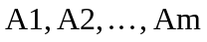, are at the lowest level (Fig. 1). The criteria,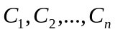, (sub-criteria) form the internal layers of the hierarchy. The preferences of decision makers are elicited in the form of ratios using pairwise comparison matrices. The judgment matrices of criteria or alternatives are deﬁned by rating the relative importance of elements based on a standard scale (where 1 = equally important;3 = weak importance; 5 = strong importance; 7 = demonstrated importance; 9 = absolute importance). Comparing any two elements at the same level of hierarchy, a decision maker can provide a numerical value aij for the ratio of the elements’ importance. Each set of comparisons for a level with n elements requires 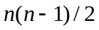judgments, which are further used to construct a positive reciprocal comparison matrix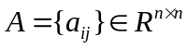, where 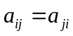, and 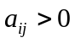,for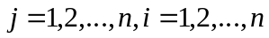. A priority vector 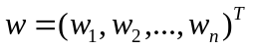may be obtained from the comparison matrix by applying a prioritization method. Several methods for deriving the local weights of criteria and the local scores of alternatives from judgment matrices have been developed (Mikhailov, 2000). At this stage the consistency of each pairwise comparison is checked. A ﬁnal aggregation of local priorities is performed to rank the alternatives.
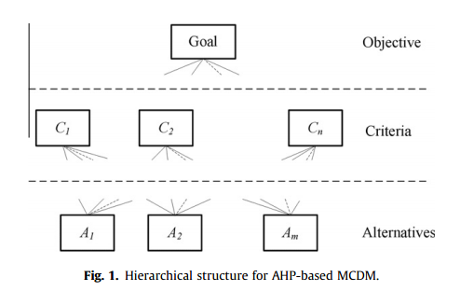
In summary, AHP is consistent, structured and intuitive. However, the AHP is criticized for its inability to accommodate uncertainty in the decision making process. Critics argue that it would be cognitively demanding to ask a decision maker to express his/her preference as a discrete numerical value in the pairwise comparison matrices. The main problem lies in the fact that, since all comparisons are done by importance comparisons, it loses the possible nuances of describing criteria as fuzzy sets. Only the relative importance of each criterion to all others is measured. In other
word, decision makers often face uncertain and fuzzy cases when considering the relative importance of one element to another.Hence, it is difficult to derive the crisp ratios from pairwise comparison matrices stated above. Fuzzy set based (van Laarhoven &Pedrycz, 1983) approach has been suggested to overcome the inability of AHP to handle uncertainties.

AHP is consistent, structured and intuitive. However, the AHP is criticized for its inability to accommodate uncertainty in the decision making process. Critics argue that it would be cognitively demanding to ask a decision maker to express his/her preference as a discrete numerical value in the pairwise comparison matrices. The main problem lies in the fact that, since all comparisons are done by importance comparisons, it loses the possible nuances of describing criteria as fuzzy sets. Only the relative importance of each criterion to all others is measured. In other word, decision makers often face uncertain and fuzzy cases when considering the relative importance of one element to another. Hence, it is difficult to derive the crisp ratios from pairwise comparison matrices stated above. Fuzzy set based ( van Laarhoven &
Pedrycz, 1983 ) approach has been suggested to overcome the inability of AHP to handle uncertainties.
层次分析法是一致的、结构化的和主观的。但是层次分析法因为它无法适应决策过程中的不适应行而遭受诟病。批评者认为让一个决策者在成对比较矩阵中使用离散数值表达他/她的偏好是认知要求。而事实上存在一个主要问题是，因为所有的比较是重要性比较，它丢失了将准则描述为模糊集的可能的细微之处。只有当每个准则与其他准则的相对重要性被准确测量时。也就是说，当考虑某个元素与其他元素的的相对重要性时，决策者经常面对不确定和模糊的情况。因此，所以很难从上述的成对比较矩阵中获得离散比率。而基于模糊集的方法被建议用来克服层次分析法无法处理不确定性的缺点。
2.1模糊判断
In this study, the triangular fuzzy numbers (TFNs) were used to represent the fuzzy relative importance. A TFN is graphically shown in Fig. 2 and can be described as:
在本文中，使用三角模糊数(TFNs)来表示模糊相对重要性，一个如图2所示的三角模糊数表示的意思为：
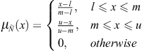(1)
in which the parameters, l, m, and u respectively denote the smallest possible value, the most promising value, and the largest possible value that describe a fuzzy event. The TFN 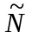 is often represented as (l, m, u).
其中参数l、m、和u分别定义为最小可能值、最大可能值、以及一个模糊事件中定义的最大值。三角模糊数通常使用(l, m, u)表示。
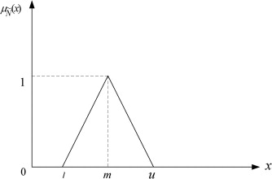
Assume that the fuzzy comparison judgments are decided with respect to the linguistic (non-numerical) judgments of decision makers. Their imprecise and uncertain assessments can be translated into corresponding triangular fuzzy numbers. Introduction of fuzzy linguistic variables instead of exact, crisp values will help a decision maker to use non-numerical terms for his/her highly subjective judgments and it can incorporate the imprecision related to the decision maker’preference. Hence, it will eliminate the drawback of the static structure of the fundamental scale in capturing uncertainty in the comparisons. In this paper, we use the fuzzy judgments employed in Wang, Chu, and Wu (2007) as depicted in Table 1
假设模糊比较判断值时通过决策者的语义(非数值)判断值。他们的不精确和不确定评价会被翻译成相应的模糊三角数。因素模糊语义变量而不是确定的，这些值将帮助决策者使用非数值项来表示他/她的主观判断，并且这可以这可以和决策者的偏好不确定性合并。因此，这将消除不确定比较时基本标度静态结构的缺点。在本文中，我们使用Wang、Chu和Wu提出模糊判断值来表示，如表1所示。
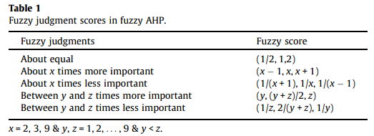
2.2模糊层次分析法
Fuzzy AHP uses fuzzy set theory to express the uncertain comparison judgments as a fuzzy numbers. The main steps of fuzzy AHP are as follows:
模糊层次分析法使用模糊集理论，表示不确定的比较判断表示为一个模糊数，模糊层次分析法的主要步骤如下：
- Structuring decision hierarchy. Similar to conventional AHP, the first step is to break down the complex decision making problem into a hierarchical structure.
(1)构造决策模型。和传统的层次分析法类似，第一步是分解复杂决策问题为层次结构；
- Developing pairwise fuzzy comparison matrices.Consider a prioritization problem at a level with n elements, where pairwise comparison judgments are represented by fuzzy triangular numbers 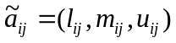. As in the conventional AHP, each set of comparisons for a level requires judgments, which are further used to construct a positive fuzzy reciprocal comparison matrix 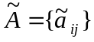, such that:
(2)构造成对模糊比较矩阵。设一个优化问题在一个层次上有n个元素，其成对比较判断值是使用模糊三角数表示的。和传统层次分析法一样，每个等级的比较集合需要个判断值，这些值将会被用来构造一个正的模糊倒数比较矩阵，如下所示：
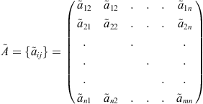(2)
- Consistency check and deriving priorities. This step checks for consistency and extracts the priorities from the pairwise comparison matrices. In existing fuzzy AHP methods, only a few past studies have addressed the issue of checking for inconsistencies in pairwise comparison matrices. According to Buckley (1985), a fuzzy comparison matrix is consistent if 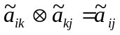, where 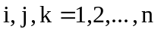, and  is fuzzy multiplication, and denotes fuzzy equal to. Once the pairwise comparison matrix, 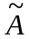, passes the consistency check, fuzzy priorities can be calculated with conventional fuzzy AHP methods. Then, the priority vector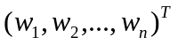 can be obtained from the comparison matrix by applying a prioritization method.
(3)一致性检验并计算权重值。这一步检验一致性并从成对比较矩阵获取权重值.在当前的模糊层次分析法中，只有少量研究解决了检验成对比较矩阵的不一致性问题。根据Buckley的研究，当时，一个模糊判断矩阵是一致的，其中i,j,k=1,2,...,n，是模糊操作符，表示模糊等于。一旦成对比较矩阵通过了一致性检验，模糊权重值可以通过传统的层次分析法来计算获得。然后可以通过使用优化方法从成对比较矩阵中获得权重向量。
- Aggregation of priorities and ranking the alternatives. The final step aggregates local priorities obtained at different levels of the decision hierarchy into composite global priorities for the alternatives based on the weighted sum method. If there are i alternatives and j criteria, then the final global priority of alternative i is given as:
(4)聚合权重并对各个方案作出评价。最后一步一句权重求和方法，聚合决策层次中不同层次的本地权重以获得各个方案的组合全局权重。如果有i个方案和j个准则，最终的各个方案i的全局权重表示如下：
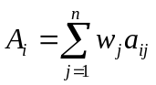(3)
where 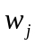 is the weight of criterion j and 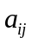 is the evaluation of alternative  against criterion j. The higher the value , the more preferred the alternative. However, if the priorities are fuzzy as in the conventional fuzzy AHP, then an appropriate ranking procedure should be applied to defuzzify the rank of alternatives.
式中表示准则j的权重，是方案相对于准则j的计算值。的值越高，表示该方案更应该选择。但是，如果权重和在传统模糊层次结构中一样是模糊的，应该使用来一个合适的评价过程来解模糊化各个方案的评价值。
- 模糊优化模型
Suppose that a fuzzy judgment matrixis constructed as in Eq. (2). The elements of the judgment matrix are pairwise comparison ratios represented by fuzzy triangular numbers ,whereand= 1,2,...,n.Moreover, it is assumed that 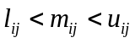when 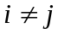. If i=j, then 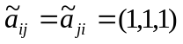. Hence, an exact priority vector derived from must satisfy the fuzzy inequalities:
设模糊判断矩阵是使用公式(2)构造的。判断矩阵的元素是使用模糊三角数，其中,= 1,2,...,n，表示的成对比较比率。而且，当时认为。如果i=j，。因此，一个由导出的精确权重向量必须满足模糊不等式：
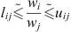(4)
where 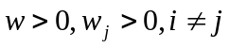and the symbol means”fuzzy less than or equal to”. To measure the degree of satisfaction for different crisp ratios 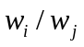 with respect to the double side inequality of Eq.(4), a new membership function can be defined as:
式中，并且符号表示“模糊小于或者等于”。为了衡量不同的离散比率与相应不等式两边的匹配程度，一个新的成员函数定义如下：
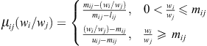(5)
where. Unlike the triangular membership function in Eq. (1), the value of 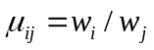 may be larger than one, and it is linearly decreasing over the interval (0, 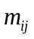] and linearly increasing over the interval [, ∞). A smaller value of indicates that the exact ratio is more acceptable.
式中。不像公式(1)中的成员函数，的值可能大于1，而且它在区间(0, ]内是线性递减，在区间[, )内线性递增。的值越小代表离散比率的可接受性越大。
To find the values of the elements of the priority vector , all exact ratios should satisfy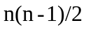fuzzy comparison judgments,i.e. 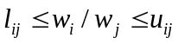, as possible as they can,where i and j = 1, 2,..., n, i≠j, and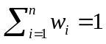. This last requirement is the main constraint of the conventional AHP method. Hence, the problem of crisp priorities assessment in Eq.(5) is transformed into an optimization problem. Assuming that the system of nonlinear equations in Eq. (5) is soluble and its solution is , the solution is equivalent to minimizing a master function described as follows:
为了寻找优先权向量中元素的值，所有的离散比率都应该尽量满足n(n-1)/2模糊比较矩阵，例如，其中i、j=1,2,...,n，i≠j，且。最后的要求是传统AHP的主要约束限制。因而，公式(5)中离散比率的赋值问题被转化为一个最优化问题。假设公式(5)中的非线性方程组是有解的并且它的解是，解决方法等效于求一个如下方程的最小值：
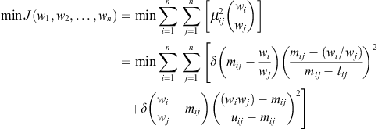(6)

subject to:
其中：
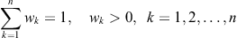(7)
where i ≠ j and is Heaviside function defined as:
式中 i ≠ j并且是Heaviside 方程，定义如下：
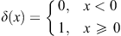(8)
The proposed prioritization model is a constrained nonlinear optimization model. General optimization algorithms limited to convex regular functions cannot be applied to this optimization problem. Therefore, an efficient optimization algorithm which can solve difficult optimization problems may be employed. We apply PSO to solve the system of nonlinear equations (Eqs. (6), (7) and (8)). The PSO method will be described in the next section.
这种优先级排序模型是一种约束非线性优化模型。常规优化算法受限于凸正则函数不能应用于优化这一困难。因此，一个可以解决困难优化问题的有效优化算法是可以使用的。我们使用微粒群优化来解决非线性方程组（公式(6)，(7)和(8)）。该微粒群优化函数将在下一节介绍。
In some cases, decision makers are unable or unwilling to give all pairwise comparison judgments of elements. Provided that the known fuzzy set of pairwise comparisons involve n elements, such as 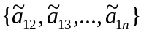or 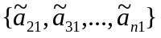, the priority vector w = can still be derived using the optimization problem above ( Wang et al., 2007). Thus, the proposed method can prioritize an incomplete comparison judgment set, which is an interesting advantage over the conventional fuzzy AHP methods.
在某些情况下，决策者不能或者不愿意给出n个元素的所有的成对比较值。假设一直的成对比较模糊集共有n个元素，例如或者，优先权向量w = 依然可以使用以上的最后化问题得出。因此，该方法可以对一个不完整的成对比较矩阵进行优先级排序，相比较传统模糊层次分析法，这是一个有趣的优点。
In order to measure the degree of consistency of the fuzzy comparison matrix, we follow the method proposed by Mikhailov (2003), in which the consistency can be evaluated using the optimal priority vector 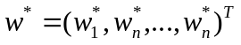. Mikhailov (2003) developed a nonlinear fuzzy prioritization algorithm for his proposed FPP method. The prioritization problem of the FPP method uses two main assumptions. First, if 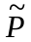is the fuzzy feasible area on the (n−1)-dimensional simplex 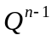, with respect to the optimization problem, the membership function of the fuzzy feasible area is defined as:
为了衡量模糊比较矩阵的一致性程度，我们是使用Mikhailov提出的方法，该方法使用最佳优先级向量来计算一致性。Mikhailov为他提出的FPP算法发明了一个非线性模糊最优化算法。FPP的最优化问题使用两个主要假设。第一，如果是模糊可行域在n-1维，关于最优化问题，成员函数的模糊可行域定义如下
(9)
Second, a selection rule to determine a priority vector with the highest degree of the membership function given in Eq. (9) may be specified. Mikhailov (2003) used a maximization problem as the prioritization method and describes that 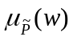 is a convex set and always a priority vector 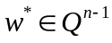 could be found that has a maximum degree of membership in 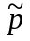, which corresponds to the maximum fuzzy feasible area:
第二，可以指定一个选择规则，来确定拥有公式(9)中的成员函数的最高隶属度的优先级向量。Mikhailov 使用一个最大化问题作为最优化问题并且定义是一个凸集合，而且总是可以找到一个优先级向量，其在中有最大隶属度，其相应的最大化模糊可行域为：
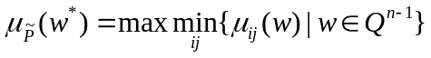(10)
Mikhailov (2003) refers to 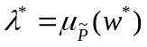as a “consistency index” and explains that this value is intended to measure the level of satisfaction from the optimized priority vector 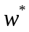. When 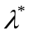is positive, it indicates that all solution ratios completely satisfy the fuzzy judgments, i.e. , which means that the initial set of fuzzy judgments is rather consistent. The takes values between 0 and 1 which shows the degree of inconsistency in the decision maker’s judgments. The principles we use for developing our prioritization approach are similar to Mikhailov’s method. However, with respect to the definition of our new fuzzy number presented in Eq. (5), we try to find a priority vector that has a minimum degree of membership, that is:
Mikhailov 将作为一个“一致性索引”，并说明该值是用来衡量与最优化优先权向量的匹配等级。当是正数，它代表所有的方案的比率完全符合模糊判断，例如，这意味着最初的模糊判断集合是相当一致的。在0和1之间取值，表明决策者判断的不一致程度。我们用来组成我们优先级排序方法的原则与Mikhailov的方法一致，但是考虑到我们公式(5)中定义的新模糊数，我们尝试找到一个有最小隶属度的优先级向量，为：
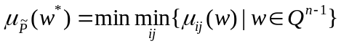(11)
Accordingly, we refer to the 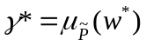as the consistency index of pairwise comparisons.
相应的，我们将作为成对比较值的一致性索引。
- 微粒群优化
PSO, first proposed by Kennedy and Eberhart (1995), is a simple model of social learning whose emergent behavior has found popularity in solving difficult optimization problems (e.g. Wang, Che, & Wu, 2010). The initial analogy had two cognitive aspects, individual learning and learning from a social group. The original idea was to simulate the social behavior of a flock of birds trying to reach an unknown destination (fitness function), e.g., the location of food resources with flying through the field (search space).
微粒群优化(PSO)由Kennedy和Eberhart首先提出，这是一个简单的社会学习模型，研究发现该模型的紧急行为在解决困难优化问题具有通用性。这个最初的模拟有两个认知度，个人学习和从一个社会组织学习。最初的想法是模拟一群鸟的社会行为来达到一个位置的目的地(适应函数)，例如，飞过地区的事物资源的位置(搜索空间)。
In an n-dimensional search space,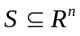assume that the swarm consists of N particles. The position of the th particle is an n-dimensional vector 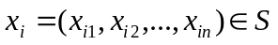. The velocity of this particle is also an n-dimensional vector 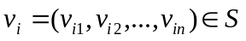. The best previous position visited by the th particle is a point in S, denoted as 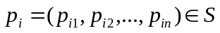. Let g be the index of the particle that attained the best previous position among the entire swarm, and t be the iteration counter. In standard PSO, the swarm is manipulated according to the following update equations
在n维的搜索空间，假定群由N个微粒组成。第i个微粒的位置是一个n维向量。该微粒的速度也是一个n维的向量。第i个微粒经历的之前的最好位置是点S，定义为。将g作为微粒在整个群中取得最好位置的序号，将t作为作为迭代计数器。在标准微粒群优化中，群通过以下等式操作
(12)
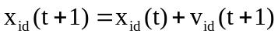(13)
where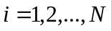is the particle’s index, 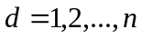 indicates the particle’s th components, and 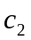are the positive constants referred to as cognitive and social parameters, respectively, and and are random numbers uniformly distributed in [0, 1], denoted as 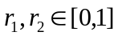 Consider the th dimension of the search space, . The right-hand-side of Eq. (12) consists of three parts ( Shi, 2004). The first part 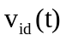 is the momentum part. The second part is the “cognitive” part which represents personal thinking of itself-learning from its own flying experience. The third part is the “social” part which represents the collaboration among particles-learning from group flying experience.
式中是微粒的序号，表示微粒是第d个组件，和正常数，表示认知的和社会的参数，同样的，和是随机分布在[0,1]区间，定义域为。考虑第d维的搜索空间。公式(12)右边由三部分组成。第一部分是是动量部分，第二部分是“认知”部分，代表从自身的飞行经验本身学习的个人思考。第三部分是“社会”部分，表示组飞行经验的微粒群学习的协同性。
In fact, the sum of the last two parts, i.e., 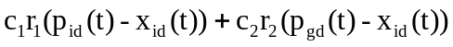, can be considered as the newly gained velocity term towards a potential position in the promising region around 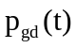 and 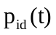. Consequently, summing the momentum part and gained velocity part results in the current velocity 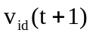. However, these two terms do not consider the influence of the feasible region. For example each or both of these two components might be so large that the corresponding particle would leave far away from the feasible region.
事实上，最后两部分的和，例如可以被认为是新得到的一个在和期望区域中潜在位置的速度项。因此，将动量部分求和，然后获得速度部分在当前速度下的结果。但是这两项不会考虑到可行域的影响。例如两项中的一项或者两项可能太大，使得相应的微粒会从可行域飞出。
One problematic characteristic of PSO is its propensity to converge, prematurely, on early best solutions. Many strategies have been developed in attempts to overcome this but by far the most popular are inertia and constriction (Shi & Eberhart, 1998)
PSO的一个难以解决的特点是它的属性是过早地收敛于早期的最佳解决方案。人们想出了跟多策略来试图克服这个缺点，但目前为止常用的方法是惯性和挤压
(14)
whereis a parameter called inertia weight.Later work ( Eberhart & Shi, 2000) indicates that the optimal strategy is to initially setto 0.9 and reduce it linearly to 0.4, allowing initial exploration followed by acceleration toward an improved global optimum. Constriction ( Clerc & Kennedy, 2002), 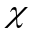, alleviates the requirement to clamp the velocity and is applied as follows:
式中是一个叫做惯性权重的参数。后续的工作表明zuiyo9u策略是将初始化为0.9，并将其线性减为0.4，容许初试探索然后向一个改进的全局最优解加速。的压缩减轻了对固定速度的要求，具体应用如下
(15)
where
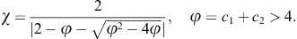
Eberhart and Shi (2000) used constant = 4.1 to ensure convergence. Hence, the values = 0.72984 and = = 2.05 are obtained.
Eberhart和Shi使用常量 = 4.1以确定收敛性。最终，获得了 = 0.72984和 = = 2.05。
To apply PSO for solving the system of nonlinear equations, Eq. (5), let the form of nonlinear equations be:
为了使用微粒群优化以解决非线性方程组，公式(5)，使得非线性方程的形式如下：
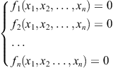(16)
The system of nonlinear equations (16) is equal to the optimization problem (17):
非线性方程组等于优化问题：
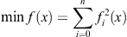(17)
Thus, the master function presented in Eq. (6) is similar to Eq. (17), and PSO can be applied to solve the optimization problem (6). The PSO algorithm is presented as follows:
因此，公式(6)的主函数和公式(17)的主函数数是很相似的，微粒群优化可以被用来解决问题(6)的优化问题。微粒群优化算法的具体步骤如下：
(1)Setup up the control parameters, and iteration t=1.
(2)Initialize position , and velocity of each particle i.
(3)Update position of each particle .
(4)Evaluate objective (fitness) function of each particle 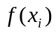.
(5)Update personal best position 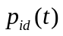 for each particle and swarm best position 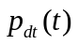.
(6)If 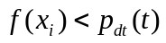, output the best position (global solution).
(7)Otherwise, update iteration, 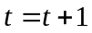 and repeat the steps 3–6.
(1)设置控制变量，以及迭代变量 t=1；
(2)初始化第i个微粒的位置为，速度为；
(3)更新每个微粒的位置为；
(4)计算每个微粒的目标（适应度）函数；
(5)更新每个微粒的个人的最佳位置和组的最佳位置；
(6)如果，输出最佳位置（全局解决方案）；
(7)否则，更新迭代变量,重复步骤3-6
- 演示实例

