Betting stuff

All data is downloaded from (so far): https://www.football-data.co.uk/

BET_DB

This is a MySQL database located in a free host.
We have 1GB of free storage and that should be enough for a while.
Is not the fastest in the world but it is for free and if we need we can check other alternatives.

Connection:

host: fusionpl.heliohost.org
user: fusionpl_ucabrera fusionpl_andrei fusionpl_alvaro
pass:
db: fusionpl_BET_DB

Clients

I’ve used the following; it is up to you:
https://dev.mysql.com/downloads/workbench/
https://www.heidisql.com/download.php

Data Base Structure

This is the structure up to now:
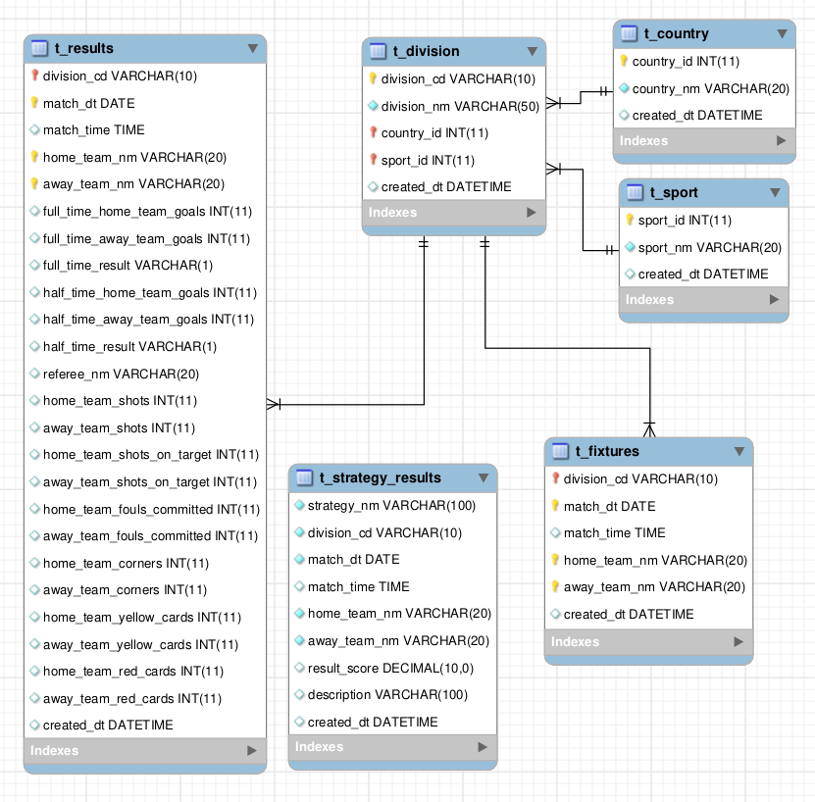

Tables:
t_country: Countries list
t_sport: Sports List
t_division: It is the relationship between countries and sports.
t_results: It holds the results for matches per division. Therefore country and sport.
t_fixtures: Calendar of matches for next days.
t_strategy_results: It stores the results of running a strategy per division, home, away. Therefore country and sport.

Tables are the “raw” data where you find just id’s and codes.

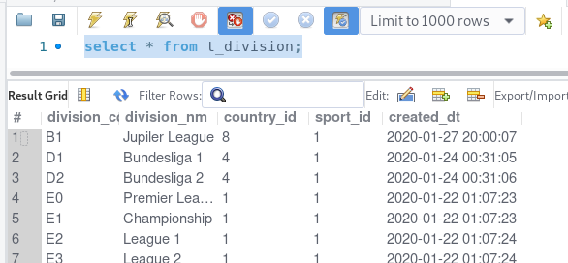
For a more friendly view I created some views where we can see descriptions rather than codes:

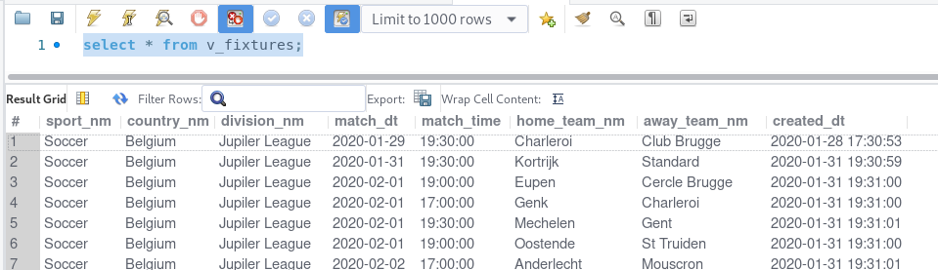
All tables names starts with t_ and views with v_

Views:
v_results: Same as t_results but with descriptions.
v_fixtures: Same as t_fixtures but with descriptions
v_strategy_results: Same as t_strategy_results but with description and join with t_results. So we can know how match ended if we already imported results for previous matches. Null when we don’t have results.

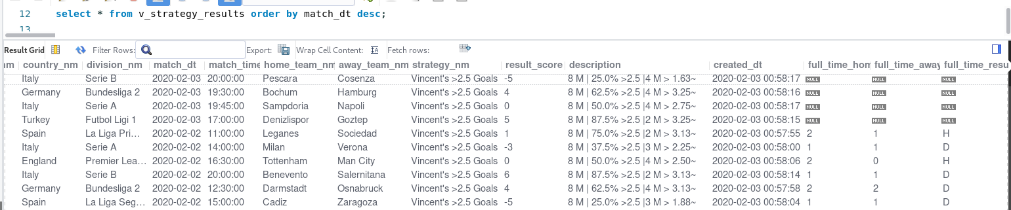
Store Procedures:

I created a few procedures to help:

sp_get_temp_results: This helps to select previous matches depending on parameters we give:
in_match_dt: kind of it explains itself ¬¬
in_home_team_nm: ¬¬
in_away_team_nm: ¬¬
in_prev_matches: how many previous matches you want to retrieve. (number)
in_prev_days: how many days back in time. (number)

It append results to a temporary table call: tmp_team_results
If it doesn’t exist it will create it.
Coz it is a temporary table; as soon as you disconnect it will be deleted.
As many time you run procedure, the same times it will append data.
So, you will need to truncate or delete table manually when doing your tests.

Examples:

select * from tmp_team_results;
delete from tmp_team_results;

To get last 4 home matches:
call sp_get_temp_results(STR_TO_DATE('03/02/2020', '%d/%m/%Y'), 'Napoli', null , 4, null);

To get last 4 away matches:
call sp_get_temp_results(STR_TO_DATE('03/02/2020', '%d/%m/%Y'), null, 'Napoli', 4, null);

To get last 4 matches home or away:
call sp_get_temp_results(STR_TO_DATE('03/02/2020', '%d/%m/%Y'), 'Napoli', 'Napoli', 4, null);

To get last 4 matches head to head:
call sp_get_temp_results(STR_TO_DATE('03/02/2020', '%d/%m/%Y'), 'Napoli', 'Milan', 4, null);

sp_run_strategy: I’ll explain after… sleep.
sp_strategy_vicent_o25: I’ll explain after… sleep.

