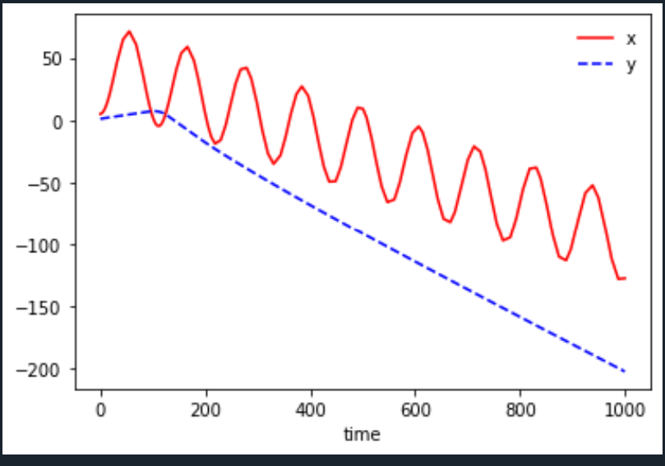

Todo – results for various initial conditions

18/04/2022 – compare softcore and effective (C=1)

Softcore with a = 0.0025

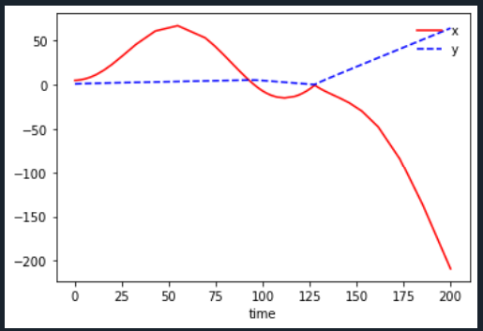

This matches effective with potParams p(0.0, 0.0, 0.0, 0.0, 0.0, 0.0);

Softcore with a = 0.025

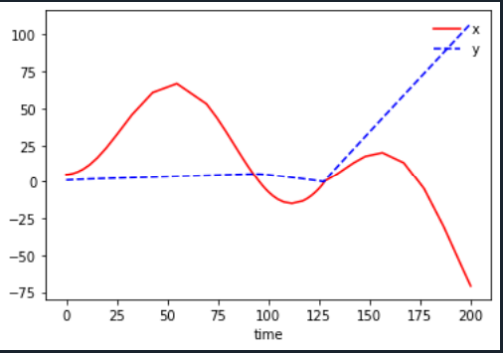

Effective with

potParams p(16.039, 2.007, -25.543, 4.525, 0.961, 0.443);

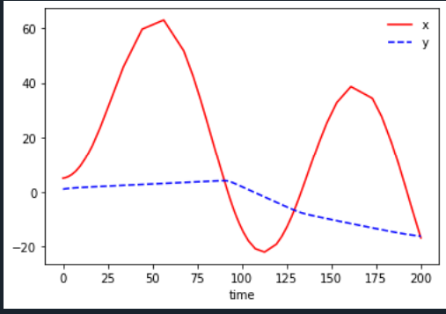

Clearly electron shielding and softer soft core reduces potency of Coulomb singularity considerably