Professor Fearing EECS192 Worksheet 2 MOSFET and Motor Spring 2015
*** For practice, not collected or graded ***

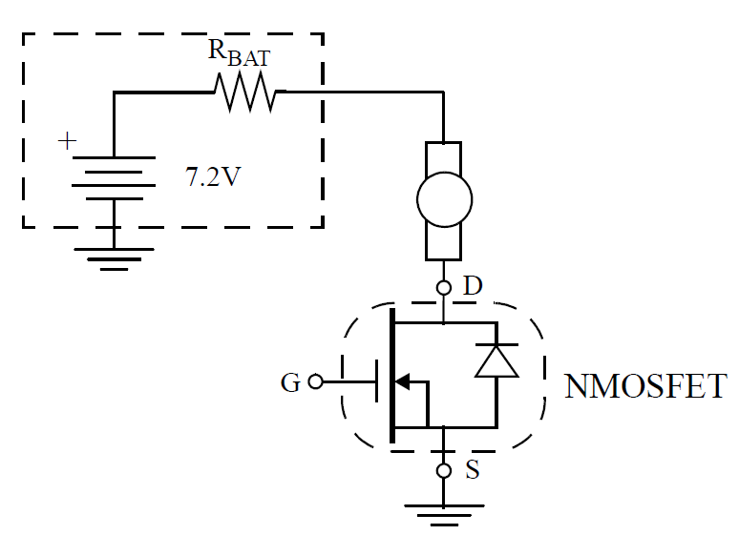 | 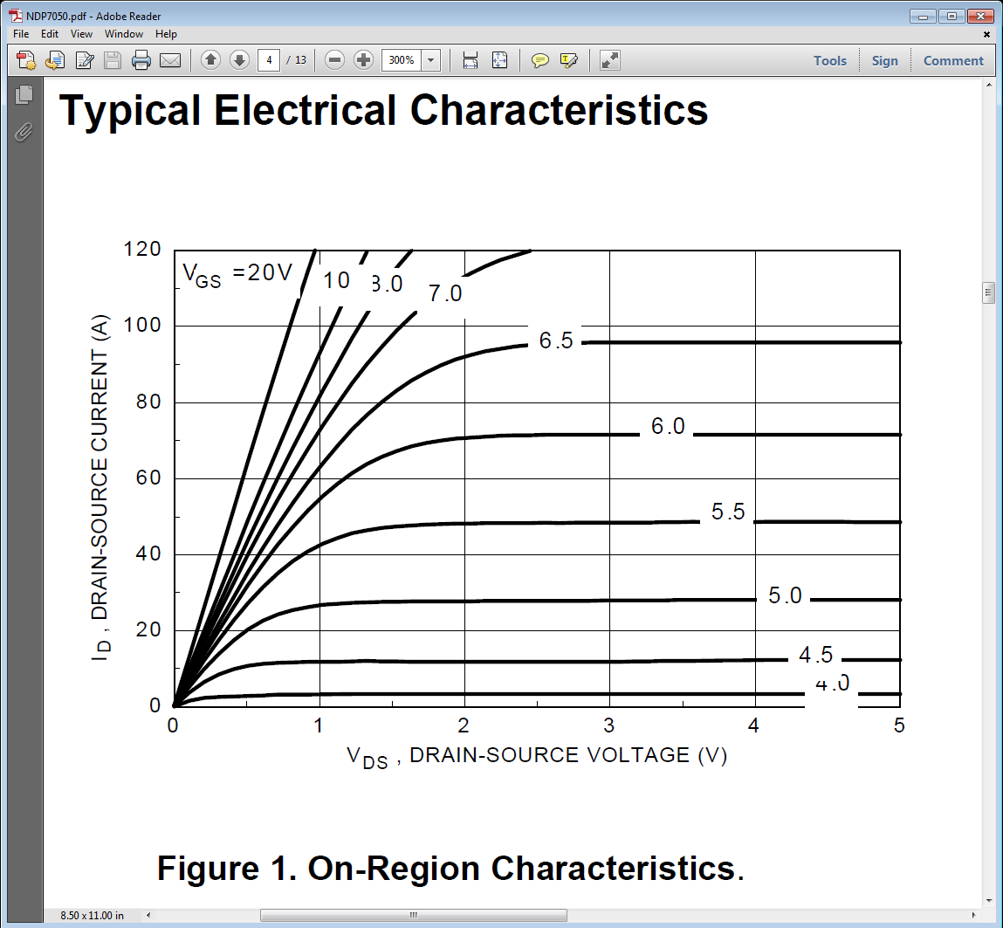
Motor and Battery | MOSFET On region Characteristic

Given: R_{BAT} = 0.06 Ohms, Rm=0.06 ohms. Neglect motor inductance, assume static case.(Motor is stalled).

1. If VDS = 0.0 V, what is motor current? What is power dissipated in motor? What is battery voltage? What is power supplied by battery?

2. If MOSFET gate is driven such that V_{DS} = 2.4V, what is the motor current? What is the power dissipated in th emotor? What is power dissipated in the MOSFET?

3. If V_{GS} = 5.5V, what is I_{DS}? What is VDS? (Hint: loadline). What is power dissipated in motor? What is power dissipated in MOSFET?

4. Repeat 2, but now V_{GS} = 20V.

