# #1

# RSS Feed

Component to read external RSS Feed & display most recent feed

## Component Design

RSSFeedService – An OSGi Service to obtain the external Feed URL and services to deliver most recent feeds

RSSFeedServiceImpl – Service Implementation for RSSFeedService and methods to retrieve feeds

RSS Source – <https://sports.ndtv.com/rss/cricket>

Dialog Design

|  |  |  |  |
| --- | --- | --- | --- |
| Field Name | Type | Value | Description |
| Build List by | Dropdown | Dynamic/Fixed List | Based on selection will either fetch feed dynamically or option build a fixed list |
| Dynamic Options | NumberField | Positive Integer | Number of feeds to display dynamically |
| Fixed List Options   * Title * Description * Published Date | Multifield   * Textfield * RTE * DateField |  | Display Feed based on values provided in fixed options |

Assumptions: Single component to display based on dropdown selection, a separate component can be created for individual feeds as well based on further requirement analysis

# #2

# Content Structure

Language Master Content Structure  
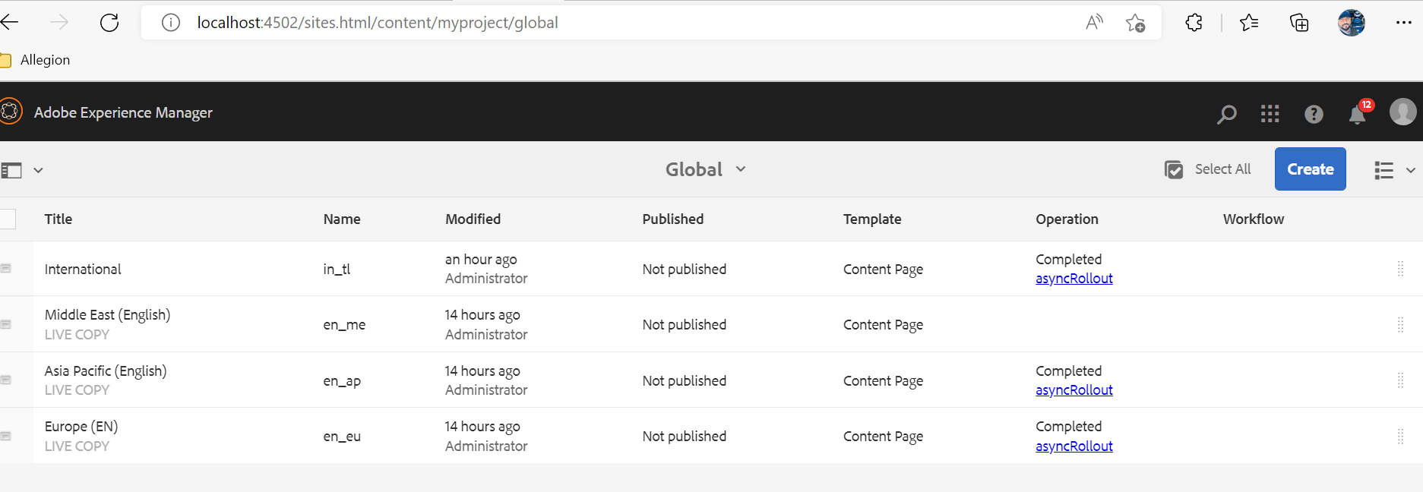

Sites content structure  
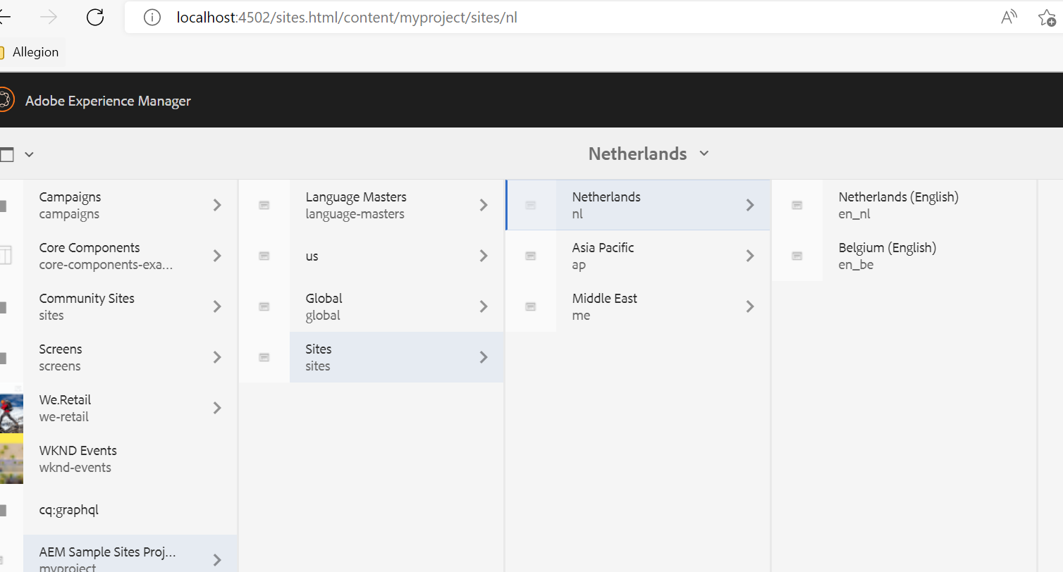

Blueprint Source: /content/myproject/global  
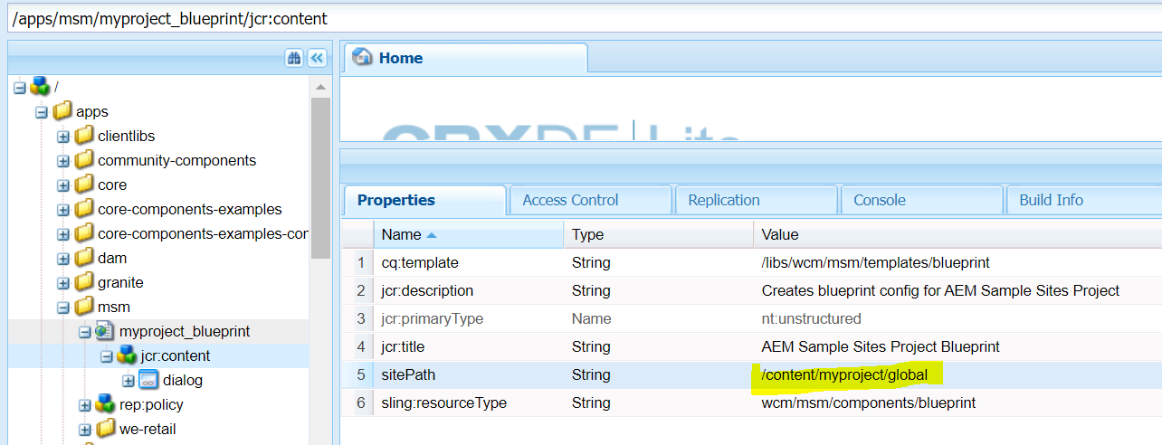

Rollout configurations: Standard  
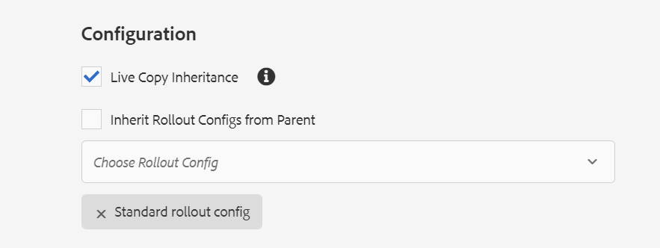

## Test Rollout

From Page Options – Select Rollout from in_tl -> en_me, en_ap, en_eu  
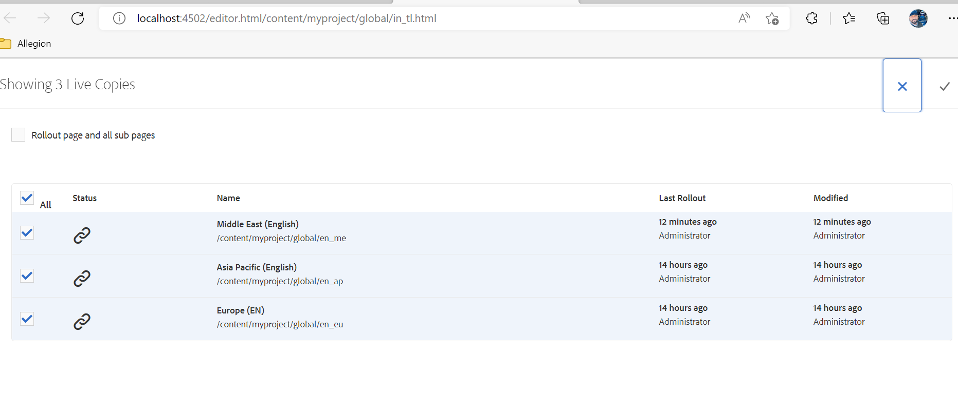

Further Rollout changes to individual sites:  
From en_eu -> en_nl, en_be  
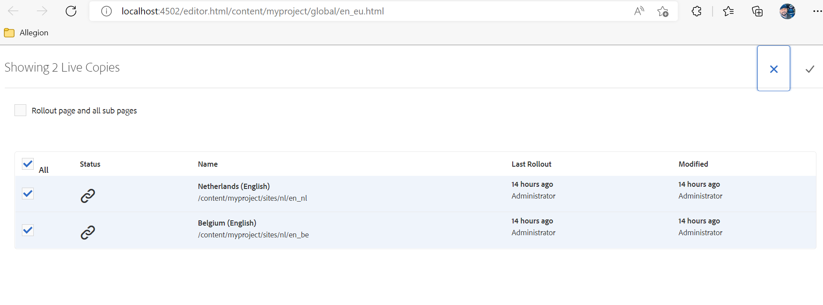

## Result

Content is pushed to live copies accordingly.

Sample – Belgium (English) site

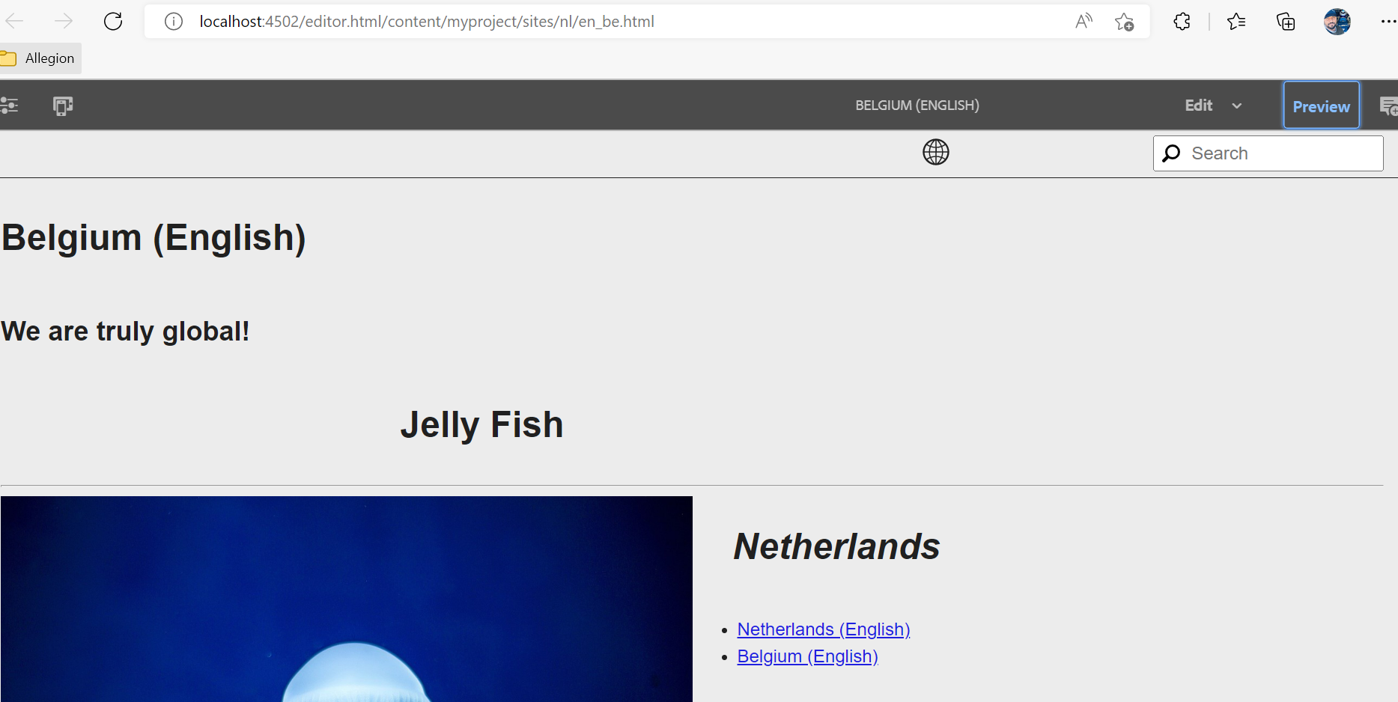

# Creating Experience Fragments with MSM Capability

1. Create experience fragment under folder structure - /content/experience-fragments/myproject/global
2. Create Master variation by adding relevant content
3. Create as many variations as live copy of master variation   
   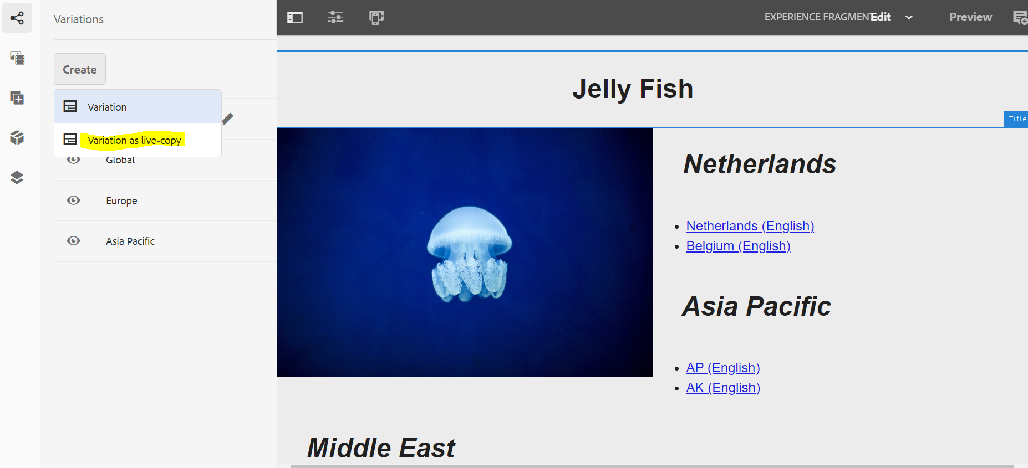
4. Update content as necessary by cancelling inheritance as shown  
   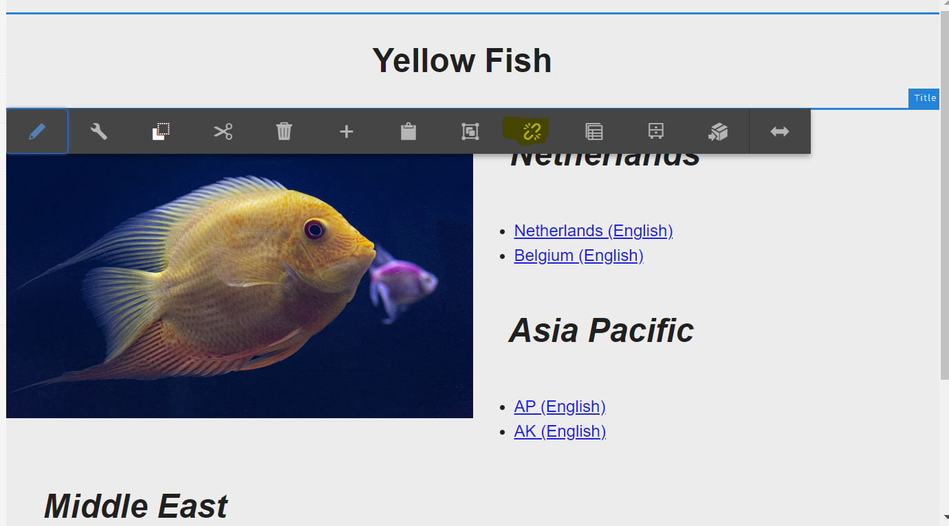
5. Add a separator component to master variation and rollout to all variations  
   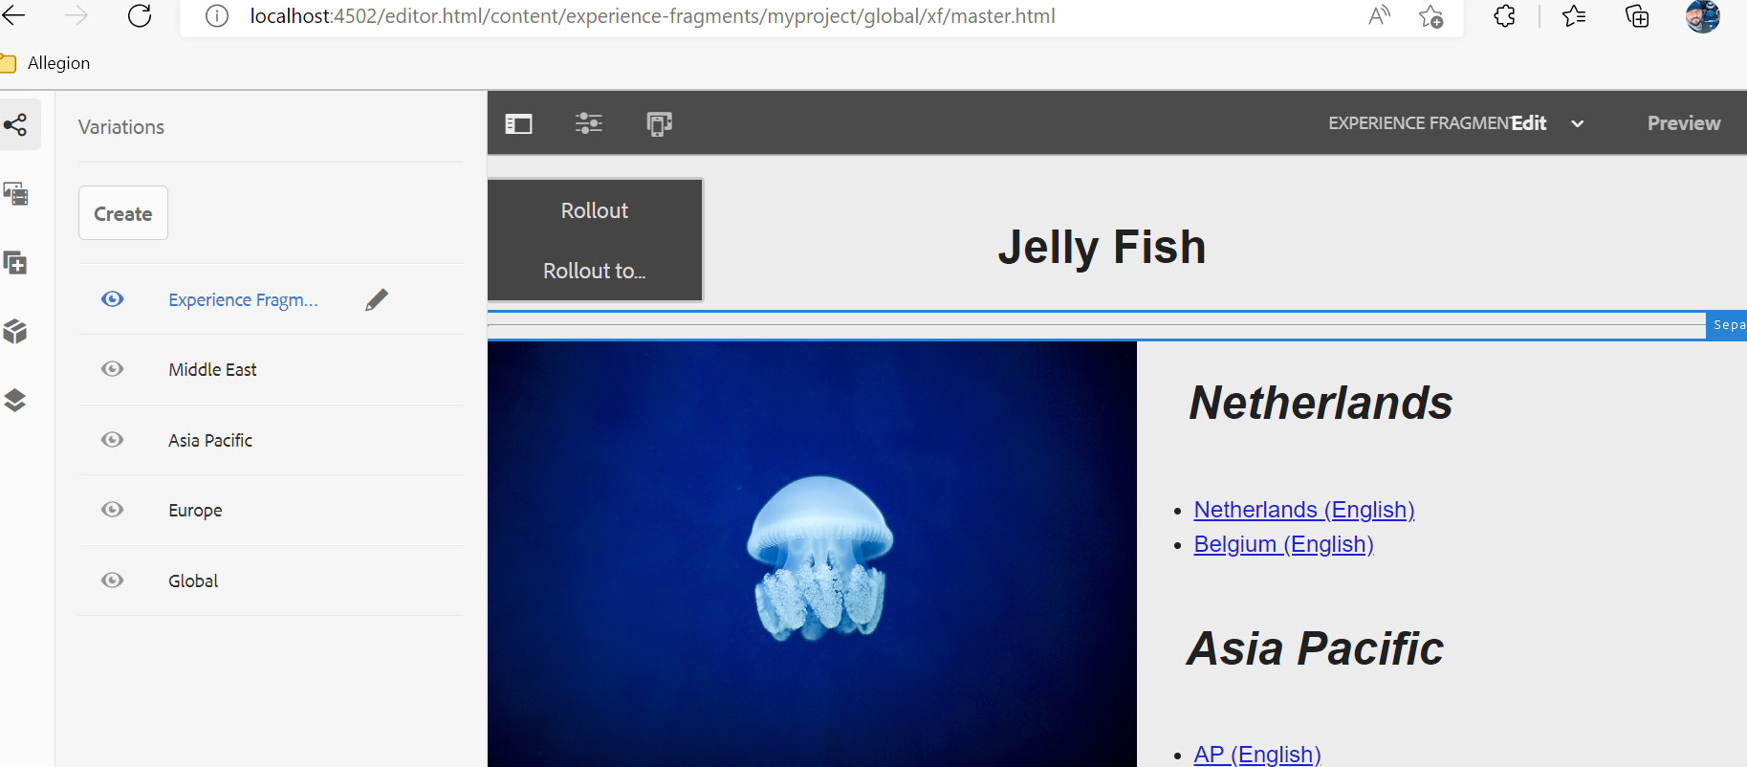  
     
   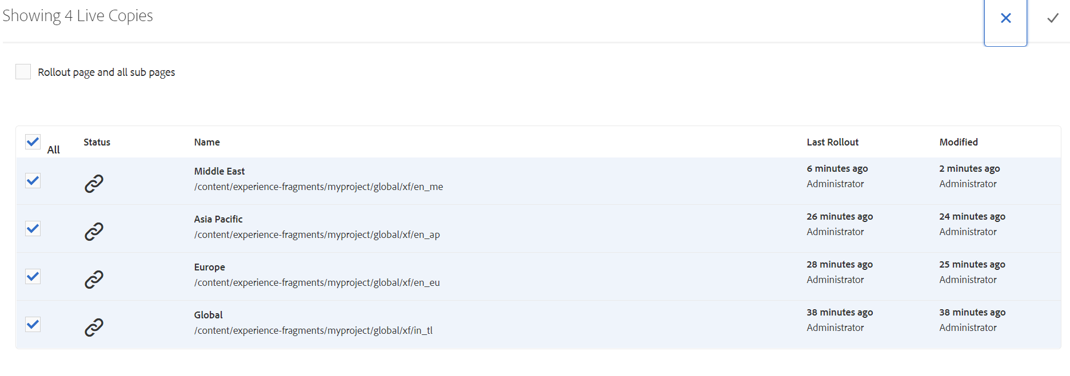
6. Updates to master variation will be rolled out to all live copies.

# Technical Documentation

## Project Creation

Maven Command used to create the project

mvn -B org.apache.maven.plugins:maven-archetype-plugin:3.2.1:generate -D archetypeGroupId=com.adobe.aem -D archetypeArtifactId=aem-project-archetype -D archetypeVersion=35 -D appTitle="AEM Sample Sites Project" -D appId="myproject" -D groupId="com.adobe.aem.myproject" -D artifactId="myproject" -D package="com.adobe.aem.guides.myproject" -D version="0.0.1-SNAPSHOT" -D aemVersion="6.5.11" -D includeDispactcherConfig=n -D frontendModule=general -D singleCountry=n -D includeExamples=y

## Command to deploy the entire project:

mvn clean install -PautoInstallPackage

## Environment:

Java Version: 11

Maven Version: 3.8.6

AEM Version: 6.5.11

Maven ArcheType: 35