
1



TECHNICAL MANUAL
&

USER GUIDE ETIX

This manual has been created by the psychologists from the Science and Innovation department of Central Test.

The assessment REASONING TEST 20’ and the Central Test logo are registered trademarks.

No reproduction, modification or adaptation is permitted without the written consent of the publisher Central Test.

Copyright © 2020 by Central Test - Empowering Talent. All rights reserved.

Table of Contents

Introduction 4
- General Description and Applicability 5
  - Main Areas of Application 7
  - Questionnaire Structure 7
  - Mode of Administration, Languages and Special Requirements 7
  - Social Desirability 8
  - Test-taker Requirements and Recommendations 8
  - Administrator Qualifications and Recommendations 8
    - Testing Conditions 9
  - Technical and Security Issues 9
    - Respecting the Ethical Charter 9
    - Confidentiality and Security 10
    - Hardware Architecture and Server Availability 10
  - Supply, Conditions, and Availability 10
- Conceptual and Practical Scale Development 11
  - The History and Value of Integrity Testing to Personnel Assessment 11
  - Theoretical Background 12
  - Development of ETIX 14
    - The Survey 14
    - ISO norm 26000 15
    - Ethics charters 15
    - Description of Factors 16
    - Item Construction and Pre-tests 20
- Sample Descriptives 23
- Norms 25
  - Norms for UK Sample 26
  - Spanish Sample 41
  - French Sample 42
- Reliability 44
  - Internal Reliability 44
  - Split-half Reliability 45
- Validity 46
  - Concurrent Validity 46
  - Construct Validity 48
    - Inter-factor Correlations 48
    - Inter-facet Correlations 49
    - Confirmatory Factor Analysis (CFA) 51
  - Consequential validity 53
    - Measurement Equivalence 53
    - Differential Item Functioning 53
    - DIF Analysis: Gender 55
      - DIF Analysis: Participants 55
      - DIF Analysis: Results 55
    - DIF Analysis: Age 61
      - DIF Analysis: Participants 61
      - DIF Analysis: Results 61
    - DIF Analysis: Study Level 64
      - DIF Analysis: Participants 64
      - DIF Analysis: Results 64
    - T-tests and ANOVAs 67
References 72

Introduction
ETIX is an assessment designed to objectively analyse an individual’s attitudes towards counterproductive work behaviour. It aims to identify those who are inclined to accept and participate in certain behaviours that may not be in the company’s best interests. These behaviours may be detrimental for the company with regards to both physical property and the psychological impact on those at the receiving end of such behaviours.

ETIX consists of 140 questions displaying various counterproductive work behaviours which are related to six factors, each representing a different aspect of work ethics: Respect for Equality, Respect for Laws and Procedures, Respect for Commitments, Respect for Other People, Respect for Facts and Honesty, and Respect for Equality. The aim of this assessment is to evaluate a person’s tolerance towards, and likelihood of engaging in, unethical work behaviour. It can aid decision-makers when recruiting by optimising candidate fit. The assessment was also developed with the aim of helping organisations to approach the subject of work ethics with their employees or candidates; in this way, they will be able to explore and develop the individual in question’s ethics and thereby ensure an alignment between individual and organisational behaviour expectations.

This user guide and manual will help the test user understand the theoretical foundations behind ETIX, how each factor is defined in organisational contexts, and the manner in which the test has evolved into its current structure. It will also serve as a guide to better understand the stages of test administration, report interpretation, and applications of the test in a range of organisational settings.

General Description and Applicability
ETIX provides an analysis of a person’s likelihood to engage in unethical work behaviour by measuring their attitudes towards, and tolerance of, various counterproductive work behaviours. It analyses six factors related to work ethics that are relevant in assessing a person’s general propensity towards ethical work behaviour. The analysis of each factor is divided into attitudes towards other people’s behaviour and attitudes towards one’s own behaviour. This is relevant in measuring an overall work ethic because:

By assessing an individual’s attitudes towards other people’s behaviour, we can assess their likelihood of accepting unethical work behaviour in others. Those who accept unethical work behaviours in others help to maintain an unproductive work environment.

By assessing attitudes towards one’s own behaviour, we can closely evaluate their level of acceptance of unethical work behaviour in their own actions and, therefore, their likelihood of taking part in behaviours that contribute to an unproductive work environment.

The combination of these two facets in each factor provides a more precise and accurate evaluation of a person’s likelihood of engaging in counterproductive work behaviour.
ETIX measures the following 6 factors and 12 facets:

Respect for Commitments

This factor measures an individual’s attitudes towards respecting commitments. It aims to evaluate people’s level of acceptance of behaviours related to people’s lack of commitment to their work.

Self: this facet measures an individual’s respect for work commitments. It evaluates the tendency to adhere to work commitments, to be trustworthy, and to be reliable.

Others: this facet measures attitudes towards other people’s level of respect for commitments of work. It evaluates the tendency to feel uncomfortable with people who do not uphold their commitments and to show disapproval of such actions

Respect for Goods and Property

This factor measures an individual’s attitudes towards respecting the goods and property of a company. It aims to measure a person’s level of acceptance, and therefore likelihood, of committing petty theft.

Self: this facet measures an individual’s attitudes towards respecting goods and property. It evaluates the likelihood of engaging in the act of stealing of any kind.

Others: this facet measures an individual’s attitudes towards other people respecting the goods and property of a company. It evaluates the tendency to believe that stealing money, products, services, or office supplies is unacceptable.

Respect for Laws and Procedures

This factor measures an individual’s attitudes towards respecting laws and procedures meant to protect organisational interests. It aims to measure a person’s level of acceptance of corrupt behaviour.

Self: this facet measures an individual’s respect for laws and procedures. It assesses the likelihood of initiating or even participating in the bending of rules to meet self-interested goals.

Others: this facet measures the tendency to be attached to the concept of legality, believing in the virtues and importance of the law above self-interest. It assesses the tendency to reject other people bending the rules to pursue self-interested goals.

Respect for Facts and Honesty

This factor aims to measure attitudes towards respecting facts and honesty. It aims to measure both individuals’ level of acceptance of the manipulation of information and their likelihood of engaging in deceitful behaviour.

Self: this facet evaluates the tendency to respect facts and honesty and to believe information must be reported in a factual and honest manner. It measures the tendency to be truthful.

Others: this facet evaluates attitudes toward other people respecting facts and honesty. It evaluates the tendency to find manipulation unacceptable and to not tolerate other people lying or engaging in deceitful behaviour.

Respect for Equality

This factor measures attitudes towards respecting equality. It aims to measure the level of acceptance and likelihood of committing acts of discrimination in the workplace.

Self: this facet measures the tendency to respect equality. It measures the tendency to treat everyone fairly and to acknowledge people based on their professional accomplishments rather than on irrelevant personal or physical characteristics.

Others: this facet measures attitudes towards other people respecting equality. It evaluates the tendency to feel uncomfortable when faced with acts of discrimination and to report such behaviour.

Respect for Other People

This factor measures attitudes towards respecting people at work. It aims to measure people’s level of acceptance of inappropriate or offensive work behaviour, which can lead to accepting and participating in bullying and harassment.

Self: this facet measures the level of respect for others at work. It evaluates the tendency to reject initiating or participating in any offensive or degrading behaviour towards other people and the tendency to remain courteous and respectful to co-workers.

Others: this facet measures attitudes towards individuals respecting other people at work. It evaluates the tendency to feel uncomfortable working in environments where people are not valued, and where harassment or bullying can take place.

Main Areas of Application
The aim of ETIX is to evaluate a person’s tolerance of unethical work behaviour and their likelihood of engaging in it. It is intended for use by Human Resources professionals in the selection and development of employees.

The assessment can also be used to identify those with a high proclivity to engage in behaviours that are deemed counterproductive and who could therefore cause damage to the company.

Applications of ETIX can vary, as it is suitable for individuals, teams, and organisational assessment. It can be applied to employee recruitment, selection, and development processes, as well as for team and individual development, and for culture and employee commitment audits.

Questionnaire Structure
ETIX consists of 6 core factors which are divided into two facets, one measuring attitudes towards one’s own behaviour (facet Self), and the other measuring attitudes towards other people’s behaviour (facet Others). There is an additional factor that serves as a social desirability scale, which is also divided into the two facets Self and Others. The final version of the questionnaire comprises of 140 questions. Each factor contains 20 questions; 10 questions are related to the facet Self and the other 10 are related to the facet Others. All questions are measured on a 4-point Likert scale, where respondents need to specify their level of agreement or disagreement with each item (1= Strongly agree, 2= Somewhat agree, 3= Somewhat disagree, 4= Strongly disagree). This is the most common form of scoring in normative questionnaires and covers the full range of possible responses.

Mode of Administration, Languages and Special Requirements
ETIX is administered online and is compatible with all computer systems including Windows, MAC-OS, and Linux. The assessment can be administered remotely and without supervision. Reports are solely generated online; therefore, if the test has been administered on paper, the administrator must manually enter candidates’ responses into the Central Test client platform to generate a report.

The questionnaire is available in English, Spanish, and French. For more information on language availability, please contact the Central Test Consulting Service at consulting@centraltest.com.

ETIX was designed to be used by individuals from diverse backgrounds and can be adapted for those with special needs. It is possible to adjust visual screen specifications, such as increasing the font size and screen display. Test instructions are accessible throughout the duration of the assessment for those who require it. Questions can be revisited and changed as desired. For candidates who are blind or have severe visual impairments, items can be read aloud by a trained administrator.

The average time for completion is 20 minutes; however, ETIX does not have a time limit and therefore candidates who need more time to answer the questions can do so freely. Please contact the test publisher for guidance on administering the questionnaire to individuals or groups with special requirements.

Social Desirability
People are sociable by nature and so are inclined to seek social acceptance. Social desirability is the tendency to present oneself in a manner that will be viewed favourably by others. An individual’s need to present themselves in a favourable light negatively impacts test results (Dodou & de Winter, 2014); therefore, it is of utmost importance to control for social desirability in respondents. This is especially true for recruitment purposes, as a candidate will be highly tempted to answer in a way that will impress the recruiter.

In order to control for social desirability, a social desirability scale was constructed for ETIX. The questions pertaining to the social desirability scale were similar to the other test items in terms of vocabulary and subject; this was done to ensure they were not easily detected. The scale is composed of 20 questions and is equally split between the facets Self and Other.

Test-taker Requirements and Recommendations
ETIX was designed for members of the general population over 20 years of age that are currently working or looking for work. It is recommended that candidates receive notification of the objective of the assessment, the conditions it will be administered in, how data will be handled and stored, and how the feedback will be delivered. Potential candidates should also be asked beforehand whether they have any special needs or requirements.

Administrator Qualifications and Recommendations
In order to administer ETIX, practitioners must complete a standardised training course and/or possess accredited testing qualifications.

The aim of the training is to ensure that the test user knows how to:

- Administer the assessment in standardised conditions
- Interpret scores and norms
- Generate written and verbal feedback from the results
- Match the results to a range of organisational needs

Prior to any administration, it is recommended that administrators take ETIX themselves. This will enable them to become familiar with it.

Test administration must be in accordance with the organisation’s code of practice and legal regulations on the use of psychometric assessments for employment purposes. It is recommended that international and country laws, such as data protection, discrimination, race and ethnicity relations etc., are taken into account prior to administration. This is to help ensure that the test administration is objective and fair.

Additionally, prior to use, administrators must be familiar with, and adhere to, Central Test’s conditions of use, Code of Ethics, and Quality Charter. Administrators must ensure that:

- The appropriate test(s) has been chosen to meet the organisational needs
- The candidate is informed about the assessment and its purpose prior to administration
- The candidate has given consent prior to administration

- Appropriate norms are used to interpret results
- The candidate is given feedback on the results
- The results and personal information will be deleted on request by the candidate
- The candidate has given consent prior to personal data or results being transferred to third parties
- Only qualified personnel administer assessments and have access to the data
- Assessment materials and reports are stored securely
For more information about Central Test’s Code of Ethics, refer to Central Test’s Quality Charter.

Testing Conditions

ETIX should be administered in a quiet, well-lit, and ventilated environment, so as to ensure that the candidate is undistracted and has a pleasant experience, thereby increasing the probability that their responses are accurate. Candidates should be allowed sufficient time to take the assessment and should thus be informed about the length of the questionnaire prior to administration. It is best to refer to the assessment as a questionnaire and not a test to reduce candidates’ anxiety levels.

Prior to testing, administrators should ensure that all relevant candidate background information has been collected and verify that the correct candidate is taking the assessment. Candidates receive an email invitation to take the questionnaire, with an embedded link and login details. All web links and login details are unique to a candidate’s account. Expiration dates can be set in order to ensure candidates complete the questionnaire within a specific timeframe.

ETIX does not have a time restriction; however, time is monitored to allow administrators to know whether a candidate has taken an overly long or short time to complete the questionnaire. Candidates are encouraged to answer questions quickly and spontaneously, in order to provide more accurate answers.

Technical and Security Issues
The following points serve as guidelines for securely administering ETIX. These are useful for ensuring that ETIX is administered in an objective and fair manner. Security specifications are also important for protecting the candidate’s information, both during administration and after the completion of the assessment.

Respecting the Ethical Charter

As a publisher of online assessment tools, Central Test respects the legal conventions of French labour law and the regulatory provisions resulting from the law of 6 January 1978 pertaining to information technology, files and freedoms: Declaration N°1834067.

Test results and personal data cannot be shared with third parties without explicit consent from the candidate. Candidates have the right to access their results and the assessor must grant them access when requested. Furthermore, if the candidate requests it, all data must be permanently deleted; to do so the candidate must contact either the organisation or Central Test directly.

Confidentiality and Security

Central Test guarantees the security and confidentiality of data generated during the administration of online tests: access codes are encrypted in the database and cannot be accessed by anyone. Passwords are computationally generated and not visible to companies. A URL rewriting module (secure link generator) has been installed and has transparent parameter passing for the user.

Browsing and data exchanged via the Central Test application can be secured and represented by an icon in the form of a padlock in the internet browser. The Central Test application has a <<GeoTrust SSL TRUE BusinessID>> digital signature, issued and certified by GeoTrust®. This certificate protects all Central Test assessments from phishing attacks and serves as proof of our dedication to providing a secure platform.

Invitations to take tests are made via secured links that are of limited use (in terms of numbers and duration). The tests are timed, and IP addresses are tracked.

Hardware Architecture and Server Availability

Central Test has a network of ten servers to provide high-quality service. Each server is housed in a specialised data centre featuring:

- Dedicated lines
- A guaranteed bandwidth of 100Mbps (per server)
- Redundant energy sources
- 4-hour Equipment Restoration time
- 2-hour Incident Intervention time
- Monitoring and assistance 24/7/365
Access to the server administration is restricted to an IP address and is password-secured. Data exchanges are secure. Central Test’s application has been tested on and is compatible with the following browsers: Internet Explorer 8 or newer, Firefox 21 or newer, Google Chrome 30 or newer, and Safari 7 or newer.

Supply, Conditions, and Availability
Conditions of supply and availability vary from country to country. However, the following points generally apply training is compulsory prior to use and distribution; ETIX can be ordered online or by contacting any Central Test customer service representative or local partner worldwide. The same applies for information about prices and related products and services.

Conceptual and Practical Scale Development

The History and Value of Integrity Testing to Personnel Assessment

Employee behaviour at work has always been a matter of concern for organisations because it can heavily impact on productivity and success. Some employees’ actions, such as loyalty to the organisation (Khuong & Tien, 2013), sharing and taking pride in the organisation’s vision, taking responsibility, and being concerned about the organisation’s growth (Kular, Gatenby, Rees, Soane, & Truss, 2008) benefit employers. These productive work behaviours help establish a good rapport between the employee and the employer, resulting in optimal work performance and lower turnover (Shore & Martin, 1989).

On the other hand, certain employee behaviours may cause harm to the organisation. Workplace behaviours that are obstructive rather than constructive, and have a negative impact within an organisational environment, are termed counterproductive work behaviours (CWB) (Barrett, 2001). These behaviours can unintentionally harm co-workers, employers, and/or the organisation (Thomas, 2012). They can range from minor forms of counterproductive work behaviour, such as taking excessive breaks, leaving early, and intentionally working slowly, to more serious forms, such as sabotage and stealing (Thomas, 2012).

Measuring Work Ethics in various organisational psychology domains, such as leadership (Hooijberg, Lane, & Diversé, 2010), employee wellness, and employee selection (Ones, Viswesvaran, & Schmidt, 1993), has attracted a lot of attention due to the damage that a poor work ethic can cause for a company.

Several studies estimated that CWB's cost organisations billions of dollars annually (Camara & Schneider, 1994; Murphy, 1993; Vardi & Weitz, 2004, as cited in Berry, Carpenter & Barratt, 2012). Yet CWBs do not only damage organisations financially and materially; they also cause a loss of resources. For instance, employees who are the target of CWBs can experience decreased job satisfaction, increased stress, and consequently an increased intention to quit (Budd, Arvey, & Lawless, 1996; Glomb, 2002).

Research on deviant employee activity has found that up to 80% of employees steal from their employers (Boye & Slora, 1993). In fact, CWBs may be responsible for more than $41.65 billion in annual damages for the retail industry alone (The Global Retail Theft Barometer, 2011). Furthermore, The Association of Certified Fraud Examiners (ACFE, 2004) states that a typical U.S. firm loses about 6% of its annual revenues due to deviant behaviour such as employee fraud, and the ACFE estimated that businesses globally suffer an annual loss of $2.9 trillion as a result of fraudulent activity (Moore et al., 2012).

While a great deal of research has recently been devoted to the measurement and prediction of CWBs, before the 1980s “integrity” or “honesty” tests were only used by a select few (Berry, Ones & Sackett, 2007; Barrett, 2001). Those who did use them were typically security companies or specialised consultants, who used them in combination with the polygraph (Barrett, 2001). In 1988, the Employee Polygraph Protection Act (1988) rendered the use of the polygraph illegal for most employers in the USA. As a result, developing an alternative way to predict employee dishonesty and lack of integrity became a major concern for organisational psychologists.

There are two types of integrity tests that are generally accepted by experts: overt integrity tests and personality-orientated integrity tests (Sackett & Wanek, 1996).

Overt Integrity Tests

These tests ask direct questions regarding a test taker’s attitudes or past behaviours. They typically consist of two sections:

- The first measures attitude and includes questions about beliefs concerning the frequency and extent of unethical behaviours, attitudes about punishing those behaviours, endorsement of rationalisations for those behaviours, and remorse for past actions (Berry, Ones & Sackett, 2007).

- The second section asks the candidate to describe the amount of theft and counterproductive behaviours they might have engaged in while with other employers (e.g., how often an individual has engaged in theft, drug use, criminal behaviour, or other wrongdoings).

Personality-oriented Tests

These tests are more covert as they assess personality constructs believed to be related to integrity. They may ask questions to assess individuals’ thrill-seeking behaviours, social conformity, attitudes towards authority, aggression, emotional stability, agreeableness, conscientiousness, and dependability. Questions are phrased similarly to those on personality tests (Berry, Ones & Sackett, 2007).

Research has generally found that both types of integrity tests (overt and personality-type) are good predictors of CWBs (Berry, Ones & Sackett, 2007). A meta-analysis by Ones, Viswesvaran and Schmidt (1993) found that an overt test predicted a composite variable of CWBs consisting of disciplinary problems, tardiness, absenteeism, turnover, violence, substance abuse, property damage, and organisational rule breaking (ρ=.39) as well as a relationship between integrity tests and theft behaviours. However, personality-orientated measures predicted CWBs slightly less (ρ=.29) than overt tests.

In addition to predicting various CWBs, integrity tests are among the best predictors of overall job performance (ρ= .41). Schmidt and Hunter (1998) found that integrity tests add more incremental validity to cognitive ability in predicting job performance than any other personnel selection tool. The two combined produce a large validity estimate (ρ= .65) (Berry, Ones & Sackett, 2007).

In recent years, the definition of work ethics has broadened from the relatively narrow concept of theft, lying, and cheating to a range of behaviours, attitudes, and dispositions considered “not conducive to efficient and effective work practices” or counterproductive to organisational health (Barrett, 2001). Now a days, work ethics assessments are usually referred to as measuring “employee reliability” (Sackett & Harris, 1985; Hogan & Hogan, 1989) and “counter-productive behaviour” (Hollinger, 1986). These tests help detect obstructive rather than constructive organisational work practices that have a negative impact within the organisational environment (Barrett, 2001). They are designed to help employers identify job applicants who are relatively likely to commit certain undesirable behaviours, including but not limited to stealing.

Theoretical Background
As a result of the damage caused by CWBs, there has been extensive research into the factors that lead employees to behave in a counterproductive manner.

Studies show a relationship between some personality traits and counterproductive work behaviours. Salgado (2002) found that an individual’s level of conscientiousness could be used to predict how likely

they would be to participate in or to accept deviant behaviours. Furthermore, the traits Neuroticism and Openness from the Five Factor Model (McCrae & Costa, 1987) have been found to be linked positively, while Agreeableness and Extraversion linked negatively to a higher likelihood of engaging in CWBs (Nurul, Kozako, Safin & Rahim, 2013).

Other studies have shown that CWBs are related to other personality traits, including narcissism and a generally negative disposition (Penny & Spector, 2002). Moreover, unclear job descriptions, employment insecurity, inappropriate appraisal systems, and a lack of internal career opportunities have also been found to relate to CWBs (Al-Shuaibi, Subramaniam, & Shamsudin, 2014).

Research into CWBs also suggests that the theory of moral disengagement, which is an extension of Albert Bandura’s more general social cognitive theory (Bandura, 1986), could be used to explain why people engage in such behaviours at work (Moore, Detert, Treviño, Baker & Mayer, 2012). According to social cognitive theory, when self-regulatory capabilities are working properly, transgressive behaviour is deterred through self-condemnation (Bandura, 1986). In other words, individuals anticipate that they will suffer if they engage in behaviour that conflicts with their internalised moral standards. Moral disengagement theory explains how this self-regulatory process can fail when moral disengagement mechanisms disable the cognitive links between transgressive behaviour and the self- sanctioning that should prevent it (Bandura 1986, 1999, 2002).

The moral disengagement process is theorised to play an important role in explaining how individuals are able to engage in corporate wrongdoing and corruption, without apparent cognitive distress (Bandura, Caprara, & Zsolnai, 2000; Brief, Buttram, & Dukerich, 2001).
According to Moore et al. (2012), moral disengagement occurs through a set of eight interrelated cognitive mechanisms that facilitate unethical behaviour:

- Moral justification (reframing unethical acts as being for the greater good)
- Euphemistic labelling (making harmful actions appear benign with positive language)
- Advantageous comparison (comparing behaviour with more reprehensible ones)
- Displacement of responsibility (blaming authority figures)
- Diffusion of responsibility (blaming the group)
- Distortion of consequences (construing it as a victimless crime, e.g. crimes against large companies)
- Dehumanisation (framing victims as underserving of basic human considerations)
- Attribution of blame (victim-blaming, e.g. thinking that the victims deserve it or were looking for it)

These serve to cognitively restructure unethical acts so that they appear less harmful. As a result, an individual is free to engage in behaviours that are damaging to the organisation either through causing material damage or hurting employees in a way that will reduce their effectiveness (Moore et al., 2012).

Others also view CWBs as a cognition-based response to experienced injustice (Skarlicki & Folger, 1997; Skarlicki, Folger, & Tesluk, 1999; Fox, Spector, & Miles, 2001). Employees may respond to perceptions of unfair treatment with negative emotions, such as anger, outrage, and resentment (Folger, 1993), desire for retribution, and a range of direct and indirect behavioural responses called Organisational Retaliatory Behaviour (ORB), such as theft (Greenberg, 1990), vandalism, sabotage, withdrawal, and resistance (Jermier, Knights, & Nord, 1994).

From the literature reviewed above, it is to be understood that an accurate way to measure a person’s likelihood of engaging in CWBs is to measure their attitudes and beliefs about unethical behaviour

when activating the different cognitive mechanisms of moral disengagement. This perspective was taken into account when developing the ETIX items.

Furthermore, research demonstrates that attitudes and subjective norms are strong predictors of behavioural intentions of various organisational misbehaviours and CWBs, such as time theft, absenteeism, tardiness, theft, and drug use (Vardi and Weitz, 2002; Kamps and Brooks, 1991; Henle et al, 2010). This further confirms the relevance of measuring attitudes in order to predict behaviour.

CWBs have been conceptualised in a number of ways, most commonly as encompassing theft, honesty, violation of policies, reliability, dependability, manipulation (IMI, Integrity Measuring Instrument), organisational aggression (Neuman & Baron, 1998; Fox & Spector, 1999), antisocial behaviour (Giacalone & Greenberg, 1997), delinquency (Hogan & Hogan, 1989), deviance (Hollinger, 1986; Robinson & Bennett, 1995), retaliation (Skarlicki & Folger, 1997), revenge (Bies, Tripp, & Kramer, 1997), mobbing/bullying, sexual harassment, and computer misuse (Knorz & Zapf, 1996). These concepts were all taken into account when developing the ETIX dimensions.

Development of ETIX
ETIX was developed in a comprehensive and scientific manner. The development of the test started in 2014, as a result of accrued demand from psychometric assessment users whose companies suffered damages due to employee counterproductive work behaviour. Extensive empirical and theoretical research was conducted to create ETIX dimensions and items. The questionnaire was pretested several times to ensure that it met the criteria for reliability and validity established by internationally recognised psychological institutions (ITC, BPS, APA). Special attention was given to the measurement of Social Desirability, in order to ensure effective detection of faking, and to the creation of subtle and realistic items.

The Survey

As ETIX sprang from an increasing demand for this type of assessment, a survey was conducted with Central Test’s users from 111 different companies across 35 countries and in three languages (English, French, and Spanish). The participants were HR professionals from large corporations across a variety of sectors. Participants were contacted by phone and asked to complete a short survey online consisting of 29 questions. The aim of the survey was to:

- Establish the level of interest for a psychometric assessment evaluating work ethics
- Establish the level of damage companies suffer as a result of employees’ CWB
- Establish the level of concern over five large dimensions related to ETIX: theft, corruption, lying and manipulating information, discrimination and bullying, and lack of commitment to one’s company

The results portray that 81% of respondents considered companies to suffer a high amount of damage due to employees’ lack of work ethics (100% for Spanish, 85% for English, and 65% for French). Furthermore, 81% of respondents stated that they would use a test which specifically measured work ethics. The five dimensions measured were rated as either being a concern or a high concern by the vast majority of respondents.

The results of this survey were used to help develop the dimensions of ETIX and to confirm the relevance of developing the test.

ISO norm 26000

To ensure that the factors within ETIX are internationally recognised and relevant, the ISO norm 26000 on Social Responsibility was referenced.

The ISO norm 26000 provides guidance for all types of organisations, regardless of their size or location, on how they can operate in a socially responsible way, which constitutes acting in an ethical and transparent manner and contributing to the health and welfare of society.

The ISO norm 26000 encompasses the following seven norms of social responsibility:

- Accountability: an organisation should be accountable for its impact on society.
- Transparency: an organisation should be transparent in its decisions and activities which impact on society and the environment.
- Ethical Behaviour: an organisation should behave ethically; an organisation's behaviour should be based on the values of honesty, equity and integrity.
- Respect for Stakeholders’ Interests: an organisation should respect, consider, and respond to the interests of its stakeholders
- Respect for the Rules of Law: an organisation should accept that respect for the rule of law is mandatory. The rule of law refers to the supremacy of law and, in particular, to the idea that no individual or organisation stands above the law and that government is also subject to the law.
- Respect for International Norms of Behaviour: an organisation should respect international norms of behaviour, while adhering to the principle of respect for the rule of law.
- Respect for Human Rights: an organisation should respect human rights and recognise both their importance and their universality.
The final 6 factors of ETIX are all present in the ISO norm 26000; this establishes ETIX as a tool that measures universally recognised factors relevant to companies aspiring to be socially responsible.

Ethics charters

To further demonstrate the relevance of ETIX’s factors, ethics charters from the following 12 large multinational companies were reviewed: L'Oréal (2007), EE (2010), Carrefour (2010), Optorg (2012),
Vinci (2014), Sunat, Eurotunnel (2013), Air France KLM (2010), Molex (2007), Sanofi (2013), SNC
Lavalin (2015) and Steria (2008).

This review yielded the below reoccurring rules of conduct, which have been grouped into clusters. Each ETIX factor relates to one cluster, which confirms the relevance of ETIX for organisations worldwide.

1st Cluster (Corresponding ETIX factor: Respect for Equality)

- Rejection of discrimination
- Respect for diversity
- Respect for equality

2nd Cluster (Corresponding ETIX factor: Respect for Other People)

- Respect for human rights and dignity
- Rejection of sexual or moral harassment

- Rejection of violence and aggression
- Respect for security and hygiene

3rd Cluster (Corresponding ETIX factor: Respect for Goods and Property)

- Respect for company property
- Lawful use of company property/resources
- Rejection of theft

4th Cluster (Corresponding ETIX factor: Respect for Commitments)

- Respect for the quality of products/work
- Appropriate use of work computer
- Rejection of drugs and alcohol use
- Respect for the environment

5th Cluster (Corresponding ETIX factor: Respect for Laws and Procedures)

- Rejection of corruption
- Lawfulness
- Rejection of conflicts of interest
- Rejection of abuse of power
- Rejection of bribery

6th Cluster (Corresponding ETIX factor: Respect for Facts and Honesty)

- Rejection of the manipulation of information
- Transparency
- Protection and lawful use of data
- Authenticity and honesty
- Appropriate use of information

Description of Factors

ETIX encompasses a total of six factors, each measuring an aspect of counterproductive work behaviour. Every factor has two facets, ‘Self’ and ‘Others’. The facet ‘Self’ measures an individual’s attitude towards their behaviour at work, while the facet ‘Others’ measures an individual’s attitude towards other people’s counterproductive work behaviour. The six factors and facets are defined as:

Respect for Goods and Property

This factor measures an individual’s attitudes towards respecting the goods and property of a company. It aims to measure a person’s level of acceptance of petty theft and to identify those who respect the boundaries between what belongs to them and what belongs to the company under all circumstances.

Others: this facet measures attitudes towards another people’s behaviour.

A person with a high score on this facet shows positive attitudes towards other people respecting the goods and property of a company. They are likely to believe that stealing money, products, services, or office supplies is unacceptable and that such behaviours should be reported and sanctioned.

On the other hand, individuals with a low score on this facet show negative attitudes towards others respecting goods and property at work and are hence more likely to tolerate acts of petty theft. Even if they may refrain from such behaviours themselves, they may fail to condemn theft under certain conditions and find ways to rationalise or justify such behaviours. In fact, their tolerance towards theft may be triggered when faced with injustice, as they may consider theft a form of compensation for the employee.

Self: This facet measures attitudes towards one’s own behaviour.

People with high scores show positive attitudes towards respecting goods and property in their own behaviour. Respecting goods and property at work is essential to them and they are very unlikely to engage in the act of stealing, of any kind.

On the other hand, people with a low score show negative attitudes towards respecting goods and property in their own behaviour. They are likely to attach little importance to respecting property boundaries and may develop feelings of entitlement when believed to be underpaid or undervalued at work. This may lead them to justify and rationalise acts of petty theft, perhaps viewing them as a form of retribution.

Respect for Facts and Honesty

This factor measures individuals’ attitudes towards respecting facts and honesty. It aims to measure individuals’ levels of acceptance of manipulation of information and deceitful behaviour. It also aims to identify those who reject all forms of dishonesty and can maintain authentic work relationships characterised by mutual trust.

Others: this facet measures attitudes towards another people’s behaviour.

Individuals with a high score on this facet show positive attitudes towards other people respecting facts and honesty. They tend to find manipulation unacceptable and show no tolerance for other peoples' lies or deceitful behaviour.

On the other hand, people with low scores on this facet show negative attitudes towards other people respecting facts and honesty. They are likely to tolerate a certain degree of dishonesty and manipulation of information under certain conditions. For instance, even if they remain honest and truthful themselves, they may accept other people hiding or transforming information if that helps them reach their objectives or make a project succeed.

Self: this facet measures attitudes towards one’s own behaviour.

Individuals with a high score on this facet show positive attitudes towards respecting facts and honesty in their own behaviour and are hence more likely to believe they must report information in a factual and honest manner. They tend to remain truthful, even if it could harm them professionally.

On the other hand, people with a low score on this facet show negative attitudes towards respecting facts and honesty in their own behaviour. They tend to have a relativist attitude towards the truth and may justify or rationalise hiding or transforming information to succeed.

Respect for Laws and Procedures

This factor measures an individual’s attitudes towards respecting laws and procedures meant to protect organisational interests. It aims to measure a person’s level of acceptance of corrupt behaviour and identify those who, by rejecting the idea that laws are meant to be reinterpreted, bent or broken in order to gain profit, are likely to contribute to a profitable work environment.

Others: This facet measures attitudes towards another people’s behaviour.

People with high scores on this facet are attached to the concept of legality, believing in the virtues and importance of the law above self-interest. They do not tolerate or accept other people bending the rules to pursue self-interested goals and may want to report or denounce acts of corruption they witness.

On the other hand, individuals with a low score on this facet show negative attitudes towards other people respecting laws and procedures and are hence more likely to tolerate other people bending laws for personal gain. Even if they may not engage in these behaviours themselves, they are likely to accept a counterproductive work culture wherein norms can be bent or even broken for more profit.

Self: This facet relates to attitudes toward one’s own behaviour.

Individuals with a high score on this facet show positive attitudes towards respecting laws and procedures in their own behaviour. Being attached to the concept of legality, they are unlikely to initiate or even participate in the bending of rules to meet self-interested goals. Unlikely to fall into corruption, they help create and maintain a harmonious work environment characterised by respect for the law.

On the other hand, individuals with a low score show negative attitudes towards respecting laws and procedures in their own behaviour, indicating that they regard the law with some degree of leniency, especially when the rules hinder personal interests. As a result they are more likely to take advantage of their position to reach their goals, sometimes at the detriment of the organisation’s interests.

Respect for Equality

This factor measures a person’s attitudes towards respecting equality. It aims to measure a person’s level of acceptance of acts of discrimination in the workplace such as the allocation of tasks based on individuals’ physical appearance or sexual orientation. This dimension intents to identify those who recognise, respect, and value people’s differences and can contribute to an inclusive work environment.

Others: This facet measures attitudes towards another people’s behaviour.

People with a high score on this facet show positive attitudes towards other people respecting equality. They are likely to feel uncomfortable when faced with acts of discrimination and to report such behaviours. They tend to encourage an inclusive work environment.

People with a low score on this facet show negative attitudes towards other people respecting equality. More likely to adhere to some stereotypes and preconceived ideas, they can tolerate acts of discrimination when they believe these are justifiable. Although they will not necessarily engage in acts of discrimination themselves, their lenient attitude towards discriminatory behaviour might lead them to support an unjust work environment.

Self: this facet relates to attitudes towards one’s own behaviour.

People with a high score on this facet show positive attitudes towards respecting equality in their own behaviour. They are likely to treat everyone fairly and to acknowledge people based on their professional accomplishments rather than on irrelevant personal or physical characteristics. They tend to recognise, respect, and value people’s differences and can contribute to an inclusive work environment.

On the other hand, people with a low score tend to show negative attitudes towards respecting equality in their own behaviour. They are likely to justify adopting discriminatory behaviour for the sake of productivity and team harmony. Believing that it is sometimes acceptable to treat people unequally under certain conditions, they may unknowingly contribute to maintaining an unjust work environment.

Respect for Other People

This factor measures a person’s attitudes towards respecting people at work. It aims to measure people’s level of acceptance of inappropriate or offensive work behaviour, which can lead to accepting bullying and harassment. It also aims to identify those likely to create and maintain a civil and respectful work environment characterised by respectfulness towards other people.

Others: this facet measures attitudes towards another people’s behaviour.

A person with a high score on this facet shows positive attitudes towards individuals respecting other people at work. They are likely to feel uncomfortable working in environments where people are not valued, and where harassment or bullying can take place. They do not tolerate people being mistreated or degraded in the workplace and are likely to report any such behaviour, thereby helping support a respectful work environment.

On the other hand, people with a low score on this facet show negative attitudes towards others’ respect of other people at work. They are likely to tolerate a certain degree of inappropriate or offensive behaviour towards others at work, which they tend to justify as necessary for people to learn and for the well-functioning of the company. For instance, they can accept advertising someone’s mistake to make an example of them. Even if they may not engage in these behaviours themselves, their tendency to approve of offensive behaviour can lead them to support a damaging work environment harmful to employees’ well-being.

Self: this facet relates to attitudes towards one’s own behaviour.

Individuals with a high score on this facet show positive attitudes towards respecting others at work in their own behaviour. They are unlikely to initiate or participate in any offensive or degrading behaviour towards other people and tend to remain courteous and respectful with their co-workers, helping create a healthy work environment where people are treated with consideration and civility. On the contrary, people with a low score on this facet show negative attitudes towards respecting others in their own behaviour. Under certain conditions they are likely to view offensive and degrading behaviour as common and tolerable aspects of the corporate world that they willingly participate in. Unbothered by some degree of mistreatment of others, they can justify these behaviours as essential for people to learn and for the company to succeed. As a result, they help create and maintain an inappropriate work environment that can be damaging to employees' well-being.

Respect for Commitments

This factor measures an individual’s attitudes towards respecting commitments. It aims to evaluate people’s level of acceptance of behaviours related to people’s lack of commitment to their work. It also aims to identify those who are likely to be reliable and dependable at work, which includes being punctual, being concerned about work quality and staffing arrangements during one’s absence and taking responsibility for one’s own actions.

Others: this facet measures attitudes towards another people’s behaviour.

Individuals with a high score on this facet show positive attitudes towards others respecting commitments at work. They are likely to feel uncomfortable with people who do not uphold their commitments and to disapprove of behaviours they deem unreliable. Believing in the importance of staying true to one’s word, they are unlikely to tolerate behaviours that demonstrate a lack of respect for work commitments, such as being late, taking too many breaks, or being unprepared for meetings.

On the other hand, people with a low score on this facet show negative attitudes towards others’ respect of work commitments. They are likely to tolerate a certain degree of flexibility in people’s adherence to work commitments, an approach that they justify as being realistic. Even if they do not necessarily lack respect for their own commitments, they can tolerate levels of unreliability in others at work and will not be bothered by people’s fickleness.

Self: this facet relates to attitudes towards one’s own behaviour.

individuals with a high score on this facet show positive attitudes towards respecting work commitments in their own behaviour. They are likely to adhere to their work commitments which renders them trustworthy and reliable. Because of their tendency to respect their work commitments, they can be counted on to work efficiently even when unsupervised.

In contrast to this, people with a low score on this facet show negative attitudes towards respecting commitments at work in their own behaviour. They are likely to grant less importance to their own work commitments which can make them unreliable at times. They view the commitments they make to their work with a degree of flexibility, and as a result cannot always be counted on to be punctual, meet deadlines, or work efficiently when unsupervised.

Item Construction and Pre-tests

The items in ETIX were developed by a team of experts consisting of psychologists and research consultants in English, and then translated and adapted into French and Spanish after the first English pre-test by the same team of experts. 20 items were created for each factor, 10 per facet, and an additional 20 items for the social desirability scale. The questionnaire consists of a total of 140 questions in normative format with the following 4-point Likert scale.
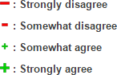
Example of item measuring Respect for Facts and Honesty:

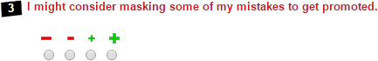

The English version of ETIX underwent a first pre-test with a sample of working professionals from various English-speaking populations. The items were tested for reliability, sensitivity, and correlation with their own factor in order to identify the items that needed to be reviewed and improved. After this first revision, the questionnaire was translated into French and Spanish and tested with a sample of working professionals from each language. ETIX underwent two different pre-tests in English before undergoing a Pilot study with 306 working professionals from the UK, one pre-test in Spanish before undergoing a Pilot study with 312 working professionals form Spain, and one pre-test in French before undergoing a Pilot study with 299 working professionals from France. These multiple revisions were conducted to obtain the best results in terms of reliability and validity. The following table summarises the evolution and improvement of ETIX in terms of reliability (Cronbach’s alpha) between the pre- tests and pilot studies for the three languages (see next page).

Table 1. Evolution of Alphas.

 |  | Respect for Laws & Procedures |  |  | Respect for Goods & Property |  |  | Respect for Facts & Honesty |  |  | Respect for Other People |  |  | Respect for Commitments |  |  | Respect for Equality
 |  | Factor | Self | Others | Factor | Self | Others | Factor | Self | Others | Factor | Self | Others | Factor | Self | Others | Factor | Self | Others
 | Pretest (N=202) | 0.78 | 0.59 | 0.68 | 0.74 | 0.57 | 0.61 | 0.66 | 0.42 | 0.47 | 0.79 | 0.64 | 0.64 | 0.72 | 0.61 | 0.49 | 0.80 | 0.72 | 0.58
English | Pretest 2 (N=502) | 0.88 | 0.77 | 0.79 | 0.88 | 0.71 | 0.81 | 0.92 | 0.84 | 0.85 | 0.88 | 0.76 | 0.80 | 0.86 | 0.78 | 0.74 | 0.90 | 0.83 | 0.77
 | Pilot (N=306) | 0.93 | 0.83 | 0.85 | 0.93 | 0.86 | 0.87 | 0.94 | 0.90 | 0.87 | 0.90 | 0.81 | 0.80 | 0.88 | 0.82 | 0.76 | 0.91 | 0.80 | 0.85
 | Pretest (N=238) | 0.81 | 0.61 | 0.69 | 0.88 | 0.67 | 0.71 | 0.83 | 0.69 | 0.72 | 0.79 | 0.57 | 0.72 | 0.85 | 0.73 | 0.73 | 0.78 | 0.55 | 0.68
Spanish
 | Pilot (N=312)
 |  | 0.88 | 0.76 | 0.80 | 0.88 | 0.78 | 0.78 | 0.92 | 0.85 | 0.85 | 0.87 | 0.75 | 0.76 | 0.89 | 0.81 | 0.77 | 0.87 | 0.71 | 0.80
 | Pretest (N=159) | 0.78 | 0.66 | 0.54 | 0.79 | 0.59 | 0.64 | 0.83 | 0.71 | 0.68 | 0.82 | 0.61 | 0.71 | 0.73 | 0.61 | 0.71 | 0.84 | 0.71 | 0.69
French
 | Pilot  (N=299) | 0.92 | 0.84 | 0.85 | 0.89 | 0.77 | 0.82 | 0.93 | 0.90 | 0.84 | 0.90 | 0.82 | 0.81 | 0.90 | 0.83 | 0.80 | 0.90 | 0.75 | 0.85

Sample Descriptives
The data presented is from a UK sample of 306 professionals (145 male, 161 female) with ages ranging from 20 to 69 (M=43.82, SD=11.04). The professional sample derived was from a range of job sectors including finance, medicine, sales, and technology, and also a variety of study levels ranging from trades training to PhD. Tables 2-5 provide an overview of the sample.

Table 2. Distribution based on Gender.

Gender | Percentage (%) | N
Male | 47.39 | 145
Female | 52.61 | 161

Table 3. Distribution based on Age.

Age | Percentage (%) | N
Under 28 | 6.86 | 21
28-33 | 14.38 | 44
34-42 | 29.08 | 89
44+ | 49.67 | 152

Table 4. Distribution based on Study Level.

Study Level | Percentage (%) | N
Level 1: Master’s/PhD | 10.13 | 31
Level 2: Bachelor’s Degree | 32.68 | 100
Level 3: Two Years Vocational Study | 18.63 | 57
Level 4: High School Diploma | 29.41 | 90
Level 5: Trades Training/No Study | 9.15 | 28

Table 5. Distribution based on Socio-professional Category.

Socio-demographic (N=306) | Percentage (%) | N
Accounting and Finance | 21.90 | 67
Training and Teaching | 8.82 | 27
Arts | 3.59 | 11
Hospitality and Tourism | 10.13 | 31
Technology and IT | 13.40 | 41
Sales | 9.15 | 28
Medical | 4.25 | 13
Administration and Secretarial | 6.86 | 21
Legal | 0.33 | 1
Research and Development | 1.63 | 5
Public and Social Services | 4.90 | 15
Communications and Marketing | 1.31 | 4
Construction | 6.21 | 19
Environmental | 2.29 | 7
Management | 5.23 | 16

Norms
Norms help in the comparison of an individual’s score with the scores of others who have completed the same assessment. The individuals who took the test are considered representative of the population and so are used for norming. The closer the sample population falls to the target population, the more accurate the distribution will be when used to rank individuals. Norm groups enable us to compare an individual’s score to those of a similar population.

ETIX was administered to 357 UK working professionals using a questionnaire compiled of 140 Likert scale items from 1 to 4 (1 being strongly disagree with the item and 4 being strongly agree) to measure attitudes towards counterproductive work behaviours. The sample was provided via the professional research and sampling firm CINT. Respondents received compensation from CINT for their participation. Respondents whose answers were deemed unreliable or those who completed the assessment in under 13 minutes were excluded from the sample, resulting in a final sample of 306 respondents.

The following histogram illustrates the general ETIX score distribution for the UK sample of working professionals. The histogram shows that the data is negatively skewed, with a mean score of 6.41 out of 10. This indicates that the data does not follow a normal distribution, which should be taken into account when interpreting the scores. Because the mean score is 6.41 instead of 5.00, which would be typical of a normal distribution, a high score will be considered to be above 8.50 and a low score will be considered to be below 4.50. While the mean global score is 6.41, the median global score is
5.98. Although the median still demonstrates that the data is negatively skewed, it is a better measure of central tendency than the mean as the mean is sensitive to extreme scores. Specific population norms discussed below will provide greater insight into the interpretation of high and low scores for specific populations.
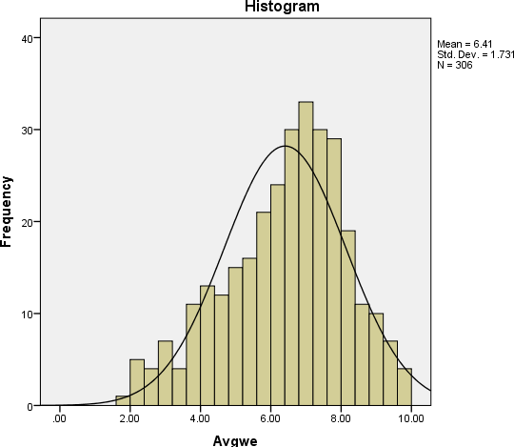

Figure 1. Distribution of UK Sample.

Norms for UK Sample
Tables 6-14 show norms for the UK sample on both the ETIX factors and their facets Self and Others. The sample is organised into categories based on study level, age, socio-professional category, and gender.

Table 6. Factor Score Norms for the UK Sample.

Factors | Score | Mean | Median | Standard  Deviation | Standard Error of  Measurement | Min | Max
 | Factor | 6.75 | 7.05 | 2.12 | 0.12 | 1.05 | 10.00
Respect for Goods and Property | Self | 6.88 | 7.30 | 2.17 | 0.12 | 0.80 | 10.00
 | Others | 6.62 | 6.90 | 2.19 | 0.13 | 0.80 | 10.00
 | Factor | 6.64 | 7.03 | 2.13 | 0.12 | 0.15 | 10.00
Respect for Facts and Honesty | Self | 6.57 | 7.00 | 2.28 | 0.13 | 0.00 | 10.00
 | Others | 6.71 | 7.00 | 2.11 | 0.12 | 0.30 | 10.00
 | Factor | 6.12 | 6.30 | 1.98 | 0.11 | 0.65 | 9.90
Respect for Laws and Procedures | Self | 5.89 | 6.00 | 2.04 | 0.12 | 0.30 | 10.00
 | Others | 6.34 | 6.50 | 2.10 | 0.12 | 0.80 | 10.00
 | Factor | 6.34 | 6.40 | 1.80 | 0.10 | 1.05 | 9.90
Respect for Other People | Self | 6.29 | 6.50 | 1.89 | 0.11 | 0.80 | 10.00
 | Others | 6.40 | 6.50 | 1.89 | 0.11 | 1.00 | 10.00
 | Factor | 6.09 | 6.40 | 1.90 | 0.11 | 1.30 | 10.00
Respect for Commitments | Self | 6.14 | 6.30 | 2.02 | 0.12 | 1.30 | 10.00
 | Others | 6.04 | 6.30 | 1.99 | 0.11 | 0.80 | 10.00
 | Factor | 6.49 | 6.75 | 2.00 | 0.11 | 0.90 | 10.00
Respect for Equality | Self | 6.51 | 6.80 | 1.94 | 0.11 | 1.30 | 10.00
 | Others | 6.48 | 7.00 | 2.21 | 0.13 | 0.50 | 10.00
 | Factor | 3.68 | 3.65 | 1.90 | 0.06 | 1.05 | 6.80
Social Desirability | Self | 3.59 | 3.50 | 1.31 | 0.08 | 0.30 | 7.50
 | Others | 3.76 | 3.50 | 1.25 | 0.07 | 0.80 | 8.80

Table 7. Study Level by Factors.

Study level | N | Commitments | Goods and  Property | Facts and  Honesty | Laws and Procedures | Other People | Equality
 | Mean | 6.01 | 6.40 | 6.37 | 5.76 | 5.93 | 6.13
Trades training/No study | Median | 6.38 | 6.65 | 6.45 | 5.70 | 6.03 | 6.20
 | 28
 | SD | 1.70 | 1.99 | 1.91 | 1.71 | 1.35 | 1.65
 | SEM | 0.32 | 0.38 | 0.36 | 0.32 | 0.25 | 0.31
 | Mean | 6.35 | 7.19 | 6.97 | 6.46 | 6.28 | 6.53
High school diploma | Median | 6.65 | 7.33 | 7.35 | 6.78 | 6.15 | 6.65
 | 90
 | SD | 1.99 | 2.09 | 2.05 | 1.91 | 1.90 | 1.96
 | SEM | 0.21 | 0.22 | 0.22 | 0.20 | 0.20 | 0.21
 | Mean | 6.34 | 7.06 | 6.78 | 6.29 | 6.85 | 6.60
Two years vocational study/University | Median | 6.80 | 7.40 | 7.15 | 6.55 | 7.05 | 7.15
 | 70
 | SD | 1.70 | 1.81 | 2.00 | 1.90 | 1.48 | 1.91
 | SEM | 0.22 | 0.24 | 0.26 | 0.25 | 0.20 | 0.25
 | Mean | 5.87 | 6.40 | 6.48 | 5.90 | 6.33 | 6.63
 | Median | 6.10 | 6.75 | 7.03 | 6.03 | 6.70 | 7.20
Bachelor’s | 100
 | SD | 1.81 | 2.10 | 2.21 | 1.99 | 1.81 | 2.05
 | SEM | 0.18 | 0.21 | 0.22 | 0.20 | 0.18 | 0.21
 | Mean | 5.63 | 6.31 | 6.20 | 5.80 | 6.01 | 6.07
 | Median | 5.90 | 6.65 | 7.00 | 6.05 | 6.75 | 6.65
Master’s/PhD | 31
 | SD | 2.23 | 2.55 | 2.34 | 2.29 | 2.15 | 2.31
 | SEM | 0.40 | 0.46 | 0.42 | 0.41 | 0.39 | 0.42

Table 8. Study Level by Facets.

Study Level | N |  | CS | CO | GS | GO | FS | FO | LS | LO | ES | EO | PS | PO
 |  | Mean | 6.23 | 5.80 | 6.57 | 6.23 | 6.46 | 6.29 | 5.53 | 5.99 | 6.19 | 6.06 | 5.99 | 5.87
Trades training/No study |  | Median | 6.30 | 5.90 | 6.65 | 6.50 | 6.25 | 6.25 | 5.40 | 6.15 | 6.25 | 6.15 | 6.15 | 6.00
 | 28
 |  | SD | 1.87 | 1.80 | 2.08 | 1.98 | 1.91 | 2.02 | 1.75 | 1.80 | 1.64 | 1.86 | 1.56 | 1.41
 |  | SEM | 0.35 | 0.34 | 0.39 | 0.37 | 0.36 | 0.38 | 0.33 | 0.34 | 0.31 | 0.35 | 0.29 | 0.27
 |  | Mean | 6.39 | 6.30 | 7.22 | 7.15 | 6.95 | 6.99 | 6.27 | 6.65 | 6.62 | 6.44 | 6.17 | 6.39
High school diploma |  | Median | 6.40 | 6.80 | 7.50 | 7.50 | 7.30 | 7.30 | 6.50 | 6.80 | 6.50 | 6.80 | 6.30 | 6.50
 | 90
 |  | SD | 2.11 | 2.06 | 2.20 | 2.13 | 2.24 | 2.03 | 2.03 | 2.04 | 1.90 | 2.16 | 1.99 | 1.93
 |  | SEM | 0.22 | 0.22 | 0.23 | 0.22 | 0.24 | 0.21 | 0.21 | 0.22 | 0.20 | 0.23 | 0.21 | 0.20
 |  | Mean | 6.31 | 6.38 | 7.15 | 6.97 | 6.66 | 6.91 | 6.03 | 6.56 | 6.61 | 6.59 | 6.83 | 6.87
Two years vocational study/University |  | Median | 6.80 | 6.50 | 7.50 | 7.30 | 7.00 | 7.00 | 6.30 | 7.00 | 6.80 | 7.30 | 7.00 | 7.30
 | 70
 |  | SD | 1.81 | 1.87 | 1.89 | 1.86 | 2.19 | 1.94 | 1.95 | 2.03 | 1.82 | 2.13 | 1.49 | 1.69
 |  | SEM | 0.24 | 0.25 | 0.25 | 0.25 | 0.29 | 0.26 | 0.26 | 0.27 | 0.24 | 0.28 | 0.20 | 0.22
 |  | Mean | 5.92 | 5.83 | 6.61 | 6.19 | 6.38 | 6.58 | 5.64 | 6.16 | 6.58 | 6.68 | 6.29 | 6.38
 |  | Median | 6.30 | 5.90 | 7.00 | 6.50 | 7.00 | 7.00 | 6.00 | 6.50 | 7.00 | 7.00 | 6.80 | 6.30
Bachelor’s | 100
 |  | SD | 1.91 | 1.89 | 2.18 | 2.16 | 2.34 | 2.18 | 2.03 | 2.12 | 1.98 | 2.27 | 1.93 | 1.82
 |  | SEM | 0.19 | 0.19 | 0.22 | 0.22 | 0.23 | 0.22 | 0.20 | 0.21 | 0.20 | 0.23 | 0.19 | 0.18
 |  | Mean | 5.69 | 5.57 | 6.48 | 6.15 | 6.04 | 6.35 | 5.60 | 5.99 | 6.02 | 6.12 | 5.89 | 6.12
Master’s/PhD | 31 | Median | 6.00 | 6.00 | 6.50 | 7.30 | 6.80 | 7.00 | 5.80 | 6.30 | 6.30 | 6.80 | 6.50 | 7.00
 |  | SD | 2.38 | 2.23 | 2.40 | 2.74 | 2.45 | 2.33 | 2.29 | 2.38 | 2.21 | 2.50 | 2.20 | 2.21

SEM | 0.43 | 0.40 | 0.43 | 0.49 | 0.44 | 0.42 | 0.41 | 0.43 | 0.40 | 0.45 | 0.39 | 0.40

- C.S – Commitment Self
- C.O – Commitment Others
- G.S – Goods and Property Self
- G.O – Goods and Property Others
- F.S – Facts and Honesty Self
- F.O – Facts and Honesty Others
- L.S – Laws and Procedures Self
- L.O – Laws and Procedures Others
- E.S – Equality Self
- E.O – Equality Others
- P.S – Other People Self
- P.O – Other People Others

Table 9. Age by Factors.

Age | N | Commitments | Goods and  Property | Facts and Honesty | Laws and Procedures | Other People | Equality
 | Mean | 5.80 | 5.97 | 5.71 | 5.17 | 5.87 | 6.29
Under 28 | Median | 6.30 | 6.15 | 6.00 | 5.00 | 6.05 | 6.65
 | 21
 | SD | 2.06 | 2.21 | 2.14 | 1.71 | 1.76 | 1.99
 | SEM | 0.42 | 0.47 | 0.5 | 0.37 | 0.4 | 0.48
 | Mean | 5.86 | 6.46 | 6.44 | 5.81 | 6.34 | 6.67
 | Median | 5.98 | 6.45 | 6.65 | 5.35 | 6.48 | 7.20
28-33 | 44
 | SD | 2.42 | 2.61 | 2.56 | 2.23 | 2.18 | 2.42
 | SEM | 0.39 | 0.41 | 0.39 | 0.35 | 0.33 | 0.37
 | Mean | 5.81 | 6.44 | 6.31 | 5.91 | 6.33 | 6.42
 | Median | 5.90 | 6.90 | 6.75 | 6.00 | 6.40 | 6.65
34-43 | 89
 | SD | 1.77 | 2.05 | 2.05 | 1.88 | 1.71 | 1.85
 | SEM | 0.18 | 0.22 | 0.21 | 0.21 | 0.19 | 0.21
 | Mean | 6.36 | 7.11 | 7.02 | 6.45 | 6.42 | 6.51
Over 44 | Median | 6.55 | 7.35 | 7.45 | 6.65 | 6.60 | 6.90
 | 152
 | SD | 1.73 | 1.92 | 1.95 | 1.92 | 1.73 | 1.96
 | SEM | 0.15 | 0.16 | 0.16 | 0.15 | 0.14 | 0.15

Table 10. Age by Facets.

Age  (years) | N | CS | CO | GS | GO | FS | FO | LS | LO | ES | EO | PS | PO
 | Mean | 5.97 | 5.63 | 6.10 | 5.85 | 5.39 | 6.03 | 4.78 | 5.57 | 6.17 | 6.41 | 5.72 | 6.01
Under 28 | Median | 6.50 | 6.30 | 6.30 | 5.80 | 5.50 | 6.50 | 4.80 | 5.00 | 6.30 | 6.80 | 6.00 | 6.00
 | 21
 | SD | 2.17 | 2.13 | 2.36 | 2.16 | 2.16 | 2.22 | 1.61 | 1.96 | 1.81 | 2.29 | 2.09 | 1.60
 | SEM | 0.42 | 0.46 | 0.48 | 0.49 | 0.53 | 0.50 | 0.38 | 0.41 | 0.47 | 0.51 | 0.45 | 0.39
 | Mean | 5.81 | 5.90 | 6.74 | 6.19 | 6.28 | 6.60 | 5.57 | 6.05 | 6.67 | 6.68 | 6.43 | 6.25
 | Median | 5.90 | 6.00 | 7.00 | 6.00 | 6.65 | 6.75 | 5.40 | 6.30 | 7.00 | 7.15 | 6.80 | 6.30
28-33 | 44
 | SD | 2.53 | 2.46 | 2.57 | 2.74 | 2.67 | 2.56 | 2.36 | 2.29 | 2.43 | 2.51 | 2.26 | 2.19
 | SEM | 0.39 | 0.40 | 0.40 | 0.42 | 0.40 | 0.39 | 0.36 | 0.35 | 0.35 | 0.41 | 0.34 | 0.33
 | Mean | 5.87 | 5.75 | 6.52 | 6.36 | 6.27 | 6.36 | 5.69 | 6.13 | 6.36 | 6.48 | 6.26 | 6.39
 | Median | 6.00 | 6.00 | 7.00 | 6.80 | 7.00 | 6.80 | 6.00 | 6.30 | 6.50 | 6.80 | 6.50 | 6.50
34-43 | 89
 | SD | 1.94 | 1.86 | 2.12 | 2.13 | 2.21 | 2.03 | 1.89 | 2.01 | 1.74 | 2.08 | 1.72 | 1.84
 | SEM | 0.20 | 0.19 | 0.22 | 0.23 | 0.23 | 0.21 | 0.21 | 0.22 | 0.21 | 0.23 | 0.19 | 0.20
 | Mean | 6.41 | 6.31 | 7.23 | 7.00 | 7.01 | 7.04 | 6.24 | 6.66 | 6.59 | 6.44 | 6.34 | 6.50
 | Median | 6.80 | 6.50 | 7.80 | 7.30 | 7.30 | 7.30 | 6.50 | 7.00 | 6.80 | 7.00 | 6.50 | 6.50
Over 44 | 152
 | SD | 1.83 | 1.84 | 1.98 | 1.97 | 2.10 | 1.93 | 1.99 | 2.06 | 1.89 | 2.19 | 1.82 | 1.79
 | SEM | 0.15 | 0.15 | 0.16 | 0.16 | 0.17 | 0.16 | 0.16 | 0.16 | 0.14 | 0.17 | 0.14 | 0.14

C.S – Commitment Self ◦ C.O – Commitment Others ◦ G.S – Goods and Property Self ◦ G.O – Goods and Property Others ◦ F.S – Facts and Honesty Self ◦ F.O – Facts and Honesty Others ◦ L.S – Laws and Procedures Self ◦ L.O – Laws and Procedures Others ◦ E.S – Equality Self ◦ E.O – Equality Others ◦ P.S – Other People Self ◦
P.O – Other People Others

Table 11. Socio-professional Category by Factors.

Job Description | N |  | Commit- ments | Goods and  Property | Facts and  Honesty | Laws and Procedures | Other People | Equality
 |  | Mean | 6.04 | 6.65 | 6.85 | 6.14 | 6.45 | 6.61
Accounting and Finance |  | Median | 6.00 | 7.00 | 7.15 | 6.15 | 6.40 | 6.65
 | 67
 |  | SD | 1.90 | 2.21 | 1.95 | 1.81 | 1.73 | 1.78
 |  | SEM | 0.23 | 0.25 | 0.24 | 0.22 | 0.21 | 0.22
 |  | Mean | 6.52 | 7.66 | 7.67 | 7.13 | 6.91 | 7.26
Training and Teaching |  | Median | 6.80 | 7.65 | 7.90 | 7.65 | 7.50 | 7.65
 | 27
 |  | SD | 1.22 | 1.33 | 1.21 | 1.52 | 1.47 | 1.32
 |  | SEM | 0.24 | 0.26 | 0.23 | 0.29 | 0.28 | 0.25
 |  | Mean | 6.14 | 7.25 | 7.58 | 6.22 | 6.47 | 7.68
 |  | Median | 6.15 | 7.40 | 8.25 | 6.05 | 6.90 | 7.50
Arts | 11
 |  | SD | 1.50 | 1.56 | 1.76 | 1.70 | 1.50 | 1.15
 |  | SEM | 0.45 | 0.47 | 0.53 | 0.51 | 0.45 | 0.35
 |  | Mean | 6.67 | 6.96 | 6.66 | 6.36 | 6.39 | 6.67
Hospitality/ training |  | Median | 7.00 | 7.30 | 7.15 | 6.65 | 6.40 | 7.25
 | 31
 |  | SD | 1.48 | 1.81 | 1.94 | 1.91 | 1.27 | 1.73
 |  | SEM | 0.27 | 0.32 | 0.35 | 0.34 | 0.23 | 0.31
 |  | Mean | 5.46 | 6.11 | 6.07 | 5.45 | 5.85 | 5.84
 |  | Median | 5.75 | 6.55 | 6.90 | 6.15 | 5.90 | 6.05
Tech/IT | 41
 |  | SD | 2.36 | 2.60 | 2.59 | 2.40 | 2.25 | 2.46
 |  | SEM | 0.37 | 0.41 | 0.40 | 0.37 | 0.35 | 0.38
 |  | Mean | 6.10 | 6.77 | 6.60 | 6.21 | 6.33 | 5.85
Sales | 28 | Median | 5.78 | 7.20 | 6.50 | 6.60 | 6.28 | 6.10
 |  | SD | 1.90 | 2.07 | 2.18 | 1.88 | 1.69 | 2.14

 |  | SEM | 0.36 | 0.39 | 0.41 | 0.35 | 0.32 | 0.41
 |  | Mean | 6.27 | 6.88 | 7.07 | 6.53 | 7.40 | 7.20
 |  | Median | 6.25 | 6.80 | 7.65 | 6.75 | 7.90 | 7.90
Medical | 13
 |  | SD | 1.63 | 2.21 | 2.08 | 1.86 | 1.71 | 1.97
 |  | SEM | 0.45 | 0.61 | 0.58 | 0.52 | 0.48 | 0.55
 |  | Mean | 6.13 | 6.95 | 6.55 | 6.35 | 6.55 | 6.93
 |  | Median | 6.50 | 7.50 | 7.00 | 6.55 | 7.00 | 7.15
Admin/Secretary | 21
 |  | SD | 1.87 | 1.92 | 2.04 | 1.77 | 1.61 | 1.67
 |  | SEM | 0.41 | 0.42 | 0.45 | 0.39 | 0.35 | 0.36
Legal | 1 | Mean | 9.15 | 7.90 | 8.40 | 7.65 | 8.00 | 8.55
 |  | Mean | 5.80 | 5.50 | 6.25 | 4.90 | 6.90 | 4.80
Research and Development |  | Median | 1.37 | 1.73 | 1.89 | 0.94 | 1.96 | 2.25
 | 5
 |  | SD | 0.61 | 0.77 | 0.84 | 0.42 | 0.88 | 1.01
 |  | SEM | 6.44 | 7.40 | 6.93 | 6.56 | 6.75 | 7.03
 |  | Mean | 6.50 | 7.40 | 6.75 | 6.90 | 6.55 | 7.05
Public/Social services |  | Median | 1.75 | 1.83 | 1.88 | 1.88 | 1.83 | 1.62
 | 15
 |  | SD | 0.45 | 0.47 | 0.49 | 0.49 | 0.47 | 0.42
 |  | SEM | 5.28 | 7.36 | 6.35 | 5.90 | 6.59 | 7.09
 |  | Mean | 4.90 | 6.78 | 6.13 | 5.53 | 6.15 | 7.28
Communications/ Marketing |  | Median | 0.98 | 1.58 | 1.66 | 1.28 | 1.75 | 1.93
 | 4
 |  | SD | 0.49 | 0.79 | 0.83 | 0.64 | 0.87 | 0.97
 |  | SEM | 5.59 | 5.92 | 5.53 | 5.20 | 5.26 | 5.28
 |  | Mean | 5.25 | 5.40 | 5.55 | 4.90 | 5.15 | 4.55
Construction | 19 | Median | 2.19 | 2.39 | 2.23 | 1.96 | 1.61 | 2.09
 |  | SD | 0.50 | 0.55 | 0.51 | 0.45 | 0.37 | 0.48

 | SEM | 6.88 | 7.41 | 6.69 | 6.36 | 6.62 | 6.94
 | Mean | 7.15 | 7.75 | 6.75 | 6.65 | 6.65 | 7.55
 | Median | 1.13 | 1.31 | 1.75 | 1.73 | 1.21 | 1.35
Environmental | 7
 | SD | 0.43 | 0.50 | 0.66 | 0.65 | 0.46 | 0.51
 | SEM | 5.95 | 6.14 | 6.17 | 5.51 | 5.65 | 6.03
 | Mean | 6.20 | 6.78 | 6.95 | 5.78 | 5.95 | 6.58
 | Median | 2.25 | 2.52 | 2.45 | 2.22 | 2.05 | 2.29
Management | 16
 | SD | 0.56 | 0.63 | 0.61 | 0.55 | 0.51 | 0.57
 | SEM | 6.04 | 6.65 | 6.85 | 6.14 | 6.45 | 6.61

Table 12. Socio-professional Category by Facets.

Job Description | N | CS | CO | GS | GO | FS | FO | LS | LO | ES | EO | PS | PO
 | Mean | 6.04 | 6.05 | 6.77 | 6.52 | 6.82 | 6.87 | 5.92 | 6.35 | 6.56 | 6.66 | 6.47 | 6.44
 | Median | 6.00 | 6.00 | 7.30 | 6.50 | 7.30 | 7.00 | 6.30 | 6.30 | 6.50 | 6.80 | 6.50 | 6.50
Accounting and Finance | 67
 | SD | 2.00 | 2.00 | 2.13 | 2.12 | 2.15 | 1.90 | 1.87 | 1.98 | 1.80 | 1.86 | 1.84 | 1.75
 | SEM | 0.24 | 0.24 | 0.26 | 0.26 | 0.26 | 0.23 | 0.23 | 0.24 | 0.22 | 0.23 | 0.23 | 0.21
 | Mean | 6.54 | 6.49 | 7.81 | 7.52 | 7.67 | 7.67 | 6.76 | 7.50 | 7.04 | 7.49 | 6.86 | 6.96
 | Median | 6.80 | 6.50 | 8.00 | 7.50 | 7.80 | 7.80 | 7.00 | 8.00 | 7.50 | 7.80 | 7.30 | 7.50
Training and Teaching | 27
 | SD | 1.35 | 1.28 | 1.42 | 1.39 | 1.35 | 1.22 | 1.73 | 1.54 | 1.44 | 1.47 | 1.63 | 1.47
 | SEM | 0.26 | 0.25 | 0.27 | 0.27 | 0.26 | 0.23 | 0.33 | 0.30 | 0.28 | 0.28 | 0.31 | 0.28
 | Mean | 6.62 | 5.65 | 7.45 | 7.06 | 7.63 | 7.54 | 5.99 | 6.45 | 7.55 | 7.82 | 6.55 | 6.40
 | Median | 6.80 | 5.50 | 7.50 | 7.50 | 8.50 | 8.00 | 6.80 | 7.00 | 7.30 | 8.00 | 6.50 | 6.80
Arts | 11
 | SD | 1.62 | 1.59 | 1.34 | 1.86 | 2.01 | 1.55 | 1.81 | 1.81 | 1.18 | 1.31 | 1.47 | 1.70
 | SEM | 0.49 | 0.48 | 0.41 | 0.56 | 0.61 | 0.47 | 0.54 | 0.55 | 0.36 | 0.39 | 0.44 | 0.51
 | Mean | 6.69 | 6.66 | 6.96 | 6.95 | 6.45 | 6.87 | 6.13 | 6.60 | 6.59 | 6.75 | 6.31 | 6.47
Hospitality/Training | 31
 | Median | 7.00 | 7.00 | 7.50 | 7.30 | 7.00 | 7.50 | 6.30 | 6.50 | 6.50 | 7.30 | 6.50 | 6.50

 | SD | 1.58 | 1.58 | 1.88 | 1.90 | 2.05 | 1.97 | 1.96 | 2.00 | 1.60 | 2.01 | 1.27 | 1.45
 | SEM | 0.28 | 0.28 | 0.34 | 0.34 | 0.37 | 0.35 | 0.35 | 0.36 | 0.29 | 0.36 | 0.23 | 0.26
 | Mean | 5.53 | 5.39 | 6.27 | 5.96 | 6.06 | 6.07 | 5.30 | 5.60 | 6.12 | 5.57 | 5.78 | 5.93
 | Median | 6.00 | 5.80 | 7.00 | 6.50 | 6.80 | 6.80 | 5.50 | 6.00 | 6.30 | 5.80 | 6.30 | 6.00
Tech/IT | 41
 | SD | 2.46 | 2.41 | 2.64 | 2.63 | 2.74 | 2.54 | 2.43 | 2.44 | 2.29 | 2.75 | 2.29 | 2.29
 | SEM | 0.38 | 0.38 | 0.41 | 0.41 | 0.43 | 0.40 | 0.38 | 0.38 | 0.36 | 0.43 | 0.36 | 0.36
 | Mean | 6.37 | 5.84 | 6.90 | 6.63 | 6.67 | 6.53 | 6.10 | 6.33 | 6.05 | 5.65 | 6.37 | 6.28
 | Median | 6.15 | 5.50 | 7.50 | 6.65 | 6.90 | 6.00 | 6.00 | 6.65 | 6.00 | 5.90 | 6.65 | 6.30
Sales | 28
 | SD | 1.99 | 1.96 | 2.18 | 2.06 | 2.31 | 2.16 | 2.04 | 1.97 | 2.09 | 2.30 | 1.67 | 1.92
 | SEM | 0.38 | 0.37 | 0.41 | 0.39 | 0.44 | 0.41 | 0.38 | 0.37 | 0.40 | 0.44 | 0.32 | 0.36
 | Mean | 6.38 | 6.17 | 7.02 | 6.75 | 7.08 | 7.07 | 6.27 | 6.80 | 7.35 | 7.05 | 7.38 | 7.42
 | Median | 6.30 | 6.30 | 7.00 | 6.00 | 7.80 | 7.30 | 6.50 | 7.00 | 7.30 | 6.80 | 8.00 | 7.30
Medical (all levels) | 13
 | SD | 1.64 | 1.85 | 2.28 | 2.22 | 2.24 | 2.04 | 1.91 | 1.92 | 2.05 | 2.14 | 1.87 | 1.63
 | SEM | 0.45 | 0.51 | 0.63 | 0.62 | 0.62 | 0.57 | 0.53 | 0.53 | 0.57 | 0.59 | 0.52 | 0.45
 | Mean | 6.24 | 6.01 | 7.20 | 6.70 | 6.36 | 6.75 | 6.20 | 6.50 | 6.80 | 7.06 | 6.40 | 6.69
Admin/Secretary | 21
 | Median | 7.00 | 6.00 | 8.00 | 7.50 | 7.00 | 7.00 | 6.30 | 7.00 | 7.00 | 7.00 | 7.00 | 7.00

 |  | SD | 2.02 | 1.89 | 1.99 | 2.00 | 2.27 | 1.92 | 1.80 | 1.96 | 1.71 | 1.79 | 1.76 | 1.61
 |  | SEM | 0.44 | 0.41 | 0.43 | 0.44 | 0.50 | 0.42 | 0.39 | 0.43 | 0.37 | 0.39 | 0.38 | 0.35
Legal | 1 | Mean | 7.80 | 9.30 | 8.80 | 9.50 | 7.80 | 8.00 | 8.30 | 8.50 | 7.50 | 7.80 | 8.00 | 8.00
 |  | Mean | 1.74 | 1.21 | 1.52 | 2.06 | 1.94 | 1.94 | 0.94 | 1.11 | 2.06 | 2.46 | 2.05 | 2.01
Research and Development | 5 | Median | 0.78 | 0.54 | 0.68 | 0.92 | 0.87 | 0.87 | 0.42 | 0.50 | 0.92 | 1.10 | 0.92 | 0.90
 |  | SD | 6.21 | 6.67 | 7.44 | 7.36 | 6.71 | 7.14 | 6.29 | 6.83 | 6.97 | 7.10 | 6.67 | 6.84
 |  | SEM | 6.00 | 6.80 | 7.50 | 7.50 | 6.00 | 7.00 | 6.80 | 6.80 | 7.30 | 7.30 | 6.50 | 6.50
 |  | Mean | 1.83 | 1.79 | 1.99 | 1.80 | 1.80 | 2.13 | 1.90 | 2.05 | 1.51 | 1.84 | 1.96 | 1.82
 |  | Median | 0.47 | 0.46 | 0.51 | 0.47 | 0.47 | 0.55 | 0.49 | 0.53 | 0.39 | 0.47 | 0.51 | 0.47
Public/Social services | 15
 |  | SD | 4.65 | 5.90 | 6.95 | 7.78 | 5.88 | 6.83 | 5.53 | 6.28 | 7.40 | 6.78 | 6.15 | 7.03
 |  | SEM | 5.30 | 5.90 | 6.90 | 7.30 | 6.00 | 6.25 | 5.40 | 5.65 | 7.15 | 7.40 | 5.40 | 7.15
 |  | Mean | 1.56 | 2.16 | 2.14 | 1.37 | 1.98 | 1.47 | 1.00 | 1.68 | 1.74 | 2.21 | 1.67 | 2.15
 |  | Median | 0.78 | 1.08 | 1.07 | 0.69 | 0.99 | 0.74 | 0.50 | 0.84 | 0.87 | 1.10 | 0.83 | 1.07
Communications/Marketing | 4
 |  | SD | 5.59 | 5.59 | 6.12 | 5.73 | 5.36 | 5.69 | 4.98 | 5.42 | 5.46 | 5.11 | 5.21 | 5.30
 |  | SEM | 4.80 | 5.80 | 5.80 | 5.00 | 5.00 | 5.50 | 4.80 | 5.50 | 4.80 | 4.80 | 5.00 | 5.50
Construction | 19 | Mean | 2.36 | 2.30 | 2.46 | 2.41 | 2.29 | 2.35 | 2.07 | 2.10 | 2.16 | 2.15 | 1.57 | 1.78

 | Median | 0.54 | 0.53 | 0.56 | 0.55 | 0.52 | 0.54 | 0.48 | 0.48 | 0.50 | 0.49 | 0.36 | 0.41
 | SD | 7.23 | 6.53 | 7.70 | 7.11 | 6.89 | 6.49 | 5.84 | 6.87 | 6.77 | 7.10 | 6.74 | 6.50
 | SEM | 7.50 | 6.30 | 7.80 | 7.50 | 6.50 | 6.80 | 5.80 | 7.30 | 7.50 | 7.50 | 7.00 | 6.30
 | Mean | 1.18 | 1.28 | 1.24 | 1.41 | 1.97 | 1.57 | 1.92 | 1.68 | 1.47 | 1.33 | 1.48 | 1.31
 | Median | 0.45 | 0.48 | 0.47 | 0.53 | 0.74 | 0.59 | 0.73 | 0.63 | 0.55 | 0.50 | 0.56 | 0.50
Environmental | 7
 | SD | 5.81 | 6.09 | 6.29 | 6.00 | 5.96 | 6.38 | 5.19 | 5.83 | 6.05 | 6.01 | 5.26 | 6.05
 | SEM | 6.00 | 6.25 | 6.80 | 6.40 | 6.75 | 7.30 | 5.25 | 6.05 | 5.90 | 7.15 | 5.50 | 6.65
 | Mean | 2.38 | 2.19 | 2.41 | 2.75 | 2.46 | 2.50 | 2.17 | 2.43 | 2.06 | 2.60 | 2.25 | 1.97
 | Median | 0.59 | 0.55 | 0.60 | 0.69 | 0.62 | 0.63 | 0.54 | 0.61 | 0.52 | 0.65 | 0.56 | 0.49
Management | 16
 | SD | 6.04 | 6.05 | 6.77 | 6.52 | 6.82 | 6.87 | 5.92 | 6.35 | 6.56 | 6.66 | 6.47 | 6.44
 | SEM | 6.00 | 6.00 | 7.30 | 6.50 | 7.30 | 7.00 | 6.30 | 6.30 | 6.50 | 6.80 | 6.50 | 6.50

C.S – Commitment Self ◦ C.O – Commitment Others ◦ G.S – Goods and Property Self ◦ G.O – Goods and Property Others ◦ F.S – Facts and Honesty Self ◦ F.O – Facts and Honesty Others ◦ L.S – Laws and Procedures Self ◦ L.O – Laws and Procedures Others ◦ E.S – Equality Self ◦ E.O – Equality Others ◦ P.S – Other People Self ◦
P.O – Other People Others

Table 13. Gender by Factors.

Gender | N | Commitments | Goods and Property | Facts and Honesty | Laws and Procedures | Other People | Equality
 | Mean | 5.78 | 6.42 | 6.13 | 5.64 | 5.74 | 6.01
 | Median | 6.15 | 6.75 | 6.50 | 5.74 | 5.75 | 6.50
Male | 145
 | SD | 2.04 | 2.25 | 2.28 | 2.11 | 1.80 | 2.12
 | SEM | 0.17 | 0.19 | 0.19 | 0.18 | 0.15 | 0.18
 | Mean | 6.36 | 7.04 | 7.10 | 6.54 | 6.89 | 6.93
 | Median | 6.50 | 7.40 | 7.50 | 6.90 | 7.15 | 7.15
Female | 161
 | SD | 1.78 | 1.96 | 1.9 | 1.85 | 1.66 | 2.01
 | SEM | 0.14 | 0.15 | 0.15 | 0.15 | 0.13 | 0.16

Table 14. Gender by Facets.

Gender | N | CS | CO | GS | GO | FS | FO | LS | LO | ES | EO | PS | PO
 | Mean | 5.87 | 5.70 | 6.53 | 6.31 | 6.05 | 6.22 | 5.42 | 5.86 | 6.04 | 5.97 | 5.70 | 5.78
 | Median | 6.30 | 6.00 | 6.80 | 6.50 | 6.50 | 6.80 | 5.50 | 5.80 | 6.30 | 6.50 | 5.80 | 5.80
Male | 145
 | SD | 2.13 | 2.05 | 2.32 | 2.30 | 2.44 | 2.26 | 2.07 | 2.20 | 1.93 | 2.18 | 1.97 | 1.93
 | SEM | 0.18 | 0.17 | 0.19 | 0.19 | 0.20 | 0.19 | 0.17 | 0.18 | 0.16 | 0.18 | 0.16 | 0.16
 | Mean | 6.38 | 6.35 | 7.18 | 6.89 | 7.04 | 7.16 | 6.30 | 6.78 | 6.92 | 6.94 | 6.82 | 6.95
 | Median | 6.50 | 6.50 | 7.50 | 7.00 | 7.50 | 7.50 | 6.50 | 7.30 | 7.00 | 7.30 | 7.00 | 7.30
Female | 161
 | SD | 1.91 | 1.85 | 2.01 | 2.06 | 2.03 | 1.91 | 1.95 | 1.94 | 1.90 | 2.24 | 1.75 | 1.72
 | SEM | 0.15 | 0.15 | 0.16 | 0.16 | 0.16 | 0.15 | 0.15 | 0.15 | 0.15 | 0.18 | 0.14 | 0.14

C.S – Commitment Self ◦ C.O – Commitment Others ◦ G.S – Goods and Property Self ◦ G.O – Goods and Property Others ◦ F.S – Facts and Honesty Self ◦ F.O – Facts and Honesty Others ◦ L.S – Laws and Procedures Self ◦ L.O – Laws and Procedures Others ◦ E.S –Equality Self ◦ E.O – Equality Others ◦ P.S – Other People Self ◦
P.O – Other People Others

Spanish Sample

The questionnaire was also administered to a sample of 312 Spanish working professionals from Spain, which consisted of 146 males (46.79%) and 166 females (53.21%), ranging in age from 20 to 65 (M=41.63, SD=10.91). The sample was provided via the professional research and sampling firm CINT. Respondents received compensation from CINT for their participation. The following table shows the norms for the Spanish sample (see Table 15).

Table 15. Norms for Spanish Sample.

Factors | Score | Mean | Median | Standard Deviation | Standard Error of  Measurement | Minimum | Maximum
 | Factor | 5.84 | 5.90 | 1.99 | 0.11 | 0.00 | 10.00
Respect for Goods and Property | Self | 5.79 | 6.00 | 2.07 | 0.12 | 0.00 | 10.00
 | Others | 5.89 | 6.00 | 2.04 | 0.12 | 0.00 | 10.00
 | Factor | 5.99 | 6.25 | 2.09 | 0.12 | 0.15 | 10.00
Respect for Facts and Honesty | Self | 5.97 | 6.00 | 2.19 | 0.12 | 0.00 | 10.00
 | Others | 6.01 | 6.30 | 2.13 | 0.12 | 0.00 | 10.00
 | Factor | 5.54 | 5.75 | 1.86 | 0.11 | 0.00 | 10.00
Respect for Laws and Procedures | Self | 5.25 | 5.30 | 1.92 | 0.11 | 0.00 | 10.00
 | Others | 5.84 | 6.00 | 1.97 | 0.11 | 0.00 | 10.00
 | Factor | 6.15 | 6.15 | 1.73 | 0.10 | 0.15 | 10.00
Respect for Other People | Self | 6.24 | 6.30 | 1.78 | 0.10 | 0.30 | 10.00
 | Others | 6.05 | 6.00 | 1.84 | 0.10 | 0.00 | 10.00
 | Factor | 5.97 | 6.00 | 1.94 | 0.11 | 0.00 | 10.00
Respect for Commitments | Self | 6.07 | 6.30 | 2.06 | 0.12 | 0.00 | 10.00
 | Others | 5.86 | 6.00 | 1.96 | 0.11 | 0.00 | 10.00
 | Factor | 6.30 | 6.40 | 1.82 | 0.10 | 0.50 | 9.90
Respect for Equality | Self | 6.17 | 6.30 | 1.76 | 0.10 | 1.00 | 9.80
 | Others | 6.43 | 6.65 | 2.01 | 0.11 | 0.00 | 10.00

 | Factor | 3.65 | 3.65 | 1.02 | 0.06 | 1.05 | 6.40
Social Desirability | Self | 2.77 | 2.80 | 1.29 | 0.07 | 0.30 | 6.00
 | Others | 4.53 | 4.50 | 1.20 | 0.07 | 1.50 | 8.00

French Sample
The questionnaire was also administered to a sample of 299 French working professionals from France, which consisted of 145 males (48.49%) and 154 females (51.51%), ranging in age from 20 to 65 (M=43.41, SD=10.91). The sample was provided via the professional research and sampling firm CINT. Respondents received compensation from CINT for their participation. The following table shows the norms for the French sample (see Table 16).

Table 16. Norms for French Sample.

Factors | Score | Mean | Median | Standard Deviation | Standard Error of  Measurement | Minimum | Maximum
 | Factor | 5.65 | 5.65 | 1.97 | 0.11 | 0.00 | 9.65
Respect for Goods and Property | Self | 5.76 | 5.80 | 1.99 | 0.12 | 0.00 | 10.00
 | Others | 5.55 | 5.50 | 2.10 | 0.12 | 0.00 | 10.00
 | Factor | 5.82 | 5.90 | 2.15 | 0.12 | 0.00 | 10.00
Respect for Facts and Honesty | Self | 6.17 | 6.30 | 2.38 | 0.14 | 0.00 | 10.00
 | Others | 5.48 | 5.50 | 2.12 | 0.12 | 0.00 | 10.00
 | Factor | 5.55 | 5.55 | 2.10 | 0.12 | 0.00 | 10.00
Respect for Laws and Procedures | Self | 5.38 | 5.30 | 2.20 | 0.13 | 0.00 | 10.00
 | Others | 5.71 | 5.80 | 2.18 | 0.13 | 0.00 | 10.00
 | Factor | 5.40 | 5.50 | 1.93 | 0.11 | 0.00 | 10.00
Respect for Other People | Self | 5.36 | 5.50 | 2.01 | 0.12 | 0.00 | 10.00
 | Others | 5.44 | 5.50 | 2.03 | 0.12 | 0.00 | 10.00
Respect for Commitments | Factor | 5.52 | 5.55 | 2.00 | 0.12 | 0.00 | 10.00
 | Self | 5.76 | 5.50 | 2.15 | 0.12 | 0.00 | 10.00

 | Others | 5.27 | 5.50 | 2.03 | 0.12 | 0.00 | 10.00
 | Factor | 6.40 | 6.65 | 1.97 | 0.11 | 0.50 | 10.00
Respect for Equality | Self | 6.30 | 6.50 | 1.86 | 0.11 | 1.00 | 10.00
 | Others | 6.51 | 6.80 | 2.23 | 0.13 | 0.00 | 10.00
 | Factor | 4.85 | 4.80 | 1.02 | 0.06 | 2.40 | 7.80
Social Desirability | Self | 4.84 | 5.00 | 1.24 | 0.07 | 1.00 | 9.80
 | Others | 4.85 | 4.80 | 1.34 | 0.08 | 2.00 | 9.30

Reliability
Reliability measures the extent to which an assessment is free from error and the degree to which items on a scale measure the same construct. For example, all of the items that measure Equality are coherent and reflect the definition of the factor. A primary concern, when developing and using assessments, is the extent to which random measurement errors influence test performance. If a test is unreliable it is impossible for it to be valid, as accuracy of results (validity) depends on the consistency (reliability) with which the same results are produced. Reliability enables test users to be confident that the results accurately reflect the test taker’s attitude, aptitude, or behaviour in the workplace. In the context of a work-based assessment, reliability helps assure test users that the scores obtained reflect how a job candidate or employee is likely to behave in the workplace, interact with others, and work on specific tasks. When an assessment has high reliability it also helps to guard against biases that may be caused from errors in human judgement during the recruitment and selection process.

Internal Reliability
Internal, or inter-item, reliability measures the extent to which items on a scale are internally consistent and all measure the same construct. Internal reliability is measured by Cronbach’s Alpha (α), which computes the average of all possible inter-item correlations by generating item factor loadings, without relying on a single indicator of reliability which may contain large amounts of error. Cronbach’s Alpha ranges from 0 to 1 and has a recommended coefficient of .7, with 1 being total reliability (Nunnally, 1978); values greater than .9 are considered excellent, .7 to .9 is considered good, values of .6 to .7 are acceptable, .5 to .6 is poor, and values of less than .5 is unacceptable. In order to ensure strong internal reliability for ETIX, items with a lower than .7 (α) factor loading were altered during the pre-test stage. Items were amended if they had an inter-item correlation of less than .5 or if their factor’s alpha would have improved if that item was deleted.

Table 17. Internal Reliability of ETIX across Factors and Facets.

Factors | Facet self (α) | Facet Others (α)
Respect for Laws & Procedures | 0.93 | 0.83 | 0.85
Respect for Goods & Property | 0.93 | 0.86 | 0.87
Respect for Facts & Honesty | 0.94 | 0.90 | 0.97
Respect for Other People | 0.90 | 0.81 | 0.80
Respect for Commitments | 0.88 | 0.82 | 0.76
Respect for Equality | 0.91 | 0.80 | 0.85

Cronbach’s Alpha was computed for both factors and facets of ETIX on the standardised UK sample (n=306). Both the factors and the facets showed good internal consistency, all alphas being above .70 (see Table 17). The factor alphas of the ETIX assessment ranged from .88 to .94, therefore the internal

consistency of the factors is excellent. Additionally, the facet alphas ranged from .76 to .90 indicating a good internal consistency. ETIX had an overall alpha of .978 indicating that it is very reliable.

Split-half Reliability
Split-half reliability is another measurement of reliability. In split-half reliability, the test is randomly divided and compared; by doing so this helps determine if, and how well, all parts of the test contribute to the measurement of the construct.

An advantage of this approach is that it only requires a single test administration. Split-half reliability is a correlation between the total scores of the two halves, and so each individual will have two scores, one for each half. For a normative test using a Likert response scale, such as ETIX, split-half reliability is calculated using Pearson Product Moment Correlation and the Spearman Brown formula.

Split-half reliability was computed using the UK sample (n=306) with a mean age of 44 (SD=11.05). Composite reliability coefficient was calculated for a random set. For this set, the first half of the test had a Cronbach’s Alpha of .943 while the second half had an Alpha of .970. As both halves have similar results the test is assumed to have good internal reliability. The ETIX scale as a whole appears to have an excellent internal consistency, with a Spearman-Brown coefficient of .944.

Validity
Validity is the extent to which an assessment measures the underlying construct, in the present case is behaviour and/or attitudes. In terms of psychometric validity, it relates to the degree to which evidence and scientific theory support the interpretations of the test scores. Reliability is a prerequisite for validity, but it does not guarantee it. It is therefore important to prove the assessment’s reliability and validity independently. A valid test enables test users to make valid associations between assessed attitudes or behaviours and to target organisational outcomes such as job commitment, motivation, job performance, and effectiveness. Established validity also protects organisations from faulty, costly, unethical and legally risky personnel decisions.

Face validity ensures that the test is reasonable to respondents and non-psychologists who may decide to use it. This is a superficial aspect of validity; however, it is crucial as it is likely that bad face validity would lead to less cooperation by respondents.

Content validity refers to item construction and analysis. This ensures that the tool is representative of the construct. To ensure items are being created to measure the construct, both experts and the literature on the field should be consulted.

Criterion-related validity is examined by comparing the questionnaire with other scales or variables. It encompasses Concurrent validity, which is relevant to identify existing attributes, and Predictive validity, which is used to predict future outcomes.

Construct validity is concerned which determining the extent to which a scale measures the theoretical construct in question. It encompasses Convergent validity, which involves exploring whether evidence from different methods indicates the same meaning of a construct, and Discriminant validity, which investigates whether unrelated constructs are uncorrelated.

Cross validation is when the test is administered to a different set of respondents than those the final version will be administered to. It is important to establish the questionnaire’s validity with different samples in order to control against random sampling errors.

The following methods were used as they were deemed crucial for the validation of ETIX; concurrent, consequential and construct validity.

Concurrent Validity
Concurrent validity allows a new method to be validated against a tried and tested one. If two tests that are believed to measure closely related attributes correlate strongly, then the new method can be deemed valid. Concurrent validity relies on the two tests being taken at the same time or with little time between them so that the correlation is pure and unaltered by changes over time.

Concurrent validity for ETIX was established using the Counterproductive Work Behavior Checklist (CWB-C, Spector, Bauer and Fox, 2010). All respondents took both ETIX and CWB-C at the same time. The CWB-C is comprised of 45 items, which ask the respondent to indicate how often they engage in certain counterproductive work behaviours. The CWB-C contains two dimensions; Organizational and Person, and five sub-groups which contributed to the dimensions: Abuse (negative behaviours which can affect others), Sabotage (destroying the work environment), Theft (stealing), Withdrawal (avoiding work), and Product Deviance (purposely making errors at work). The Organizational group refers to any counterproductive work behaviour which can cause harm to the organisation, while the Person

group refers to any behaviour which can cause harm to individuals. Table 18 shows the correlation between the ETIX factors and the CWB-C dimensions.

Table 18. Correlation Between ETIX Factors and the CWB-C Dimensions.

ETIX factors | CWB-C dimensions
 | Organisational | Person
Respect for Goods and Property | 0.58 | 0.43
Respect for Facts and Honesty | 0.54 | 0.43
Respect for Laws and Procedures | 0.48 | 0.37
Respect for Equality | 0.41 | 0.37
Respect for Other people | 0.49 | 0.42
Respect for Commitments | 0.58 | 0.39

There are good correlations between the CWB-C groups and the ETIX factors, as they range from .37 to 0.58. The correlations between the Organizational group from the CWB-C and ETIX factors range from 0.40 to 0.58, whereas the correlations between the Person group of CWB-C and the ETIX factors range from 0.37 to 0.43, indicating that there are stronger correlations between the ETIX factors and CWB-C’s Organizational group. This finding supports the idea that the ETIX assessment intends to measure likelihood of engaging in behaviours that are considered harmful to an organisation instead of harmful to other individuals.

Furthermore, as shown in Tables 19 and 20, there is a good correlation of 0.53 between the two scales’ global scores, and good correlations that range from 0.38 and 0.51 between the facets and factors of the ETIX and the CWB-C global score.

Table 19. CWB-C Global Score Correlated with ETIX Factors.

Goods | Facts | Laws | Equality | People | Comm
0.51 | 0.49 | 0.42 | 0.38 | 0.45 | 0.50

Goods – Goods and Property ◦ Facts – Facts and Honesty ◦ Laws – Laws and Procedures ◦ People– Other People
- Comm– Commitments

Table 20. CWB-C Global Score Correlated with ETIX Facets.

CS | CO | GO | GS | FS | FO | LS | LO | ES | EO | PS | PO
0.48 | 0.42 | 0.44 | 0.45 | 0.38 | 0.41 | 0.41 | 0.36 | 0.25 | 0.21 | 0.33 | 0.33

C.S – Commitment Self ◦ C.O – Commitment Others ◦ G.S – Goods and Property Self ◦ G.O – Goods and Property Others ◦ F.S – Facts and Honesty Self ◦ F.O – Facts and Honesty Others ◦ L.S – Laws and
Procedures Self ◦ L.O – Laws and Procedures Others ◦ E.S –Equality Self ◦ E.O – Equality Others ◦ P.S – Other People Self ◦ P.O – Other People Others

Construct Validity
Construct validity measures the degree to which a test measures what it claims to measure. Construct validity is essential to the overall validity (perceived and actual) of a scale. When a construct is not clearly defined, direct inferences are unable to be made between construct and other behaviours (Cronbach & Meehl, 1955). Often there is no accepted unit of measurement for constructs and even fairly well-known ones, such as intelligence, are open to debate. The construct validity of a scale may therefore be threatened if a construct is: a) either too broad or too narrow; b) mislabelled as a specific dimension of or component within the construct; c) confounded by other related constructs that mask the effects of the main construct; or d) developed with insufficient research. Therefore, in order to develop a scale that measures work-based interests, the construct must reflect known theories that define interests, identify the components that comprises it and pin point positive and negative behaviours associated with each dimension.

Construct validity is particularly important for work-based tests, as it adds legitimacy and acceptability to the standardised measurement of employee behaviour. Construct validity also facilitates an understanding of organisational implications of findings, while enabling organisations and individuals to tailor interventions to meet desired performance targets. Two approaches were used to established construct validity in ETIX test: subscale inter-correlations and confirmatory factor analysis.

Inter-factor Correlations

Correlations were run between the ETIX factors to explore the relationship between them. Results are shown in Table 21.

Table 21. Correlation Between ETIX Factors.

Factors | Goods | Facts | Laws | Equality | People | Commitments
Respect for Goods and  Procedures | 1.00
Respect for Facts and  Honesty | 0.82 | 1.00
Respect for Laws and Procedures | 0.80 | 0.83 | 1.00
Respect for Equality | 0.60 | 0.68 | 0.64 | 1.00

Respect for Other People | 0.67 | 0.72 | 0.70 | 0.70 | 1.00
Respect for Commitments | 0.77 | 0.74 | 0.68 | 0.53 | 0.63 | 1.00

Goods – Goods and Property ◦ Facts – Facts and Honesty ◦ Laws – Laws and Procedures ◦ People– Other People

As illustrated in Table 20, there are strong correlations between ETIX factors ranging from .53 to .83. Respect for Goods and Property, Respect for Facts and Honesty, and Respect for Laws and Procedures all highly correlate with each other (.80 to .83). This implies that if a respondent scores highly on one of these factors then it is likely that they will also score highly on the other two, and vice versa; this could be due to the fact that if you follow the laws and procedures of the company you are also unlikely to steal or manipulate information because that would involve breaking the organisation’s rules.

Although all correlations between the factors remain above .50, the correlations between Respect for Equality and all other factors are generally lower. This could be due to people accepting a lack of equality more than other factors and therefore scoring lower on it. People are more likely to score higher on factors where there is a clear right or wrong, e.g. Respect for Laws and Procedures, compared to factors that could be more ambiguously interpreted, e.g. Respect for Equality.

Inter-facet Correlations

The choice to discriminate between people’s attitudes towards their own behaviours and other people’s behaviours was made in the early stages of test development. This decision was made to see if people’s attitudes towards their own behaviours and others behaviour in regard to counter productive work behaviours differed. A correlation between the facets can be found in Table 22 and a dependent t-test illustrating the findings in Table 23.

Table 22. Correlation Between ETIX Facets.

 | C.S | C.O | G.S | G.O | F.S | F.O | L.S | L.O | E.S | E.O | P.S | P.O
C.S | 1.00
C.O | 0.80 | 1.00
G.S | 0.75 | 0.65 | 1.00
G.O | 0.72 | 0.71 | 0.89 | 1.00
F.S | 0.71 | 0.63 | 0.79 | 0.75 | 1.00
F.O | 0.70 | 0.68 | 0.78 | 0.79 | 0.88 | 1.00
L.S | 0.63 | 0.60 | 0.76 | 0.72 | 0.78 | 0.74 | 1.00
L.O | 0.63 | 0.61 | 0.74 | 0.76 | 0.76 | 0.80 | 0.83 | 1.00

E.S | 0.52 | 0.50 | 0.59 | 0.58 | 0.67 | 0.66 | 0.58 | 0.63 | 1.00
E.O | 0.47 | 0.47 | 0.54 | 0.56 | 0.61 | 0.63 | 0.54 | 0.62 | 0.87 | 1.00
P.S | 0.60 | 0.58 | 0.65 | 0.61 | 0.69 | 0.69 | 0.64 | 0.65 | 0.68 | 0.65 | 1.00
P.O | 0.55 | 0.59 | 0.63 | 0.62 | 0.64 | 0.67 | 0.62 | 0.65 | 0.65 | 0.64 | 0.85 | 1.00

C.S – Commitment Self ◦ C.O – Commitment Others ◦ G.S – Goods and Property Self ◦ G.O – Goods and Property Others ◦ F.S – Facts and Honesty Self ◦ F.O – Facts and Honesty Others ◦ L.S – Laws and
Procedures Self ◦ L.O – Laws and Procedures Others ◦ E.S – Equality Self ◦ E.O – Equality Others ◦ P.S – Other People Self ◦ P.O – Other People Others

The correlations in this table are high between all facets (.47-.88), which indicates a strong link between participants’ responses across all factors. All correlations between facets of the same factor are above .83, which indicates a very strong inter-facet correlation for all factors. It therefore seems that participants’ attitudes and responses are similar for what they deem acceptable for other people to do and what they find acceptable in their own behaviour. Additionally, this supports the theory that a hypothetical construct, such as a global Work Ethics score, could exist. To test potential differences between the facets, a dependent t-test was performed. Afterwards, the results of a confirmatory factor analysis are shown to explore the underlying construct and model of the test and verify that ETIX factors and facets are independent from each other.

Table 23. Dependent T-test Between ETIX Self and Others Facets.

Factor | Self |  | Others |  | Sig | t
 | Mean | SD | Mean | SD
Goods and Property | 6.88 | 2.18 | 6.62 | 2.20 | 4.40 | .000
Facts and Honesty | 6.57 | 2.28 | 6.71 | 2.11 | -2.22 | .027
Laws and Procedures | 5.89 | 2.04 | 6.34 | 2.10 | -6.67 | .000
Equality | 6.51 | 1.94 | 6.48 | 2.22 | 0.38 | .706
Other People | 6.29 | 1.90 | 6.40 | 1.86 | -1.88 | .060
Commitments | 6.14 | 2.02 | 6.04 | 1.99 | 1.30 | .195

After conducting dependent t-tests for all factors, results showed that there were no significant differences between the facets of Self and Others for the factors Equality (p=.706), Other People (p=.060) and Commitments (p=.195) (see table 23). This indicates that respondents’ attitudes towards their own behaviour and other people’s behaviour are similar when it comes to the factors Equality, Other People and Commitments. As a result, they would justify or reject such behaviours independently of who committed them (themselves or others).

A significant difference between Self and Others was found for the factors Facts and Honesty (p=.027), and Laws and Procedures (p=.001), with candidates obtaining higher scores on Others than on Self. In other words, people would more easily justify acts of corruption or of manipulation of information in themselves than if other people commit them. An explanation for this type of discrepancy is called the correspondence bias. The correspondence bias is a tendency to attribute one’s own behaviour to the circumstances, but other people’s to their personality. According to this perspective, when people judge others misbehaving, they look for internal causes and may perceive the act as morally wrong, while they may justify their own misbehaviour by blaming external factors.

However, this was not found to be true with the factor Goods and Property. A significant difference was found between the two facets (p=.001), whereby respondents generally obtained a higher score on Self than on Others, indicating that people might be more willing to accept theft committed by others than by themselves. This could be due to people finding it acceptable for others who find themselves in desperate situations to steal, but perhaps, unable to imagine themselves in a similarly dire situation, they can less easily envision a way to justify committing theft.

Confirmatory Factor Analysis (CFA)

To investigate the theoretical constructs or factors that may be represented by a set of items as well as the quality of individual items, exploratory factor analysis (EFA) and confirmatory factor analysis (CFA) are usually performed. EFA and CFA are both forms of factor analysis. Factor analysis analyses the factors (hypothetical constructs) of an assessment which are developed to interpret clusters of strong inter-correlations between items in a correlation matrix. Factor analysis aims to simplify a range of items into a few common variables; these can be identified by extracting and grouping items which have high correlations on a factor to reveal common variables.

The goal of EFA is to identify and maximise the importance of each dimension (percentage of variance), while CFA is a hypothesis driven approach that determines the degree to which observed indicators reflect the underlying construct by specifying the number of dimensions expected and then classifying the value of expected relationships (Schreiber, Nora, Stage, Barlow, & King, 2006). In doing so, CFA provides a numerical estimate of the degree to which the proposed factor structure is an accurate fit of the phenomenon in the real world. CFA therefore investigated the degree to which measures of a construct are consistent with established understanding and theoretical arguments for that construct.

A confirmatory factor analysis (CFA) with continuous factor indicators was conducted in order to check the convergence of the results with the model of the assessment. CFA is a form of factor analysis used to measure that a construct is consistent with its intended meaning. There are two key approaches to confirming the factor structure of a scale. A strict confirmatory approach is one in which a model is tested using structural modelling (SEM) goodness of fit tests to determine if the model specified by the research is consistent with the data. On the other hand, an alternative models approach allows two or more models to be tested to identify which has the best fit. For the development of ETIX, a strict confirmatory approach was adopted as there is only one formulated model for ETIX. ETIX is polytomous in nature, meaning that the items are restricted but not binary, and therefore it lends itself well to CFA. This also helped confirm the existence of a global ETIX score.

CFA is used to determine how well the model fits the data, and therefore evaluating the goodness of fit indices is crucial. Several statistical tests are used to determine how well the model fits the data in CFA and SEM. The closer fit indices meet statistical requirements, the better the model. The Chi Square (X²) statistic is considered the primary index of goodness-of-fit. However, due to problems associated with reliance on the X² (sensitivity to sample sizes and inappropriateness when distributional assumptions are violated), measures of relative fit are strongly recommended. The X² is a measure of

absolute fit, and provides a fundamental indication of how well the proposed theory fits the data and does not rely on comparison with a baseline model (Jöreskog & Sörbom, 1993).

For the validation of ETIX, the Root Mean Square Error of Approximation (RMSEA, Steiger & Lind, 1980), the Bentler Comparative Fit Index (CFI), and the Tucker-Lewis Index (TLI) were chosen as additional measures of fit, as they are the least likely to be affected by sample size (Fan, Thompson, & Wang, 1999). Furthermore, using a variety of indices is necessary as different indices reflect different aspects of model fit (Hooper, Coughlan, & Mullen, 2008). Like the X², the RMSEA is a measure of absolute fit that assesses the amount of error associated with a proposed model. The lower the RMSEA, the more robust the model; indices of .005 – .075 are considered to be a good fit (Hu & Bentler, 1999). This is because RMSEA is related to the residuals in the model and assesses the degree to which the proposed model is inaccurate. Both the CFI and TLI are incremental or relative fit indices that assess overall improvement of a proposed model compared with an independence model where observed variables are uncorrelated (Hooper et al. 2008; Holtzman & Vezzu, 2011). While higher values of the CFI and TLI (.9 and above) indicate good fit, it should be noted that a CFI or TLI of .90 or higher may not correspond to a RMSEA of .05 or less (Hu & Bentler, 1999).

Four CFA analyses were conducted in order to distinguish the difference between factors and facets: the first included the 6 factors, the second was broken down into the 12 facets, and the third and fourth analyses explored the facets Self and Others individually. Table 25 shows the goodness of fit indices model results.

Table 24. 6 Factor Analysis.

CFA | N | X2 | df | X2/df | p | RMSEA | low 90% C.I. | high 90% C.I. | CFI | TLI
 | 306 | 14624.568 | 7005 | 2.077 | 0.000 | 0.060 | 0.058 | 0.061 | 0.659 | 0.653

Table 25. 12 Facet Analysis.

CFA | N | X2 | df | X2/df | p | RMSEA | low 90% C.I. | high 90% C.I. | CFI | TLI
 | 306 | 14388.380 | 6954 | 2.058 | 0.000 | 0.059 | 0.057 | 0.06 | 0.667 | 0.658

Table 26. Self Facet Analysis.

CFA | N | X2 | df | X2/df | p | RMSEA | low 90% C.I. | high 90% C.I. | CFI | TLI
 | 306 | 3185.824 | 1695 | 1.879 | 0.000 | 0.056 | 0.055 | 0.057 | 0.817 | 0.809

Table 27. Other Facet Analysis.

CFA | N | X2 | df | X2/df | p | RMSEA | low 90% C.I. | high 90% C.I. | CFI | TLI
 | 306 | 3118.309 | 1695 | 1.839 | 0.000 | 0.054 | 0.051 | 0.056 | 0.825 | 0.817

The confirmatory factor analysis (CFA) confirmed that the 6 factors are independent of each other in measuring the construct of counterproductive work behaviour (CWB). CFA also confirmed that the 12 facets are independent of each other while measuring CWB. CFA on the two facets, Self and Others, separately revealed that they are independent of one another and both measure the construct effectively. As all four CFAs are significant (p<.00), it can be concluded that there is no relationship between the variables investigated.

CFA converged on all four analyses, meaning that the construct measured in ETIX is therefore applicable in ‘real world’ situations. The fact that the analyses converged also demonstrates that ETIX does not measure external factors or other related constructs, and instead it only measures what it intended to.

Consequential Validity
Consequential validity refers to what happens to assessment results when used and interpreted in a ‘real-life context’. It is of particular importance to take this into account due to the potentially negative consequences and misinterpretations that can arise from an assessment of this nature. Consequential validity was established by running various analyses to measure the invariance of the questionnaire’s applications across gender, age and study level. Scores should be interpreted with care when there is a significant difference between groups (p<.05).

Measurement Equivalence

Measurement equivalence (ME) refers to the consistency of measurement across specified group demarcation, such as nationality, ethnicity and gender. The focus of ME is to ensure that individuals from different groups with the same score on a trait have the same set of observations on an assessment (Drasgow, 1984; McLeary & Cruise, 2012). Understanding ME is important in an assessment to establish confidence, validity and equivalence across groups. ME is obtained when candidates from different cultural backgrounds, age groups, ethnicities, genders and occupational groups with the same level on a trait, have an equal chance of being selected for a role that requires the desired level on this trait. ME helps to determine the extent to which respondents are interpreting items similarly, and identified differences across groups reflect actual differences in the trait being measured (Drasgow, 1984). One approach to assessing measurement equivalence is differential item functioning analysis.

Differential Item Functioning

An item functions differently, or displays differential item functioning (DIF), if respondents from different groups have different probabilities of endorsing the item, despite having the same level of the trait. When a different probability of endorsing an item remains constant across different levels of the trait, the DIF is said to be uniform (Figure 2). Here, the item of interest consistently gives one group an advantage across all levels of the trait, even when the groups are matched on ability. Conversely, when a different probability of endorsing an item varies along the level of the trait, the DIF is characterised as non-uniform (Clauser & Mazor, 1998; Hanson, 1998). Rather than a consistent

advantage being given to the reference group across the ability continuum, an advantage to one group over another exists at different levels of the trait. For instance, an item may give the reference group an advantage at the higher end of the continuum, while a disadvantage at the lower end (Figure 3).

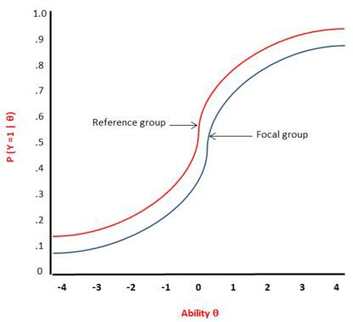
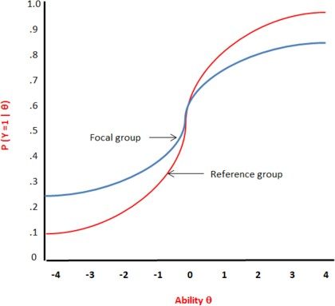

Figure 2. Item characteristic curve with uniform  DIF. | Figure 3. Item characteristic curve with non-  uniform DIF.

Traditionally testing for the presence of DIF under the logistic regression framework is based on likelihood ratio χ² test (Swaminathan & Rogers, 1990). Initially used for dichotomous items, this technique was then extended for polytomous items¹, in which case the proportional-odds logistic regression model (Agresti, 1990) is used.

The logistic regression procedure, as used in ETIX to assess DIF, focuses on one item after the other, looking for difference between groups when participants are matched on similar level of trait. The matching criterion is the IRT score of each factor.

For each item, different nested models are fit to the data to test the null hypotheses (no difference between the groups) and the alternative hypotheses (a: there is a difference between groups or b: there is a difference between groups, and this difference is not constant across all trait levels):

Model 0: logit P(ui ≥ k) = αk
Model 1: logit P(ui ≥ k) = αk + β1 * trait level
Model 2: logit P(ui ≥ k) = αk + β1 * trait level + β2 *group
Model 3: logit P(ui ≥ k) = αk + β1 * trait level + β2 *group + β2 * trait level * group

Where P(ui ≥ k) is the cumulative probabilities that the item response falls in response option k or higher, and αk are the intercepts.

The log-likelihood of each of the 3 models are recorded. Uniform DIF (degrees of freedom (df) = 1) is tested by comparing the log likelihood values for Model 1 and Model 2, non-uniform DIF (df = 1) by comparing Model 2 and Model 3, and the global overall DIF (df = 2) effect by comparing Model 1 and Model 3. These comparisons are performed with the likelihood ratio X² statistic.

¹ Data is polytomous when item levels are available in multiple categories (ordinal and interval), whereas dichotomous assessments have items with only two levels (binary).

Criteria for detecting DIF:

Items were flagged as DIF if any of the three likelihood ratio X² statistics was significant. Significance level was fixed at alpha =.01 (due to multiple comparison). Moreover, Cox and Snell (1989), Nagelkerke (1991), and McFadden (Menard, 2000) pseudo R2 were reported as a magnitude effects. The level of the effect size provided by the difference between the R² coefficients of the nested models were classified as "negligible" (<.13), "moderate" (.13 to .26) or "large" (>.26) based on Zumbo and Thomas’ (1997) scale of DIF effect.

Purification process:

Ordinal logistic regression uses IRT factor scores as a matching criterion for detecting DIF, assuming that all items except the item of interest are DIF free. Iterative purification is a process used in order to determine whether the IRT factor score was already biased prior to running an ordinal logistic regression analysis, due to items with DIF being included in the scale. It iteratively recalculates the matching criterion and the DIF, by using just the items which are identified as non-DIF. Iterative purification therefore reduces the effect of DIF on the factor estimates which are used for matching criterion (Choi, Gibbons & Crane, 2011).

Gender, study level and age differences were separately subjected to Dif analyses for each factor. Analyses were performed using R software version 3.1.3 and the lordif package for R (Choi, Gibbons & Crane, 2011).

DIF Analysis: Gender

In order to discover if items performed differently across gender, we first defined two groups of professionals by gender (males and females). These analyses were conducted to ensure that all of the items were interpreted in the same way by participants of either gender, and that there was not a bias towards either males or females.

DIF Analysis: Participants

Analyses were conducted with a total of 320 participants all from the UK norm sample. Participants were separated in two groups according to their gender. 168 women (53%) aged from 21 to 65 years (M=43.80; SD=10.8) and 152 men (47%) aged from 23 to 65 years (M=43.62; SD=10.3) were included in the analysis.

DIF Analysis: Results

Analyses identified 2 items relating to Respect for Commitments, 3 for Equality, 1 for Goods and Property and 2 items for Laws and Procedures displaying a general DIF effect for gender, due to the presence of non-uniform DIF for all items, and the presence of uniform and non-uniform DIF in the Goods and Property and Laws and Procedures items. However, the size of the effects, as indicated by the pseudo R2, were negligible: <.02, which is far below Zumbo’s (1999) threshold of .13 indicating a negligible size effect.

No DIF was flagged for the factors Facts and Honesty, and Other People. The results of these analyses show that the majority of items (132 out of 140) on ETIX do not function differently across genders. Table 27 shows the Likelihood Ratio X2 Statistics for this analysis; all items with demonstrated DIF have been included in this table. Uniform DIF is displayed as χ²12, while non-uniform DIF is displayed as χ²23, and global DIF is displayed as χ²13.

Table 28. Likelihood Ratio X2 for Uniform (R212), Non-Uniform (R223) and Global (R213) DIF and Magnitude Measures for Each Item which Demonstrates DIF across Genders (alpha = .01).

Probability |  |  |  |  |  | McFadden |  |  | Nagelkerke |  |  | Cox & Snell |  |  | %Δβ1
Factor | Item | No cat | Χ²12 | Χ²13 | Χ²23 | R²12 | R²13 | R²23 | R²12 | R²13 | R²23 | R²12 | R²13 | R²23
C | 15 | 4 | 0.641 | 0.001 | 0.000 | 0.000 | 0.016 | 0.016 | 0.001 | 0.039 | 0.038 | 0.001 | 0.035 | 0.035 | 0.011
C | 20 | 4 | 0.813 | 0.015 | 0.004 | 0.000 | 0.010 | 0.010 | 0.000 | 0.021 | 0.020 | 0.000 | 0.019 | 0.019 | 0.004
E | 1 | 4 | 0.410 | 0.000 | 0.000 | 0.001 | 0.022 | 0.021 | 0.001 | 0.019 | 0.018 | 0.001 | 0.018 | 0.017 | 0.011
E | 8 | 4 | 0.572 | 0.012 | 0.004 | 0.000 | 0.011 | 0.010 | 0.001 | 0.016 | 0.015 | 0.001 | 0.015 | 0.015 | 0.009
E | 12 | 4 | 0.568 | 0.002 | 0.000 | 0.000 | 0.016 | 0.015 | 0.001 | 0.022 | 0.021 | 0.001 | 0.020 | 0.019 | 0.009
G | 1 | 4 | 0.001 | 0.004 | 0.871 | 0.014 | 0.014 | 0.000 | 0.017 | 0.017 | 0.000 | 0.016 | 0.016 | 0.000 | 0.060
L | 4 | 4 | 0.006 | 0.020 | 0.641 | 0.010 | 0.010 | 0.000 | 0.014 | 0.015 | 0.000 | 0.013 | 0.014 | 0.000 | 0.060
L | 14 | 4 | 0.000 | 0.000 | 0.749 | 0.025 | 0.026 | 0.000 | 0.050 | 0.051 | 0.000 | 0.046 | 0.047 | 0.000 | 0.053

C – Commitments ◦ E – Equality ◦ G – Goods and Property ◦ L – Laws and Procedures

One item displaying DIF was chosen to graphically illustrate DIF in ETIX with relation to gender. Figure 4 displays analyses of the one item for Commitments, which has negligible gender differences. The reference group (males) is more likely to endorse the item (Figure 4) than the focal group (females).

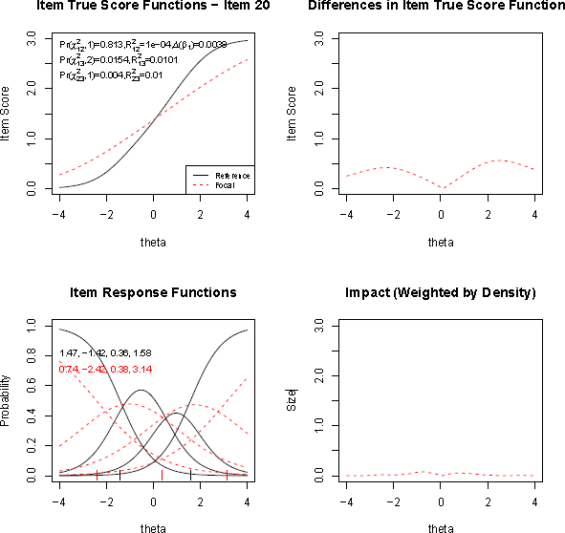

Figure 4. Graphical Display of an Item “If I was offered a better opportunity elsewhere, I would not
feel I had to give much advance warning.” for the Factor Commitments which Illustrates Non-Uniform DIF with Respect to Gender. Reference Group = Men, Focal Group = Women.

The top left graph displays the item characteristic curves (ICCs) for the item for male (solid curve) vs. female (dotted curve) professionals based on item true-score functions. The Logistic Regression χ² test for uniform DIF (χ²12) was not significant (p=.813), whereas non uniform DIF (χ²23) was significant (p=.0154). The slope of the function for males was slightly higher than that for females at a high theta level, whereas it was higher for females than males at a lower theta level, further indicating a non- uniform DIF.

The top right and the bottom right graphs both show the absolute difference between the ICCs for male and female professionals. The top right graph illustrates the difference in scores between groups along the continuum of trait level (theta score), and shows that the small difference in item true score function is present only at low and high level of the trait Commitments. The bottom right graph shows this same difference in score between groups but weighted by the score distribution of the focal group, thus indicating that the impact of the difference between the item score of the two groups is actually minimal.

The bottom left graph shows the item response functions for the two groups separately for each response options. Slope (discrimination parameter) and category threshold values (difficulty parameters at the intersection of categories response options) are printed on the left of the graph. Difference between groups on the slope parameters (1.47 for men, .74 for women) is an indicator of non-uniform DIF, which is confirmed by the visual inspection of the graph “item true score function” (top left figure). The category threshold values, calculated for each group, indicate at which point of the response option the difference between groups occurs. For this item, category threshold value

differs between groups at the intersection of response option “Strongly agree” and “Somewhat agree” (-1.42 for men and -2.42 for women): as the items in ETIX have reversed coding (“Strongly disagree” with the item results in a higher ethical score than “Strongly agree” meaning that the curve from left to right of the graph corresponds to “Strongly agree”, “Somewhat agree”, “Somewhat disagree” and “Strongly disagree” respectively), the probability of endorsing the “Strongly agree” over the “Somewhat agree” option for men starts at lower level of trait compared to women. Category threshold value also differs between groups at the intersection of response option “Somewhat disagree” and “Strongly disagree” (1.58 for men, 3.14 for women): the probability of endorsing the “Strongly disagree” over the “Somewhat disagree” option for men starts at lower level of trait compared to women.

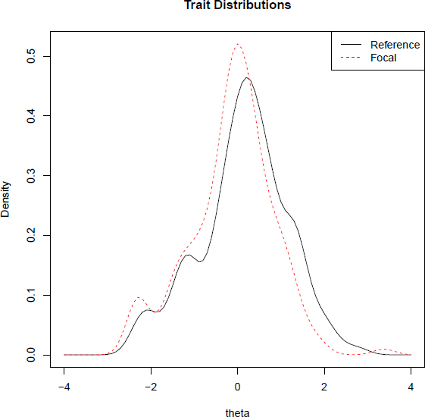
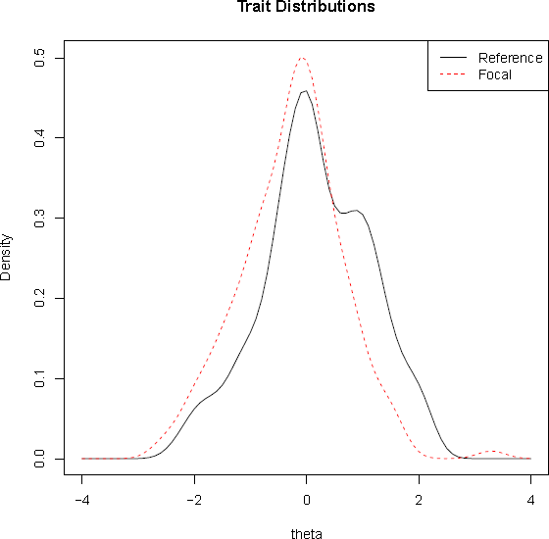
Figure 5. Trait Distributions for the Factor Figure 6. Trait Distributions for the Factor Commitments – Male Reference) vs. Female (Focal). Equality – Male (Reference) vs. Female
(Focial).

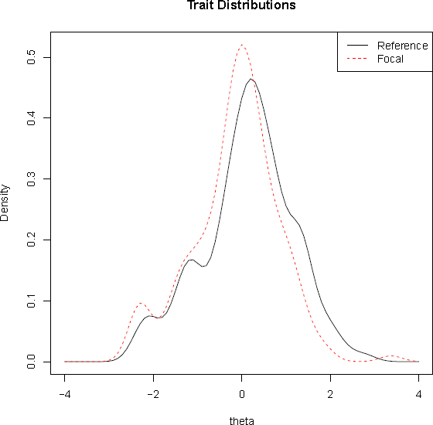
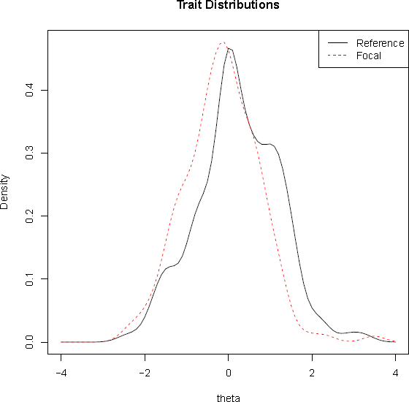

Figure 7. Trait Distributions for the Factor Goods and Property – Male (Reference) vs. Female (Focal).
Figure 8. Trait Distributions for the Factor Laws and Procedures – Male (Reference) vs. Female (Focal).

At the trait level, the distribution of theta scores for the factor Commitments is illustrated in Figure 5. This graph shows the distribution of the theta score for males (solid line) and females (dotted line) participants. We can observe a broad overlap in the distributions, though more females compared to males obtain medium theta estimates. Regarding the factors Equality (Figure 6), Goods and Property (Figure 7), Laws and Procedures (Figure 8), we can observe a broad overlap in the trait distributions between males (solid line) and females (dotted line), though more males compared to females obtain medium theta estimates.

Importantly, as displayed in Figure 9, the test characteristic curves for the factors Commitments, Equality, Goods and Property and Laws and Procedures show a perfect overlap between groups, indicating that for all level of trait, the item with DIF had no impact on the theta estimated scores at the factor level.

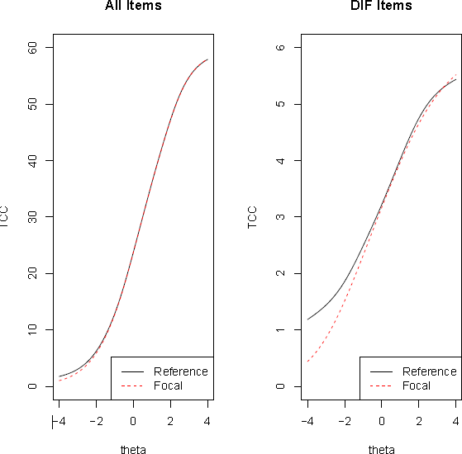
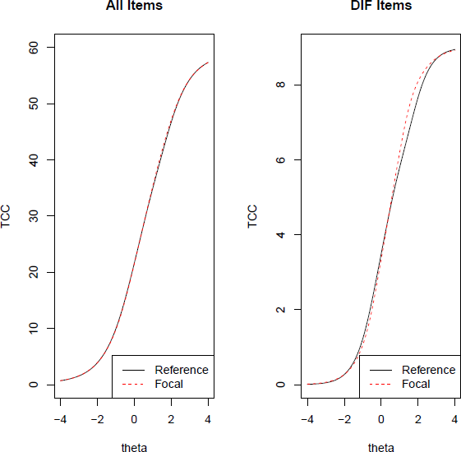
Factor Commitments Factor Equality

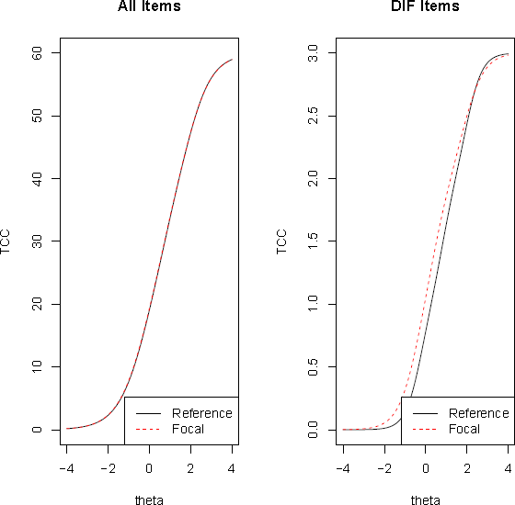
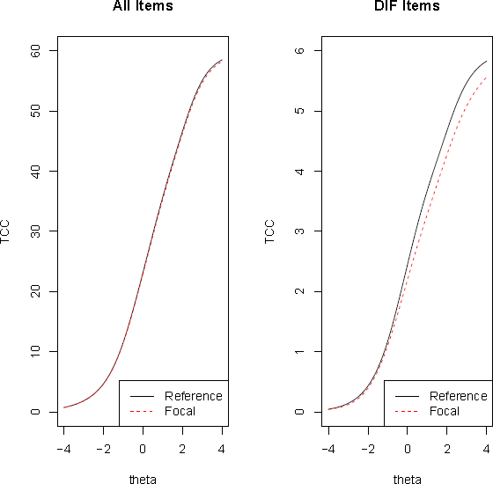

Factor Goods and Property Factor of Laws and Procedures

Figure 9. Impact of All Items for the Factor Commitments (All Items - Top Left), Equality (All Items - Top Right), Goods and Property (All Items - Bottom Left), and Laws and Procedures (All Items - Bottom

Right) on Test Characteristic Curves (TCCs), with Male Professionals (reference) Represented by a Solid Curve, and Female Professionals (focal) Represented by a Dotted Curve.

Finally, the non-significant impact of the DIF item on the level of trait for factor Commitments, Equality, Goods and Property, and Laws and Procedures is confirmed by the comparison between theta factor score estimated on all items (including items with DIF) and the theta score estimated without DIF items (see Figure 10).

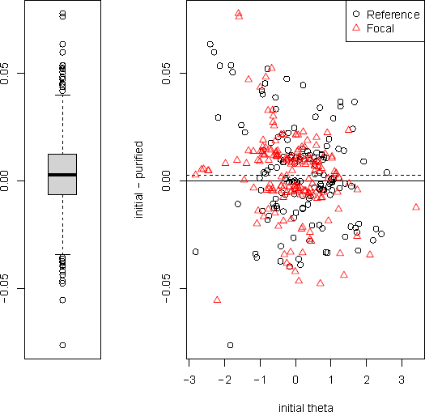
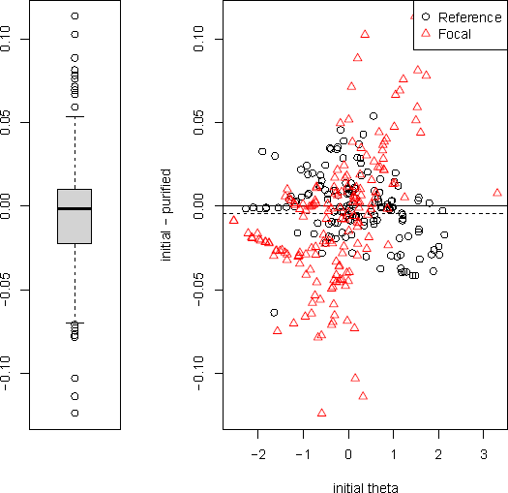
Factor Commitments Factor Equality
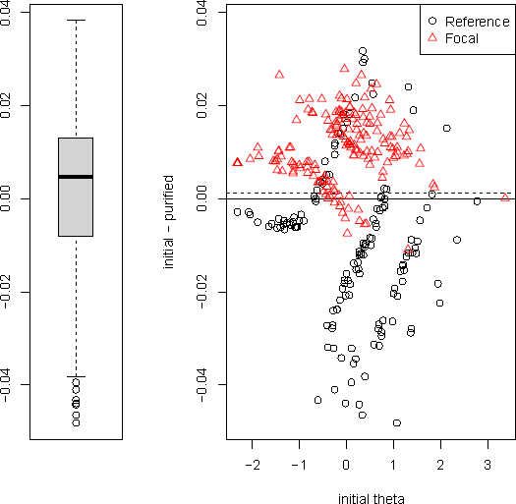
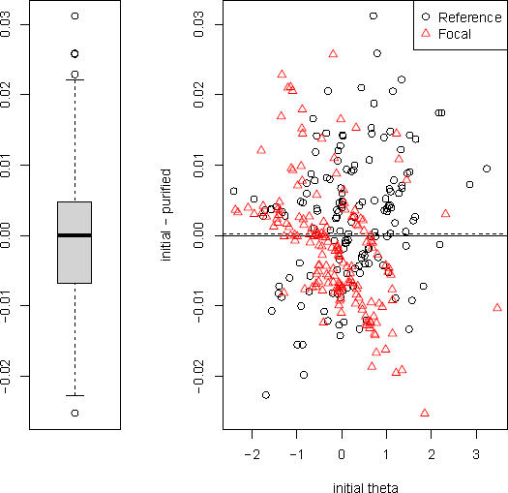
Factor Goods and Property Factor Laws and Procedures

Figure 10. Individual-level DIF Impact.

The graphs above compare the initial theta estimate (which include DIF items) and the purified theta estimates from the final run accounting for DIF. The median difference over all respondents which is represented by the thick black line on the left graph at roughly 0.00. The box and whisker plots all illustrate an interquartile range (the shaded box), ranging from roughly -0.01 to +0.01. The solid line on the scatterplot illustrates where the median would be if there was no DIF, a dotted line depicts the mean of differences and it is evident that the DIF on these factors is extremely small.

Conclusion: Overall, the results of DIF analyses for gender showed that only 8 items out of 140 displayed a DIF effect with only a negligible size effect. Moreover, the impact of the 8 items with DIF on the IRT factor score of their respective dimension was non-significant. Therefore, we can conclude that ETIX questionnaire is appropriate for use for both male and female professionals without causing any discrimination, and practitioners can be confident of obtaining valid, representative and fair results from its use.

DIF Analysis: Age

In order to discover if items performed differently across gender, we first defined two groups of professionals by age; one group consisted of those aged under 50 and the other of those aged 50 and over.

DIF Analysis: Participants

Younger professionals were used as the reference group and comprised of 218 participants (51% women) aged from 21 to 49 years (M=37.9; SD=7.1). The focal group included 102 participants (56% women) aged from 50 to 65 years (M=56.05; SD=4.3) and were classified as older professionals.

DIF Analysis: Results

Analyses flagged 4 items relating to Equality, 3 for Facts and Honesty, 1 for Goods and Property and 1 item for Laws and Procedures with a DIF effect for age. 1 item for Equality displayed a non-uniform DIF effect, while the other items displayed both a uniform and a non-uniform DIF (Table 28). No DIF was identified for the factors Commitments and Other People. Table 28 shows the Likelihood Ratio DIF statistics for this analysis; all items with demonstrated DIF have been included in this table. The results of these analyses show that the majority of items (131 out of 140) on ETIX do not function differently across age groups.

Table 29. Likelihood Ratio X2 for Uniform (R212), Non-Uniform (R223) and Global (R213) DIF and Magnitude Measures for Each Item which Demonstrates DIF across Age Groups (alpha = .01).

All items with demonstrated DIF have been included in this table.

Probability |  |  |  |  |  | McFadden |  |  | Nagelkerke |  |  | Cox & Snell |  |  | %Δβ1
Factor | Item | No. cat | Χ²12 | Χ²13 | Χ²23 | R²12 | R²13 | R²23 | R²12 | R²13 | R²23 | R²12 | R²13 | R²23
E | 1 | 4 | 0.00  2 | 0.00  1 | 0.03  8 | 0.01  2 | 0.01  7 | 0.00  5 | 0.01  1 | 0.01  6 | 0.00  5 | 0.01  0 | 0.01  4 | 0.00  4 | 0.028
E | 2 | 4 | 0.00  4 | 0.01  3 | 0.44  4 | 0.01  0 | 0.01  1 | 0.00  1 | 0.02  1 | 0.02  2 | 0.00  2 | 0.01  9 | 0.02  0 | 0.00  1 | 0.004
E | 5 | 4 | 0.59  3 | 0.00  6 | 0.00  2 | 0.00  0 | 0.01  3 | 0.01  2 | 0.00  1 | 0.02  1 | 0.02  0 | 0.00  1 | 0.01  9 | 0.01  8 | 0.000
E | 11 | 4 | 0.00  0 | 0.00  1 | 0.12  1 | 0.01  6 | 0.01  9 | 0.00  3 | 0.01  5 | 0.01  7 | 0.00  3 | 0.01  3 | 0.01  6 | 0.00  3 | 0.043
F | 19 | 4 | 0.00  7 | 0.02  3 | 0.72  6 | 0.01  0 | 0.01  0 | 0.00  0 | 0.01  0 | 0.01  1 | 0.00  0 | 0.01  0 | 0.01  0 | 0.00  0 | 0.035
F | 20 | 4 | 0.00  1 | 0.00  6 | 0.68  7 | 0.01  5 | 0.01  5 | 0.00  0 | 0.01  3 | 0.01  3 | 0.00  0 | 0.01  1 | 0.01  2 | 0.00  0 | 0.012

G | 16 | 4 | 0.00  3 | 0.01  2 | 0.94  3 | 0.01  3 | 0.01  3 | 0.00  0 | 0.01  6 | 0.01  6 | 0.00  0 | 0.01  5 | 0.01  5 | 0.00  0 | 0.047
L | 1 | 4 | 0.04  3 | 0.00  3 | 0.00  6 | 0.00  5 | 0.01  4 | 0.00  9 | 0.00  8 | 0.02  2 | 0.01  4 | 0.00  7 | 0.02  0 | 0.01  3 | 0.002

E – Equality ◦ F – Facts and Honesty ◦ G – Goods and Property ◦ L – Laws and Procedures
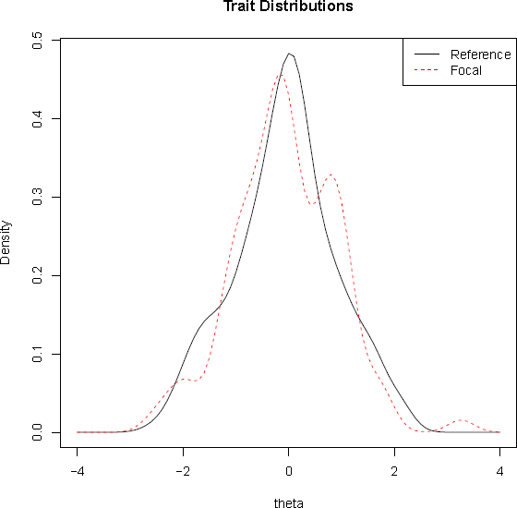
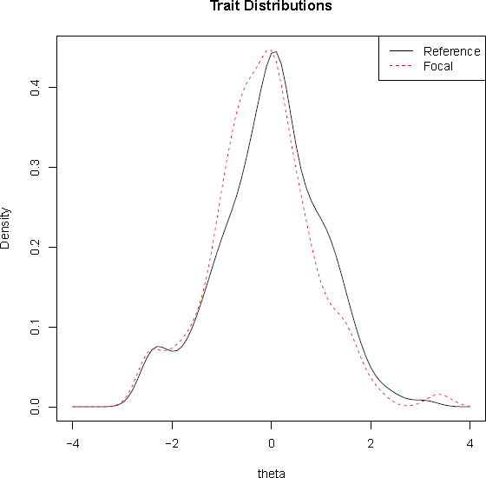
Factor Equality Factor Facts and Honesty

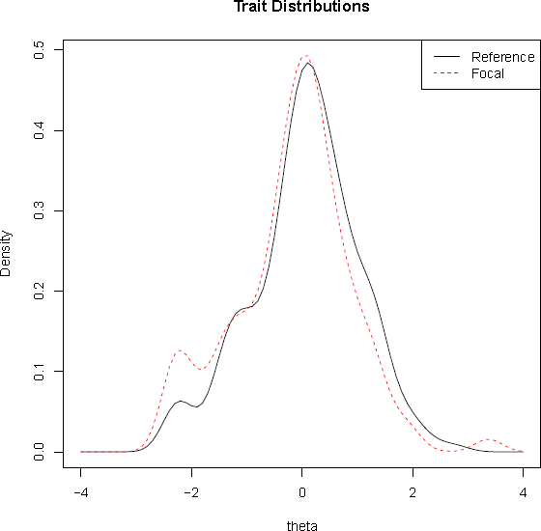
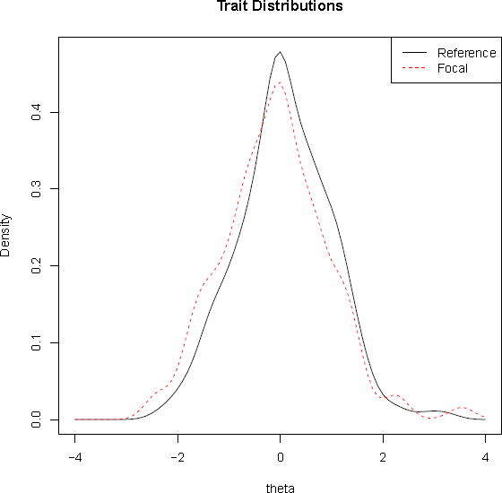
Factor Goods and Property Factor Laws and Procedures

Figure 11. Trait Distributions for the Factors Respect for Equality (Top Left), Facts and Honesty (Top Right), Goods and Property (Bottom Left), and Laws and Procedures (Bottom Right) – Younger (Reference) vs. Older (Focal) Professionals.

At the trait level, the distributions of the estimated theta scores for Respect for Equality, Facts and Honesty, Goods and Properties, and Laws and Procedures are very similar across both age groups and broadly overlap, though a higher number of younger professionals obtained medium score estimates, compared to older professionals (see Figure 11).

Importantly, as displayed in Figure 12, the test characteristic curves for the factor Respect for Equality, Facts and Honesty, Goods and Property, and Laws and Procedures show a perfect overlap between groups, indicating that for all level of trait, the item with DIF has no impact on the theta estimated score at the factor level.

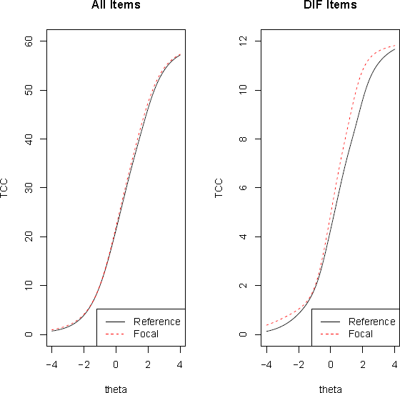
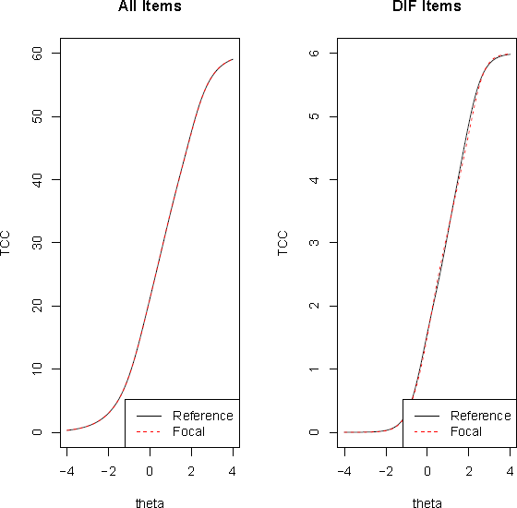
Factor Equality Factor Facts and Honesty

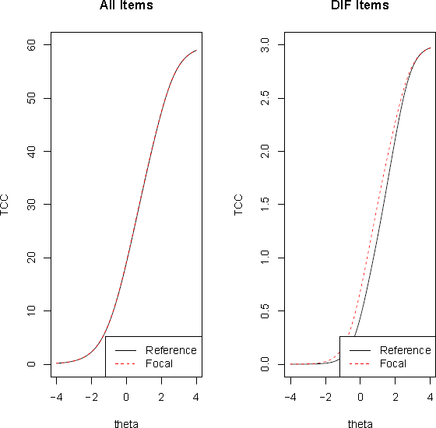
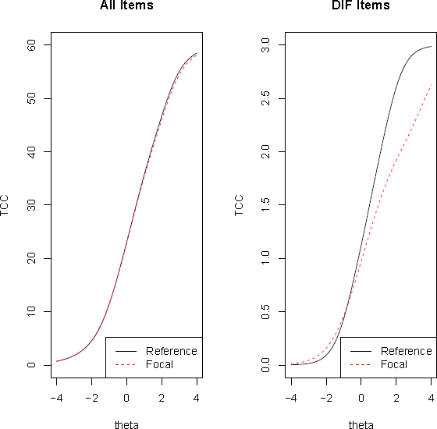
Factor Goods and Property Factor Laws and Procedures

Figure 12. Test Characteristic Curves (TCCs) for the Factors Equality, Facts and Honesty, Goods and Property, and Laws and Procedures.

The left graph for each factor shows the TCC for all 20 items of each factor, with younger professionals (reference) represented by a solid curve, and older professionals (focal) represented by a dotted curve. The graph on the right illustrates TCC only for the items identified with DIF for age.

Conclusion: Overall, only 9 items out of the 140 items of ETIX questionnaire were flagged with DIF for age. These DIF items, which relate to the factors Respect for Equality, Respect for Facts and Honesty, Respect for Goods and Property, and Respect for Laws and Procedures, had a small size effect and no significant impact on theta score estimated at the factor level. In other words, items with DIF did not produce any difference between groups at the trait level. Therefore, we can conclude that ETIX questionnaire is appropriate for use for professionals regardless of their age without causing any discrimination, and practitioners can be confident of obtaining valid, representative and fair results from its use.

DIF Analysis: Study Level

In order to discover if items performed differently across study level, we first defined two groups of professionals; one group consisted of those with a Bachelor’s, Master’s or PhD degree and the other of those with trades training or no study, a high school diploma and those with 2 years vocational study.

DIF Analysis: Participants

University level professionals were used as the reference group and comprised of 140 participants (54% men) aged from 21 to 44 years (M=40.8; SD=10.3). The focal group included 180 participants (57% women) aged from 25 to 63 years (M=46; SD=10.2) and were classified as working professionals.

DIF Analysis: Results

Analyses flagged 8 items with DIF out of the 140 items included in the ETIX questionnaire: 1 item relating to Facts and Honesty, 2 items from Equality and 3 items from Laws and Procedures displayed both a uniform and a non-uniform DIF for educational level, while 1 item from Equality and 1 item for Laws and Procedures displayed a non-uniform DIF (Table 29). No DIF was identified for the factors Commitments, Goods and Property, and Other People.

Table 30. Likelihood Ratio X2 for Uniform (R212), Non-Uniform (R223) and Global (R213) DIF and Magnitude Measures for Each Item which Demonstrates DIF across Study Levels (alpha = .01).

All items with demonstrated DIF have been included in this table.

Probability |  |  |  |  |  | McFadden |  |  | Nagelkerke |  |  | Cox & Snell |  |  | %Δβ1
Factor | Item | No. cat | Χ²12 | Χ²13 | Χ²23 | R²12 | R²13 | R²23 | R²12 | R²13 | R²23 | R²12 | R²13 | R²23
E | 3 | 4 | 0.00  3 | 0.01  2 | 0.79  6 | 0.01  1 | 0.01  1 | 0.00  0 | 0.01  2 | 0.01  3 | 0.00  0 | 0.01  1 | 0.01  2 | 0.00  0 | 0.025
E | 12 | 4 | 0.00  5 | 0.01  8 | 0.65  7 | 0.01  0 | 0.01  0 | 0.00  0 | 0.01  3 | 0.01  4 | 0.00  0 | 0.01  2 | 0.01  3 | 0.00  0 | 0.021
E | 14 | 4 | 0.07  9 | 0.00  4 | 0.00  5 | 0.00  4 | 0.01  4 | 0.01  0 | 0.00  7 | 0.02  4 | 0.01  7 | 0.00  6 | 0.02  2 | 0.01  6 | 0.000
F | 20 | 4 | 0.00  4 | 0.00  1 | 0.02  0 | 0.01  2 | 0.02  0 | 0.00  8 | 0.01  1 | 0.01  7 | 0.00  7 | 0.01  0 | 0.01  5 | 0.00  6 | 0.003
L | 1 | 4 | 0.55  7 | 0.00  4 | 0.00  1 | 0.00  0 | 0.01  4 | 0.01  3 | 0.00  1 | 0.02  1 | 0.02  0 | 0.00  1 | 0.02  0 | 0.01  9 | 0.007

L | 4 | 4 | 0.00  2 | 0.00  0 | 0.00  4 | 0.01  2 | 0.02  2 | 0.01  0 | 0.01  9 | 0.03  4 | 0.01  5 | 0.01  7 | 0.03  1 | 0.01  4 | 0.044
L | 14 | 4 | 0.00  3 | 0.00  2 | 0.05  8 | 0.01  1 | 0.01  6 | 0.00  4 | 0.02  3 | 0.03  1 | 0.00  9 | 0.02  1 | 0.02  9 | 0.00  8 | 0.008
L | 18 | 4 | 0.00  4 | 0.00  2 | 0.06  0 | 0.01  1 | 0.01  5 | 0.00  5 | 0.01  5 | 0.02  1 | 0.00  6 | 0.01  4 | 0.01  9 | 0.00  6 | 0.001

E – Equality ◦ F – Facts and Honesty ◦ L – Laws and Procedures

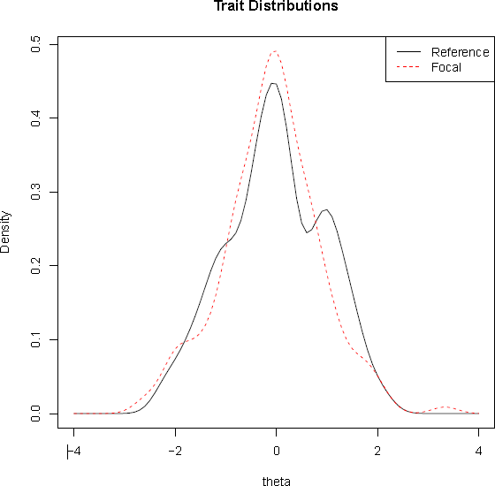
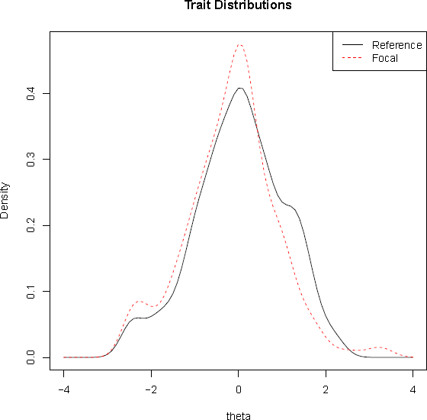
Factor Equality Factor Facts and Honesty
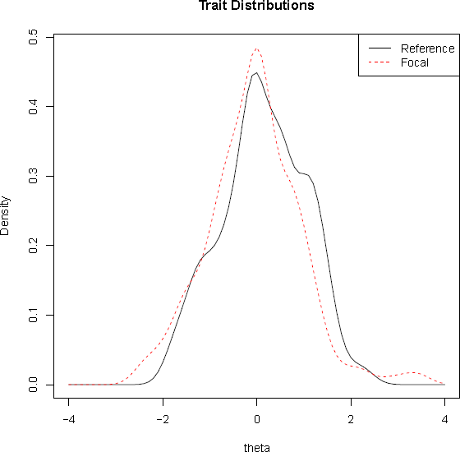

Factor Laws and Procedures

Figure 13. Theta Estimates Distribution of Both Groups for the Factors Equality, Facts and Honesty and Laws and Procedures. University Level Group (Reference Group - Solid Line) and Working Professional Group (Focal Group - Dotted Line).

At the factor score level, Figure 13 shows that theta estimated distribution of both groups broadly overlap for the 3 factors flagged with DIF items, though university level professionals were more represented at medium level of trait compared to working professionals.

Notably, the test characteristic curves of the three factors identified with DIF items (Equality, Fact and Honesty, and Laws and Procedures) show a perfect overlap between groups (left graph for each factor), indicating that for all levels of trait, the items with DIF had no impact on the theta estimated scores (Figure 14).

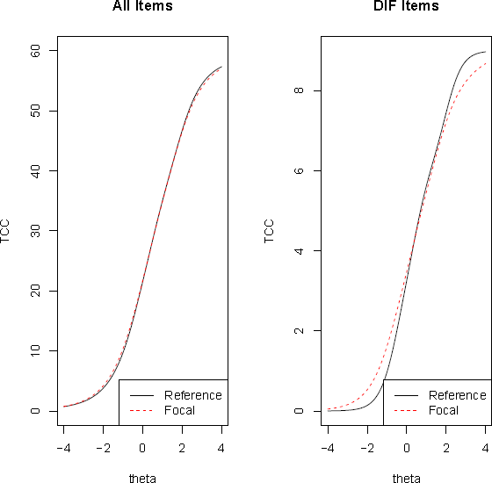
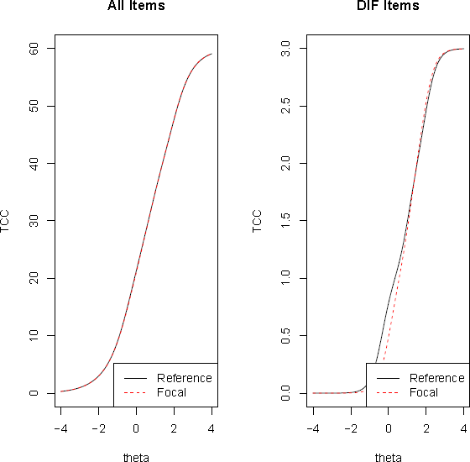
Factor Equality Factor Facts and Honesty
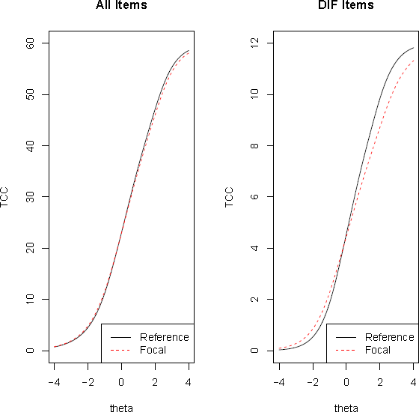
Factor Laws and Procedures

Figure 14. Impact of All Items on Test Characteristic Curves (TCCs) for the Factors Equality, Facts and Honesty, Laws and Procedures. University Level Professionals (Reference) are Represented by a Solid Curve and Working Professionals (Focal) by a Dotted Curve.

The graphs on the left illustrate the TCC for the 3 factors for each group, while the graphs on the right illustrate the TCC of the factors for the items flagged with DIF.

Overall, 24 out of 140 items were flagged for negligible DIF related to gender, age and study level. It is important to emphasise that the impact of DIF on the TCCs of all dimension was non-significant. This means that the ETIX questionnaire has very high consistency of measurement across gender, age and study level. Therefore, we can conclude that the ETIX questionnaire is appropriate for use with professionals regardless of their educational level, as long as they have had at least a secondary school education (high school level), and regardless of their age or gender, without causing any discrimination. Practitioners can be confident of obtaining valid, representative and fair results from its use. ETIX provides candidates from different genders, age groups and study levels with the same level on a factor, the same chance of being selected for a role that requires the desired level on this factor.

T-tests and ANOVAs

The DIF analyses demonstrate that ETIX has high consequential validity and, although some items were flagged with DIF, there was a negligible impact on the overall assessment meaning that it does not have bias towards any age group, gender or study level. Therefore, any significant differences found between genders, age groups, or study levels are due to real differences and not biases of the questionnaire. To further explore the differences between the groups, t-tests and ANOVAS were performed between genders, age groups and study levels (see Tables 31-33).

Gender: In order to check for differences in scores between genders, an independent-samples t-test was conducted to compare all ETIX factors and facets between females (n=161) and males (n=145).

Table 31. Independent T-test Between Females and Males on ETIX.

Factors | Males |  | Females |  | t | Sig
N=306 | Mean | SD | Mean | SD
Good and Property | 6.42 | 2.25 | 7.03 | 1.96 | -2.53 | .012
Self | 6.53 | 2.32 | 7.18 | 1.99 | -2.60 | .010
Others | 6.31 | 2.29 | 6.89 | 2.08 | -2.32 | .021
Facts and Honesty | 6.13 | 2.29 | 7.10 | 1.88 | -4.00 | .000
Self | 6.05 | 2.44 | 7.04 | 2.02 | -3.83 | .000
Others | 6.22 | 2.24 | 7.16 | 1.89 | -3.94 | .000
Laws and Procedures | 5.64 | 2.12 | 6.54 | 1.75 | -4.03 | .000

Self | 5.42 | 2.17 | 6.30 | 1.83 | -3.81 | .000
Others | 5.86 | 2.23 | 6.78 | 1.88 | -3.89 | .000
Equality | 6.01 | 2.13 | 6.93 | 1.79 | -4.08 | .000
Self | 6.04 | 2.05 | 6.92 | 1.73 | -4.02 | .000
Others | 5.97 | 2.35 | 6.94 | 1.99 | -3.87 | .000
Other People | 5.74 | 1.81 | 6.89 | 1.63 | -5.82 | .000
Self | 5.70 | 1.91 | 6.82 | 1.72 | -5.40 | .000
Others | 5.78 | 1.85 | 6.95 | 1.70 | -5.75 | .000
Commitments | 5.78 | 2.04 | 6.36 | 1.73 | -2.66 | .008
Self | 5.87 | 2.15 | 6.38 | 1.87 | -2.21 | .028
Others | 5.70 | 2.11 | 6.35 | 1.83 | -2.86 | .005

Females scored significantly higher than males on all ETIX factors and facets (see Table 31). These differences might be due to the deeply rooted societal gender roles wherein women are expected to act nicely, making them more prone to follow the norms, avoid conflicts and respect others, while men are expected to be ambitious and successful, hence making them more prone to bending the norms in order to achieve their goals. However, some studies have shown that gender differences on ethical judgement may not be as significant (Loo, 2003). These results should therefore be interpreted with caution and further investigated.

Age: Participants were separated into four groups according to their age: under 28s (n=22), 28 to 33- year olds (n=43), 34 to 43-year olds (n=90), and over the age of 44 (n=151).

Table 32. One-way ANOVA Between Age Groups.

Factors | Under 28 |  | 28-33 |  | 34-43 |  | Over 44 |  | F | Sig
N=306 | Mean | SD | Mean | SD | Mean | SD | Mean | SD
Goods and Property | 5.97 | 2.21 | 6.46 | 2.61 | 6.44 | 2.05 | 7.11 | 1.92 | 3.39 | 0.018

Self | 6.1 | 2.36 | 6.74 | 2.57 | 6.52 | 2.12 | 7.23 | 1.98 | 3.15 | 0.025
Others | 5.85 | 2.16 | 6.19 | 2.74 | 6.36 | 2.13 | 7 | 1.97 | 3.42 | 0.018
Facts and Honesty | 5.71 | 2.14 | 6.44 | 2.56 | 6.31 | 2.05 | 7.02 | 1.95 | 4.44 | 0.009
Self | 5.39 | 2.16 | 6.28 | 2.67 | 6.27 | 2.21 | 7.01 | 2.1 | 4.68 | 0.003
Others | 6.03 | 2.22 | 6.6 | 2.56 | 6.36 | 2.03 | 7.04 | 1.93 | 2.91 | 0.035
Laws and Procedures | 5.17 | 1.71 | 5.81 | 2.23 | 5.91 | 1.88 | 6.45 | 1.92 | 3.14 | 0.01
Self | 4.78 | 1.61 | 5.57 | 2.36 | 5.69 | 1.89 | 6.24 | 1.99 | 4.37 | 0.005
Others | 5.57 | 1.96 | 6.05 | 2.29 | 6.13 | 2.01 | 6.66 | 2.06 | 2.76 | 0.042
Equality | 6.29 | 1.99 | 6.67 | 2.42 | 6.42 | 1.85 | 6.51 | 1.96 | 0.48 | 0.875
Self | 6.17 | 6.3 | 1.81 | 0.47 | 6.67 | 7 | 2.43 | 0.35 | 0.57 | 0.639
Others | 6.41 | 6.8 | 2.29 | 0.51 | 6.68 | 7.15 | 2.51 | 0.41 | 0.14 | 0.938
Other People | 5.87 | 1.76 | 6.34 | 2.18 | 6.33 | 1.71 | 6.42 | 1.73 | 1.47 | 0.629
Self | 5.72 | 6 | 2.09 | 0.45 | 6.43 | 6.8 | 2.26 | 0.34 | 0.75 | 0.521
Others | 6.01 | 6 | 1.6 | 0.39 | 6.25 | 6.3 | 2.19 | 0.33 | 0.53 | 0.661
Commitments | 5.8 | 2.06 | 5.86 | 2.42 | 5.81 | 1.77 | 6.36 | 1.73 | 1.47 | 0.11
Self | 5.97 | 2.17 | 5.81 | 2.53 | 5.87 | 1.94 | 6.41 | 1.83 | 2.22 | 0.085
Others | 5.63 | 2.13 | 5.9 | 2.46 | 5.75 | 1.86 | 6.31 | 1.84 | 0.84 | 0.47

As illustrated in Table 31, a one-way ANOVA was conducted to explore the differences between the age groups on ETIX factors and facets. Significant differences were found for Factors Respect for Goods and Property, Respect for Facts and Honesty and Respect for Laws and Procedures as well as all of their corresponding facets. A similar trend can be observed in the aforementioned factors, with the older age group (44 or more) obtaining the highest scores on all factors and facets, while the youngest age group (28 or less) obtained the lowest scores. A possible explanation for this might be that older people tend to lead a financially more secure life than younger people (Miron-Shatz, 2009); consequently they might have a stricter stance on stealing, lying and corruption as they have “more to loose and less to gain” from such behaviours. Another explanation for the present findings could be that as people age, their brain’s cognitive control system changes, improving their capacity for self-regulation, which in turn decreases the impulse towards sensation seeking and risk-taking behaviour (Steinberg, 2008). This might in turn affect the way older people view the counterproductive work behaviours attached to these factors, making them less likely to engage in them.

However, no significant differences were found for the factors Respect for Others, Respect for Equality and Respect for Commitments. This could be due to the fact that these factors are more indirectly

related to breaking the rules or the law, and constitute more modern preoccupations, which might balance the differences discussed in the previous paragraph.

Study Level: In order to explore the difference between participants with different levels of education, a one-way ANOVA was conducted. The results are shown in Table 33.

Table 33. One-way ANOVA Between Study Level Groups.

Factor | Trades Training / No studies  (N=28) |  | High school diploma (N=90) |  | 2 years vocational study (N=57) |  | Bachelor’s degree (N=100) |  | Masters / PhD (N=31) |  | F | Sig
 | Mean | SD | Mean | SD | Mean | SD | Mean | SD | Mean | SD
Goods and Property | 6.4 | 1.99 | 7.19 | 2.09 | 7.06 | 1.81 | 6.4 | 2.1 | 6.31 | 2.55 | 2.51 | 0.042
Self | 6.57 | 2.08 | 7.22 | 2.2 | 7.15 | 1.89 | 6.61 | 2.18 | 6.48 | 2.4 | 2.74 | 0.178
Others | 6.23 | 1.98 | 7.15 | 2.13 | 6.97 | 1.86 | 6.19 | 2.16 | 6.15 | 2.74 | 2.04 | 0.011
Facts and Honesty | 6.37 | 1.91 | 6.97 | 2.05 | 6.78 | 2 | 6.48 | 2.21 | 6.2 | 2.34 | 1.71 | 0.311
Self | 6.46 | 1.91 | 6.95 | 2.24 | 6.66 | 2.19 | 6.38 | 2.34 | 6.04 | 2.45 | 1.25 | 0.291
Others | 6.29 | 2.02 | 6.99 | 2.03 | 6.91 | 1.94 | 6.58 | 2.18 | 6.35 | 2.33 | 1.14 | 0.34
Laws and Procedures | 5.76 | 1.71 | 6.46 | 1.91 | 6.29 | 1.9 | 5.9 | 1.99 | 5.8 | 2.29 | 3.02 | 0.196
Self | 5.53 | 1.75 | 6.27 | 2.03 | 6.03 | 1.95 | 5.64 | 2.03 | 5.6 | 2.29 | 1.62 | 0.17
Others | 5.99 | 1.8 | 6.65 | 2.04 | 6.56 | 2.03 | 6.16 | 2.12 | 5.99 | 2.38 | 1.22 | 0.301
Equality | 6.13 | 1.65 | 6.53 | 1.96 | 6.6 | 1.91 | 6.63 | 2.05 | 6.07 | 2.31 | 2.91 | 0.56
Self | 6.19 | 1.64 | 6.62 | 1.9 | 6.61 | 1.82 | 6.58 | 1.98 | 6.02 | 2.21 | 0.83 | 0.511
Others | 6.06 | 1.86 | 6.44 | 2.16 | 6.59 | 2.13 | 6.68 | 2.27 | 6.12 | 2.5 | 0.71 | 0.588
Other People | 5.93 | 1.35 | 6.28 | 1.9 | 6.85 | 1.48 | 6.33 | 1.81 | 6.01 | 2.15 | 2.2 | 0.125
Self | 5.99 | 1.56 | 6.17 | 1.99 | 6.83 | 1.49 | 6.29 | 1.93 | 5.89 | 2.2 | 1.79 | 0.13
Others | 5.87 | 1.41 | 6.39 | 1.93 | 6.87 | 1.69 | 6.38 | 1.82 | 6.12 | 2.21 | 1.68 | 0.155
Commitments | 6.01 | 1.7 | 6.35 | 1.99 | 6.34 | 1.7 | 5.87 | 1.81 | 5.63 | 2.23 | 2.16 | 0.216
Self | 6.23 | 1.87 | 6.39 | 2.11 | 6.31 | 1.81 | 5.92 | 1.91 | 5.69 | 2.38 | 1.13 | 0.345
Others | 5.8 | 1.8 | 6.3 | 2.06 | 6.38 | 1.87 | 5.83 | 1.89 | 5.57 | 2.23 | 1.65 | 0.161

As illustrated in Table 32, there is a significant difference for the factor Respect for Goods and Property (p=.042), and its facet Others (p=.011) depending on the level of education. Those with a Bachelor’s degree obtained the highest scores, and those with a high school diploma obtained the lowest scores. No significant differences were found for any of the other factors or facets.

References

Agresti A (1990). Categorical Data Analysis. John Wiley & Sons, New York.

Air France KML (2010), Social rights and ethics charter. Retrieved from http://www.airfranceklm.com/sites/default/files/publications/charte_sociale_afkl_0713_gb web.pdf

Al-Shuaibi, A. S. I., Subramaniam, C., & Shamsudin, F. M. (2014). The Mediating Influence of Job Satisfaction on the Relationship between HR Practices and Cyberdeviance. Journal of Marketing and Management, 5(1), 105-119.

Association of Certified Fraud Examiners (2004). Report to the Nation on Occupational Fraud and Abuse. (2004). Retrieved from http://www.acfe.com/uploadedfiles/ACFE_Website/Content/documents/2004rttn.pdf

Bandura, A. (1986). Social foundations of thought and action: A social cognitive theory. Prentice-Hall, Inc.

Bandura, A. (1999). Moral disengagement in the perpetration of inhumanities. Personality and social psychology review, 3(3), 193-209.

Bandura, A. (2002). Social cognitive theory in cultural context. Applied Psychology, 51(2), 269-290.

Bandura, A., Caprara, G. V., & Zsolnai, L. (2000). Corporate transgressions through moral disengagement. Journal of Human Values, 6(1), 57-64.

Barrett, P. (2001). Pre-employment integrity testing: Current methods, problems, and solutions. British Computer Society: Information Security Specialist Group.
Berry, C. M., Carpenter, N. C., & Barratt, C. L. (2012). Do other-reports of counterproductive work behavior provide an incremental contribution over self-reports? A meta-analytic comparison. Journal of Applied Psychology, 97(3), 613.

Berry, C. M., Ones, D. S., & Sackett, P. R. (2007). Interpersonal deviance, organizational deviance, and their common correlates: a review and meta-analysis. Journal of applied psychology, 92(2), 410.

Bies, R. J., Tripp, T. M., & Kramer, R. M. (1997). At the breaking point: Cognitive and social dynamics of revenge in organizations.

Brief, A. P., Buttram, R. T., & Dukerich, J. M. (2001). Collective corruption in the corporate world: Toward a process model. Groups at work: Theory and research, 471, 499.

Boye, M. W., & Slora, K. B. (1993). The Severity and Prevalence of Deviant Employee Activity within Supermarkets. Journal of Business and Psychology, 8(2), 245-253. Http://dx.doi.org/10.1007/bf02230388

Budd, J. W., Arvey, R. D., & Lawless, P. (1996). Correlates and Consequences of Workplace Violence. Journal of Occupational Health Psychology, 1(2), 197-210.
Http://dx.doi.org/10.1037/1076-8998.1.2.197

Camara, W. J., & Schneider, D. L. (1994). Integrity tests: Facts and unresolved issues. American Psychologist, 49(2), 112.

Carrefour (2010), Charte sociale et éthique pour ses fournisseurs. Retrieved from http://www.carrefour.com/sites/default/files/CHARTESOCIALE_ENv2.pdf

Choi, S. W., Gibbons, L. E., & Crane, P. K. (2011). Lordif: An R package for detecting differential item functioning using iterative hybrid ordinal logistic regression/item response theory and Monte Carlo simulations. Journal of statistical software, 39(8), 1.

Clauser, B. E., & Mazor, K. M. (1998). Using statistical procedures to identify differentially functioning test items. Educational Measurement: Issues and Practice, 17(1), 31-44.

Cox, D. R. and Snell, E. J. (1989). The Analysis of Binary Data. 2nd edition. Chapman and Hall, London. Cronbach, L. J., & Meehl, P. E. (1955). Construct validity in psychological tests. Psychological Bulletin, 52(4), 281‑302. Http://doi.org/10.1037/h0040957

Dodou, D., & De Winter, J. C. F. (2014). Social desirability is the same in offline, online, and paper surveys: A meta-analysis. Computers in Human Behavior, 36, 487-495.

Drasgow, F. (1984). Scrutinizing psychological tests: Measurement equivalence and equivalent relations with external variables are the central issues. Psychological Bulletin, 95(1), 134-135.

Drasgow, F. (1987). Study of the measurement bias of two standardized psychological tests. Journal of Applied Psychology, 72(1), 19.

EE (2010), Our Ethical charter for suppliers. Retrieved from http://ee.co.uk/content/dam/everything- everywhere/documents/Our%20Company%20responsibility/Supplier%20Ethical%20Charter
%20Dec%202013-1.pdf

Eurotunnel (2013), Charter of ethics and behaviour. Retrieved from http://www.eurotunnelgroup.com/uploadedFiles/assets-uk/Suppliers/pdf/Charter-Ethics- UK-Groupe-Eurotunnel.pdf

Fan, X., Thompson, B., & Wang, L. (1999). Effects of sample size, estimation methods, and model specification on structural equation modeling fit indexes. Structural Equation Modeling: A Multidisciplinary Journal, 6(1), 56-83.

Folger, R. (1993). Reactions to mistreatment at work. Social psychology in organizations: Advances in theory and research, 161, 183.

Fox, S., & Spector, P. E. (1999). A model of work frustration–aggression. Journal of organizational behavior, 20(6), 915-931.

Fox, S., Spector, P. E., & Miles, D. (2001). Counterproductive work behavior (CWB) in response to job stressors and organizational justice: Some mediator and moderator tests for autonomy and emotions. Journal of vocational behavior, 59(3), 291-309.

Giacalone, R. A., & Greenberg, J. E. (1997). Antisocial behavior in organizations. Sage Publications, Inc.

Glomb, T. M. (2002). Workplace anger and aggression: informing conceptual models with data from specific encounters. Journal of occupational health psychology, 7(1), 20.

Greenberg, J. (1990). Organizational justice: Yesterday, today, and tomorrow. Journal of management, 16(2), 399-432.

Hanson, B. A. (1998). Uniform DIF and DIF defined by differences in item response functions. Journal of Educational and Behavioral Statistics, 23(3), 244-253.

Henle, C. A., Reeve, C. L., & Pitts, V. E. (2010). Stealing time at work: Attitudes, social pressure, and perceived control as predictors of time theft.Journal of Business Ethics, 94(1), 53-67.

Hogan, J., & Hogan, R. (1989). How to measure employee reliability. Journal of Applied psychology, 74(2), 273.

Hollinger, R. C. (1986). Acts against the workplace: Social bonding and employee deviance. Deviant Behavior, 7(1), 53-75.

Holtzman, S., & Vezzu, S. (2011). Confirmatory Factor Analysis and Structural Equation Modeling of Noncognitive Assessments using PROC CALIS. Retrieved from http://www.lexjansen.com/nesug/nesug11/sa/sa07.pdf

Hooijberg, R., Lane, N., & Diversé, A. (2010). Leader effectiveness and integrity: wishful thinking?.
International Journal Of Organizational Analysis, 18(1), 59-75. http://dx.doi.org/10.1108/19348831011033212

Hooper, D., Coughlan, J., & Mullen, M. (2008). Structural equation modelling: Guidelines for determining model fit. Articles, 2.

Hu, L., & Bentler, P. M. (1999). Cutoff criteria for fit indexes in covariance structure analysis: Conventional criteria versus new alternatives. Structural Equation Modeling: A Multidisciplinary Journal, 6(1), 1‑55. Http://doi.org/10.1080/10705519909540118

IMI – Integrity Measurement Integrity. Retrieved from: http://www.optimumpeople.co.za/index.php/our-services/psychometric-assessments/risk- behaviour-integrity/integrity-measuring-instrument-imi

Jermier, J. M., Knights, D. E., & Nord, W. R. (1994). Resistance and power in organizations. Taylor & Frances/Routledge.

Jöreskog, K. G., & Sörbom, D. (1993). LISREL 8: Structural Equation Modeling with the SIMPLIS Command Language. Scientific Software International.

Khuong, M. N., & Tien, B. D. (2013). Factors influencing employee loyalty directly and indirectly through job satisfaction- A study of banking sector in Ho Chi Minh City. International Journal of Current Research and Academic Review, 1(4), 81-95.

Kamp, J., & Brooks, P. (1991). Perceived organisational climate and employee counterproductivity.
Journal of Business and Psychology, 5, 447-458.

Knorz, C., & Zapf, D. (1996). Mobbing—eine extreme Form sozialer Stressoren am Arbeitsplatz. Zeitschrift für Arbeits-und Organisationspsychologie.

Kular, S., Gatenby, M., Rees, C., Soane, E., & Truss, K. (2008). Employee Engagement: A Literature Review. Kingston University.

Loo, R. (2003). Are women more ethical than men? Findings from three independent studies.
Women in Management Review, 18(4), 169-181.

L’Oréal (2007), Charte Ethique, L’éthique au quotidien. Retrieved from http://www.loreal.com/group/governance/acting-ethically/code-of-ethics--a-guide-for- action

McLeary, C., & Cruise, P. (2012). Modeling Organisational Trust: Addressing Challenges of Measurement Invariance. In Proceedings of the 11th European Conference on Research Methods: ECRM 2012 (p. 470). Academic Conferences Limited.

McCrae, R. R., & Costa, P. T. (1987). Validation of the five-factor model of personality across instruments and observers. Journal of personality and social psychology, 52(1), 81.
Menard S (2000). “Coeﬃcients of Determination for Multiple Logistic Regression Analysis.” The American Statistician, 54, 17–24.

Miron-Shatz, T. (2009). “Am I going to be happy and financially stable?”: How American women feel when they think about financial security. Judgment and Decision Making. 4(1), 102-112.

Molex (2007), Code de conduite et d’éthique des affaires. Retrieved from http://www.molex.com/Code_Of_Business_Conduct/Code_Of_Business_Conduct%28English
%29.pdf

Moore, C., Detert, J. R., Treviῆo, L. K., Baker, V. L., & Mayer, D. M. (2012). Why Employees do Bad Things: Moral Disengagement and Unethical Organizational Behavior. Personnel Psychology, 65(1), 1-48.
http://dx.doi.org/10.1111/j.1744-6570.2011.01237.x

Nagelkerke N.J.D. (1991). “A Note on a General Deﬁnition of the Coeﬃcient of Determination.” Biometrika, 78, 691–692.

Neuman, J. H., & Baron, R. A. (1998). Workplace violence and workplace aggression: Evidence concerning specific forms, potential causes, and preferred targets. Journal of management, 24(3), 391-419.

NF ISO 26000 (2010) Lignes directrices relatives à la responsabilité sociétale. France, Afnor. Nunnally, J. C. (1978). Psychometric theory. New York: McGraw-Hill.

Nurul, I., Kozako, A. M. F., Safin, S. Z., & Rahim, A. R. A. (2013). The Relationship of Big Five Personality Traits on Counterproductive Work Behaviour among Hotel Employees: An Exploratory Study. International Conference of Economics and Business Research. Procedia Economics and Finance, 7, 181-187.
http://dx.doi.org/10.1016/S2212-5671(13)00233-5

Ones, D. S., Viswesvaran, C., & Schmidt, F. L. (1993). Comprehensive Meta-Analysis of Integrity Test Validities: Findings and Implications for Personnel Selection and Theories of Job Performance. Journal of Applied Psychology, 78(4), 679-703. Http://dx.doi.org/10.1037/0021-9010.78.4.679

Ones, D. S., Viswesvaran, C., & Schmidt, F. L. (1995). Integrity tests: Overlooked facts, resolved issues, and remaining questions. American Psychologist, 50(6), 456-457. Doi: http://dx.doi.org/10.1037/0003-066X.50.6.456

OPTORG (2012), Ethics Charter. Retrieved from http://www.optorg.com/wp-content/uploads/Charte- Ethique-OPTORG-UK.pdf

Penney, L., & Spector, P. (2002). Narcissism and Counterproductive Work Behavior: Do Bigger Egos Mean Bigger Problems?. International Journal of Selection and Assessment, 10(1&2), 126-134. Http://dx.doi.org/10.1111/1468-2389.00199

Robinson, S. L., & Bennett, R. J. (1995). A typology of deviant workplace behaviors: A multidimensional scaling study. Academy of management journal, 38(2), 555-572.

Sackett, P., & Harris, M. (1985). Honesty testing for personnel selection: Review and critique. Chapter 9 in H. J. Bernardin & D. A. Bownas (Eds.) Personality assessment in organizations, pp. 236-276, New York, NY Praeger.

Sackett, P. R., & Wanek, J. E. (1996). New developments in the use of measures of honesty integrity, conscientiousness, dependability trustworthiness, and reliability for personnel selection. Personnel Psychology, 49(4), 787-829.

Salgado, J. (2002). The Big Five Personality Dimensions and Counterproductive Behaviors. International Journal Of Selection And Assessment, 10(1&2), 117-125. Http://dx.doi.org/10.1111/1468- 2389.00198

Sanofi (2013), corporate social responsibility. Retrieved from http://interactivepdf.sanofi.com/CodeEthicsEN2011-05/

Schreiber, J. B., Nora, A., Stage, F. K., Barlow, E. A., & King, J. (2006). Reporting Structural Equation Modeling and Confirmatory Factor Analysis Results: A Review. The Journal of Educational Research, 99(6), 323‑338.

Shore, L. M., & Martin, H. J. (1989). Job satisfaction and organizational commitment in relation to work performance and turnover intentions. Human relations, 42(7), 625-638.

Schmidt, F. L., & Hunter, J. E. (1998). The validity and utility of selection methods in personnel psychology: Practical and theoretical implications of 85 years of research findings. Psychological bulletin, 124(2), 262.

Skarlicki, D. P., & Folger, R. (1997). Retaliation in the workplace: The roles of distributive, procedural, and interactional justice. Journal of applied Psychology, 82(3), 434.

Skarlicki, D. P., Folger, R., & Tesluk, P. (1999). Personality as a moderator in the relationship between fairness and retaliation. Academy of Management Journal, 42(1), 100-108.

SNC Lavalin (2015), código de ética y conducta empresarial. Retrieved from, http://www.snclavalin.com/en/code-of-ethics

Spector, P. E., Bauer, J. A., & Fox, S. (2010). Measurement artifacts in the assessment of counterproductive work behavior and organizational citizenship behavior: Do we know what we think we know? Journal of Applied Psychology, 95(4), 781-790. Http://dx.doi.org/10.1037/a0019477

Steiger, J. H., & Lind, J. C. (1980). Statistically based tests for the number of common factors. In annual meeting of the Psychometric Society, Iowa City, IA (Vol. 758).

Steingberg, L. (2008). A Social Neuroscience Perspective on Adolescent Risk-Taking. Developmental Review. 28(1), 78-106.

Steria (2008), Charte éthique, principes de conduit dans nos pratiques professionnelles. Retrieved from http://www.soprasteria.co.uk/docs/librariesprovider41/brochures/sopra-steria-code-of- ethics.pdf?sfvrsn=0

Sunat, Código de ética. Retrieved from http://www.sunat.gob.pe/cuentassunat/codigoEtica/codigoEtica-SUNAT.pdf

Swaminathan, H., & Rogers, H. J. (1990). Detecting differential item functioning using logistic regression procedures. Journal of Educational measurement, 361-370.

The Employee Polygraph Act (1988). H.R. CONF. REP. No. 659, 100th Cong., 2d Sess. 11, reprinted in 1988 U.S. CODE CONG. & ADMIN. NEWS 726, 749 [hereinafter H.R. CONF. REP. No. 659].

The Global Retail Theft Barometer (2011). Retrieved from: http://www.retailresearch.org/grtb_currentsurvey.php

Thomas, J. (2012). Counterproductive Work Behaviour - Living in Wonderland. White Paper. Retrieved
6 November 2015, from https://cdn.auckland.ac.nz/assets/psych/about/our- people/documents/Counterproductive%20Work%20Behaviour%20Josh%20Thomas%20Whit e%20Paper.pdf

Vinci (2014), Charte éthique et comportements. Retrieved from http://www.vinci- concessions.com/wp-content/uploads/2015/04/vinci-annual-report-2014.pdf

Yoav Vardi, Ely Weitz. (2002). Organizational misbehavior: Hypotheses, research and implications, in (ed.)Re-Imaging Business Ethics: Meaningful Solutions for a Global Economy (Research in Ethical Issues in Organizations, Volume 4) Emerald Group Publishing Limited, pp.51 – 84

Zumbo, B. D., & Thomas, D. R. (1997). A measure of effect size for a model-based approach for studying DIF. Prince George, Canada: University of Northern British Columbia, Edgeworth Laboratory for Quantitative Behavioral Science.

Zumbo B.D. (1999). A Handbook on the Theory and Methods of Diﬀerential Item Functioning (DIF): Logistic Regression Modeling as a Unitary Framework for Binary and Likert-Type (Ordinal) Item Scores. Directorate of Human Resources Research and Evaluation, Department of
National Defense, Ottawa, ON.

CONTACT US

Client Service: customer@centraltest.com

Training and Consulting: consulting@centraltest.com



www.centraltest.com

© 2020 by Central Test – Empowering Talent.
All rights reserved.

