The Lamplighter

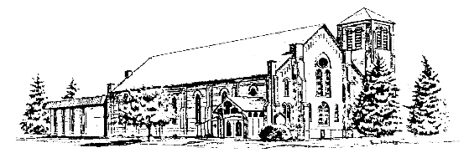

**The United Church Canandaigua, NY**  **11 Gibson Street 585-394-0503**

**Worship Service 8:45 and 11:00 am**

**October 2022 Rev. Dr. Wade Allen**

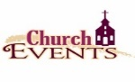

**Oct 2** – Exploring Membership Class, 9:45 am

**Oct 3** – Trustees, 7 pm

**Oct 4** – Stewards, 7 pm

**Oct 5** – Youth Club begins!

**Oct 7-8** – American Baptist Biennial

**Oct 9** – Congregational Meeting, noon

**Oct 17** – Official Board, 7 pm

**Oct 21** – Organ Concert, Kateri Andress, 7 pm

**Oct 30** –Intergenerational Sunday School class, 9:45 & Stewardship Kickoff

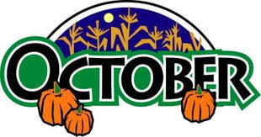

**Table of Contents**

Church Family News …………………..………….…………Page 2

Pastor’s Page and Congregational Meeting...………...…..…. Page 3

Remembering the Past…………………………………..……Page 4

Mission News and Stewards Info …….….…………………. Page 5-6

Organ Concert and Treasurer’s Summary.…...……..………..Page 7

Adult Ministry………………………………………………. Page 8

Youth News..…………………….……….……………..…....Page 9

Children’s Christian Ed News …………..………… …….… Page 10-11

Calendar and Retreat Registration...…………………….……Inserted

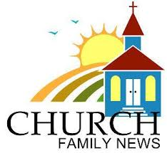**SPECIAL MEMBER UPDATES:**

Special Members are those in their 90s, and/or who are homebound, in nursing homes, or need temporary special care. **They really appreciate cards from their church family!!**

**Barbara Scott’s birthday:** Oct. 24th, age 89.Barbarajoined the church in November 2000 with her late husband Odell. They were very active in adult Sunday School and Barb in the ladies Circle groups. Barb currently resides at The Elderwood Senior Home in Hornell, where she enjoys activities with other residents such as Bingo, watching old movies, and painting colorful garden rocks and pumpkins. She also loves making cards for her family and friends. At one time, she had a large display of dolls that she collected over many years. Barb has two children, Bonnie and David, who themselves are parents and grandparents. Barb enjoys their visits and once in a while she gets out for a ride with them for ice cream!

**NEW SPECIAL MEMBER:**

**Jim Peck:** We’ve been in close touch with Jim since February after he suffered a stroke. He currently resides at the Ewing Continuing Care Center and works diligently with PT and other rehabilitation to regain mobility. Jim and his wife Ann joined the church in 2014 and have been active in adult Sunday School and attending Services. They have been in the crop and dairy farming business for many years in Newark…more on that next time. Jim watches the Sunday Service online now and enjoys waving back to us when the camera scans the congregation!!

**NEW ADDRESS FOR SPECIAL MEMBER:**

**Marilynn Frost:** Marilynn has moved to The Terrace Nursing Home in Newark. We encourage you to send cards of encouragement and prayers. Her new address is: Marilynn Frost - Memory Care Unit 4B, The Terrace at Newark, 208 Rt. 88 South; Newark, NY 14513.

**------------------------------------------------------------------------------------------------------------------------------------------------------------------------------------------------------------------------------------------------------------------------------**

**REMEMBERING:**

Our prayers and sympathies are with **Scott Davis**, whose mother, **Betty Davis**, passed away on September 13th. Please keep the Davis family in your prayers during this difficult time.

**CELEBRATING:**

Congratulations to **Paul and Beth Johnson** on the birth of their new grandson, **Remy Stephen Johnson**, on August 23rd. His parents are **Will and Kathryn Johnson** and he is the sixth grandchild for Paul and Beth. Please keep the family in your prayers during this special time.

Double congratulations to **Sally Seeber** for the recent birth of her twin great-grandsons, **Sawyer Thomas Seeber and Holden Wallace Seeber**. The boys’ parents are **Austin and Ronica Seeber** (big sister, Tavie, is 3.) Sawyer and Holden are in the NICU in Syracuse.  Please keep the family in your prayers during this special time.

**---------------------------------------------------------------------------------------------------------------------------------------------------**

**MEMBER CARE:** If you are aware of anyone in our church family who is ill, having surgery, who had a death in the family, is having troubles in some way? Are you missing your neighbor who sits in the pew next to yours? O***r*** do you know someone who has a happy occasion to celebrate, please let us know!! The Staff works with the ***Outreach and Congregation Care Committee*** to connect with members of our church family who need encouragement and recognition. ***We care about you!*** Call the church office orCongregation Care Committee Chair: Sue Vadney, at (585) 739-8615

-----------------------------------------------------------------------------------------------------------------------------------------

**Exploring Membership Class ~** We have great news for those of you who have been considering joining our church!  We will hold the next Exploring Membership Class on Sunday, **October 2nd** from 9:45-10:45 am.  We are excited and welcome you to attend and learn more about our programs and "our two denominations sharing a common love in Christ".  We hope you'll join us!  Please contact the church office (585-394-0503 or email at secretary@uccdga.org) if you are interested.



I have a reminder on my phone that reminds me of when we are ninety days from Thanksgiving, another one for Christmas. With children living in other time zones, we must plan for airplane travel and holiday schedules. These reminders have started dinging my phone. The holiday season is approaching, along with transitioning to a new year.

At The United Church, we begin planning for 2023 this month. We are discussing budgets; the Nominating and Stewardship Committees are busy at work, and even the 2023 calendar is starting to populate. As we approach this planning season, it is clear that 2023 will bring change. By the end of the year, we will have celebrated significant anniversaries and reflected on God's faithfulness throughout our long history. At the same time, two current staff members will retire at the end of this year. Paul and Ed have contributed so much to The United Church. While they will continue to be a part of our church family, staffing dynamics will shift. New faces are showing up for worship each week, adding to our numbers. Indeed, God is working and moving among us. But change, even good change, can be daunting.

As we plan for 2023 and beyond, please pray for your church. Pray that God will direct each decision, each line item of the budget, and each staff transition. Pray that He will provide all we need through the faithfulness of each person. Pray that we will remain faithful to hear His voice, internalize His Word and obey His calling in our lives.

During October, we will continue our sermon series on Ruth. On the last Sunday of the month, we will begin a four-week series on the central values that hold us together as a church. I look forward to reflecting theologically on all God has called us to be and do.

---------------------------------------------------------------------------------------------------------------------------------------

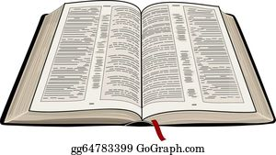**September Worship Schedule**

* October 02 - The Threshing Floor (Ruth 3:1–18)
* October 09 - Redeemed (Ruth 4:1–12)
* October 16 - New Life (Ruth 4:13-17)
* October 23 - The Larger Story (Ruth 4:18–22)
* October 30 - The United Church Values: Worship (Romans 12:1-2)

**----------------------------------------------------------------------------------------------------**

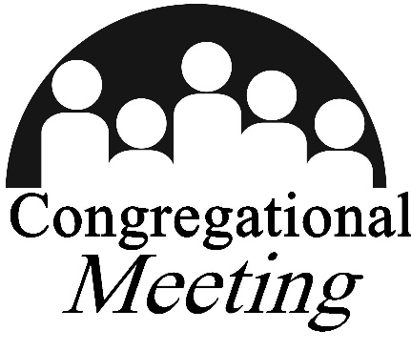A **Congregational Meeting** will be held at **noon on Sunday, October 9, 2022** in the sanctuary. The purpose of the meeting is to request that the Official Board be appointed as a Pastor Nominating Committee with the intention to consider calling Mark Slomski as candidate for Pastor of Youth and Adult Ministry.

**Remembering the Past**

On November 20, 2022 The United Church of Canandaigua will be celebrating many milestone anniversaries. Leading up to this celebration, the Past Team (the team responsible for putting together the celebration), will be sharing with you several stories and historical excerpts about our church’s past and the reasons why we have so much to celebrate this year as a church family.

**Our Story #4 – Celebrating Missions!**

“That all might come to know, love, and follow Jesus Christ as their personal Lord and Savior” has created and guided the fellowship and programs for one hundred-fifty years in this building on the corner of Main and Gibson streets!

Programs have been created, leadership has been affirmed, facilities have been created, and finances have been organized inviting others into fellowship. Missions includes:

* Proclaiming the Good News
* Teaching, nurturing, and baptizing new believers
* Responding to human needs in loving service (education, medical, physical requirements that include food, clothing, and safe housing)
* Pursing end of violence and reconciliation

“Our Story editions #1, #2, and #3” in previous Lamplighter issues have recorded us becoming THE UNITED CHURCH. “In 1947, the First Presbyterian Church of Canandaigua “promoting the spirit of Christ in our community””, welcomed the Baptist to share our building. Our Mission continues to “become aware of needs and forming helpful responses”.

Youth Club, a program for community children grades 2 - 8, was introduced by Rev. Fred Magley in 1966. Youth gather for Bible Study – Worship – Recreation – Family meal time Wednesday afternoon of each year from October to April. The Cause was developed in 2005 for “Youth Club graduates”, high school youth.

Each denomination providedan **organized effort for the propagation of the Christian faith** prior to joining together. Missions involve sending individuals and groups across boundaries to carry on evangelism or other activities, such as educational or hospital work. For services beyond Ontario County prayer, personal contact, and financial support is provided in collaboration with the national Baptist and Presbyterian mission agencies.

Short term international and regional mission trips with our Baptist or Presbyterian organizations were introduced by Rev. Fred Magley following his retirement. Teams to Mexico, the Dominican Republic, and Nicaragua have served with one of our denomination connections annually from 1998. High school youth have contributed in a work camp each year as well. The United Church supports regional programs including Canandaigua Churches in Action, local health, food, safe housing initiatives, Church World Service, Cameron Community Ministries in Rochester, and others.

From our 1947 becoming The United Church we have established an annual benevolence/mission budget separate from the operating budget to support mission activity.

*“Therefore go and make disciples of all nations, baptizing them in the name of the Father and of the Son and of the Holy Spirit, and teaching them to obey everything I have commanded you. And surely I am with you always, to the very end of the age.” Matthew 28:19-20*

God is doing new and exciting things through world mission! God can use your participation not only to change lives internationally, but also to deepen your own discipleship in Christ when you share your financial blessing with the **World Mission Offering.**

Each October our congregation is asked to share of our abundance in the World Mission Offering to support church building around the world. For more than two hundred years American Baptist and Presbyterian ministries have combined resilience, adaptability, and creative approaches to cross-cultural ministry with faithfulness to Scripture. Two hundred eighteen global servants are now serving around the world with our B and P missions.

You can take part in what the Holy Spirit is doing to bring God’s kingdom “on earth as it is in heaven. “WE” become part of the global witness. We serve together with and learn from our many local partners in ministry around the globe.

On Sunday, October 9th, we will receive the World Mission Offering (WMO) supporting our global servants. Place your contribution in the envelope in this Lamplighter, a check with WMO marked on the MEMO line, or “WMO” on our online giving. Each little bit amounts to a lot. Give as you are able!

Drs. Anita and Rick, American Baptist Global Servants, will be at the United Church for the October 7 and 8 Biennial Gathering. Pray for our Global Servants and our sister congregations in New York.

**Missions Effort Locally in September - October**

* Supporting our young adults attending “Champ Camp” weekend at Beaver Camp
* Providing volunteers to the CCIA sponsored Drive Thru Food Pantry and delivered 28 food boxes to households that had no transportation
* Support to Gleaners Community Kitchen at 183 N Main
* Food is collected each week for CCIA and Canandaigua Salvation Army
* Support for the five day a week after school Phoenix Program at the Salvation Army
* Continuing interaction with Ontario County Family Promise
* **OPPORTUNITY**: phone 396-4554 to volunteer assistance with the Oct 24, Nov 21 or the December 19 planned Drive Thru Food Pantry distribution.

Thank you for the continuing support of missions

**Called to Care, Canandaigua**… is a group of individuals from local churches and organizations who are working together to welcome and support Ukrainian and other refugee families in Canandaigua. Our mission is to promote and facilitate the resettlement of refugees in Canandaigua by providing a support network to help them as they start a new life. We offer a “shout out” to many of you who helped support our first community fundraiser “Night for Ukraine” which raised $4,500 which will be available for housing, transportation and other expenses when a first family arrives this Fall.

Our work continues on several fronts. We are on wait lists for an apartment rental. But before we resettle a family in their own apartment, we are looking for an individual or a family who will open their hearts and their home for a short-term homestay of a few days, a week or two, or at most a month. This will allow our resettled family to become used to a new life and culture as well as to be welcomed with a very personal show of warm hospitality. You would have the support of a “good neighbor team” of volunteers from our Called to Care group. If this is something that calls to you, please speak with Ulana Fuller or Linda Werts as soon as possible.

And speaking of “good neighbor teams,” the September monthly meeting of Called to Care, Canandaigua will be held on Wednesday, September 21st from 4-6pm at St. Mary’s Church, 95 North Main Street, Canandaigua in the Parish Hall. We have extended our meeting time and invited Eric Lintala, Volunteer Coordinator from World Relief of Western NY, to present the “Good Neighbor Team Information Session.” Good Neighbor Teams are caring groups of 6-10 individuals who work with newly arrived refugees for at least six months to develop a relationship and accomplish all of the necessary tasks…finding housing, employment, medical insurance, schooling for children and English lessons for adults, and many more. We encourage anyone interested in working closely with these teams and with incoming families to attend the September 21st meeting and begin this first level of information and training offered by World Relief WNY.

Ulana Fuller and I, along with many of the United Church mission committee members, have been actively engaged with others from the local faith community and service organizations. When families begin arriving over the course of the next few years there will be many ways…both large and small… for everyone to get involved. At present we are asking, if you have interest…speak with one of us, come to one of the monthly meetings: September 21st, October 19th, and November 16th, pray for refugee families in need around the world, and for Called to Care, Canandaigua as we seek to offer hope to some of them as they begin new lives among us.

*“The King will reply, ‘Truly I tell you, whatever you did for the least of these brothers and sisters of mine,*

*you did for me.’ Matthew 25:40*

----------------------------------------------------------------------------------------------------------------------------------------

**THE** **STEWARDS ASSISTANCE FUND** supports families in our congregation who need a little temporary financial help. These funds are supported through member donations, and they are given to help purchase groceries, pay for medicine & medical bills, utilities, car repairs, and other essential household expenses. The recipients of these funds are very, very appreciative!!

If you, or someone you know in our church family needs assistance, please contact Virginia Holroyd at church or via email at: virginia.holroyd@uccdga.org. All requests remain completely confidential.

**----------------------------------------------------------------------------------------------------------------------------**

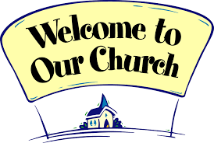**GREETERS of ALL AGES needed for BOTH SERVICES in OCTOBER:**

Greeters play an important role in extending hospitality in our church on Sundays. Greeters welcome people as they enter the church building, they hand out Bulletins, and they collect the offerings at each Sunday Service. This is a role where kids can help too!

The **Sign-up Sheet** is on the **Church Office door**. Reminders and instructions are emailed the Friday before your scheduled Sunday. If you have any questions about being a Greeter, please contact the **October Steward of the Month, Becky Boseck** or call the Office. ***We really appreciate your service!***

**Fall Organ Concert…** Kateri Andress, our beloved and talented young organist here at the United Church, will offer a Fall Organ Concert on **Friday, October 21st** in our sanctuary at 7:00pm. This is a community event so please consider bringing your friends and family to enjoy her performance on our organ and meet her during a reception to follow. Kateri is currently pursuing a Master of Music degree in Organ Performance and Literature at the Eastman School of Music in the studio of David Higgs. In May of 2021, she completed her Bachelor of the Arts degree in Music with a double concentration in organ performance and sacred music, summa cum laude, from Ave Maria University in Southwest Florida, where she studied with Dr. Brice Gerlach. Her musical interests have always centered around sacred music and her gifts and abilities enhance our Sunday morning worship experience. A reception following the concert will be hosted by the organ concert committee. If you can provide cookies or other refreshment items please speak with Ellen Parsons or Joyce Laursen.

**--------------------------------------------------------------------------------------------------------------------------------------**

Treasurer's Financial Summary for January-August 2022

|  |  |  |
| --- | --- | --- |
| Description | Jan-Aug 2022 Amount | Budget |

|  |  |  |
| --- | --- | --- |
| Income |  |  |
| Total Giving | 259,334.75 | 240,018.00 |
| Other Income | 15,958.97 | 37,373.00 |
| Total Income | 275,293.72 | 277,391.00 |

|  |  |  |
| --- | --- | --- |
| Spending |  |  |
| Education and Ministry | 11,635.44 | 17,961.00 |
| Operating | 45,925.14 | 48,210.00 |
| Personnel & Related | 214,789.23 | 214,741.00 |
| Total Expenses | 272,349.81 | 280,912.00 |

|  |  |  |
| --- | --- | --- |
| Net Income Year to Date | 2,943.91 | (3,521.00) |

|  |
| --- |
| Thanks to your generosity over the first eight months of the year, |
| we are doing better than we had anticipated when we created the budget. |
| Now that fall has arrived our programs and activities are increasing so the |
| church is counting on your continued financial support. |

|  |
| --- |
| Nancy Lamberson |
| Treasurer |

**~~~~~~~~~~~~~~~~~~~~~~~~~~~~~~~~~~~~~~~~~~~~~~~~~~~~**

**Coming Soon …** information on the Stewardship season.

Watch your bulletins or listen for announcements. There will be a new look to our church website soon, as well as a few changes for our online giving and background checks.

**Adult Ministry** 

There is a spot for you this fall on Sunday mornings at 11 Gibson Street.

Choose from 3 groups that meet during Sunday School time:

1. Parents

Are Sunday mornings crazy at your house?

Join with parents in the Fellowship Room, 9:45 – 10:45.

Running late? Doesn’t matter, come on in for

faith-filled discussion, fellowship and food!

2. Book of John

Our study, using the Warren Wiersbe guide, follows chapter-by-chapter through this beloved gospel. The class will run to mid-February and meets in the Dining Room at 9:45.

3. The Feasts of Leviticus 23

We are learning about the 7 feasts established by God to tell a story. We see now the prophetic message in each feast, something the Israelites could not have understood. Christ fulfilled the first feasts in His 1st coming. The last 3 feasts picture His 2nd coming! We meet in the Dining Room at 9:45.

|  |
| --- |
| **Our annual Adult Retreat** will take place on Saturday, November 5,  at Camp LeTourneau on the eastern shore of Canandaigua Lake.  Registration Form is enclosed in this Lamplighter … or register online at https://uccdga.churchcenter.com/registrations/events/1446769  Cost: $30/person. Deadline: October 23.  **“Encountering our Culture: Becoming an Everyday Missionary”**  Our speaker Dr. Dana Goodnough will take us into 3 cities in the book of Acts where the Apostle Paul presented the gospel to people who were hostile to the faith, disinterested, or felt it was intrusive to their lifestyle. Sounds like 2022!  With Paul, we’ll walk from Thessalonica, Athens and Ephesus into  Ontario County, New York. What does it take *to be a missionary*? |

**Paul Johnson / Adult Education Director / 585-794-2746**

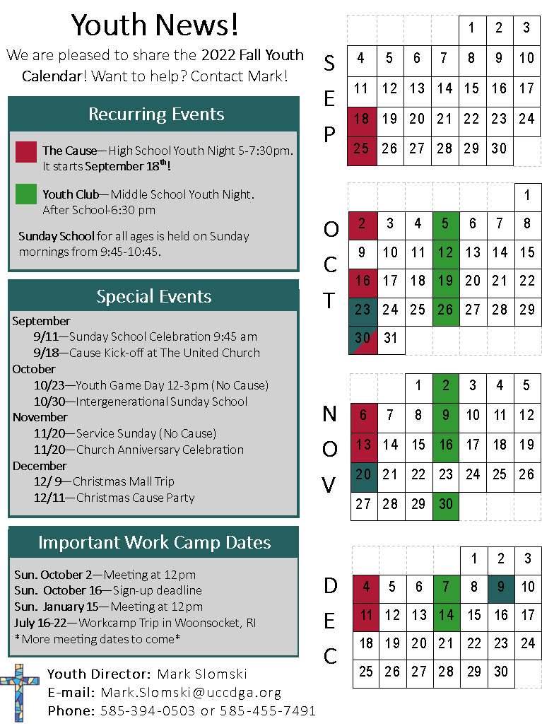

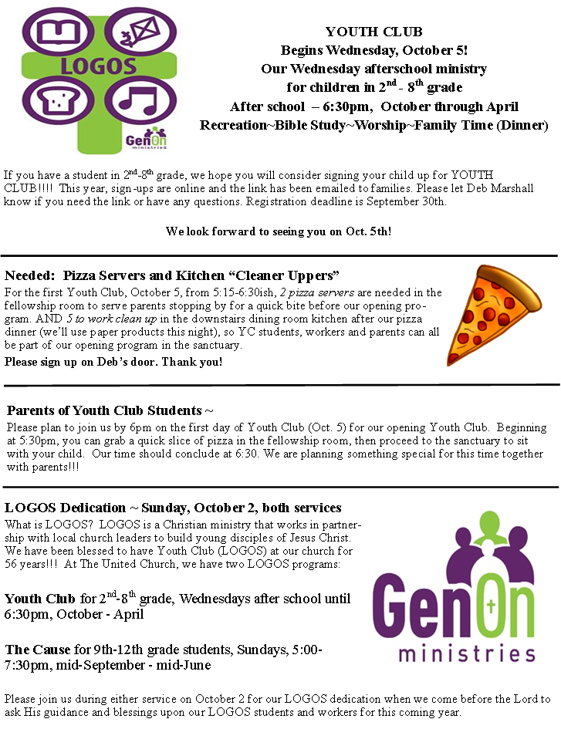**Deb’s pages**

