The Lamplighter

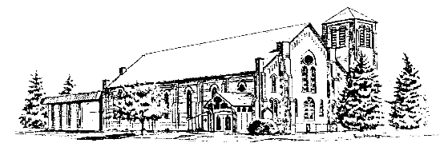

**The United Church Canandaigua, NY**  **11 Gibson Street 585-394-0503**

**Worship Service 8:45 and 11:00 am**

**November 2022 Rev. Dr. Wade Allen**

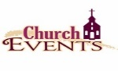

**Oct 30** –Intergenerational Sunday School class, 9:45 & Stewardship Kickoff

**Nov 1** – Stewards, 7 pm

**Nov 5** – Adult Retreat, LeTourneau, 8:30 am

**Nov 7** – Trustees, 7 pm

**Nov 11** – Office closed for Veteran’s Day

**Nov 20** – 150 Year Celebration, Potluck lunch, noon

**Nov 20** – Stewardship finale

**Nov 21** – Official Board, 7 pm

**Nov 21** – Stewards and friends, Decorating for Christmas, 6 pm

**Nov 24-25** – Happy Thanksgiving, office closed

**Nov 27** – First Sunday of Advent

**Table of Contents**

Church Family News …………………..………….…………Page 2

Pastor’s Page...………………………………..……...…..…. Page 3

Remembering the Past…………………………………..……Page 4

Stewards Info …………………………….…………………. Page 5

Mission News……………………………..………………….Page 6-7

Treasurer’s Summary and Stewardship.……...……..………..Page 8

Adult Ministry………………………………………………. Page 9

Youth News..…………………….……….……………..…....Page 10-11

Children’s Christian Ed News …………..………… …….… Page 12-13

Stampin’ Up…………………………………………………..Page 14

Poinsettia order form………………………………………….Page 15

Calendar...…………………………………………….….……Inserted

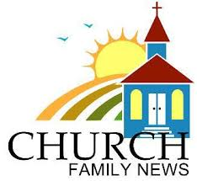**SPECIAL MEMBER UPDATES:**

Special Members are those in their 90s, and/or who are homebound, in nursing homes, or need temporary special care. **They really appreciate cards from their church family!!**

**SPECIAL MEMBER BIRTHDAYS:**

**Marilynn Frost: Nov. 10**, age 91.Marilynnjoined the church in December 1977. She resides at The Terrace Assisted Living Community in Newark. During her active years at our church, Marilynn served in a variety of ways including the Choir for many years, Circle 7, a Small Group Bible Study, Knitting/Prayer Shawl Group, and VBS. Marilynn was a high school English teacher at the Midlakes School District for her entire teaching career and some of her students are members of our church who have kids and grandkids of their own!

**Ruth Bullock: Nov. 18**, age 91.Ruthjoined the church in April 1943; that’s 79 years ago!! And she still enjoys attending Sunday Services with her family, with the 5th generation now growing up in our church family. Ruth grew up on the Day family dairy farm in Canandaigua, where she was one of five siblings. She really enjoys telling stories about family fun on the farm with the cows, chickens and horses. Ruth has four children and several grandchildren and great-grandkids. You may know some of them: Nancy Abdallah, Lauren Slomksi, & Carter!

**David Crowe: Nov. 29**, age 81.Davidjoined the church in February 2009, soon after marrying his wife, Kathie Meredith. David currently resides at The Clifton Springs Hospital Nursing Care Center where he enjoys watching sports on TV especially from his alma mater, Purdue University! Dave also looks forward to weekly massages at the Clifton Springs Hospital Spa. Before his stroke in 2016, David and Kathie enjoyed travelling, especially to Alaska, Italy, Hawaii, and across the country. David was a Science and Phys Ed teacher for many years in Indiana and he also had his own auto parts store. Dave has three sons and four grandkids.

**REMEMBERING:**

Our prayers and sympathy are with the family of **Dorothy LaBrake**, a longtime member who passed away on October 5th. Please keep her daughter and granddaughter, **Karen and Elizabeth Roaix**, and their families in your prayers during this difficult time.

Our prayers and sympathy are with **Jeff Van Riper**, whose mother, **Jean**, passed away on October 17th. Please keep the family in your prayers during this difficult time.

**CELEBRATING:**

Congratulations to **Jim and Jane Kerr** on the birth of their new grandson, **Walker Benjamin Beiler**, on September 27th. His parents are **Meghan and Eric Beiler**. Walker is the 5th child for Meghan and Eric and the 6th grandchild for Jim and Jane. Please keep the family in your prayers during this special time.

**---------------------------------------------------------------------------------------------------------------------------------------------------**

**MEMBER CARE:** If you are aware of anyone in our church family who is ill, having surgery, who had a death in the family, is having troubles in some way? Are you missing your neighbor who sits in the pew next to yours? O***r*** do you know someone who has a happy occasion to celebrate, please let us know!! The Staff works with the ***Outreach and Congregation Care Committee*** to connect with members of our church family who need encouragement and recognition. ***We care about you!*** Call the church office orCongregation Care Committee Chair: Sue Vadney, at (585) 739-8615

-----------------------------------------------------------------------------------------------------------------------------------------

**Have you been on our church website recently? We’ve got a nice new look**,

and hopefully it will be easier for everyone to find what they’re looking for.

<https://www.unitedchurchcanandaigua.com/>

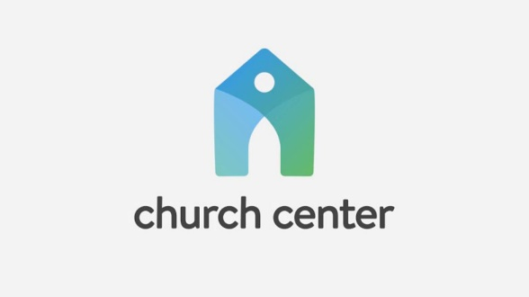Some of the links on the website will take you to updated versions of things like the calendar, livestreams, bulletins and Lamplighters, online giving, and registration for events. Check it out!

If you use a smartphone or tablet, download the free Church Center app to have easy access to everything church related!



November is a month of giving thanks for God's provision. Many will gather with family and friends to share a special meal later in the month. We will also assemble as a church family for a special weekend of anniversary celebrations the weekend before Thanksgiving. We will recount how God has poured out His blessings on this congregation throughout its history. Such reflections and celebrations are critical. God's people have been doing this for thousands of years, remembering God's faithfulness through feasts and festivals.

As we recall the past with gratitude, we can focus on the future. While we cannot fully know all that will happen, we are inspired to prioritize our energy toward God's purposes. In other words, as we look back, we begin to make sense of the future. A team of dedicated volunteers has been gathering to discuss the future of The United Church. Four words (we will call them values) express who we are at The United Church. During our stewardship preaching series, we will highlight one word each Sunday. Let me share a brief synopsis of each term.

Worship - We worship the Triune God in Spirit and Truth (John 4:24). Worship involves submitting ourselves to God as the Spirit empowers us.

Grow - We must grow in our faith, training ourselves to distinguish good from evil. (Hebrews 5:11-6:2, 1 Peter 2:2, 1 Corinthians 3:1-3)

Reach - Jesus sends his followers out on mission for God. We must carefully discern how God might call us to invite others into His Kingdom. (Luke 10:1-20, John 20:21)

Care - As a Christian family, we must bear one another's burdens (Galatians 6:2). Walking alongside each other to meet spiritual and physical needs is at the center of who we are.

I hope you will join us each week as we explore these values. Why does The United Church exist? What sort of work should we be doing? Would it make any difference in our community if we closed our doors? May God continue to provide for The United Church, and may we be a part of making this happen.

The final Sunday in November is the first Sunday in Advent.

---------------------------------------------------------------------------------------------------------------------------------------

**November Worship Schedule**

* ****November 06 - The United Church Values: Grow (Hebrews 5:11-6:3)
* November 13 - The United Church Values: Reach (Luke 10:1-20)
* November 20 - The United Church Values: Care (Galatians 6:1-10)
* November 27 - Wake Up (Romans 13:11-14)

**----------------------------------------------------------------------------------------------------**

**Remembering the Past**

**Our Story #5-Celebrating God's People**Throughout the past four Lamplighters, we have highlighted the many milestones that our congregation will be celebrating this year on Sunday, November 20, 2022.    
  
On November 21, 1971, the church commemorated and celebrated the first 100 years since the cornerstone was laid.  The service was held during the 10:30am worship service with a focus on the Past, Present and Future.  The children's sermon was titled "when the walls were built", the choir sang  
"Built on the Rock the Church doth stand" and the sermon that Sunday was given by Rev. Fred Magley, titled "The Second Hundred Years!"  So much growth and expansion has occurred within our church since that day.    
  
Although the focus of our updates has been primarily on the buildings, expansions, the merging of two denominations, missions and programs, we would be remiss not to celebrate those that have been members of our church since that 100-year celebration.   So today we celebrate you!    
Bill Adams-80 years Betty Leistman-57 years  
  
Ruth Bullock-79 years Dorothy Sheppard-56 years  
  
Edie Robbins 74 years Sue Vadney-56 years  
  
Gary larder-68 years Sandi DiCicco-53 years  
  
Mary Lou Havens-64 years Jim Sheppard-52 years  
  
Ed Olson-60 years Royal Purdy-51 years  
  
 Judy Richmond-50 years

As we come to a close on Remembering the Past, Our Story doesn't end there. We have a beautiful future ahead and look forward to all that God will provide our church and congregation as we continue to build on Our Story over the next 150 years.

***"For I know the plans I have for you, declares the Lord,***

***plans for welfare and not for evil, to give you a future and a hope"****-Jeremiah 29:11*

**AN IMPORTANT MESSAGE FROM THE STEWARDS:**

As the weather grows colder and the snow flies, our seniors and others in our congregation may be using canes, walkers, and wheelchairs more frequently. They could use helping hands in many situations, whether it’s entering the church or during the Services.

We have a very caring congregation, so we’re asking you to continue noticing the needs of others and to offer assistance if you’re able. You many observe someone who needs their walker moved to the side or to retrieve it for them after a Service. Or maybe someone needs some assistance with their wheelchair, getting situated in a pew, picking up a Bulletin, or using the elevator. Thank you!

*I give you a new commandment: love one another. As I have loved you, so you also should love one another.*

*This is how all will know that you are my disciples, if you have love for one another.”* John 13:34-35

----------------------------------------------------------------------------------------------------------------------------------------

**THE** **STEWARDS ASSISTANCE FUND:**

The loose money (coins and cash) placed in the **Offering Plates** on **Nov. 6th** (Communion Sunday) will be deposited to the **Stewards Assistance Fund.** We take this collection six times per year, however you may write a check to *The United Church*, with anote: “Stewards Fund”and give it to the church ***anytime!***

Your donations go directly to those in our church family who are going through financial challenges. If ***you*** need some assistance ***or know of someone*** in our church family who does, please contact Virginia Holroyd at the Church. Monies have been given to help pay for groceries, car repairs, electric bills, other household expenses, surgeries, and other medical expenses. The recipients of these funds are very, very appreciative!!

*Thank you for helping your church family!*

**-----------------------------------------------------------------------------------------------------------------------------**

**GREETERS of ALL AGES needed for BOTH SERVICES in NOVEMBER:**

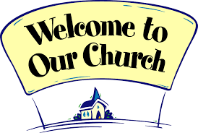Greeters play an important role in extending hospitality in our church on Sundays. Greeters welcome people as they enter the church building, they hand out Bulletins, and they collect the offerings at each Sunday Service. This is a role where kids can help too!

The **Sign-up Sheet** is on the **Church Office door**. Reminders and instructions are emailed the Friday before your scheduled Sunday. If you have any questions about being a Greeter, please contact the **November Steward of the Month, Shirley Kem** or call the Office.

***We really appreciate your service!***

-----------------------------------------------------------------------------------------------------------------------------------------

**The STEWARDS invite you to help DECORATE the CHURCH for CHRISTMAS!**

**On **Monday, Nov. 21,** beginning **at 6:00pm,** we’ll decorate the Sanctuary so it’s adorned for the first Sunday of Advent, which is November 27th. We have a new Christmas tree for this year which will be much easier to assemble!

It takes many hands from our church family to *hang all the greens,* so please join us in the Sanctuary anytime between **6:00-8:00pm.** We’ll assemble the tree, set up the crèche, arrange the candles in the Sanctuary windows, and hang wreaths. **Christmas music & cookies provided!**

-----------------------------------------------------------------------------------------------------------------------------------------

**POINSETTIA ORDERS**

Enjoy the beautiful colors of the Christmas season with a poinsettia plant! The order forms are due by **Sunday,** **December 4th,** and you may note if the plant(s) are being named in memory of, or in honor of your loved ones or friends. Order forms are in the Welcome Center and are included in this Lamplighter (page 15). Call the Office if you need one or print one from our website.

**Please place your order form in an Offering Plate or in the Office, or mail to the Church Office at 11 Gibson St., Cdga, 14424. Checks payable to: The United Church Stewards; $11/plant.** The plants will be delivered in mid-December to decorate the church and you may take them with you after the Christmas Eve 7:00pm Service, or after the 11:00am Service on Christmas Day.

**Field Mission trips for 2023:**

**Nicaragua:**

Nicaragua (A.M.O.S.) mission trip is scheduled for **February 10-19th, 2023.**

The destination for next year is a small community called El Socorro - a 5-6 hour drive from AMOS in an open air truck. The mission: install solar panels in the medical clinic; install in home water filters; build lockable medicine cabinets; and provide basic first aid training.

Members of The United Church are once again teaming up with Elmira Baptist Church. The team has partnered for several mission trips to Nicaragua A.M.O.S.

For further information, or interest in this trip, contact Don Rensberger, Mike Walker, or Lynn Bernard.

**Yucatan Mexico:**

The United Church Living Waters for the World (LWW) team trip is scheduled for **February 13-20th, 2023.**

The LWW team will visit three water systems supported by our church. Visits will be made to Cedralito, Limones, and our latest installation in Tabi. We will also investigate the possibility for a vision clinic in the future. The team will also attend the Living Waters for the World Yucatan Network conference – an opportunity to serve, continue to build relationships with our in-country partners and others, and learn new techniques.

If interested in joining, or looking for further information, contact Linda Werts or Ken Allen.

Financial assistance is available through the mission committee.

~~~~~~~~~~~~~~~~~~~~~~~~~~~~~~~~~~~~~~~~~~~~~~~~~~~~~~~~~~~~~~~~~~~~~~~~~~~~~~~~~~~

**Drive Thru Food Pantry Report**

The September 26 Canandaigua food distribution drive thru served a total of 328 households containing 1,008 persons. That’s over 1,000 people who didn’t have to worry about where they were going to get money for their food that week. All this was distributed within an hour and a half.

How this works: the Foodlink truck delivers pallets of food (lots of produce, sometimes dairy and occasionally meat) to our distribution location at Zion Fellowship on Bristol St. Volunteers set to work unpacking pallets and repackaging them for a quick handoff once the drive thru opens at 11am. This is the volunteers’ busiest and most rushed part of our job. We keep up with packing bags and boxes even as the cars start coming thru the line. MANY HANDS are needed during this time!!! Other volunteers direct the long lines of cars and place the groceries in the trunks, then sent them off with a smile and a wave. “Thank you”s can be heard amongst the bustle. After everyone has been served, volunteers are needed to fold and put away tables and canopies and clean up the area. Whew! Job well done.

Others from the United Church take boxes of groceries to subsidized apartments where many don’t have easy access to transportation. Groceries are divided up and delivered there. Don Rensberger heads up this initiative.

Consider joining us for our next Drive Thru Food Pantries on Monday, October 24 or Monday, November 21. Questions? Speak with Cathy Bush or Don Rensberger from our church. Or Call the Partnership for Ontario County at 396-4554.

~~~~~~~~~~~~~~~~~~~~~~~~~~~~~~~~~~~~~~~~~~~~~~~~~~~~~~~~~~~~~~~~~~~~~~~~~~~~~~~~~~

**CCIA (Canandaigua Churches in Action)** food pantry**, Salvation Army** food pantry, and the many families served by these pantries would like to express their gratitude for the very generous food contributions given by YOU. Your kindness has greatly helped those experiencing food insecurity. **THANK YOU** and God bless you.

**~~~~~~~~~~~~~~~~~~~~~~~~~~~~~~~~~~~~~~~~~~~~~~~~~~~~~~~~~~~~~~~~~~~~~~~~~~~~~~~~~~~~**

**Called to Care, Canandaigua** has been moving forward on many fronts.

Donations are coming in from fundraising appeals and events. Thank you to the many churches, organizations and individuals for generous donations. Our “Night for Ukraine” raised $4,500. So, with other donations we have nearly reached our goal of $10,000 to have on hand and ready to support a first family.

Interested volunteers are signing on to small committee groups and the “housing” and “fundraising” committees are active. Cathy Bush is leading the “housing” committee with responsibilities to secure an apartment or other rental, gather all of the furnishings, and arrange for movers when the time comes, etc. etc. Cheryl Drake is leading the “fundraising” committee. Plans are under way for a November benefit concert by the First Congregational Church and there is a hearty agenda of varied fundraisers for 2023. Other groups will start meeting soon.

Twenty-five volunteers attended the September 21st monthly meeting when Eric Lintala, Volunteer and Community Engagement Coordinator from World Relief’s Rochester office, presented World Relief of Western NY’s “Good Neighbor Team Information Session.” We learned more about World Relief, the resettlement agency we will be working with as we seek to welcome refugee families into Canandaigua, and had a wonderful introduction to “good neighbor teams” - the caring group of 6-10 volunteers who will welcome and support a family during their first six months. From this group we expect to form several “Good Neighbor Teams” and look forward to the training sessions that World Relief will provide.

But the most exciting news is that we have identified a Ukrainian family to sponsor under the humanitarian parole immigration category. It is a father, recently discharged from the military, his wife and their month old baby girl. A family has agreed to welcome them for a short homestay before they move to an apartment. We are praying that one of the apartments we are wait listed for will open up soon. Our “core group” will serve as this first family’s “caring support team.”

The October 19th monthly meeting is scheduled for 4-5pm at St. Mary’s Church in the Parrish Hall and will be primarily for volunteers who attended the September meeting. We’ll have some fun getting to know each other a little better and consider what it means to become a “good neighbor team.” Hopefully we’ll form one or two teams and be ready to train with World Relief in November.

A November 16th monthly meeting will be our last general meeting for the year. It will be held again from 4-5pm at St. Mary’s Church in the Parrish Hall. We will update everyone on where our work stands as we close out a year, offer volunteer opportunities, talk about moving forward to consider other Ukrainian families and making plans for World Relief training sessions which will prepare us to welcome other refugee families.

For more information please reach out to Linda Werts, 315-447-0276.

Our entire “core group” which is functioning as a “board” appreciates the support of many others:

Ulana Fuller - co-chair and “acting” treasurer

Linda Werts - co-chair

Shannon Hicks - secretary

Cathy Bush - “housing” committee chair

Cheryl Drake - “fundraising” committee chair

Meg Huff - “transportation” committee co-chair

Olga Tabinsky - “transportation” committee co-chair

Ellie Babcock -

Kathi Nevin -

Marie Oakleaf -

Pat Wolfanger -

Joyfully submitted,

Linda Werts

----------------------------------------------------------------------------------------------------------------------------------------

|  |  |  |
| --- | --- | --- |
| **Treasurer's Financial Summary for January-September 2022** | | |
|  |  |  |
| **Description** | **Jan-Sept 2022 Amount** | **Budget** |
|  |  |  |
| **Income** |  |  |
| **Total Giving** | **286,160.10** | **270,018.00** |
| **Other Income** | **16,685.81** | **41,050.00** |
| **Total Income** | **302,845.91** | **311,068.00** |
|  |  |  |
| **Spending** |  |  |
| **Education and Ministry** | **11,593.74** | **21,452.00** |
| **Operating** | **48,480.49** | **51,955.00** |
| **Personnel & Related** | **240,813.07** | **240,743.00** |
| **Total Expenses** | **300,887.30** | **314,150.00** |
|  |  |  |
| **Net Income Year to Date** | **1,958.61** | **(3,082.00)** |
|  |  |  |
| **Generous giving continues to make our financial picture much** | | |
| **brighter than we were expecting it to be. Thank you! If you happen** | | |
| **to compare this to last month's summary, you will notice that our** | | |
| **Education and Ministry expense total is less than it was last month.** | | |
| **This is due to several factors: the largest of those is that the Youth** | | |
| **Club Registrations received in September have been netted against** | | |
| **the expense. There was also a refund for Vacation Bible School and** | | |
| **some donations made specifically for adult education programs.** | | |
|  |  |  |
| **Nancy Lamberson** |  |  |
| **Treasurer** |  |  |

**~~~~~~~~~~~~~~~~~~~~~~~~~~~~~~~~~~~~~~~~~~~~~~~~~~~~**

**Stewardship**

Our Stewardship season has begun! Sunday, October 30th marks the beginning of our time of financial planning for 2023. Pledge forms will be available at church on the 30th, and any not picked up then will be mailed to homes the following week. Please return your pledges by November 20th. They can be brought on Sundays, mailed to the church office or you can even submit your pledge online any time by scanning this QR code.

**Online Giving**

Our new church management program makes online giving very easy! Access it through our website, app, or scan this QR code. You can give one-time gifts, or set up recurring giving to happen on whatever schedule you choose. (If you have recurring giving set up under the old Vanco program and are having trouble turning it off, let Carolyn know! She can help!)

**Adult Ministry** **Paul Johnson / Adult Education Director / 585-794-2746**

**Oct 29: Testimony Saturday**

Come together in the Fellowship Room on Saturday, Oct 29, 10:00 – 11:15, for a powerful, informal time of fellowship in the Lord. You will hear a personal story of faith in Christ from one of our own flock. Refreshments provided.

**~~~~~~~~~~~~~~~~~~~~~~~~~~~~~~~~~~~~~**

**Nov 6, 13, 20: Sunday School**

Choose from 3 adult groups during Sunday School hour, 9:45 – 10:45.

1. Parenting Coffee Hour

* Faith-filled discussion, fellowship and food.
* A different pain point of parenting each week.
* Running late? Doesn’t matter, come on in.

2. Book of John

* Warren Wiersbe study thru mid-February, 2023.
* Guide books at no charge!

3. The Feasts of Leviticus 23

* We conclude our study of seven prophetic feasts with these, which foreshadow the 2nd coming of Christ:
* Atonement on Nov 6.
* Tabernacles on Nov 13.

**Nov 5: Annual Adult Retreat**

Encountering the Culture: Becoming an Everyday Missionary

Saturday, Nov 5, at LeTourneau Christian Camp, 8:45 – 3:00, with speaker Dr. Dana Goodnough.



We’ll walk with the Apostle Paul in the book of Acts into Ontario County, NY in 2022. What does it take to become an everyday missionary?

[For those who have registered, confirmation is coming by mail.]

**~~~~~~~~~~~~~~~~~~~~~~~~~~~~~~~~**

**Nov 27: Advent Sunday School**

“The Star of Bethlehem,” a video.

All adults together in the Dining Room at 9:45, presented by Andrew Duncan. The video “walks you through Biblical and historical clues revealing the incredible significance of this celestial event as well as the vastness of God’s creativity.”

|  |  |
| --- | --- |
| YOUTH NEWS | |
| Youth Ministry at The United Church | |
| **November 2022** | |
| Reflections  Serving as Youth Director these last few months has been life-giving. Our church is blessed with incredible members who make Youth Ministry a reality. My orientation into this role has helped me understand all the time, effort, heart, and prayer required to effectively minister to our students. I am privileged to observe and be a part of this important work.  It is helpful to integrate theology into the happenings of any ministry work. In this new era of Youth Ministry at the United Church, we can focus our hearts and minds on what it means to be “New Creation”. As newly created in Christ by the indwelling of the Spirit within us, we take on new characteristics. Some of these changes are surface facing. At the same time, we are still ourselves. Frankly, we have become our true selves more than ever before. God’s story is never forgotten and enhances the sweetness of our transformation.  Likewise, we will see surface-level changes in our Youth Ministry. The youth office is being transformed into a relational, collaborative, and creative space that our students are invited to make their own. The Cause Room will continuously adjust as the needs of our students evolve. These visible alterations can be viewed as leading indicators of our Youth Ministry’s future. | **Before Picture:** The Youth Office is undergoing significant updates as the church enters a new era of Youth Ministry. Come and visit the office to see the transformation in progress!  Yet, the dichotomy of our metaphor comes into play. The visible changes in our Youth Ministry does not abandon the history of our program. We are made up of the stories, experiences, and people that make us who we are today. God gave us that history, and we move forward remembering it with a celebratory posture. Our history is a part of our fullness in Christ, just as Christ’s history on earth (e.g. his pierced hands) are a part of His fullness.  I look forward to celebrating the past, working in the present, and planning for the future of Youth Ministry with you all. |
| November Dates | Contact Information |
| **11/6 – The Cause**  **11/13 – The Cause**  **11/20 – Service Sunday** |  |

|  |  |
| --- | --- |
| YOUTH NEWS | |
| Youth Ministry at The United Church | |
| **November 2022** | |
| Learnings  To start our Cause program year, the students are discussing their learnings and contemplations from our Sunday sermons.  In our sermon series on the book of Ruth, we learn about Naomi and the severe trials she experienced. Her sons married women who worshipped false gods, lost her husband, and later lost her sons, too.  Then we were introduced to Ruth. When she faced with the decision to either return to her homeland and their false gods, she chose to stay with Naomi and worship the God of Abraham, Isaac, and Jacob.    **Cause Kick-Off Night**: Students and adult volunteers worshipping together, led by the worship band from Browncroft Community Church. | Our students reflected on why Ruth had decided to stay with Naomi, despite the danger and the inevitable suffering. We also recalled others in history who suffered because of their faith, such as the disciples and the early Christians.  Our attention was also directed upon Christ, who came and suffered. As Pastor Wade shared, sometimes the book of Ruth is referred to as the Gospel of Ruth, as this story exhibits the same self-sacrificing love of her descendant Jesus.  We took time to reflect on our current situations and how this story can apply to us. Sometimes being a Christian has its societal benefits. Yet, we can all point towards moments where our faith has and can cost us. Sometimes we are isolated from friend groups. Sometimes we are viewed suspiciously. Other times we are mocked for our faith in Jesus.  Following Jesus is not easy. There is a cost to being a Christian. Yet, we find the cost worth it, as we have experienced Jesus and His transforming love. We are attracted to Him so much, we are willing to lose what we have in order to gain Him.  After our discussions and at the end of our Cause events, we worshipped the Lord through song. The songs selected by the Browncroft Community Church Band had our learnings in mind. Together, we praised God, proclaiming that He is worth it! |
| How You Can Help | |
| Want to make a difference in the lives of our students? We always need help in a variety of ways. Here is a list of needs you can consider: | * Cause worship support and facilitation * Cause discussion and teaching * Cause dinner prep & clean up * Cause game coordination * Special Events participation & planning |

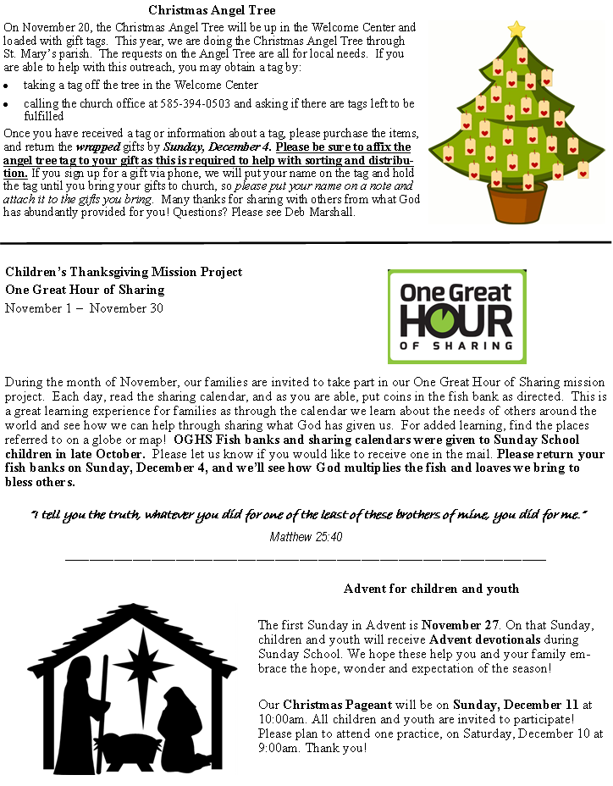

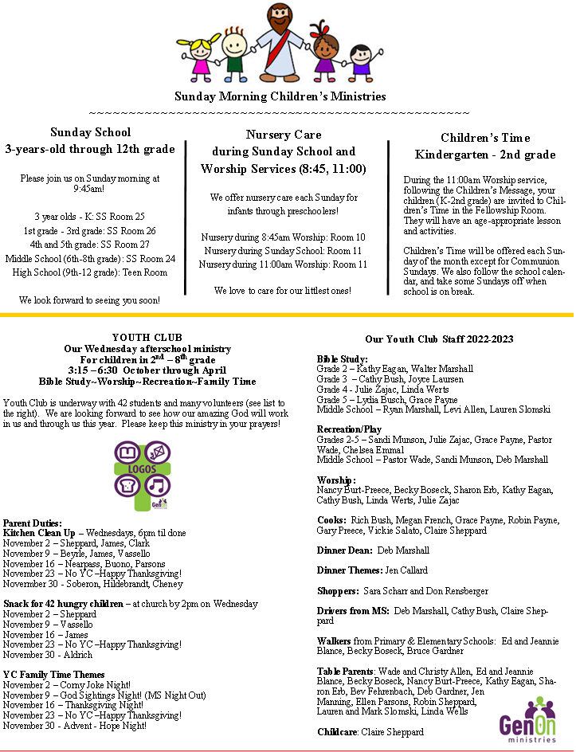

**Stampin Up**

The November **Stampin’ Up** class is scheduled for **Nov 19th** at 9:30 am in the Fellowship Room.  We will make the 5 cards pictured (the bottom right is a gift card holder). Please call or email Sharon Meyer (585-924-8792 or shargmeyer@gmail.com) to sign up **by Nov 1st**.  Sarah Gross will be leading this class.

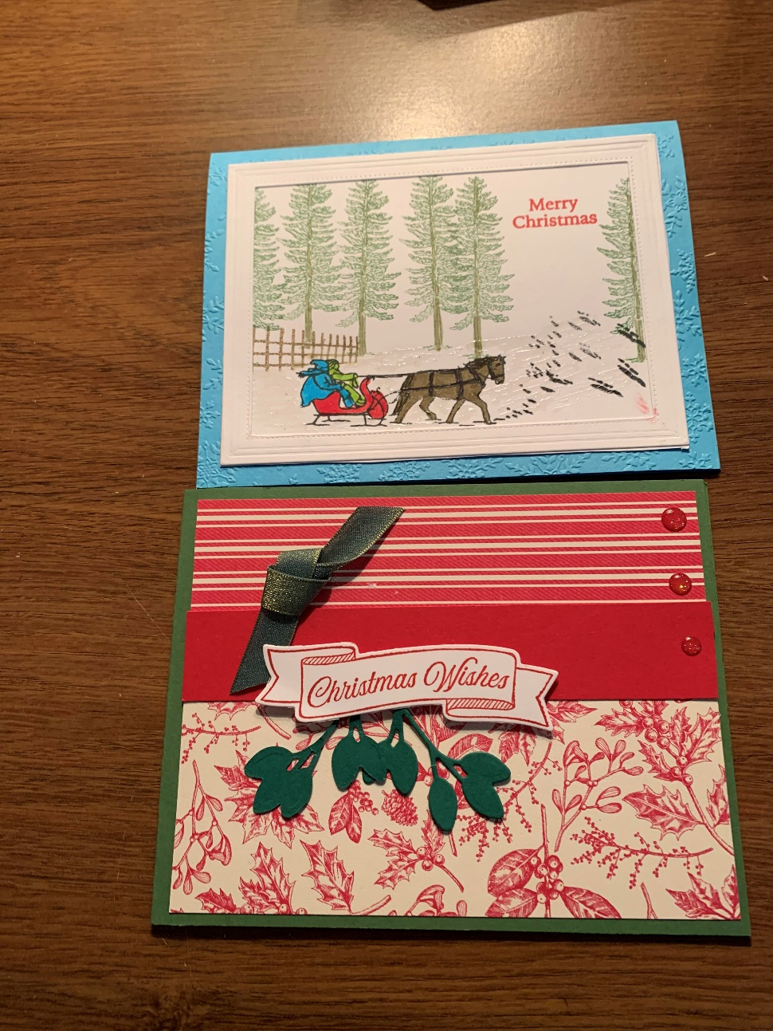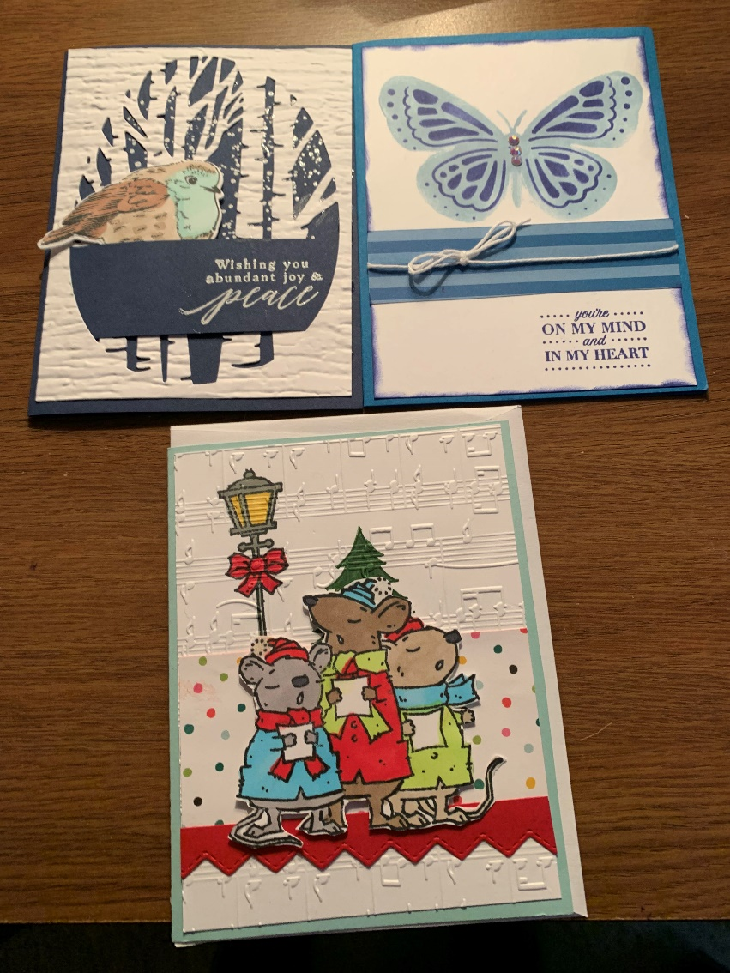

*Christmas Poinsettia Order Form*

PLEASE PRINT

NAME:

I would like to order Poinsettias at $11.00 each.

They are given in memory or honor (circle one) of:

1.

Given by:

2.

Given by:

3.

Given by:

Please pick up your poinsettia(s) after the Christmas Eve Service,

or on Sun., Dec. 25 after the 11:00 Service.

**Checks payable to:** “The United Church Stewards – Poinsettia “

Place your form and check in the offering plate or mail to the church at 11 Gibson St., Canandaigua 14424

**ORDERS MUST BE IN BY DECEMBER 4th**

The United Church Non-Profit Org.

Presbyterian-American Baptist US Postage Paid

11 Gibson Street Permit No. 26

Canandaigua, NY 14424 Canandaigua, NY 14424

Or Current Resident