Activity
Scout patrol secret grilles—Symmetric key encryption

Summary
Modern algorithms for the symmetric encryption of electronic data, such as DES, IDEA etc., are very complex. It is not only impossible, but also unnecessary, to explain in schools how these algorithms work in details. Our pupils should learn about cryptography concepts and ideas through exploring details of nontrivial examples of historical encryption methods in an entertaining way and with high motivation. The activity presents a symmetric key encryption method built around one of the techniques known as grille transposition ciphers (Fleißnerschen Schablone). The ciphers had been used by the German army for several months during World War I.
One may use this hands-on activity to give a broader understanding of Internet web browser secure (HTTPS) communication concepts (e.g. session key’s strength, problem of session key exchange) to primary and secondary school students.

Originally the activity was published in a professional journal for Polish mathematics teachers.

Age
10 and up

Materials
Each group of children will need:
- Worksheet Activity: Jenny’s cipher
- scissors
- square sheets of paper

Scout patrol secret grilles

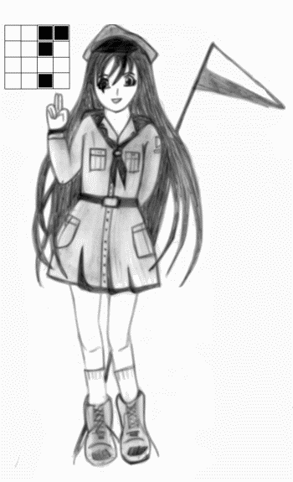
What to do
The activity uses elements of fantasy and storytelling and is framed in the context of a scout story .
It begins with the following scenario: “Jenny’s scout patrol is in deep trouble. The girls used to encrypt their messages simply by writing them backwards. But it is not a secret any more. Jenny,
the best mathematician in the team, was asked to suggest a better cipher.”
The activity continues as follows:
1. Pupils are organised in groups, and each group is given a worksheet “Jenny’s cipher”. It illustrates Jenny’s idea of a non-trivial encryption by anagramming the letters of a plain text. The teacher says that she decided to use a rotating 4 x 4 grille. And the pupils are asked to decrypt Jenny’s exemplary message, i.e. 16 letters. One pupil in each group should use the scissors to remove four square “windows” from the grid. Next they try to discover rules that can be used for decoding.
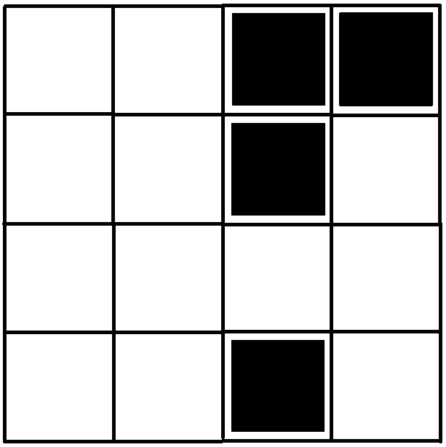
Figure 1: A grille from an activity worksheet
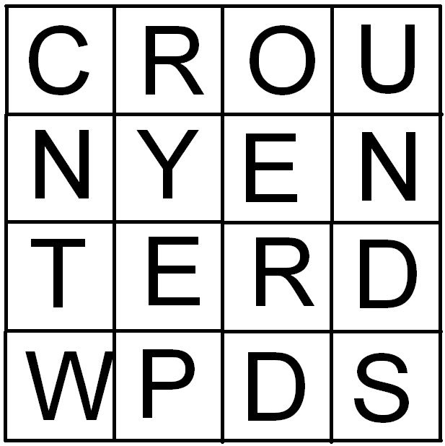
Figure 2: An encrypted message from an activity worksheet

It may turn out not to be so simple. There are eight positions in which a grille can be used: observe and reverse surface up and with one of four sides placed at the top for each of the surfaces. Additionally the grille may be rotated in two directions (clockwise or anticlockwise). Finally the unencrypted words should appear (UNENCRYPTED WORDS). And the teacher should explain the important role of encryption key (and the secrecy of key storage).
2. The next challenge for pupils is to make up their own grilles and to encrypt their own message. They should work in pairs. First they are asked to fold properly a few square sheets of paper in half several times to get 4 x 4 grids. Than they try to remove four “windows” from one of the grids and encrypt their text.
The first attempt may fail. The teacher should discuss with pupils the reasons for their failure. It turns out to be quite difficult: the holes are so distributed that when the grille is turned four times successively around its centre in 90 degree steps, all the cells of the underlying sheet will have been exposed for inscription.
The pupils may be encouraged to try the divide-and-conquer strategy (i.e. divide the grid into quarters) for discovering the rules of distribution of “windows”. It is shown in Figure 3.
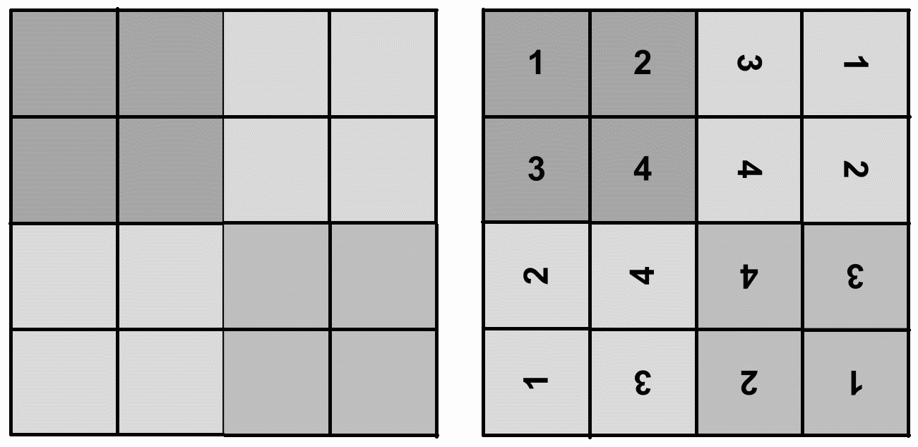
Figure 3: A 4 x 4 grid before distributing the “windows”
The correct-versions of grille-keys may be seen as the keys used by Jenny’s scout patrol in following weeks.
Extensions
The extension exercises, dedicated for older children, are:
– to consider the number of “worse” 4 x 4 grilles (which may be seen as geometrical figures with reflection symmetry);
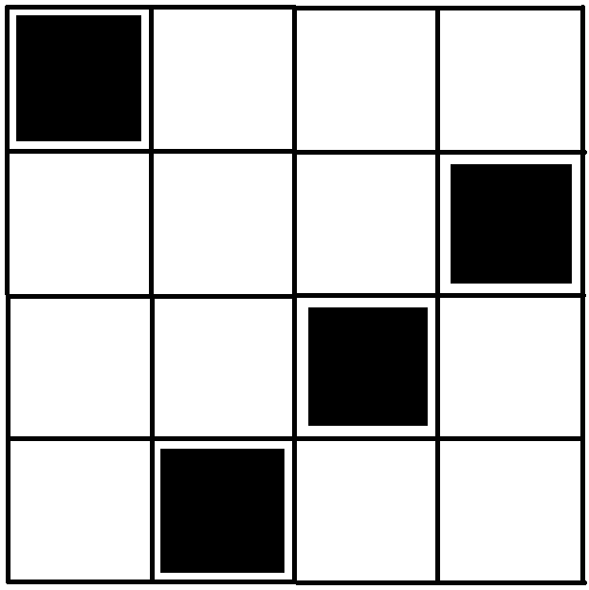
Figure 4: One of “worse” grilles
– to consider the total number of 4 x 4 grille-keys (pupils may imagine Jenny’s enemy who knows the method of encryption – it is not a secrecy – and uses exhaustive search of grilles);
– to analyse the problem of the distribution of Jenny’s grilles as an example of the difficult problem of key exchange (Jenny’s friends may use maps of bits);
– to devise an attack exploiting weaknesses of the grilles (related to a rotational symmetry of “windows” in grilles).
Finding the exact answers to these problems may be energy- and time consuming even for smart youngsters. But the experience of looking for solutions without success is not a waste of time. Students then are more likely to appreciate the power and beauty of the mathematics and computing sciences. Eventually the teacher may ask teenagers to analyse at home an outdated version of “US Navy Elementary Course in Cryptanalysis” typescripts (http://www.nku.edu/~christensen/) to understand the French cryptanalysis method used during World War I. An opportunity to work with such resources may be an extra motivation for students
Worksheet Activity: Jenny’s cipher
Use the scissors cut out the grid and to remove four square “windows” from the grid.
Next try to decode an encrypted message below.

What's it all about?
One of the main methods of providing computer networks security is encryption. With millions
of financial transactions conducted daily over the Internet, cryptography has become more important than ever. The diagram below shows the overview of the Internet cryptography.
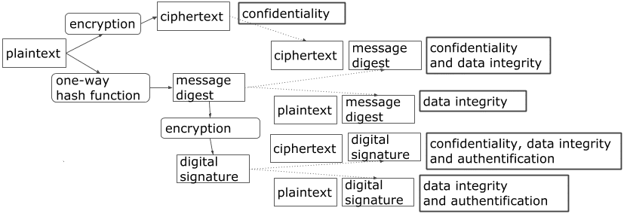
A Web page secured with SSL/TLS has a URL that begins with “https://”. In the HTTPS protocol, the types of data encrypted include the URL, the HTTP header, cookies, and data submitted through forms
Internet web browser secure communication uses a combination of both symmetric and asymmetric encryption. SSL/TLS uses public key (asymmetric) encryption to authenticate the server to the client (initial handshake). Public key cryptography is also used to establish a session key. Once both peers agreed upon a shared session key then the rest of the communication would be using symmetric encryption. This combines the benefit of asymmetric encryption for authentication with the faster, less processor-intensive symmetric key encryption for the bulk data.

Turning grilles in fiction and history
A 6 x 6 grille is used by Mathias Sandorff, the character of the novel by Jules Verne (1885).
Verne gives a very good description of the system. He tells his readers that such a cipher is ...unbreakable unless you have the grille. Verne had come across the idea in Baron Fleißner’s (a retired Austrian cavalry colonel) Handbuch (1881).
The grilles (in various sizes) were used by the German army at the end of 1916 (till French cryptanalysts devised attacks exploiting the weaknesses of the grilles).

