Outfield Tournament Impact v4
Qatar 2022 · positionally balanced · opposition-aware · evidence-reliability adjusted
Active model: outfield-tournament-impact-v4+goalkeeper-event-profile-v3

Executive summary
Release decision · PASSED
All publication blockers passed. The released composite applies pre-match opposition context, OOF 360-frame positional prevention, evidence and bootstrap-SE shrinkage, preregistered variance rescaling, and continuous role-mixture weights—in that order. Lionel Messi remains #1.

Release measure | Count
Unified publication cohort | 585.0
Eligible outfielders | 553.0
Unified 300+ minutes | 142.0
Outfield 300+ minutes | 126.0
Preregistered configurations | 1296.0
Writer-owned artifacts | 2029.0

What changed
- Defense now contributes an exact realized 35% of attributed channel variance; parity remains capped at 50%.
- Opponent strength is frozen before kickoff (selected FIFA log-rank variant), so current/future match outcomes cannot alter context.
- The 360 entry-denial family passed match-grouped OOF validation and does not require a recorded player defensive event.
- Role weights are continuous, identity-free, bounded in [0.25, 0.75], and sum to one for every outfielder.
- Every existing *_v3 column and v3 artifact is byte-preserved; v4 is a parallel, explicit release family.

Method and selected configuration
Mandatory defensive pipeline
opposition_adjusted → prevention_augmented → reliability_shrunk → variance_rescaled → mixture_weighted

Parameter | Selected value
Configuration ID | 165.0
Defensive variance target | 0.350
Continuous mixture bounds | [0.25, 0.75]
Attack reliability constant | 80.0
Defense reliability constant | 300.0
Bootstrap-SE shrink constant | 0.500
Opposition variant | fifa_log_rank
Opposition exposure scale | 1.000
Prevention weight | 0.750

Validation and stability
Diagnostic | Result
360 OOF Spearman | 0.684
360 OOF RMSE | 6.229
Mean-only RMSE | 8.851
Bootstrap top-50 Jaccard · median | 0.449
Bootstrap top-50 Jaccard · p10 | 0.333
Leave-one-match-out top-50 Jaccard · median | 0.961
LOMO p95 absolute rank shift | 11.3
Single-attribution p95 rank shift | 113.7

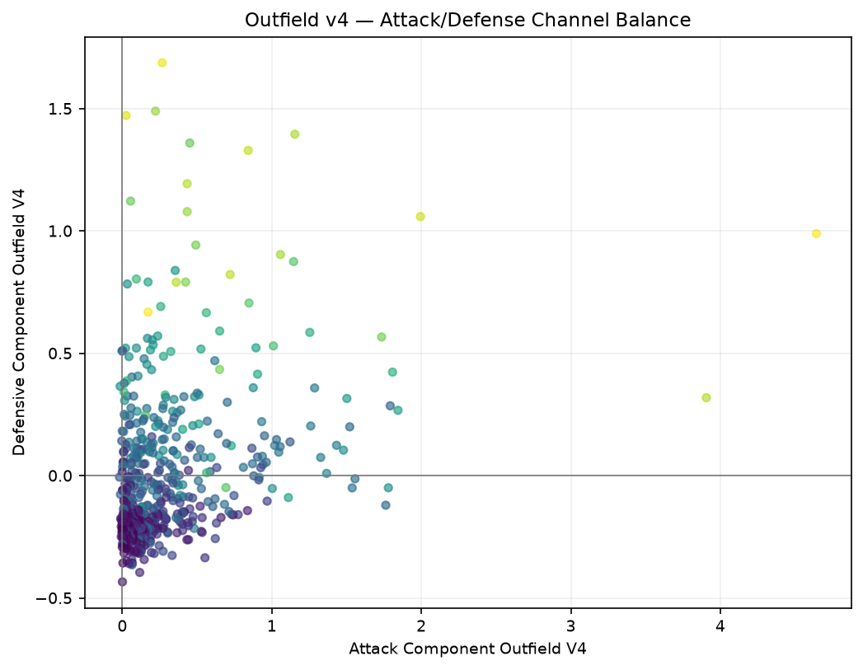

Final v4 outfield top 50
Tournament Impact rank is outfield-only; publication rank is the unified 585-player bridge with one main goalkeeper per team. The display score retains the FIFA-style 55–99 one-decimal scale.

Ranks 1–25
TI | Player | Team | Position | Pub. | 55–99
1 | Lionel Andrés Messi Cuccittini | Argentina | Attacking Midfield/Wing | 1 | 99.0
2 | Kylian Mbappé Lottin | France | Forward | 2 | 88.8
3 | Ivan Perišić | Croatia | Attacking Midfield/Wing | 3 | 80.3
4 | Mateo Kovačić | Croatia | Central/Wide Midfield | 4 | 76.6
5 | Antoine Griezmann | France | Attacking Midfield/Wing | 5 | 74.8
6 | Julián Álvarez | Argentina | Forward | 6 | 74.3
7 | Luka Modrić | Croatia | Central/Wide Midfield | 7 | 73.9
8 | Olivier Giroud | France | Forward | 8 | 73.5
9 | Jamal Musiala | Germany | Attacking Midfield/Wing | 9 | 73.2
10 | Alexis Mac Allister | Argentina | Central/Wide Midfield | 10 | 72.8
11 | Rodrigo Javier De Paul | Argentina | Defensive Midfield | 11 | 72.4
12 | Joško Gvardiol | Croatia | Center Back | 13 | 72.3
13 | Andrej Kramarić | Croatia | Attacking Midfield/Wing | 14 | 71.5
14 | Harry Kane | England | Forward | 15 | 71.3
15 | Marcelo Brozović | Croatia | Defensive Midfield | 16 | 71.3
16 | Robert Lewandowski | Poland | Forward | 17 | 70.7
17 | Neymar da Silva Santos Junior | Brazil | Attacking Midfield/Wing | 18 | 70.6
18 | Dejan Lovren | Croatia | Center Back | 19 | 70.6
19 | Richarlison de Andrade | Brazil | Forward | 20 | 70.1
20 | Lautaro Javier Martínez | Argentina | Forward | 21 | 70.1
21 | Achraf Hakimi Mouh | Morocco | Fullback/Wingback | 22 | 69.9
22 | Daniel Olmo Carvajal | Spain | Attacking Midfield/Wing | 23 | 69.6
23 | Christian Pulisic | United States | Attacking Midfield/Wing | 24 | 69.4
24 | Youssef En-Nesyri | Morocco | Forward | 25 | 69.4
25 | Cristiano Ronaldo dos Santos Aveiro | Portugal | Forward | 26 | 69.3

Final v4 outfield top 50 · continued

Ranks 26–50
TI | Player | Team | Position | Pub. | 55–99
26 | Hakim Ziyech | Morocco | Attacking Midfield/Wing | 27 | 69.3
27 | Adrien Rabiot | France | Defensive Midfield | 28 | 69.3
28 | Josip Juranović | Croatia | Fullback/Wingback | 29 | 69.1
29 | Sofyan Amrabat | Morocco | Defensive Midfield | 30 | 69.0
30 | Ángel Fabián Di María Hernández | Argentina | Central/Wide Midfield | 31 | 68.9
31 | Breel-Donald Embolo | Switzerland | Forward | 32 | 68.8
32 | Azzedine Ounahi | Morocco | Central/Wide Midfield | 33 | 68.5
33 | Jude Bellingham | England | Defensive Midfield | 34 | 68.4
34 | Raphael Dias Belloli | Brazil | Attacking Midfield/Wing | 35 | 68.3
35 | Ismaïla Sarr | Senegal | Attacking Midfield/Wing | 36 | 68.1
36 | Cody Mathès Gakpo | Netherlands | Attacking Midfield/Wing | 37 | 67.7
37 | Marco Asensio Willemsen | Spain | Forward | 39 | 67.3
38 | Sofiane Boufal | Morocco | Central/Wide Midfield | 40 | 67.2
39 | Bruno Miguel Borges Fernandes | Portugal | Attacking Midfield/Wing | 41 | 67.1
40 | Frenkie de Jong | Netherlands | Defensive Midfield | 42 | 67.1
41 | Enzo Fernandez | Argentina | Defensive Midfield | 43 | 67.0
42 | Carlos Henrique Casimiro | Brazil | Defensive Midfield | 44 | 66.8
43 | Serge Gnabry | Germany | Attacking Midfield/Wing | 45 | 66.7
44 | Cristian Gabriel Romero | Argentina | Center Back | 46 | 66.7
45 | Salem Mohammed Al Dawsari | Saudi Arabia | Central/Wide Midfield | 47 | 66.7
46 | João Félix Sequeira | Portugal | Attacking Midfield/Wing | 48 | 66.5
47 | Aurélien Djani Tchouaméni | France | Defensive Midfield | 49 | 66.5
48 | Vinícius José Paixão de Oliveira Júnior | Brazil | Central/Wide Midfield | 50 | 66.4
49 | Memphis Depay | Netherlands | Forward | 51 | 66.4
50 | Phil Foden | England | Attacking Midfield/Wing | 52 | 66.2

Fixture movement and channel attribution
Player | v3 | v4 | ↑ | Attack | Defense
Lionel Andrés Messi Cuccittini | 1 | 1 | 0 | 4.642 | 0.989
Jude Bellingham | 55 | 34 | 21 | 0.894 | 0.523
Virgil van Dijk | 287 | 70 | 217 | 0.094 | 0.804
Cristian Gabriel Romero | 296 | 46 | 250 | 0.055 | 1.122
Nicolás Hernán Otamendi | 478 | 77 | 401 | 0.173 | 0.669
Achraf Hakimi Mouh | 84 | 22 | 62 | 0.434 | 1.193
Sofyan Amrabat | 497 | 30 | 467 | 0.025 | 1.472
Josip Juranović | 80 | 29 | 51 | 0.434 | 1.079

Four-fixture defensive decomposition
Player | Raw | Opp. | Off-ball | Shrunk | Final D
Jude Bellingham | -0.056 | 0.454 | 0.230 | 0.452 | 0.523
Virgil van Dijk | 0.200 | 0.580 | 0.046 | 0.516 | 0.804
Cristian Gabriel Romero | 0.262 | 0.674 | 0.054 | 0.594 | 1.122
Nicolás Hernán Otamendi | -0.249 | 0.827 | 0.075 | 0.490 | 0.669

Face-validity results
- Van Dijk +217, Romero +250, and Otamendi +401 unified publication places versus v3.
- Bellingham reaches #34 with attack and defense shown separately.
- Hakimi is Morocco’s top-ranked outfielder (#22); Amrabat reaches #30 with a positive off-ball prevention lift.
- Messi remains #1. No member of the prior attacking top ten falls more than 15 places.
- Juranović rises to #29. His lift comes from accumulated raw defense plus the hardest average opponent schedule among the watch fixtures; his modeled off-ball increment is negative, so the rise is not a prevention-term artifact.
- The uncoupled raw-defense experiment leaves Otamendi at #553; the released coupled pipeline places him #74.

External consensus comparison
External sources were evaluated only after configuration lock and were never scoring or grid-selection inputs. FIFA did not publish an official tournament Best XI; FIFA TSG material is treated as technical context, not as a fabricated selection.
Player | Team | v4 | External signal | Assessment
Lionel Andrés Messi Cuccittini | Argentina | 1 | universal tournament-leading consensus | directionally consistent
Jude Bellingham | England | 34 | strong two-way midfielder consensus | directionally consistent
Achraf Hakimi Mouh | Morocco | 22 | strong Team-of-the-Tournament consensus | directionally consistent
Sofyan Amrabat | Morocco | 30 | strong analyst/TSG recognition; weaker event-only XI presence | directionally consistent
Nicolás Hernán Otamendi | Argentina | 77 | positive but less universal consensus | directionally consistent
Cristian Gabriel Romero | Argentina | 46 | mixed external selection support | directionally consistent
Virgil van Dijk | Netherlands | 70 | mixed external selection support | directionally consistent
Josip Juranović | Croatia | 29 | watch fixture; limited broad-XI consensus | directionally consistent

Cited sources
- FIFA — Qatar 2022 Technical Study Group tournament summary: https://publications.fifa.com/en/annual-report-2022/2022-at-a-glance/fifa-world-cup-qatar-2022-summary/
- FIFA — TSG review of the semi-finalists and Morocco: https://inside.fifa.com/talent-development/technical-study-group/news/tsg-runs-the-rule-over-the-semi-finalists-and-moroccos-magnificent-run
- ESPN — World Cup 2022 best XI: https://www.espn.com/soccer/story/_/id/37634927/world-cup-2022-best-xis-makes-our-team-tournament
- The Guardian — World Cup 2022 team of the tournament: https://www.theguardian.com/football/2022/dec/19/world-cup-2022-team-of-the-tournament-martinez-mbappe
- BBC Sport / Opta — Statistical team of the World Cup: https://www.bbc.co.uk/sport/football/64019356
- The Athletic — World Cup team of the tournament: https://theathletic.com/4008254/2022/12/18/world-cup-team-of-the-tournament/
- WhoScored — WhoScored statistical XI (contemporary reproduction): https://www.uol.com.br/esporte/futebol/colunas/rafael-reis/2022/12/20/messi-e-o-unico-argentino-em-selecao-da-copa-montada-por-robos-confira.htm
- SofaScore — World Cup tournament data registry: https://api.sofascore.com/api/v1/unique-tournament/16/seasons
- FBref — 2022 World Cup standard statistics: https://fbref.com/en/comps/1/2022/stats/2022-World-Cup-Stats

Artifacts, auditability, and limitations
Reproducibility chain
Balance base 955168fdc774 · generation head 265db0eb5c0c · preregistration commit 9a5c1b0a3b92 · 2046 pre-DOCX artifact hashes

Release surfaces
- Unified 585-player and outfield-only rankings; 300+ minute views; CSV and JSON.
- 32 rich team ranking families and 32 unified team families.
- 593 player profiles, 593 starter Markdown/JSON pairs, 32 team profiles, and 32 team report pairs.
- Canonical final summary, model summary, coaches notebook, four figures, methodology, diagnostics, complete rejected grid, and manifests.
- Every generated ranking surface carries an explicit active model version and derives from the same rich 593-row table.

Remaining limitations
- StatsBomb 360 is event-triggered rather than continuous optical tracking; player prevention attribution blends a validated team-shape signal with identity-free player shape.
- Single-attribution sensitivity is evaluated at the player-match channel-contribution granularity available to the released defensive OOF model.
- FIFA ordinal rank is a pre-tournament strength proxy, not a direct measure of the exact attacking lineup on the pitch.
- The ranking measures Qatar 2022 accumulated contribution, not career ability or future performance.
Interpretation
This is accumulated Qatar 2022 contribution, not career ability. Totals reward sustained minutes and evidence; there are no round, winner, nationality, reputation, award, or named-player bonuses.

