# California Environmental Flows Framework (CEFF) Background

Flow alterations are a significant driver of species population declines and biodiversity loss in California and globally. Multiple state and local agencies across California share responsibility for setting flow criteria that protect and improve the ecological health of California’s water resources. These approaches historically have not been coordinated at the statewide level, resulting in fragmented and siloed flow management programs.

In 2016, a group of experts self-organized to pool knowledge and data, evaluate methods, and ultimately develop a statewide framework for determining environmental flow criteria for California. The strategy is organized into a two-tiered approach that varies in scale and detail.

The framework establishes targets for environmental flows on all streams in California  
based on their natural reference flow conditions (Tier 1), and then provides guidance on  
further refining these statewide flow criteria using site-specific hydrologic, geomorphic  
and ecologic conditions (Tier 2).

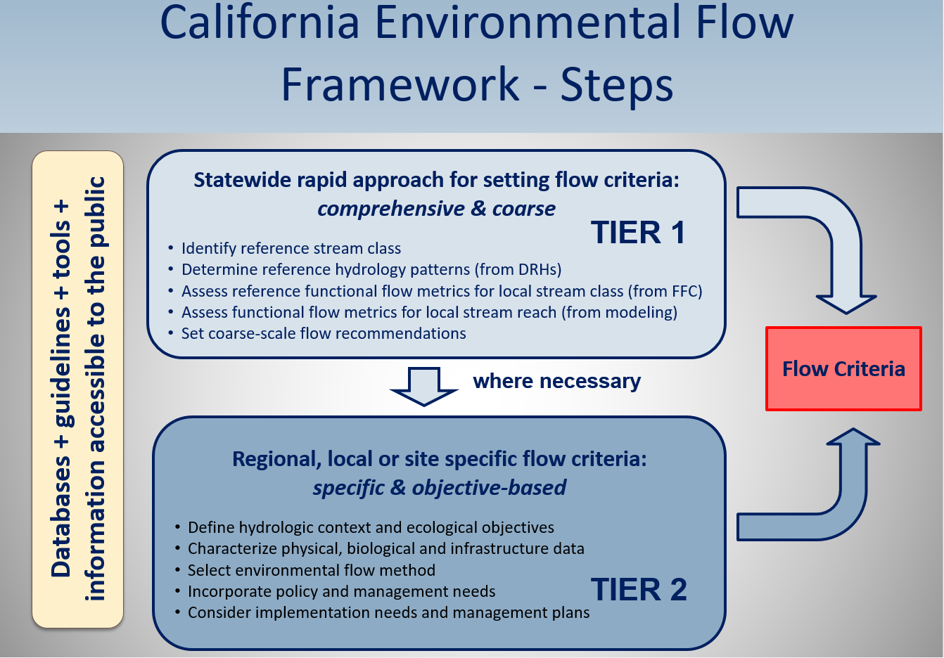

CEFF provides a process for evaluating existing conditions of flows, identifying potential limiting factors, and developing recommendations for establishing ecologically relevant flow targets in light of competing water uses, statewide. CEFF has been developed in collaboration with the State Water  
Resources Control Board, CA Department of Fish and Wildlife, federal resource agencies, academic institutions and non-profit organizations within the Environmental Flows Workgroup, a sub-group of the California Water Quality Monitoring Council.

# Biological Endpoints and Environmental Flow Recommendations

The identification of priority biological endpoints across the state is a key step in refining  
environmental flow recommendations under Tier 1. Based on a literature review of documented relationships between aquatic species and flow conditions, we found that data directly linking individual species to quantifiable flow metrics is lacking (Yarnell et al.?). Therefore, we needed to more broadly relate stream flow conditions directly to aquatic species community composition and to specific life history requirements for taxa of concern. To do this, we developed an approach for determining regional fish assemblages across California that are geographically distinct and thus are assumed to have evolved under local hydrologic conditions.

# Methods

We used fish distribution data and a clustering analysis to group species assemblages geographically within four broad regions across California. This approach allowed us to determine sub-regional assemblages of species that are most distinct within a defined sub-region, based on their inherent geographic similarity and their dissimilarity with other clusters within the region. We will then relate these assemblages to hydrologic conditions to flow metrics to determine environmental flow recommendations.

Fish distribution data were obtained from the PISCES database (Santos et al, 2014). Distribution data used in this analysis only included current species ranges, and did not include historic ranges or areas where translocations have occurred. We focused on the 75 flow-sensitive species identified by Grantham et al 2014 (See Appendix X for complete list of species), which are known to be susceptible to altered flow regimes, and thus will directly benefit from improved environmental flows.

Regional boundaries

*(Map of regions with areas grayed out that weren’t part of the analysis.)*

Map caption: Map of regions used for clustering analysis. Note, gray areas indicate areas excluded from our analysis. These areas either do not contain flow-sensitive species, or were manually excluded because they have unique management considerations and should be managed separately (ie. the San Francisco Bay and HUCs immediately draining into it, the Delta).

K means discussion

We used k-means clustering to determine fish assemblages within each of the four regions in the state. We evaluated a range of cluster sets (2-8 clusters) for each region, where each cluster set is made up of a HUC12-scale species assemblage (SCHEMATIC BELOW). UC Davis ecologists reviewed the cluster sets for each region and selected the set based on groupings that were the most geographically-pertinent and ecologically- relevant.

It is important to note that the results of this clustering analysis will be used to inform a community approach to flow management, and are not intended for managing individual species or ESUs.

# Map of Results

See here for an interactive map of results. (ADD LINK)

# Questions for Experts

Do the fish species within these assemblages make sense from an ecological and management perspective and based on geographic boundaries we have established?

Please email your responses back to XX by XXX.

# References

Grantham, T.E., Viers, J.H. & Moyle, P.B. (2014). Systematic screening of dams for environmental flow assessment and implementation. BioScience 64:1006-1018.  
https://doi.org/10.1093/biosci/biu159P.B

Santos, N. R., Katz, J. V. E., Moyle, P. B., & Viers, J. H. (2014). A programmable information system for management and analysis of aquatic species range data in California. Environmental Modelling and Software, 53. https://doi.org/10.1016/j.envsoft.2013.10.024