There are three deliverables that you should make available within your team Github by the end of the day on Tuesday 16th June:

**A clear description of the overall vision for your project (min 300 words, max 500 words):**

The aim of our group project is to provide users with a website where they will be able to receive news in the context of their locality i.e. the news they receive will be related to their geographical location. Nowadays most news websites focus exclusively on global and national events. This was highlighted in the recent BBC ‘Future of News’ report*.* There is strong evidence to suggest that local news is becoming increasingly neglected. For example many counties in Ireland have recently experienced the loss of local newspapers e.g. The Kilkenny Voice*).* Our project will provide a more granular, tailored news service for local communities.

There is a global trend towards dynamic website personalisation that allows users to customise web services to give a more personal experience. For example social media services allow users to customise their profile pages and have easy access to features that are relevant to the user e.g. Facebook, Twitter, Flipboard. Based on this trend we are confident that there is a market for a more localised/ personal news service. People want access to news more relevant to their daily lives and local area. This market is still in its infancy and a local news service has very good potential for strong business growth.

The goal of our project will be to design and implement a web based news service, using scrum methodology, to provide local news to users/ customers. We will use geolocation to provide relevant news articles to a user based on their location from existing news sources and social media. We are going to use the broad definition of news e.g. including news, business, sport, entertainment etc.

User Story 1 - News in context of the User's location: The user is on holiday and arrives in a new location. They want to know what is happening in the locality. They can go to our website and they will be presented with stories related to the location.

User Story 2 – News for another location: A user from Cork is working in Dublin and wants to keep in touch with what is going on at home. They can select the location of Cork on our website map to access the local Cork news.

We will use the following software to implement our project:

- Python NLTK Toolkit

- Django Framework

- Openlayers Javascript

- HTML/ CSS

We are currently researching a viable business model for our product. We believe the value of our product will be tied to the locality. For example local newspapers carry local advertisements. In this context we are considering how to sell our product. One suitable business type we are researching is to offer a free version to customers containing targeted local advertising. Following on from this we could offer a “premium” version with the ads removed to other customers. This would give us the advantage of appealing to a wide market. As the project evolves we may revise the business models.

**A description of your first minimal viable product including what you would learn from deploying this and what you would measure in order to learn it (min 200 words, max 500 words). Even if you are not taking a lean approach to managing your project you should be able to articulate an MVP:**

We are using scrum methodology to design and implement a Minimum Viable Product. Our final product will be a website that will retrieve relevant news for a user based on their location. Our MVP will be a prototype of our local news service website. The website will focus on retrieving relevant news articles for locations from one news source. We will have a simple website that will return news and information for 5 of the main cities in Ireland. We have chosen Dublin, Belfast, Cork, Galway and Limerick as the cities.

Our MVP will consist of the following. On the website there will be a map of Ireland. The five cities will be highlighted on the website map with pins. When the user clicks on a city pin the website will present news articles related to this city. The news articles presented on the website will be from one news source – [www.rte.ie](http://www.rte.ie).

At this early stage we’re looking to have a basic product that demonstrates our final products core functions. It will have a basic geolocation feature. It will also have a basic news article retrieval feature. The news article retrieval feature will use the ‘Newspaper’ package to retrieve articles, NLTK to do named entity recognition. It will use Google places API and the Geolite named places database to identify locations and there coordinates. It will also use Postgres SQL for the persistence layer.

Using the scrum method we have developed a product backlog for our project. For this project we have defined a work item as ‘done’ when it has been deployed and tested on our server where appropriate. We have planned and started the first project sprint to develop the MVP. We selected the items for the first sprint based on their importance to the MVP and our understanding of how to implement them. The duration of the sprint will be two weeks. From our sprint review we will be able to identify any unknown difficulties and adjust any items velocity in a sprint retrospective if required. From this sprint we will be learn how to design the core functions of the product and how to further develop them for our final product. For example we will identify how to connect the geolocation aspect of the product to the retrieval of relevant news stories for a location. We have identified methods to develop the core functionality for our MVP and this sprint will highlight any difficulties with our approach. This sprint may also identify new methods and techniques that we can use to add additional features to the product that initially appeared unachievable.

**Appropriate project management artefacts that demonstrate that you have a clear plan on how you will execute your project. For example, if you are following the PMP method you would include a work break down structure and a Gantt chart. If you are using Scrum you would include your product backlog and some details on how you are running your sprints.**

To execute our project plan we are using different types of communication and project management software. We are currently using Slack and Github for team collaboration purposes and are using Trello for the Team Burgundy Scrum Board. Here is a link to our Scrum Board (screenshot below): <https://trello.com/b/mAXZmqKA/product-board>

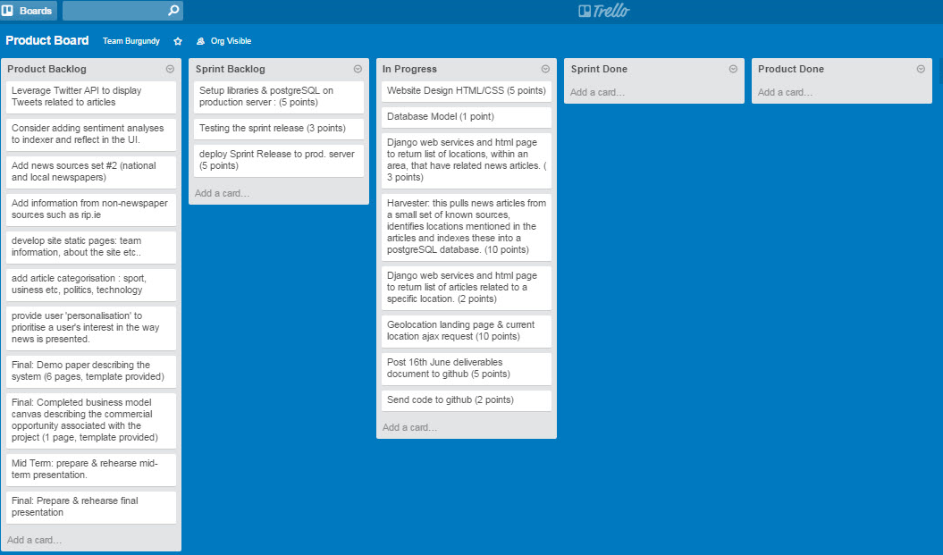

In addition we meet at least twice a week and more frequently when required.

Our first step was to develop a product backlog incorporating all of the work items required to successfully implement the project. We are going to use two week scrum sprints for the duration of the project. The team with guidance, from the scrum master – Paul Skelton – picks work items from our product backlog depending on the target of our sprint. For our first sprint we have chosen work items that are crucial for the development of our MVP. We use slack to hold scrums when required. We will hold a sprint review after the first sprint and decide on what the target for the next sprint will be and what work items are required.